NAME; AHMED AMINA
MATRIC NUMBER; 16/MHS02/007
COURSE; NSC404
COURSE TITLE; MATERNAL HEALTH AND NORMAL MIDWIFERY II

QUESTIONS
- Use of partograph in the management of first stage of labor.
- Management of second and third stages of labor.

ANSWERS
- A partograph is a graphical tool that is used to observe and monitor the progress of labor, maternal and fetal condition during labor, and to detect any abnormalities during labor. It is the best tool to aid the midwife or the physician know if the labor is progressing normally or abnormally once the woman begins to shows true signs of labor.
Components of a partograph
- Mother information
- Fetal wellbeing which includes fetal heart rate, character of liquor and moulding
- Labor progress which includes; dilation, uterine contractions
- Medication which include oxytocin and analgesics
- Maternal wellbeing which includes; blood pressure, temperature, pulse, respiration, urine (urinalysis), and urine output
First stage of labor can be defined as the onset of painful frequent uterine contractions to full cervical dilation(10cm), during this period, a partograph can be used to manage the first stage of labor by:

- Charting the patient’s information which includes; full name, gravida, parity, hospital number, date and time of admission, on top of the graph.
- Time is recorded using the time of admission as zero-time. The actual time of the day is recorded below the hour line.
- Charting the maternal condition which are; temperature and respiration are recorded in the spaces provided. Blood pressure is recorded with a plus sign (+), pulse is recorded with a dot sign (.).
- Charting all observations on the mother’s condition on the time line which is on the bottom of the partograph (every 4 hours).
- Assessing the woman’s urine and carrying out urinalysis; ask the woman to empty her bladder every 2 hours, check urine for amount and concentration as concentrated urine could be a sign of dehydration.
Test for proteins, glucose and acetones routinely on admission. Protein in the urine may be a sign of pregnancy induced hypertension. Acetone in the urine may be a sign of dehydration or diabetes.
- Drugs and rehydration fluids are recorded in the space provided if these are given. Oxytocin is charted in separate column above for fluids and drugs
- The fetal heart rate is recorded initially and then every 30 minutes. The scale for fetal heart rate covers the range from 80 to 200 beats per minute.
- Below the fetal heart rate, there are two rows close together. The first of these is liquor or amniotic fluid; if the fetal membranes have ruptured or is intact it is recorded stating the color of the fluid initially and every 4 hours. For example, if the fluid is clear it is indicated as C, if blood stained, it is indicated as B.
- The row below liquor’ is labelled Moulding; this is the extent to which the bones of the fetal skull are overlapping each other as the baby’s, it is recorded from zero to pluses, which indicated no moulding to the extent of moulding, that is; mild to severe.
- Another column on a partograph from which labor is managed is cervical dilation, it is plotted with an X on the chart from when it reaches 4cm to 10cm.
- Uterine contraction is also observed for frequency and duration, dots are used to indicate mild contraction, and diagonal lines are used for moderate contractions while solid lines are used for strong contractions. This is recorded each 10 minutes.
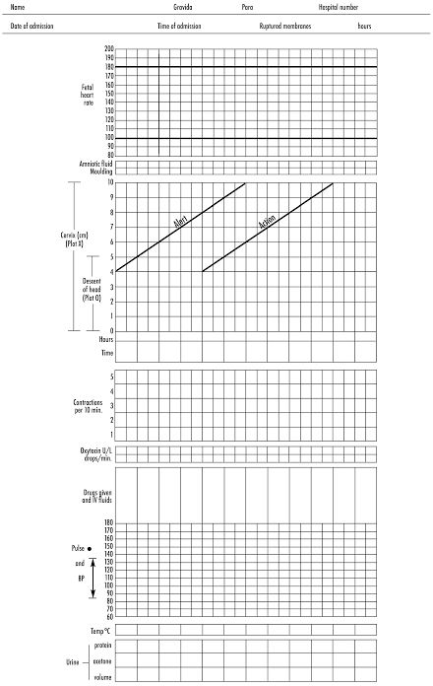
Illustration of partograph

- Management of second stage of labor
The second stage of labor can be defined as the period from full cervical dilation (10cm) to the birth of the baby. The second stage is divided into two phases which are the active and passive stages.
The passive stage; this is the time from full cervical dilation and the onset of involuntary expulsive contraction.
The active stage; this involves maternal urge to push and the fetal head is often visible.
Proper management during this stage of labor is necessary to prevent still births, newborn complications, maternal mortality and morbidity such as genital tract lacerations, infections, etc.
PRINCIPLE OF MANAGEMENT OF SECOND STAGE LABOR
- To assist in the natural expulsion of the fetus slowly and steadily
- To prevent perenial injuries
GENERAL MEASURES FOR THE MANAGEMENT OF SECOND STAGE LABOR
- The patient should be in bed
- Constant supervision of the woman and baby
- Administration of analgesics
- Vaginal examination

The management of the second stage of labor involves the :
- maternal position,
- bearing down,
- fetal monitoring,
- vaginal examination;
- delivery of the fetus
During the management of the second stage of labor, the midwife or physician is expected to;
- Continuously provide information, support, and encouragement to the woman and her companion.
- Encourage active pushing once the urge to bear down is present, with encouragement to adopt any position for pushing preferred by the woman, except lying supine which pose a risk for aortocaval acompression and reduced uteroplacental perfusion
- Continue to give bladder care
- Ensure the woman is hydrated and in general good condition
- Listen frequently (every 5 minutes) to the fetal heart in between contractions to detect bradycardia.
- Check the vital signs mostly the maternal pulse and blood pressure, especially where there is a pre‐ existing problem of hypertension, or cardiac disease.
- Observe progressive descent and rotation of the presenting part. This includes observing progressive distension of the perineum and visibility of the presenting part, and vaginal examination especially where progress appears to be slow.
- Conduct the delivery with support for the perineum to avoid tears, and use of episiotomy only where a tear is very likely.
- Be ready to augment contractions with an intravenous oxytocin infusion during the second stage where contractions have become infrequent and where the fetal heart rate remains normal, to avoid the need for instrumental vaginal delivery or transfer.
- Be ready to undertake instrumental vaginal delivery (vacuum or forceps) where indicated for fetal bradycardia or no advance of the presenting part.
- Conduction of delivery which involves three phases:
- The delivery of the head
- The delivery of the shoulders
- The delivery of trunk
- Immediate care of the newborn.

ii. Management of the third stage of labor
The third stage of labor can be defined as the period from birth of the baby to the delivery of the placenta and membrane, this usually takes 5 to 15 minutes after the baby is born. The management of the third stage of labor occur in two stages;
- Physiologic or expectant management
ii. Active management
- Physiologic or expectant management
In this management,
- the placenta is delivered naturally with maternal effort,
- oxytocic’s are not used
- The cord is clamped after the placenta is delivered.
- It takes more time and more bleeding occurs
- Active management
The active management of third stage of labor involves the use of drugs like oxytocin, ERGOT alkaloid and prostaglandin; the management include;
- Administering an uterotonic (oxytocin or misoprostol) within 1 minute after the baby’s birth and after ruling out the presence of another baby (the uterotonic of choice is oxytocin 10 IU IM).
- Clamping and cutting the cord after cord pulsations have ceased or approximately 2–3 minutes after birth of the baby, whichever comes first. Cover the cord with a piece of gauze when cutting the cord to avoid splashing blood.
- Performing controlled cord traction (CCT):
Place the clamp near the woman’s perineum to make it easier.
Hold the cord close to the perineum using a clamp.
Place the palm of the other hand on the lower abdomen just above the woman’s pubic bone to assess for uterine contractions. If a clamp is not available, it can be applied by encircling the cord around the hand.
- As the placenta is delivered, hold and gently turn it with both hands until the membranes are twisted. Slowly pull to complete the delivery. Gently move membranes up and down until delivered
- Massaging the uterus immediately after delivery of the placenta and membranes until it is firm. Ensure the uterus is not massaged until the placenta has been delivered.

