ABU DANIEL BABA
18/ENG02/003
COMPUTER ENGINEERING
ENG 284

- The scope of work are as follows
-Project overview ;The main objective is the rehabilitation of the alpha belgore hall
-Project scope; this contains the technical specifications and the budget allocation for the completion of the project
-Project deliverables; the objective is to ensure the rehabilitation of the alpha belgore hall from top to bottom beginning with the roof top. The top needs to be reformed due to its current state of appearance. The walls are to be reformed due to its states of appearance has brought discomfort to the school.
-Project schedule; the project is to last for a minimum of 8months but taking other problems that might come it should last for about a year.
-Project management; the project administrators are to make sure the projects are carried out effectively and ensure the payments of the workers when due.

2 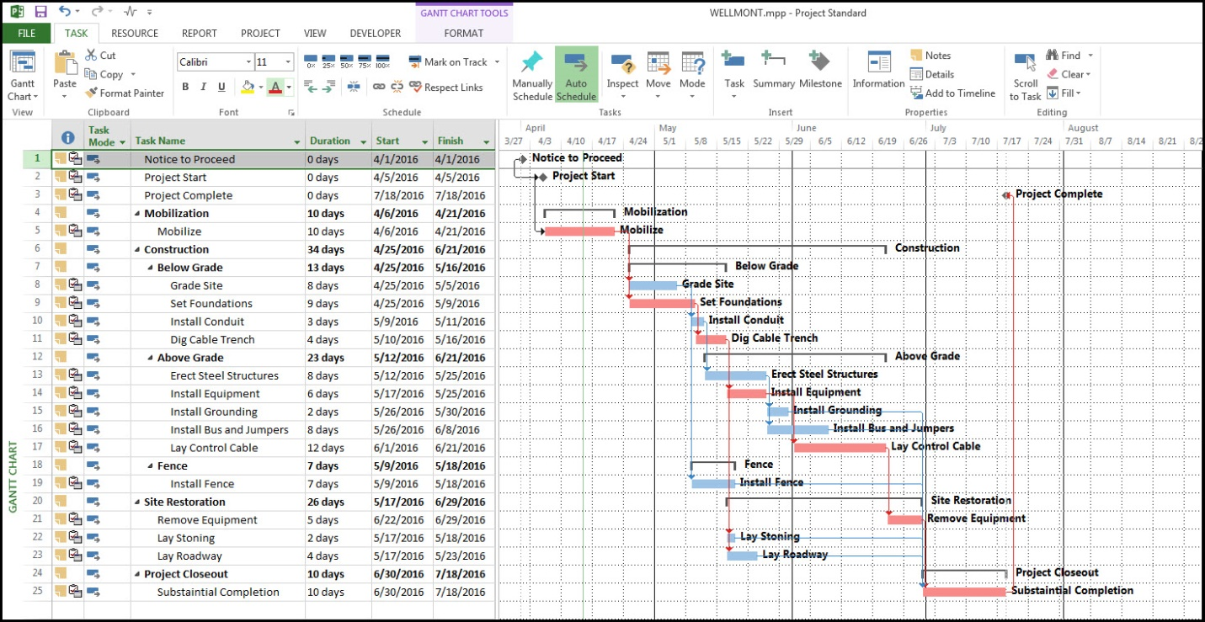

3 – Cement
- Blocks
- Mixer
- Building tools
Project teams
The engineer(civil)
The architect
The workers
The tradesman

4. the site was secured to prevent people from coming close to the construction site so as to avoid dangers from occurring and to give room for the workers to do their job.
5
The projections | Cost
At 10% | 5 million naira
At 15% | 11 million naira
At 5% | 1 million naira
At 12% | 15 million naira
At 20% | 22 million naira

6
Mobilization | 20 million naira
Completion | 15 million naira
Completion and hand over | 10 million naira
Defect liability period | 22 million naira

7. BEME is a reported in a systematic, transparent and scholarly manner with the aim of being user friendly, enabling the practitioner to judge and employ evidence according to their individual criteria and context.

Defect liability period is a period of time following practical completion during which a contractor remains reliable under the building contract for dealing with any defects which become apparent.

Lead consultant is the consultant that directs the work of the consultant team and is the main point of contract for communication between client and the consultant team

Project life cycle is the sequence of phases that a project goes through from its initiation to its closure

Environmental impact assessment is the assessment of the environmental consequences of a plan, policy, program, or actual projects prior to the decision to move forward with the proposed action.

