EHONDOR MALCOLM
18/MHS01/135
ANATOMY
ANA212
DISCUSS WITH DIAGRAMS THE FEMALE EXTERNAL GENITALIA

Female External Genitalia (Vulva)
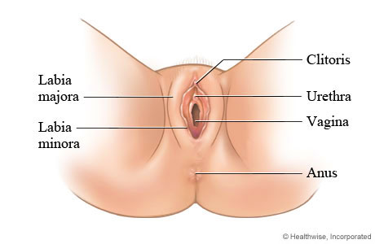

The external genitalia are the accessory structures of the female reproductive system that are external to the vagina. They are also referred to as the vulva or pudendum. The external genitalia include the labia majora, mons pubis, labia minora, clitoris, and glands within the vestibule.
The clitoris is an erectile organ, similar to the male penis, that responds to sexual stimulation. Posterior to the clitoris, the urethra, vagina, paraurethral glands and greater vestibular glands open into the vestibule.
The external female genitalia (vulva) include:
- The opening of the vagina (also called the birth canal). The vagina is part of the reproductive tract and extends from the womb (uterus) to outside the body.
- The fleshy lips (labia majora and labia minora) around the vagina.
- A small bump of tissue (clitoris) covered with a thin flap of tissue. The clitoris is the main source of sensations during sexual activity.
During a vaginal self-examination, you can also see the urethra, an opening that leads to the bladder, and the anus, the opening that leads to the colon.

External Genitalia
The vulva, also known as the pudendum, is a term used to describe those external organs that may be visible in the perineal area (see the images below). The vulva consists of the following organs: mons pubis, labia minora and majora, hymen, clitoris, vestibule, urethra, Skene glands, greater vestibular (Bartholin) glands, and vestibular bulbs. ^{[1, 2, 3]} The boundaries include the mons pubis anteriorly, the rectum posteriorly, and the genitocrural folds (thigh folds) laterally.
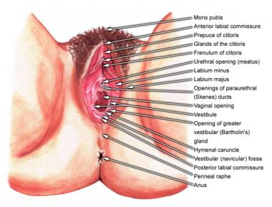External female genitalia.

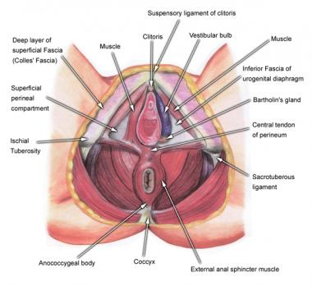Deeper view of external structures.
Mons pubis
The mons pubis is the rounded portion of the vulva where sexual hair development occurs at the time of puberty. This area may be described as directly anterosuperior to the pubic symphysis.
Labia
The labia majora are 2 large, longitudinal folds of adipose and fibrous tissue. They vary in size and distribution from female to female, and the size is dependent upon adipose content. They extend from the mons anteriorly to the perineal body posteriorly. The labia majora have hair follicles.
The labia minora, also known as nymphae, are 2 small cutaneous folds that are found between the labia majora and the introitus or vaginal vestibule. Anteriorly, the labia minora join to form the frenulum of the clitoris.
Hymen
The hymen is a thin membrane found at the entrance to the vaginal orifice. Often, this membrane is perforated before the onset of menstruation, allowing flow of menses. The hymen varies greatly in shape.
Clitoris
The clitoris is an erectile structure found beneath the anterior joining of the labia minora. Its width in an adult female is approximately 1 cm, with an average length of 1.5–2.0 cm. The clitoris is made up of 2 crura, which attach to the periosteum of the ischiopubic rami. It is a very sensitive structure, analogous to the male penis. It is innervated by the dorsal nerve of the clitoris, a terminal branch of the pudendal nerve.
Vestibule and urethra
Between the clitoris and the vaginal introitus (opening) is a triangular area known as the vestibule, which extends to the posterior fourchette. The vestibule is where the urethral (urinary) meatus is found, approximately 1 cm anterior to the vaginal orifice, and it also gives rise to the opening of the Skene glands bilaterally. The urethra is composed of membranous connective tissue and links the urinary bladder to the vestibule externally. A female urethra ranges in length from 3.5 to 5.0 cm.
Skene and Bartholin glands
The Skene glands secrete lubrication at the opening of the urethra. The greater vestibular (Bartholin) glands are also responsible for secreting lubrication to the vagina, with openings just outside the hymen, bilaterally, at the posterior aspect of the vagina. Each gland is small, similar in shape to a kidney bean.
Vestibular bulbs
Finally, the vestibular bulbs are 2 masses of erectile tissue that lie deep to the bulbocavernosus muscles bilaterally.

