NAME: OGBEWELE EXCELLENT OSEMEGAN
MATRIC NO: 15/ENG07/032
DEPT: PETROLEUM ENGINEERING
COURSE TITLE: FUNDAMENTAL ENHANCED OIL RECOVERY
CODE: PTE512
BRIEFLY DISCUSS THE FOLLOWING THERMAL EOR METHODS
1. Steam Assisted Gravity Drainage (SAGD):
This is an enhanced oil recovery technology for producing heavy crude oil and bitumen. It is an advanced form of steam stimulation. High pressure steam is continuously injected into the upper wellbore to heat the oil and reduce its viscosity, causing the heated oil to drain into the lower wellbore, where it is pumped out.
Steam Assisted Gravity Drainage (SAGD) and Cyclic Steam Stimulation (CSS) Steam injection (oil industry) are two commercially applied primal thermal recovery processes used in the oil sands, in Geological formation sub-units, such as Grand Rapids Formation, Clearwater Formation, McMurray Formation, General Petroleum Sand, Lloydminster Sand, of the Mannville Group, a Stratigraphic range in the Western Canadian Sedimentary Basin.
The SAGD process of heavy oil or bitumen production is an enhancement on the steam injection techniques originally developed to produce heavy oil from the Kern River Oil Field of California. The major purpose to all steam flooding processes is to deliver heat to the producing formation to reduce the viscosity of the heavy oil and enable it to move toward the producing well.
PROCESS:
Here, two parallel horizontal oil wells are drilled in the formation, one about 4 to 6 metres above the other. The upper well injects steam, and the lower one collects the heated crude oil or bitumen that flows down due to gravity, plus recovered water from the condensation of the injected steam. The basis of the SAGD process is that thermal communication is established with the reservoir so that the injected steam forms a "steam chamber". The heat from the steam reduces the viscosity of the heavy crude oil or bitumen which allows it to flow down into the lower wellbore. The steam and associated gas rise because of their low density compared to the heavy crude oil below, ensuring that steam is not produced at the lower production well tend to rise in the steam chamber, filling the void space left by the oil. Associated gas forms, to a certain extent, an insulating heat blanket above or around the steam. Oil and water flow is by a counter current, gravity driven drainage into the lower well bore. The condensed water and crude oil or bitumen is recovered to the surface by pumps such as progressive cavity pumps that work well for moving high-viscosity fluids with suspended solids.
Sub-cool is the difference between the saturation temperature (boiling point) of water at the producer pressure and the actual temperature at the same place where the pressure is measured. The higher the liquid level above the producer the lower the temperature and higher is the sub-cool. However real life reservoirs are invariably heterogeneous therefore it becomes extremely difficult to achieve a uniform sub-cool along the entire horizontal length of a well. As a consequence many operators, when faced with uneven stunted steam chamber development, allow a small quantity of steam to enter into the producer to keep the bitumen in the entire wellbore hot hence keeping its viscosity low with the added benefit of transferring heat to colder parts of the reservoir along the wellbore. Another variation sometimes called Partial SAGD is used when operators deliberately circulate steam in the producer following a long shut-in period or as a startup procedure. Though a high value of sub-cool is desirable from a thermal efficiency standpoint as it generally includes reduction of steam injection rates but it also results in slightly reduced production due to a corresponding higher viscosity and lower mobility of bitumen caused by lower temperature. Another drawback of very high sub-cool is the possibility of steam pressure eventually not being enough to sustain steam chamber development above the injector, sometimes resulting in collapsed steam chambers where condensed steam floods the injector and precludes further development of the chamber.
Continuous operation of the injection and production wells at approximately reservoir pressure eliminates the instability problems that plague all high-pressure and cyclic steam processes and SAGD produces a smooth, even production that can be as high as 70% to 80% of oil in place in suitable reservoirs. The process is relatively insensitive to shale streaks and other vertical barriers to steam and fluid flow because, as the rock is heated, differential thermal expansion allows steam and fluids to gravity flow through to the production well. This allows recovery rates of 60% to 70% of oil in place, even in formations with many thin shale barriers. Thermally, SAGD is generally twice as efficient as the older cyclic steam stimulation (CSS) process, and it results in far fewer wells being damaged by the high pressures associated with CSS. Combined with the higher oil recovery rates achieved, meaning that SAGD is much more economic than cyclic steam processes where the reservoir is reasonably thick.
DISADVANTAGES:
i. Use of natural gas for steam generation:
As in all thermal recovery processes, cost of steam generation is a major part of the cost of oil production. Historically, natural gas has been used as a fuel for Canadian oil sands projects, due to the presence of large stranded gas reserves in the oil sands area. However, with the building of natural gas pipelines to outside markets in Canada and the United States, the price of gas has become an important consideration. The fact that natural gas production in Canada has peaked and is now declining is also a problem. Other sources of generating heat are under consideration, notably gasification of the heavy fractions of the produced bitumen to produce syngas, using the nearby (and massive) deposits of coal, or even building nuclear reactors to produce the heat.

ii. Use of water for steam generation:
A source of large amounts of fresh and brackish water and large water re-cycling facilities are required in order to create the steam for the SAGD process. Water is a popular topic for debate in regards to water use and management. As of 2008, American petroleum production (not limited to SAGD) generates over 5 billion gallons of produced water every day. The concern of using large amounts of water has little to do with proportion of water used, rather the quality of the water. Traditionally close to 70 million cubic metres of the water volume that was used in the SAGD process was fresh surface water. There has been a significant reduction in fresh water use as of 2010, when approximately 18 million cubic metres were used. Though to offset the drastic reduction in fresh water use, industry has begun to significantly increase the volume of saline groundwater involved. This, as well as other, more general water saving techniques has allowed surface water usage by oil sands operations to decrease by more than threefold since production first began. Relying upon gravity drainage, SAGD also requires comparatively thick and homogeneous reservoirs, and so is not suitable for all heavy-oil production areas.
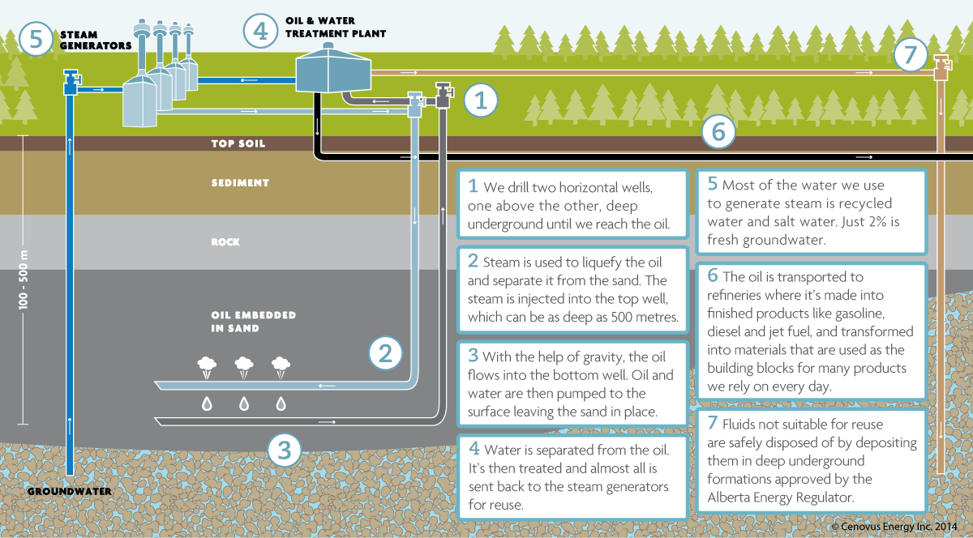
FIG 1: STEAM ASSISTED GRAVITY DRAINAGE PROCESS
2. Cyclic steam stimulation:
This method is also known as the Huff and Puff method, consists of 3 stages: injection, soaking, and production. Steam is first injected into a well for a certain amount of time to heat the oil in the surrounding reservoir to a recover approximately 20% of the Original Oil in Place (OOIP), compared to steam assisted gravity drainage, which has been reported to recover over 50% of OOIP. It is quite common for wells to be produced in the cyclic steam manner for a few cycles before being put on a steam flooding regime with other wells.
PROCESS:
The mechanism proceeds through cycles of steam injection, soak, and oil production. First, steam is injected into a well at a temperature of 300 to 340° Celsius for a period of weeks to months. Next, the well is allowed to sit for days to weeks to allow heat to soak into the formation. Finally, the hot oil is pumped out of the well for a period of weeks or months. Once the production rate falls off, the well is put through another cycle of injection, soak and production. This process is repeated until the cost of injecting steam becomes higher than the money made from producing oil.

ADVANTAGE and DISADVANTAGE:
The CSS method has the advantage that recovery factors are around 20 to 25% and the disadvantage that the cost to inject steam is high.

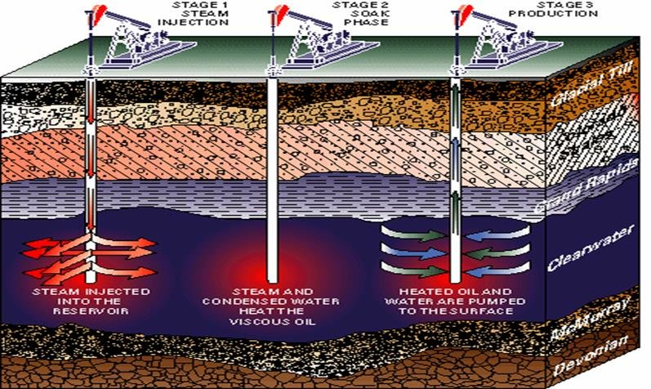
FIG 2: CYCLIC STEAM STIMULATION PROCESS

3. Hot water flooding:
Hot water flooding is also known as hot water injection, a method of thermal recovery in which hot water is injected into a reservoir through specially distributed injection wells. Hot water flooding reduces the viscosity of the crude oil, allowing it to move more easily toward production wells.
PROCESS:
The hot water is injected through an injection well which is drilled parallel to the primary producing well. Over time the pressure in an oil reservoir slowly and steadily decreases and as a result the production rate decreases. The heat from the hot water acts as a way of reducing the viscosity of crude oil, making it to flow toward the producing well with ease. Hot water flooding is generally used to extract crude oil which has an API degree of less than 20. It is typically less effective than a steam-injection process because water has lower heat content than steam. It is preferable under certain conditions such as formation sensitivity to fresh water.
The benefits of injecting water into the reservoir are:
i. It supports the reservoir pressure, also known as void age replacement.
ii. As oil is lighter than water hence it floats on top of the water. Also, the heat content of the water reduces the viscosity of heavy crude oil, making it not to stick on the edges of the reservoir and move quickly toward the producing well. Thus, water helps in displacing oil from its location in the reservoir and pushes it toward the producing well.
iii. Oil recovery factor can be increased and well production rate can be maintained for a longer period.

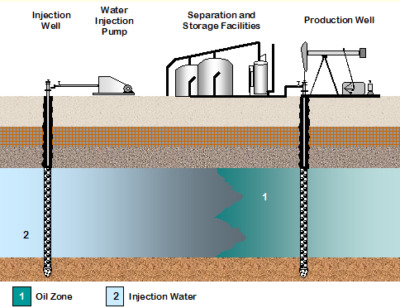
FIG 3: HOT WATER FLOODING PROCESS

