OLUKOWI OMOLARA OLUWANIFEMI
18/MHS01/385
MEDICINE & SURGERY
HISTOLOGY ASSIGNMENT

QUESTIONS:
- Write an essay on the histological importance of the eye in relation to their cellular function.
- Corona virus can penetrate the body through the eye and implicate the immune system, briefly discuss the layers of the retina for information penetration.

1) The eye is an organ of visual system. It is an organ that reacts to light and allows vision. The rods and cone cells in the retina allows conscious light perception and vision including color differentiation and the perception of depth. The eye is part of the sensory nervous system. The external structure of the eye includes the eyelashes, lids, muscles, accessory glands and conjunctiva. The internal layers of the eye consist of 3 layers
- The external layer- Sclera and Cornea
- The vascular layer- Uvea (Iris, ciliary body and choroid)
- The innermost layer- The retina.

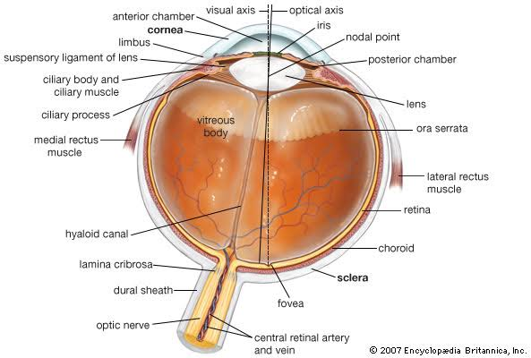
The sclera is a dense connective tissue made up of mainly type I collagen fibers, these fibers have no definite orientation thus the giving the sclera a white appearance. The sclera has 4 layers; episclera, stroma, lamina fusca, endothelium. The cornea is the transparent front layer of the eye, it consists of type I collagen fibers and they are oriented in a parallel direction to maintain transparency. The cornea consists of 5 layers which are:
- The corneal epithelium- which is non-keratinized stratified squamous epithelium, a regenerative layer
- The Bowman’s layer- a layer of subepithelial basement membrane that protects the stroma, it consists of type I collagen, laminin, heparin sulfate proteoglycan
- Stroma- the largest layer of the cornea, it contains collagen fibers, keratocytes. This layer functions in maintaining transparency.
- Descemet’s membrane- This is an acellular layer made of type IV collagen that serves as a modified basement membrane of the corneal endothelium
- Corneal endothelium- Made up of either simple cuboidal or squamous cells, these cells are regenerative. They help to maintain fluid balance and prevent swelling of the stroma.
The iris consists of the stromal layer which is a pigmented, fibrovascular layer (this pigmented layer helps to block rays of light and ensures that light moves through the pupil to reach the retina), the sphincter pupillae and dilator pupillae muscles are connected to the stroma. The ciliary body is a tissue that divides the posterior chamber and vitreous body. It consists of the ciliary muscles and epithelium. The muscle via the lens zonules controls the structure of the lens while the epithelium produces the aqueous humor that fills the anterior component of the eye. The choroid consists of a dense network of blood vessels that provide nourishment to structures of the eye, it has loose connective tissue. The choriocapillary layer is located in the innermost part of the choroid layer and it supplies the retina.
The lens separates the aqueous and vitreous chambers, it consists of an outer capsule, a middle layer called cortex and an inner layer called the nucleus. The capsule is the basement membrane of the lens epithelium and new lens cells differentiate from this epithelium. The vitreous is a jelly-like space made of type II collagen separating the retina and the lens. The retina is a nervous tissue of the eye where photons of light convert to neurochemical energy via action potentials.
The eyes have the rod and cone cells. The cone cells are photoreceptor cells that are located in the retina. They respond differently to light of different or color vision and function best in relatively bright light unlike the rod cells that function better in dim lights. There are about 6-7 million cones in the human eye. The cones are not as sensitive to light but allow the perception of color. They are also able to perceive finer details and more rapid changes in images because their response time are faster than that of rods. The cones are of 3 types, the S, M and L-cones and they respond to different wavelengths which allows the brain to perceive a continuous range of colors.
The rod cells are also photoreceptor cells in the retina, they function in lower light. They are found concentrated at the outer edges of the retina and are used in peripheral vision. There are about 92 million rod cells in the human retina. The rod cells are more sensitive than cone cells and are almost entirely responsible for night vision. However, they have little role in color vision which is why colors are much less apparent in dim light. The rod cells functions in photoreception, it also reverts the eye to its resting state after a flash of light by using rhodopsin kinase.
The layers of the eye perform distinct functions which coalesce to create a unified, perpetual experience. The essential role of the external eye structures is to protect the delicate tissue of the internal eye. The internal parts of the eye have primarily structural and visual functions. The cornea serves as a protective role and is responsible for two-third of the refractive properties of the eye. The remaining one-third of refraction is performed by the lens which is functionally adjustable through the action of the zonular fibers and ciliary muscles. The uvea of the eye is a crucial mediator of the nutrition and has exchange as blood vessels course through the ciliary body and iris while the choriocapillaris in the posterior eye help support the retina. This abundant blood supply is implicated in uveitis.

2) The layers of the retina are:
- The retinal pigment epithelium- Made of cuboidal cells containing melanin which absorbs light and these cells establish a blood-retina barrier
- Outer limiting membrane- A layer of Muller cells and rod/cones junction that serves to separate the photosensitive regions of the retina from the areas that transmit the electrical signals
- Outer nuclear layer- Consists of nuclei of rods and cones cells
- Outer plexiform layer- Contains synaptic processes of rods and cones cells
- Inner nuclear layer- Contains the cell body of glial, amacrine, bipolar and horizontal cells
- Inner plexiform layer- Relays information from the cells of the inner nuclear layer. It has axons of amacrine, bipolar and glial cells and dendrites of retinal ganglions cells
- Ganglion cell layer- Contains nuclei of retinal ganglion cells
- Nerve fiber layer- Contains axons of retinal ganglion cells and the astroglia that support them
- Internal limiting membrane- A thin layer of Muller glial cells and basement membrane which demarcates the vitreous anteriorly from the retina posteriorly.

