JAMES, Emem Grace
18/MHS01/192
BCH 20
BETA OXIDATION STEPS
The steps are namely;
- Dehydrogenation
- Hydration
- Oxidation
and Thyolisis
Each step is catalyzed by a distinct enzyme. Briefly, each cycle of the cycle begins with an acyl-CoA, one FADH2, one NADH and water, and the acyl-CoA chain becomes 2 carbons shorter. The total energy yield per cycle is 17 ATP molecules.
- Dehydrogenation
Dehydrogenation by FAD: The first step is the oxidation of the fatty acid by Acyl-CoA-Dehydrogenase. The enzyme is acyl CoA dehydrogenase. This enzyme catalyzes the formation of a double bond between the C-2 and C-3.
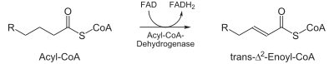
The enzyme is acyl CoA dehydrogenase

- Hydration
The next step is the hydration of the bond between C-2 and C-3. The reaction is stereospecific, forming only the L isomer.
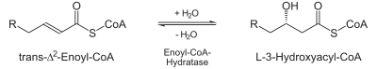
The enzyme is enoyl CoA hydratase

- Oxidation
Oxidation by NAD⁺: The third step is the oxidation of L-β-hydroxyacyl CoA by NAD⁺. This converts the hydroxyl group into a keto group.
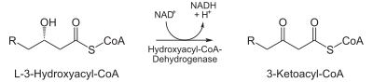
Enzyme active here is 3-hydroxyacyl-CoA dehydrogenase and the end product being β-ketoacyl CoA
- Thiolysis
The final step is the cleavage of β-ketoacyl CoA by the thiol group of another molecule of Coenzyme A. The thiol is inserted between C-2 and C-3.
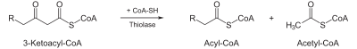
The enzyme present is β-ketothiolase and the end product, an acetyl-CoA molecule, and an acyl-CoA molecule that is two carbons shorter.
This process continues until the entire chain is cleaved into acetyl CoA units. The final cycle produces two separate acetyl CoAs, instead of one acyl CoA and one acetyl CoA. For every cycle, the Acyl CoA unit is shortened by two carbon atoms. Concomitantly, one molecule of FADH₂, NADH and acetyl CoA are formed.

