NAME- OGAR REGINA OWOGOGA
MATRIC NUMBER- 17/MHS02/110
USE OF PATHOGRAPH IN MANAGEMENT OF STAGES OF LABOUR

The partograph is a graphical presentation of the progress of labour, and of fetal and maternal condition during labour. It is the best tool to help you detect whether labour is progressing normally or abnormally, and to warn you as soon as possible if there are signs of fetal distress or if the mother’s vital signs deviate from the normal range. Research studies have shown that maternal and fetal complications due to prolonged labour were less common when the progress of labour was monitored by the birth attendant using a partograph. For this reason, you should always use a partograph while attending a woman in labour, either at her home or in the Health Post.
Monitoring the Progress of Labour with the Partograph
The first stage of labour is divided into the latent and active phases.
Starting the partograph: A partograph chart must only be started in the active phase, when the cervix is 4 cm or more dilated.
In the latent phase Contractions must be 1 or more in 10 minutes, each lasting 20 seconds or more. In the active phase Contractions must be 2 or more in 10 minutes, each lasting 20 seconds or more.
Cervical dilatation
The rate of cervical dilatation changes from the latent to the active phase of labour. The latent phase (slow period of cervical dilatation) is from 0–2 cm, with a gradual shortening of the cervix. The active phase (faster period of cervical dilatation) is from 3–4cm to 10 cm or full cervical dilatation. In the centre of the partograph is a graph. Along the left side are the numbers 0–10 beside squares; each square represents 1 cm dilatation. Along the bottom of the graph are numbers 0–12; each square represents 1 hour. Dilatation of the cervix is measured in centimetres (cm)
The dilatation of the cervix is plotted (recorded) with an ―X‖. The abnormalities of the first stage of labour include
- Prolonged latent phase
- Disorders of active phase
Prolonged latent phase: it is prolonged when it exceeds 20 hours in primigravidae and 14 hours in multiparum. According to WHO a prolonged latent phase is when cervix is not dilated beyond 4cm after 8 hours from admission. Women should NOT be admitted to a maternity unit in the latent phase of labour unless there is a medical indication. If admission is required for a medical indication, the woman should be cared for in a non-labouring area of the health care facility. Assessment of women in early labour should take place in a triage area or another area away from the main maternity or delivery unit. Observation, rest, and therapeutic analgesia are preferable compared to a more active approach of amniotomy and oxytocin induction. A plan must be established to meet the woman’s needs either at home or in a non-labouring area of the health care facility. The plan should include information about coping strategies, and how and when to access support from care providers. The plan should also include a specific time when the woman should return for reassessment. In settings where transportation to a higher-level health care facility is lengthy, this information needs to be considered when planning care. The inappropriate use of active management of labour in the latent phase leads to an increase in cesarean sections performed for dystocia, especially in the nulliparous woman. Appropriate management of early labour could result in a decrease in the cesarean section rate.
Prolonged active phase
Moving to the right of the alert line In the active phase of labour, plotting of cervical dilatation will normally remain on, or to the left of, the alert line. But some will move to the right of the alert line, warning that labour may be prolonged. When the dilatation moves to the right of the alert line and if adequate facilities are not available to deal with obstetrical emergencies, the woman must be transferred to a hospital unless she is near delivery. By transferring her at this time, it allows time for the woman to be adequately assessed for appropriate intervention if she reaches the action line. At the action line The action line is 4 hours to the right of the alert line. If a woman’s labour reaches this line, a decision must be made about the cause of the slow progress, and appropriate action taken. This decision and action must be taken in a hospital with facilities to deal with obstetric emergencies.
At the action line the woman must be carefully reassessed to determine the possible reason for lack of progress and a decision made on further management
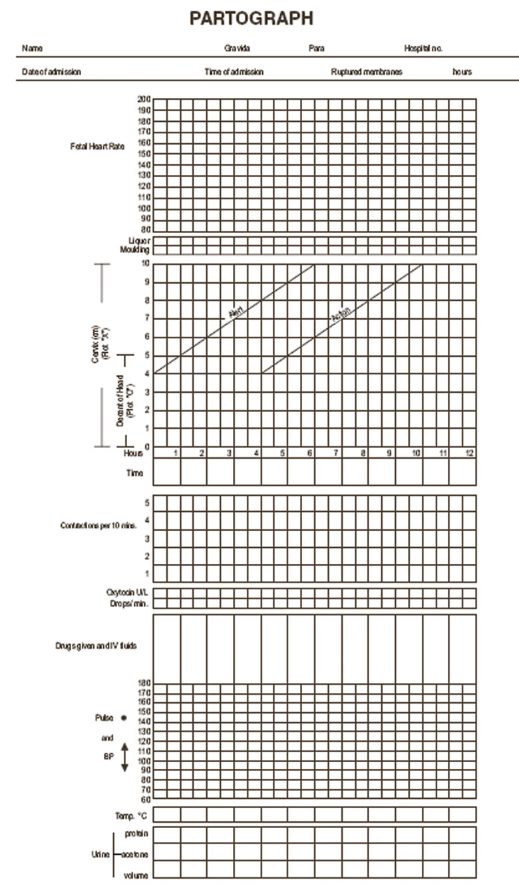
The WHO partograph is simple and easy to use. The partograph begins in the active phase when the cervix is 4 cm dilated. Record the following on the partograph:
- Patient information: Fill out name, gravida, para, hospital number, date and time of admission, and date and time of rupture of membranes.
- Fetal heart rate: Record every half-hour or according to your health facility protocol.
- Amniotic fluid: Record the colour of amniotic fluid at every vaginal examination: I: Membranes intact C: Membranes ruptured, clear fluid M: Meconium-stained fluid B: Blood-stained fluid
- Moulding: 1: Sutures apposed 2: Sutures overlapped but reducible 3: Sutures overlapped and not reducible.
- Cervical dilation: Assessed at every vaginal examination and marked with a cross (X). Begin plotting on the partograph at 4 cm.
- Alert line: A line starts at 4 cm of cervical dilation to the point of expected full dilation at the rate of 1cm per hour.
- Action line: Parallel and 4 hours to the right of the alert line.
- Descent assessed by abdominal palpation: Refers to the part of the head (divided into 5 parts) palpable above the symphysis pubis; recorded as a circle (O) at every vaginal examination. At 0/5, the sinciput (S) is at the level of the symphysis pubis.
- Hours: Refers to the time elapsed since onset of active phase of labour (observed or extrapolated).
- Time: Record actual time.
- Contractions: Chart every half-hour; palpate the number of contractions in 10 minutes and their duration in seconds.
- Less than 20 seconds:
- Between 20 and 40 seconds:
- More than 40 seconds:
- Oxytocin: Record the amount of oxytocin per volume of IV fluids in drops per minute every 30 minutes when used.
- Drugs given: Record any additional drugs given.
- Pulse: Record every 30 minutes and mark with a dot (●).
- Blood pressure: Record every 4 hours and mark with arrows.
- Temperature: Record every 2 hours.
- Protein, acetone and ketones, and volume: Record every time urine is passed

The partograph requires the assessment of several observations. The first set of observations relate to progress of labour: cervical dilatation, descent of the fetal head, and uterine contractions. The second set of observations focuses on the fetus: fetal heart rate, membranes and liquor, and moulding of the fetal head.
Descent may be assessed abdominally in fifths above the pelvic brim. An abdominal examination should be done before the pelvic assessment. Contractions are observed for frequency and duration. The number of contractions in 10 minutes is recorded with three ways of shading on the partograph: (a) <20 seconds, (b) 20–40 seconds, and (c) >40 seconds.
Actions Taken Based on the Partograph
The alert line: A labouring mother should be referred from a health center to a hospital when the cervical dilatation moves to the RIGHT of the ALERT line. Amniotomy may be performed if the membranes are still intact, and she may be observed for a short time prior to considering transfer. In hospital, movement to the RIGHT of the ALERT line should signal the need for an amniotomy and close observation.
The action line : If the woman’s partograph crosses the ACTION line in a central hospital, active intervention is required. Initially this would include rehydration, possibly including oral rehydration, the start of an intravenous line, encouraging the mother to empty her bladder or bladder catheterization, providing analgesia and augmentation of contractions using oxytocin. These measures would be carried out as long as there was no evidence of fetal distress or obstructed labour.

Management of prolonged latent phase
Management is controversial because of the limited number of published studies. Avoid admission to the labour and delivery area until active labour is established. A plan must be established to meet the woman’s needs either at home or in a non-labouring hospital unit. Observation, rest and therapeutic analgesia are favoured over a more active approach of amniotomy and oxytocin induction. Support and information from caregivers to provide coping strategies for what to do at home.
- Prepared childbirth: There is little high-quality data on the effect of prepared childbirth on the pain of labour. Advantages may include: Less apprehension Lower pain scores and less use of analgesia No adverse effects on labour Reduction in anesthetic required
- Creating a Mother-Friendly Birth Environment: In addition to allowing and encouraging women to have a supportive companion with them during labour, there are many other simple practices that humanize the birth experience for women. The behaviour and attitude of health care providers is just as important as clinical care to the health and well-being of the mother and baby. Women have a right to expect caring and helpful care providers during labour and birth. Some simple steps care providers and maternity units can take to ensure a mother-friendly environment includes: Provide a comfortable, clean birth environment. Provide seating for birth companions. Encourage birth companions to provide physical support, such as rubbing back, cool wash cloths, etc.
- Remain with the woman as much as possible. Talk to the woman, ask about her needs, keep her informed about her progress and any procedures that may become necessary. Avoid routine procedures. Explain the reason for performing all interventions. Encourage the woman to move around and adopt a variety of positions during labour and birth. Encourage the woman to drink and eat lightly in labour to keep her energy up. Deliver the baby onto the mother’s abdomen or place the baby in her arms; provide immediate and continued skin-to-skin contact. Allow the mother and family time with their new baby and delay non-urgent procedures, such as measurements and weight. Initiate immediate breastfeeding within the first hour. If baby is ill and needs to be separated from mother, ensure information about baby is provided quickly to the mother and family. Encourage the mother and her family to participate in the care of, and to have contact with, an ill baby.
- Birthing companion and continuous emotional support Supportive: care during labour includes: Emotional support: Continuous presence, reassurance by supportive family members, relatives, or friends Information: Labour progress and advice regarding coping techniques Comfort measures: Comforting touch, massage, warm baths or showers, promoting adequate fluid intake Advocacy
- Ambulation and positions in labour: It is important to acknowledge the women’s choice of position for labour and birth. Women should be encouraged to use whatever position they find most comfortable. For many women, moving around in labour and frequent position changes comes naturally, and should be allowed and encouraged. Ambulation and upright postures have been shown to reduce the amount of pain perceived by women in labour. There are many simple adaptations that can be used in the birthing unit to facilitate this such as chairs, birth stools, and birthing balls. Unless directed by a care provider, most women will not adopt a static supine position. This position is associated with more pain for the woman, and is a harmful practice that results in aorto-caval compression. Maternal hypotension and non-reassuring fetal heart rate status are common consequences of the supine position. See Appendix 2 for more about various positions for labour and birth that assist the natural birthing process.

- Analgesia: The severity and tolerance of pain is unique to each labouring woman, and cannot be predicted reliably prior to its occurrence. Studies have suggested that labour pain is among the most severe forms of pain experienced. Some women in labour reach the limit of their pain tolerance. Women experiencing excessive pain or anxiety have high endogenous catecholamines. This produces a direct inhibitory effect on uterine contractility and establishes a vicious circle of poor uterine progress; increased anxiety leads to increased catecholamines, which in turn leads to further impairment of progress. The relief of pain by effective analgesia may allow release of the uterus from the constraints of the endogenous catecholamines and allow progress in labour.
- Amniotomy: Routine early use of amniotomy (i.e. ARM) after 3 cm dilation shortens the average length of labour, but does not in itself reduce the incidence of dystocia or cesarean section. Early amniotomy at <3 cm dilatation may increase the incidence of dystocia.
Management of the Prolonged Second Stage
The setting of an arbitrary time limit for the second stage in the absence of suspected fetal compromise is not supported by research. Lack of descent in second stage with active pushing requires assessment.
Many women experience a latent period in second stage, a period of time during which they are fully dilated (10 cm) but have no urge to push. Women should not be encouraged to push unless they feel the urge to do so. If no urge to push occurs after 1 hour of second stage, reassess the contractions and consider the use of oxytocin augmentation, if contractions are inadequate. The routine use of oxytocin in the second stage is controversial and widely practiced.
The second stage of labour begins with full dilation of the cervix and ends with the birth of the baby. The expulsive phase is marked by the urge to bear down and may not coincide with full dilation. It is commonly believed that pushing when cervical dilation is not complete can be both unproductive and damaging to the cervix, especially in nulliparas.
The Latent Phase of Second Stage
The latent phase of second stage is the period after reaching full dilation where the client experiences a decrease in strength and frequency of contractions and no urge to push. Some do not have a latent phase in second stage, while others may experience this phase lasting up to an hour. The latent phase can provide an opportunity for maternal rest prior to the active phase of pushing.
The Active Phase of Second Stage The active phase of second stage begins after full dilation of the cervix accompanied with regular contractions and an urge to push.
Prolonged Second Stage of Labour The risk of postpartum hemorrhage, maternal and perinatal morbidity, low 5-minute Apgar score or admission to the neonatal care unit increases with prolonged second stage. Prolonged second stage is defined as:
Consultation is required and continuous electronic fetal monitoring (EFM) recommended for prolonged second stage (PSBC 2014). If labour is taking place in an out-of-hospital setting and second stage is likely to be prolonged (birth is not imminent), the amount of time it takes to transport to the hospital should be taking into account in order to facilitate timely consultation and access to monitoring and/or intervention.
Guideline for Managing the Second Stage of Labour
  - Encourage the provision of emotional support during labour.
  - Support the client in choosing a position in which to give birth.
  - Pushing should generally not be encouraged unless an urge to do so is felt. If there is no urge to push after one hour during second stage, reassess the contractions, fetal presentation and descent, and consider amniotomy and the use of oxytocin if contractions are not adequate.
  - Consider delayed pushing if the fetal head is in the transverse or posterior position. In nulliparas with epidural at full dilation, one can use delayed pushing for a maximum of two hours or can encourage immediate pushing.
  - Continue epidural analgesia if it has been initiated, as research indicates that it does not increase the incidence of assisted vaginal birth. Discontinuing an epidural during second stage may result in the return of pain which may be perceived as worse than if no pain relief had been provided.
  - Do not sent time limits for the second stage as long as progress is being made. The setting of a time limit for the second stage in the presence of progress and absence of suspected fetal compromise is not well-evidenced.
  - During active second stage, assess descent after each hour of pushing unless the fetal head is visible at the introitus, and consider a proactive approach to incoordinate uterine contractions, malposition or malpresentation.
  - If labour is taking place out of hospital, consider the length of time it takes to transport to hospital and available hospital resources to facilitate timely access to monitoring and/or interventions if indicated.
  - Avoid early intervention with operative delivery if fetal health surveillance is normal
  - Use gentle perineal support and warm compresses, and/or a “hands off” approach
  - Use episiotomy only to expedite birth in situations of an abnormal fetal heart rate or maternal distress, or in the rare instance when the fetal head is at the perineum for a sustained period of time without further progress.

