MATRIC NO: 16/MHS02/011
NAME: ABDUL AMINU LILIAN
COURSE CODE: NSC 404
ASSIGNMENT

QUESTION 1: Use of partograph in the management of first stage of laour
The first stage of labour extends from the first signs of labour to full dilation of the cervix. The first stage of labour management involves the following:
- Care of the mother
- Preparation of labour room
- Admission
- Examination of the mother: it covers vital signs, general examination, abdominal examination every 4 hourly, type of blood group Hb, blood glucose, urine analysis is also undertaken for protein and glucose 4hourly.
- ASSESSMENT BY PARTOGRAPH(A partograph is a chart on which the progress of labour over time can be presented): it include the following:
- IDENTIFICATION
- Name of patient
- Tribe
- Race
- VITAL SIGNS
- Pulse rate: pulse is recorded every 30 minutes and marked with a (.) in the partograph
- Temperature: it is recorded every 2 hourly
- Blood pressure: it is measured every 4hourly and marked with an (↨)
- Urinalysis: all urine passed during labor must be tested for glyucose, ketones and proteins.
- Fluid balance: a record should be kept of all urine passed to ensure that the bladder is being emptied. Observe the tongue periodically for hydration
- ABDOMINAL EXAMINATION
- Contractions: the length, strength and frequency of contractions should be noted. The strength of contraction are judged by laying a hand on the uterus and noting the degree of hardness during contraction and by timing its length.
The number of contraction in 10 minutes and duration of each contraction in seconds are recorded in partograph. Contraction duration between 20-40seconds
- PELVIC GRIP
Gradual disappearance of poles of the head (sinciput and occiput) which were felt
- VAGINAL EXAMINATION
The following are been carried out
- Noting the progress of the dilation of the cervix in centimeters in relation to hours of labour
- Noting the position of the head and degree of flexion
- Noting the station of the head in relation to the ischial spines
- Noting the color of the liquor if the membrane are ruptured
- Degree of moulding of the head
- Caput formation: progressive increase is more important that its mere presence
- PELVIC EXAMINATION
- Cervix: Dilatation: the diameter of the external os is measured by the finger (s) during P/V examination and expressed in cm, one finger = 2 cm, 2 fingers = 4 cm and the distance resulted from their separation is added to the 4 cm in more dilatation.
- Position (posterior, midway, central): Patient is allowed to walk during the early first stage particularly with intact membranes.
If rest is needed the patient lies on her left lateral position to prevent inferior vena cava compression and hence placental insufficiency and foetal distress.
- FETAL HEART
- Rate: it should be between 120-160beats/min
- Rhythm: should be noted every half hour in 1st stage
- Continuous recording: it combines a fetal cardiograph and a maternal tocograph in a cardiograph apparatus. It provides information on the baseline fetal heart rate, baseline variability, baseline tachycardia acceleration and deceleration pattern
- NUTRITION
When labour is established no oral feeding is allowed, but sips of water. 15 ml magnesium trisilicate is given every 2 hours as an oral antacid to guard against bronchospasm occurs if the acid vomitus is inhaled during general anaesthesia "Mendelson’s syndrome". Antacid injections may be used instead.
If labour is delayed more than 8 hours, IV drip of glucose 5% or saline-glucose solution is given.
- MEDICATION
- Oxytocin and misoprostol are commonly used agent in labour
  - Analgesia:
    - Pethidine 100 mg IM,
    - trilene inhalation, or
    - epidural anaesthesia are the most common use.
- N.B. Patient should not bear down during the first stage as this is useless, exhausts the patient and predisposes to genital prolapse

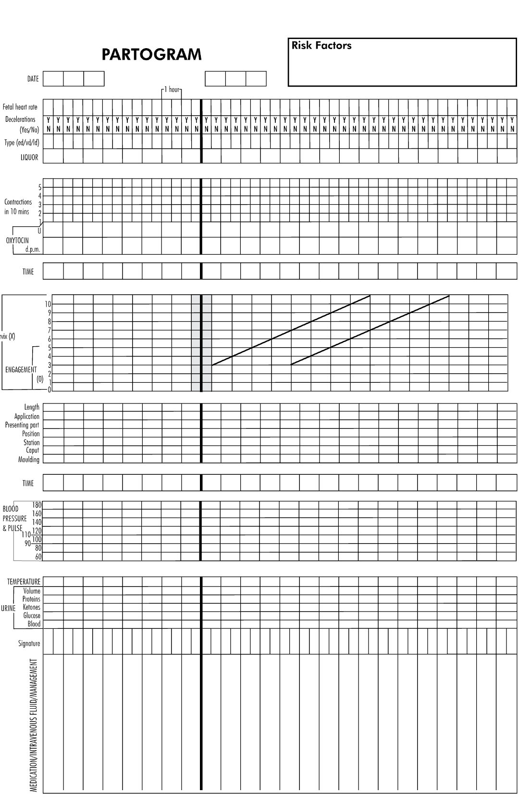
AN IMAGE OF A PARTOGRAPH

QUESTION 2: Management of 2nd and 3rd stages of labour
SECOND STAGE OF LABOUR
Its beginning is identified by:
- The patient feels the desire to defecate.
- The contractions become more prolonged and painful.
- Reflex desire to bear down during the contractions.
- The expulsive effort is accompanied by sustained expiratory grunt.
- Rupture of membranes, although this is not specific as it may occur earlier even before start of labour " prelabour rupture of membranes" or later even to the degree that the foetus is delivered in an intact sac.
- Full dilatation of the cervix (10 cm) in between uterine contractions is the most sure sign.
Delivery room
- The patient is transferred on a wheel or trolley to the delivery room.
- Put her in the lithotomy position.
- The lower abdomen, upper parts of the thighs, vulva and perineum are swabbed with antiseptic lotion.
- Sterile legs and towels are applied.
Bearing down
Ask the patient to bear down during contractions and relax in between.

Delivery of the head
The main aim during delivery of the head is to prevent perineal lacerations through the following instructions:
- Support of the perineum: When the labia start to separate by the head, a sterile pad is placed over the perineum and press on it with the right hand during uterine contractions. This is continued until crowning occurs to maintain flexion of the head.
- Crowning: is the permanent distension of the vulval ring by the foetal head like a crown on the head. The head does not recede back in between uterine contractions.
- Episiotomy: It is done at crowning when the perineum is stretched to the degree that it is about to tear.
- Swab and aspirate: the mouth and nose once the head is delivered before respiration is initiated and the liquor, meconium or blood is inhaled.
- Coils of the umbilical cord: if present around the neck are slipped over the head but if tight or multiple they are cut between 2 clamps.
Delivery of the shoulders
Gentle downward traction is applied to the head till the anterior shoulder slips under the symphysis pubis. The head is lifted upwards to deliver the posterior shoulder first then downwards to deliver the anterior shoulder.
Delivery of the remainder of the body
Usually slips without difficulty otherwise gentle traction is applied to complete delivery.
NOTE THE POSTIONS USED: Standing supported squat, semi sitting, sitting,sitting on toilet, squatting,side lying,walking,standing,leaning or kneeling forward with support, knee chest, lithotomy
Clamping the cord
The baby is held by its ankles with the head downwards at a lower level than its mother for few seconds. This may be enhanced by milking the cord towards the baby, to add about 100 ml of blood to its circulation.The cord is divided between 2 clamps to avoid bleeding from a possible 2nd uniovular twin.

THIRD STAGE OF LABOUR: is the time between the birth of the baby and the delivery of the placenta and membranes.
The uterus usually rest for a few minutes after the delivery of the baby. But normal contractions soon start again to separate the placenta and push it to the lower uterine segment or vagina. While the placenta separate there may be slight blood loss. The midwife must observe the woman’s condition as she wait for signs of placenta separation. The woman lies in dorsal position. The midwife places her left hand on the uterus to know that it well contracted. When well contracted the uterus feels hard like a cricket ball. Also to note the size of the uterus. The hand must not meddle with the uterus. Signs of placenta separation are also observed for. Asepsis and antisepsis must be maintained throughout this stage.
There are two ways of managing the third stage of labour:
- The active method.
- The passive method.
Whenever possible, the active method should be used. However, a midwife working on her own may need to use the passive method.
ACTIVE METHOD
- Immediately after the delivery of the infant, an abdominal examination is done to exclude a second twin.
- An Oxytocic drug (Syntocinon 10 units is given intramuscularly OR Syntometrine ) is given if no second twin is present.
- When the uterus contracts, controlled cord traction must be applied:
- Keep steady tension on the umbilical cord with one hand.
- Place the other hand just above the symphysis pubis and push the uterus upwards.
NOTE: Controlled cord traction is also called the Brandt-Andrews method (manoeuvre).
- Placental separation will take place when the uterus contracts. When controlled cord traction is applied the placenta will be delivered from the upper segment of the uterus.
- Once this occurs, continuous light traction on the umbilical cord will now deliver the placenta from the lower uterine segment or vagina.
- If placental separation does not take place during the first uterine contraction after giving the oxytocic drug, wait until the next contraction occurs and then repeat the manoeuvre.

PASSIVE METHOD

After delivery of the infant the signs of placental separation are waited for.
- When the signs of placental separation appear, the patient is asked to bear down and the placenta is delivered spontaneously, by maternal effort only.
- Only after the placenta has been delivered is an oxytocic drug given.

