MATRIC NO-17/MHS02/108
COURSE CODE-NSC404
LEVEL-400L

USE OF PARTOGRAH IN THE MANAGEMENT OF FIRST STAGE OF LABOUR
PARTOGRAPH
A partograph is a graphic record of vital observations during the course of labour in order to assess its progress and carry out appropriate interventions if and when necessary. Correct use of the partograph can help prevent and manage prolonged or obstructed labour and serious complications, including ruptured uterus, obstetric fistula and stillbirth. The partograph was developed in Africa (Zimbabwe in 1970).
It is a composite graphical recording of cervical dilatation and descent of head against duration of labour in hours. It also gives information about fetal and maternal condition that are all recorded on single sheet of paper.
PRINCIPLES OF PLOTTING PARTOGRAPH
- The active phase of labour commence at 4cm cervical dilatation
- The latent phase of labour should not last longer than 8hours
- During active labour, the rate of cervical dilatation should not be slower than 1cm/hours.

METHOD OF RECORDING PARTOGRAPH
Patient Information: Fill out name, gravida, para, hospital number, date and time of admission and time of ruptured membranes.
Fetal Heart Rate: The rate of the fetal heart rate indicates the state of the fetus inside the uterus. Record every 30mins or half an hour.
Amniotic Fluid: Record the colour of amniotic fluid at every vaginal examination
- I: membrane intact
- C: membranes ruptured, clear fluid
- M: Meconium- stained fluid
- B: Blood stained fluid
Moulding: Moulding is a state of reduction or loss of space between skull bones.
Recording of degree of moulding
- 0: Bones are separated and sutures can be felt easily
- 1: Sutures are apposed
- 2: Sutures overlapped but reducible
- 3: Sutures overlapped and not reducible
Cervical Dilatation: This is assessed at every vaginal examination and marked with a cross(X). Plotting begins at 4cm on the partograph. This graph consists of homogenous squares, ten squares, each square indicate one centimetre of cervical dilatation.
The cross(X) in the graph are joined by a continuous line, begin plotting on the partograph at 4cm.The climbing tendency of this line normally lies on the left of the middle of the graph
Alert line: A line that starts at 4cm of cervical dilatation to the point of expected full dilatation at the rate of 1cm per hour. Crossing the alert line suggests that the patient should be transferred to a hospital for extra care.
Action line: This line lies parallel and also 4hours to the right of the alert line. Crossing the action line suggests the need for intervention (e.g. artificial rupture of the membranes)
Descent of The Head: This is assessed by abdominal examination before doing vaginal examination. It refers to the part of the head (divided into 5 parts) palpable above the pubis symphysis.
Hours: Refers to the time elapsed since onset of active phase of labour
Time: Record actual time
Uterine Contractions: Are recorded graphically on the partograph according to their strength and frequency. Observation of contraction is made half hourly in the active phase and also the palpation of the number of contractions in 10minutes is done in which its duration is in seconds.
Oxytocin Drip: This consists of two lines, one for the record of the unit of oxytocin per litre of intravenous fluid and other is for the drop of fluid per minute. The recording is made at interval of 30minutes as the uterine contraction.
Drugs and other intravenous fluids
Record any additional drug given and are recorded at the particular point in time. This includes sedatives, antibiotics, iv fluids, etc. The name of the drugs, the dose given should be written clearly in the long box
Maternal Condition
Pulse: Record every 30minutes and mark with a dot(.)
Blood Pressure: Record every 4hours and mark with arrow
Temperature: Record every 2 hours
Urine Analysis: During the course of labour, the examination of urine is important and in case of maternal distress the volume of urine may decrease and it may contain ketone bodies.

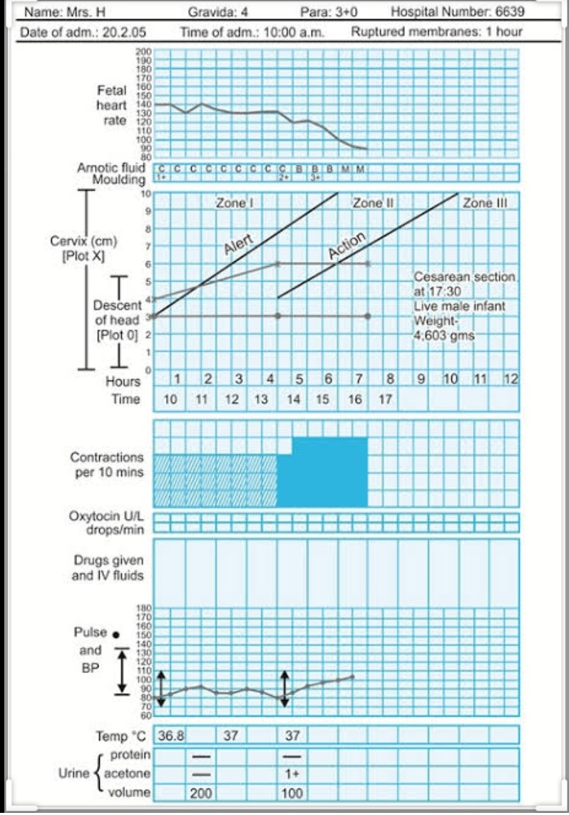

MANAGEMENT OF SECOND STAGE OF LABOUR
The second stage of labour starts when the patient’s cervix is fully dilated and ends when the infant is completely delivered.
Its beginning is identified by:
- The patient feels the desire to defecate.
- The contractions become more prolonged and painful.
- Reflex desire to bear down during the contractions.
- The expulsive effort is accompanied by sustained expiratory grunt.
- Rupture of membranes, although this is not specific as it may occur earlier even before start of labour " prelabour rupture of membranes" or later even to the degree that the foetus is delivered in an intact sac.
Delivery room
- The patient is transferred on a wheel or trolley to the delivery room.
- Put her in a lithotomy or dorsal or lateral position.
- The lower abdomen, upper parts of the thighs, vulva and perineum are swabbed with antiseptic lotion.
- One sterile sheet is placed beneath the buttocks of the patient and one over the abdomen. Sterilized leggings are used.
- Catheterize the bladder if it is full
Bearing down
Ask the patient to bear down during contractions and relax in between.
Delivery of the head
The main aim during delivery of the head is to prevent perineal lacerations through the following instructions:
- i) Support of the perineum:
  - When the head start to separate the labia, a sterile pad is placed over the perineum and press on it with the right hand during uterine contractions. This is continued until crowning occurs to maintain flexion of the head.
- Crowning:
  - is the permanent distension of the vulval ring by the foetal head like a crown on the head. The head does not recede back in between uterine contractions.
  - This means that the bi-parietal diameter is just passed the vulval ring and the occipital prominence escapes under the symphysis pubis.
  - After crowning, allow slow extension of the head so the vulva is distended by the sub-occipito frontal diameter 10 cm.
  - If the head is allowed to extend before crowning the vulva will be distended by the occipito-frontal 11.5 cm increasing the incidence of perineal lacerations.
  - Ritgen manoeuvre: upward pressure on the perineum by the right hand and downward pressure on the occiput by the left hand to control the extension of the head.
- Episiotomy:
  - It is done at crowning when the perineum is stretched to the degree that it is about to tear.
- Swab and aspirate:
  - the mouth and nose once the head is delivered before respiration is initiated and the liquor, meconium or blood is taken in.
- Coils of the umbilical cord:
  - if present around the neck are slipped over the head but if tight or multiple they are cut between 2 clamps.
Delivery of the shoulders
Gentle downward traction is applied to the head till the anterior shoulder slips under the symphysis pubis. The head is lifted upwards to deliver the posterior shoulder first then downwards to deliver the anterior shoulder.
Delivery of the remainder of the body
Usually slips without difficulty otherwise gentle traction is applied to complete delivery.
Clamping the cord
The baby is held by its ankles with the head downwards at a lower level than its mother for few seconds. This is contraindicated in:
- Preterm babies.
- Erythroblastosis foetalis.
- Suspicion of intracranial haemorrhage.
This may be enhanced by milking the cord towards the baby, to add about 100 ml of blood to its circulation.
The cord is divided between 2 clamps to avoid bleeding from a possible 2nd uniovular twin.
MANAGEMENT OF THE THIRD STAGE OF LABOUR
The active management of the third labour is a combination of actions to speed the delivery of the placenta and prevent postpartum hemorrhage.Through these simple actions, trained providers can prevent post partum hemorrhage and play a vital role in saving women’s lives.
Delivery of the placenta
The Conservative method:
- Put the ulnar border of the left hand just above the fundus at the level of the umbilicus to detect any bleeding inside the uterus known by rising level of the atonic uterus.
- Wait for signs of placental separation and descent but do not massage the uterus.
- As soon as they are detected massage the uterus to induce its contraction, ask the patient to bear down and push the uterus downwards to deliver the placenta.
- Hold the placenta between the two hands and roll it to make the membranes like a rope in order not to miss a part of it.
- Give ergometrine 0.5 mg or oxytocin 5 units IM after delivery of the placenta to help uterine contraction and minimise blood loss. These may be given before delivery of the placenta.
Signs of placental separation and descent:
- The body of the uterus becomes smaller, harder and globular.
- The fundal level rises as the upper segment overrides the lower uterine segment which is now distended with the placenta.
- Suprapubic bulge due to presence of the placenta in the lower uterine segment.
- Elongation of the cord particularly on pressing on the uterine fundus and it does not recede back into the vagina on relieving the pressure.
- Gush of blood from the vagina.
The active method (Brandt- Andrews method):
- With delivery of the anterior shoulder, 0.5 mg ergometrine or syntometrine (0.5 mg ergometrine + 5 units oxytocin) is given IM.
- When the uterus contracts, put the left hand suprapubic and push the uterus upwards while gentle downward and backward traction is applied on the cord by the right hand when the placenta is delivered it is rolled as in the conservative method.
- Advantage: reduction of the blood loss.
- Disadvantages:
  - Constriction ring may occur with retention of the placenta.
  - Avulsion of the cord if undue pressure is applied.
  - Inversion of the uterus if fundus is pressed while the uterus is lax.
Routine examinations
- Examination of the placenta and membranes:
  - by exploring it on a plain surface to be sure that it is complete. If there is missed part, exploration of the uterus is done under general anaesthesia.
- Explore the genital tract:
  - For any lacerations that should be immediately repaired.

