REVIEW ON THE ACTIOLOGY OF COVID-19,IT PATHOGENESIS,HISTOPATHOLOGICAL FEATURES AND THE CURRENT POTENTIAL THERAPIES TO ADDRESS IT,ALSO THE FUTURE OF COVID-19 ON PUBLIC HEALTH.

BY

OLUDELE DOYINSOLA ESOSA
16/MHS01/196
ANA 404
HISTOPATHOLOGY

AN ASSIGNMENT SUBMITTED TO THE
DEPARTMENT OF ANATOMY,
FACULTY OF BASIC MEDICAL SCIENCES,
COLLEGE OF MEDICINE AND HEALTH SCIENCES,
AFE BABALOLA UNIVERSITY,ADO-EKITI,
EKITI STATE,NIGERIA

IN PARTIAL FULFILMENT OF THE REQUIREMENTS FOR
THE AWARD OF THE DEGREE OF
BACHELOR OF SCIENCE (B.Sc)
IN ANATOMY

CONTENT

- Introduction……………………………………………………………
- Pathogenesis…………………………………………………………..
- Transmission………………………………………………………….
- Histopathological features……………………………………………
- Therapeutic feature……………………………………………………
- Feature of covid19 0n public health…………………………………..

INTRODUCTION
Coronavirus is one of the leading pathogens that mainly targets the human respiratory system. Past outbreaks of coronaviruses (CoVs) include the severe acute respiratory syndrome (SARS)-CoV and the Middle East respiratory syndrome (MERS)-CoV which have been previously characterised as agents that are a great public health threat. In late December 2019, a cluster of patients was admitted to hospitals with an initial diagnosis of pneumonia of an unknown etiology. These patients were epidemiologically linked to a seafood and wet animal wholesale market in Wuhan, Hubei Province, China (H. Lu et al., 2020).
The coronavirus belongs to a family of viruses that may cause various symptoms such as pneumonia, fever, breathing difficulty, and lung infection ( Wuhan Municipal Health and Health Commission’s Briefing on the Current Pneumonia Epidemic Situation in Our City, 2020).
These viruses are popular in animals worldwide, but very few cases have been known to affect humans. The World Health Organization (WHO) used the term 2019 novel coronavirus to refer to a coronavirus that affected the lower respiratory tract of patients with pneumonia in Wuhan, China on 29 December 2019(Li Q et al., 2020).The WHO announced that the official name of the 2019 novel coronavirus is coronavirus disease (COVID-19) and the current reference name for the virus is severe acute respiratory syndrome coronavirus 2 (SARS-CoV-2). It was reported that a cluster of patients with pneumonia of unknown cause was linked to a local Huanan South China Seafood Market in Wuhan, Hubei Province, China in December 2019(Zhu N et al., 2020).

In event to the outbreak, the Chinese Center for Disease Control and Prevention (China CDC) sent a rapid response team to accompany health authorities of Hubei province and Wuhan city to conduct epidemiological and etiological investigations. The WHO affirmed that the outbreak of the coronavirus epidemic was related with the Huanan South China Seafood Marketplace, but no particular animal association was identified (Japan (ex-China), 2020).
Scientists straightaway started to research the origin of the new coronavirus, and the first genome of COVID-19 was published by the research team led by Prof. Yong-Zhen Zhang, on 10 January 2020. Within 1 month, this virus spread quickly throughout China during the Chinese New Year – a period when there is a high level of human mobility among Chinese people. Although it is still too early to predict sensitized populations, early patterns have shown a trend similar to Severe Acute Respiratory Syndrome (SARS) and Middle East respiratory syndrome (MERS) coronaviruses. Susceptibility seems to be associated with age, biological sex, and other health conditions. COVID-19 has now been declared as a Public Health Emergency of International Concern by the WHO (WHO, 2005).

Pathogenesis

The severe symptoms of COVID-19 are associated with an increasing numbers and rate of human death specially in the pandemic region of China. On January 22, 2020, the China National Health Commission reported the details of the first 17 deaths and on January 25, 2020 the death cases increased to 56 deaths. The percentage of death among the reported 2684 cases of COVID-19 was approximately 2.84% as of Jan 25, 2020 and the median age of the deaths was 75 (range 48–89) years (W. Wang et al., 2020).Patients infected with COVID-19 showed higher leukocyte numbers, abnormal respiratory findings, and increased levels of plasma pro-inflammatory cytokines. One of the COVID-19 case reports showed a patient at 5 days of fever presented with a cough, coarse breathing sounds of both lungs, and a body temperature of 39.0 °C. The patient's sputum showed positive real-time polymerase chain reaction results that confirmed COVID-19 infection. The laboratory studies showed leucopenia with leukocyte counts of 2.91 × 10^9 cells/L of which 70.0% were neutrophils. Additionally, a value of 16.16 mg/L of blood C-reactive protein was noted which is above the normal range (0–10 mg/L). High erythrocyte sedimentation rate and D-dimer were also observed (J. Lei et al., 2020).
The main pathogenesis of COVID-19 infection as a respiratory system targeting virus was severe pneumonia, RNAaemia, combined with the incidence of ground-glass opacities, and acute cardiac injury. Significantly high blood levels of cytokines and chemokines were noted in patients with COVID-19 infection that included IL1-β, IL1RA, IL7, IL8, IL9, IL10, basic FGF2, GCSF, GMCSF, IFNγ, IP10, MCP1, MIP1α, MIP1β, PDGFB, TNFα, and VEGFA. Some of the severe cases that were admitted to the intensive care unit showed high levels of pro-inflammatory cytokines including IL2, IL7, IL10, GCSF, IP10, MCP1, MIP1α, and TNFα that are reasoned to promote disease severity (C. Huang et al., 2020).

Transmission
Based on the large number of infected people that were exposed to the wet animal market in Wuhan City where live animals are routinely sold, it is suggested that this is the likely zoonotic origin of the COVID-19. Efforts have been made to search for a reservoir host or intermediate carriers from which the infection may have spread to humans. Initial reports identified two species of snakes that could be a possible reservoir of the COVID-19. However, to date, there has been no consistent evidence of coronavirus reservoirs other than mammals and birds. Genomic sequence analysis of COVID-19 showed 88% identity with two bat-derived severe acute respiratory syndrome (SARS)-like coronaviruses, indicating that mammals are the most likely link between COVID-19 and humans. Several reports have suggested that person-to-person transmission is a likely route for spreading COVID-19 infection. This is supported by cases that occurred within families and among people who did not visit the wet animal market in Wuhan. Person-to-person transmission occurs primarily via direct contact or through droplets spread by coughing or sneezing from an infected individual. In a small study conducted on women in their third trimester who were confirmed to be infected with the coronavirus, there was no evidence that there is transmission from mother to child. However, all pregnant mothers underwent cesarean sections, so it remains unclear whether transmission can occur during vaginal birth. This is important because pregnant mothers are relatively more susceptible to infection by respiratory pathogens and severe pneumonia.The binding of a receptor expressed by host cells is the first step of viral infection followed by fusion with the cell membrane. It is reasoned that the lung epithelial cells are the primary target of the virus. Thus, it has been reported that human-to-human transmissions of SARS-CoV occurs by the binding between the receptor-binding domain of virus spikes and the cellular receptor which has been identified as angiotensin-converting enzyme 2 (ACE2) receptor. Importantly, the sequence of the receptor-binding domain of COVID-19 spikes is similar to that of SARS-CoV. This data strongly suggests that entry into the host cells is most likely via the ACE2 receptor (Y. Wan et al., 2020).

Histopathological features
Since December 2019, the outbreak of a novel coronavirus, severe acute respiratory syndrome coronavirus 2 (SARS-CoV-2), infection (coronavirus disease 2019 [COVID-19]) that started in Wuhan, Hubei Province, People’s Republic of China,1,2 has spread to all parts in the People’s Republic of China, other parts of Asia such as Japan and Thailand, Australia, Europe, and North America. The number of confirmed cases in the People’s Republic of China has reached 42,700, including 1017 deaths, as of February 11, 2020. Although patients initially present with fever with or without respiratory symptoms, various degrees of pulmonary abnormalities develop later in all patients, and these can be seen on chest computed tomography (CT) imaging.1,3 Most patients only have a common, mild form of illness, but approximately 15% to 20% fall in the severe group, meaning they require assisted oxygenation as part of treatment.3 The severe group has a high mortality rate and is associated with older age, underlying diseases such as diabetes, and medical procedures (such as patients who were infected in a hospital setting while undergoing an operation for other indications). Although there have been several studies describing clinical features and characteristic radiographic findings (mainly chest CT scans),1,3 no pathologic studies have been conducted on the basis of autopsies or biopsies. Some of the reasons for the lack of autopsies and biopsies include suddenness of the outbreak, vast patient volume in hospitals, shortage of health care personnel, and high rate of transmission, which makes invasive diagnostic procedures less of a clinical priority. Fortunately and unfortunately, we encountered two patients who underwent an operation for malignancy and were later found to have been infected with SARSCoV-2. The operation overlapped in time with the infection, which allowed us to obtain the necessary specimens to examine the histopathology of COVID-19 pneumonia.
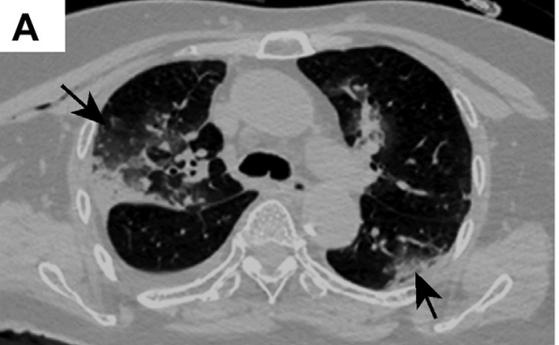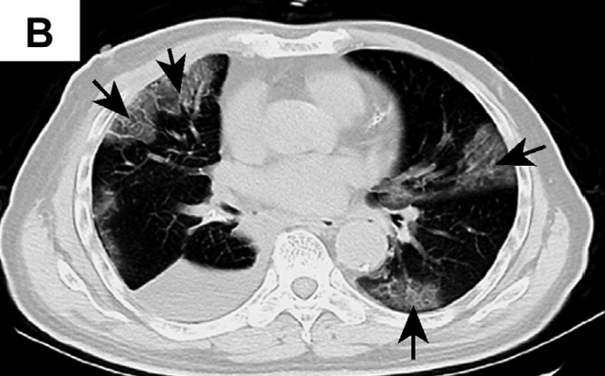
Figure 1:Representative images of chest computed tomography scan. (A) Case 1: image on postoperative day 1 revealing changes in the right lung and increased ground-glass opacities bilaterally (arrows); (B) case 2: foci of ground-glass opacity seen bilaterally (arrows).
Case Presentation Case 1
Case 1: was a female patient aged 84 years, who was admitted for treatment evaluation of a tumor measuring 1.5 cm in the right middle lobe of the lung. The tumor was discovered on a chest CT scan at an outside hospital. She had a medical history of hypertension for 30 years and type II diabetes. On day 6 of hospitalization, an enhanced chest CT scan was performed that confirmed an irregular solid nodule in the right middle lobe and bilateral ground-glass opacity (GGO). At that time, the importance of the latter findings was unknown. Her overall condition was good, with no fever or respiratory symptoms, and with clear lung sounds on auscultation bilaterally. She underwent presurgical tests and preparations. On day 12, a thoracoscopic resection of the right middle lobe was performed without event. On day 13 (postoperative day 1), a repeat CT scan revealed postresection changes and bilateral GGO in the lower lobes of the lungs (Fig. 1A). White blood cell (WBC) count was 12.49 1012/liter, whereas lymphocyte count decreased to 0.4 109 /liter and the differential to 5%. There was a slight wheezing sound on auscultation on the right side. On day 16, the patient experienced some difficulty in breathing, chest tightness, wheezing, and dry cough. She received a diagnosis “suggestive of viral pneumonia,” with intermittent peripheral capillary oxygen saturation between 72% and 88%. On day 24, she was transferred to a special isolation ward owing to a pharyngeal swab test result that was positive for the 2019 novel coronavirus (2019-nCoV). Laboratory specimens drawn on the previous day (day 23) revealed the following: increased WBC count to 33.52 109 /liter; increased neutrophils to 89.80%; decreased lymphocytes to 1.90%; decreased eosinophils to 0%; increased neutrophil count to 30.10 109 /liter; decreased lymphocyte count to 0.65 109 /liter; increased monocyte count to 2.50 109 /liter; decreased eosinophil count to 0.01 109 /liter; and increased basophil count to 0.26 109 /liter. Despite comprehensive treatment, including antibiotics, assisted oxygenation, and other supportive care, the patient’s condition deteriorated. Her peripheral capillary oxygen saturation (SpO2) decreased to 62.6% and heart rate to 40 bpm. A do-not-resuscitate order was given. She went into coma on day 27 and died on day 29. She did not manifest fever during the hospital stay. Subsequent clinical information confirmed that she was exposed to another patient in the same room who was subsequently found to be infected with the 2019-nCoV. The right middle lobe resection specimen was delivered to the surgical pathology laboratory and processed according to the routine biosafety standards. Hematoxylin and eosin–stained sections were reviewed. A firm area of 1.5 cm in diameter was identified grossly, which in the histologic diagnosis was consistent with typical adenocarcinoma, with half exhibiting a lepidic and half an acinar pattern (not revealed). Sections away from the tumor, as found in Figure 2, revealed evident alveolar damage, including alveolar edema and proteinaceous exudates (Fig. 2A). Prominent inspissated spherical secretions or globules were also noted (Fig. 2B). There was vascular congestion but patchy and mild inflammatory infiltration. Focal fibrin clusters mixed with mononuclear inflammatory cells and multinucleated giant cells were noted in the airspaces (Fig. 2C). No significant neutrophil infiltration was present in the tissue. There was patchy and severe pneumocyte hyperplasia and interstitial thickening, indicating an ongoing reparative process. Suspected viral inclusions were also noted in some of these cells (Fig. 2D).
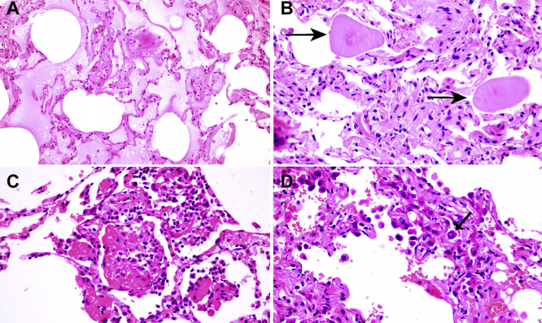
Figure 2. Histologic changes from case 1. (A) Proteinaceous exudates in alveolar spaces, with granules; (B) scattered large protein globules (arrows); (C) intra-alveolar fibrin with early organization, mononuclear inflammatory cells, and multinucleated giant cells; (D) hyperplastic pneumocytes, some with suspected viral inclusions

Case 2
Case 2 was a male patient aged 73 years, who presented for elective surgery for lung cancer. Nine months earlier, a nodule was discovered radiologically in the right lower lobe of the lung during a health examination. He had a medical history of hypertension for 20 years, which had been adequately managed. A diagnosis of adenocarcinoma was made in a subsequent needle biopsy. The patient was admitted 1 week after the biopsy to the thoracic tumor ward, where he underwent a right lower lobe lung resection with lymph node dissection 3 days after admission. He recovered well and was discharged on day 6 postoperationally. A chest CT scan was performed on postoperative day 2, which revealed postoperative changes and patchy GGO in the right upper lobe. On retrospective re-examination of the images, the patient was diagnosed as “suspect for atypical viral pneumonia.” A fever developed in the patient on postoperative day 9 (38.2C), with dry cough, chest tightness, and muscle pain. A nucleic acid test for 2019-nCoV came back positive. Other laboratory specimens were significant for decreased lymphocyte count. He was readmitted to the infectious disease ward. A repeat chest CT scan revealed additional foci of GGO in the bilateral upper lobes, consistent with viral pneumonia (Fig. 1B, case 2). Tests for influenza virus and other infectious agents were negative. He underwent treatment for novel coronavirus pneumonia. He gradually recovered and was discharged after 20 days of treatment in the infectious disease ward. On pathologic examination of the resected lobectomy specimen, a 1.2-cm gray-white nodule adjacent to the pleura was identified, which was poorly demarcated from the adjacent nontumor lung parenchyma. Histopathologic diagnosis of the tumor was that of adenocarcinoma, pT1bN0 (28 lymph nodes all negative). The resection margins were negative as well. Histologically, the surrounding lung parenchyma was patchy but with evident proteinaceous and fibrin exudates (Fig. 3A). There was diffuse thickening of alveolar walls (Fig. 3B), consisting of proliferating interstitial fibroblasts and type II pneumocyte hyperplasia. Focal fibroblast plug and multinucleated giant cells were seen in the airspaces (Fig. 3C), indicating varying degrees of proliferative phase of diffuse alveolar damage. Some areas had abundant alveolar macrophages along with type II pneumocyte hyperplasia (Fig. 3D).
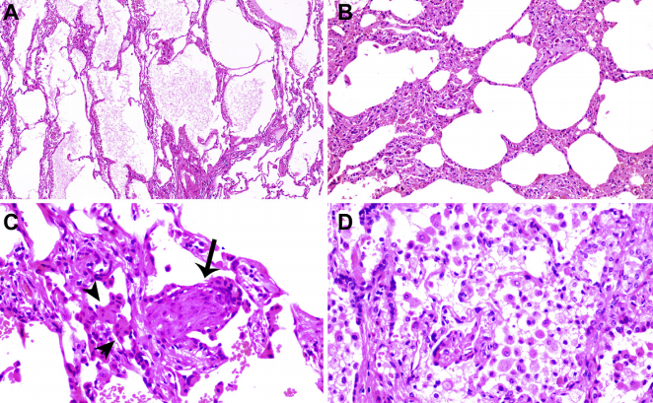
Figure 3. Histologic changes of coronavirus disease 2019 pneumonia in case 2. (A) Evident proteinaceous and fibrin exudate; (B) diffuse expansion of alveolar walls and septa owing to fibroblastic proliferations and type II pneumocyte hyperplasia, consistent with early diffuse alveolar damage pattern; (C) plugs of proliferating fibroblasts or “fibroblast balls” in the interstitium (arrow); (D) abundant macrophages infiltrating airspaces and type II pneumocyte hyperplasia.

Histopathological discussion:
The pathologic findings reported here represent the first for SARS-CoV-2 pneumonia or COVID-19. At the time of manuscript preparation, no autopsies had been performed on patients with COVID19. Data on lung biopsies performed for COVID-19 are similarly lacking. Pathologic findings from these two patients were edema and prominent proteinaceous exudates, vascular congestion, and inflammatory clusters with fibrinoid material and multinucleated giant cells. Reactive alveolar epithelial hyperplasia was seen in case 1, and fibroblastic proliferation (fibroblast plugs) in case 2 is indicative of early organization. No prominent neutrophil infiltration was seen. The significance of the large protein globules is not entirely clear, as these were described in patients with SARS but could also represent a nonspecific change with aging. More cases with sufficient controls are necessary to further clarify this change. The two cases reported here represent “accidental” sampling of COVID-19, in which surgeries were performed for tumors in the lungs at a time when the superimposed infections were not recognized. These provided the first opportunities for studying the pathology of COVID-19. For case 1, the operation was performed 6 days after the CT findings of early GGO signs, meaning the pathologic changes of the non–tumor lung parenchyma indeed represent at least the peripheral part of COVID-19 pneumonia, as the imaging changes were more prominent toward the lower lobes. For case 2, as recognized later, the patient was unknowingly placed in the same room with patients who were positive for SARS-CoV-2 infection; the status of infection was not known to anyone at the time. He developed early lung lesions on a chest CT scan performed to evaluate the result of the operation. However, owing to a lack of sufficient knowledge about the new infection, the lesions were recognized only retrospectively as representing COVID-19 pneumonia. The differential diagnoses of COVID-19 pneumonia might include, but is not limited to, acute or chronic pneumonia resulting from other infections. Comprehensive clinical analyses of the epidemiologic status, CT scan, and nucleic acid test can easily exclude such possibilities. As for the original SARS, SARS-COV-19 shares high genetic homology with SARS-CoV. Therefore, the International Committee on Taxonomy of Viruses recently renamed the 2019-nCoV to SARS-CoV-2 and the disease as COVID-19. Compared with pathologic findings in a cohort of autopsy cases of SARS, the two cases presented here also exhibited exudative and proliferative phases of acute lung injury, such as edema, inflammatory infiltrate, type II pneumocyte hyperplasia, and organization, but without obvious hyaline membrane formation and other long-term processes, such as squamous metaplasia.4-6 Of note, the pathologic changes seen in our two cases preceded the development of clinical symptoms and likely represent an earlier phase of the disease. Future studies of autopsies may add to the current findings. Although case 1 patient was never febrile, her complete blood count profile, especially from postoperative day 1, revealed high WBC counts and lymphocytopenia, which is consistent with COVID-19. This may be a good clue for early diagnosis in the future. Case 2 developed a fever a few days after the CT findings, suggesting a delay in symptom development in these patients. During the earlier days of the outbreak, there had been limitations in both capacity and turnaround time for the nucleic acid test, which had further caused delay in confirming the diagnosis of COVID-197 in many patients. It seems that the time for the early lung lesions or COVID-19 to become severe enough to cause clinical symptoms is rather long. Even among patients with fever, the typically used pharyngeal swab polymerase chain reaction Figure 3. Histologic changes of coronavirus disease 2019 pneumonia in case 2. (A) Evident proteinaceous and fibrin exudate; (B) diffuse expansion of alveolar walls and septa owing to fibroblastic proliferations and type II pneumocyte hyperplasia, consistent with early diffuse alveolar damage pattern; (C) plugs of proliferating fibroblasts or “fibroblast balls” in the interstitium; (D) abundant macrophages infiltrating airspaces and type II pneumocyte hyperplasia.Tian et al Journal of Thoracic Oncology Vol. - No. - test may be negative, owing to the absence of viruses in the upper respiratory tract despite the presence of pneumonia. However, radiographic changes can occur early (chest CT scan is mostly employed in the People’s Republic of China during the current outbreak). Therefore, during an epidemic season, it is prudent to carefully evaluate any lung infiltration for GGO, and an appropriate serology test must be performed to rule out potential infection.These two incidents also typify a common scenario during the earlier phase of the SARS-CoV-2 outbreak, during which a significant number of health care providers became infected in hospitals in Wuhan, and patients in a same room were cross-infected, as they were exposed to unknown transmission sources. Because of this, it is important to practice “universal precaution” in surgical pathology laboratories and regard all fresh specimens as potentially infectious. In the People’s Republic of China, most surgical specimens are received already fixed in formalin. However, for larger specimens, the center of a specimen may not be sufficiently fixed and still pose potential risk for infection. Therefore, proper personal protective equipment with surgical masks or N95 respirators is worn all the time in the gross room. Fortunately, thus far, to our knowledge, no cases of pathologists being infected by COVID-19 had occurred. It would be beneficial if reverse-transcriptase polymerase chain reaction or immunohistochemical stains, or both could be performed on these two cases to further confirm the presence of the viruses that may be associated with pneumonia. Unfortunately, these tests are currently under development, and adaptation to tissue specimens is not yet available. Nevertheless, we believe that it is imperative to report the findings of routine histopathology for better understanding of the mechanism by which the SARS-CoV-2 causes lung injury in the unfortunate tens of thousands of patients in Wuhan and worldwide.
Therapeutic feature to address covid-19
The person-to-person transmission of COVID-19 infection led to the isolation of patients that were administered a variety of treatments. At present, there are no specific antiviral drugs or vaccine against COVID-19 infection for potential therapy of humans. The only option available is using broad-spectrum antiviral drugs like Nucleoside analogues and also HIV-protease inhibitors that could attenuate virus infection until the specific antiviral becomes available (H. Lu and Biosci, 2020). treatment that have so far been attempted showed that 75 patients were administrated existing antiviral drugs. The course of treatment included twice a day oral administration of 75 mg oseltamivir, 500 mg lopinavir, 500 mg ritonavir and the intravenous administration of 0·25 g ganciclovir for 3–14 days. Another report showed that the broad-spectrum antiviral remdesivir and chloroquine are highly effective in the control of 2019-nCoV infection in vitro. These antiviral compounds have been used in human patients with a safety track record. Thus, these therapeutic agents can be considered to treat COVID-19 infection. Furthermore, there are a number of other compounds that are in development. These include the clinical candidate EIDD-2801 compound that has shown high therapeutic potential aganist seasonal and pandemic influenza virus infections and this represents another potential drug to be considered for the treatment of COVID-19 infection(M. Toots et al., 2020). Along those lines, until more specific therapeutics become available, it is reasonable to consider more broad-spectrum antivirals that provide drug treatment options for COVID-19 infection include Lopinavir/Ritonavir, Neuraminidase inhibitors, peptide (EK1), RNA synthesis inhibitors. It is clear however, that more research is urgently needed to identify novel chemotherapeutic drugs for treating COVID-19 infections. In order to develop pre-and post-exposure prophylaxis against COVID-19, there is an urgent need to establish an animal model to replicate the severe disease currently observed in humans. Several groups of scientists are currently working hard to develop a nonhuman primate model to study COVID-19 infection to establish fast track novel therapeutics and for the testing of potential vaccines in addition to providing a better understanding of virus-host interactions.

Future of covid-19 on public health

Extensive measures to reduce person-to-person transmission of COVID-19 are required to control the current outbreak. Special attention and efforts to protect or reduce transmission should be applied in susceptible populations including children, health care providers, and elderly people. A guideline was published for the medical staff, healthcare providers, and, public health individuals and researchers who are interested in the 2019-nCov. The early death cases of COVID-19 outbreak occurred primarily in elderly people, possibly due to a weak immune system that permits faster progression of viral infection. The public services and facilities should provide decontaminating reagents for cleaning hands on a routine basis. Physical contact with wet and contaminated objects should be considered in dealing with the virus, especially agents such as faecal and urine samples that can potentially serve as an alternative route of transmission. China and other countries including the US have implemented major prevention and control measures including travel screenings to control further spread of the virus (W.G. Carlos et al., 2020). Epidemiological changes in COVID-19 infection should be monitored taking into account potential routes of transmission and subclinical infections, in addition to the adaptation, evolution, and virus spread among humans and possible intermediate animals and reservoirs. There remains a considerable number of questions that need to be addressed. These include, but are not limited to, details about who and how many have been tested, what proportion of these turned positive and whether this rate remains constant or variable. Very few paediatric cases have so far been reported; is this due to lack of testing or a true lack of infection/susceptibility? Of the ones that have so far been tested, how many have developed severe disease and how many were tested positive but showed no clinical sign of disease? There are some basic questions that would provide a framework for which more specific and detailed public health measures can be implemented.

REFERENCE

Arksey H, O’Malley L. Scoping studies: towards a methodological framework. Int J Soc Res Methodol. 2005;8:19–32.
Backer JA, Klinkenberg D, Wallinga J. The incubation period of 2019-nCoV infections among travellers from Wuhan. China Euro Surveill. 2020; https://doi.org/10.2807/1560-7917.ES.2020.25.5.2000062

CDC. 2019 Novel coronavirus, Wuhan, China. 2020. https://www.cdc.gov/coronavirus/2019-nCoV/summary.html. Accessed 1 Feb 2020.
Chen N, Zhou M, Dong X, Qu J, Gong F, Han Y, et al. Epidemiological and clinical characteristics of 99 cases of 2019 novel coronavirus pneumonia in Wuhan, China: a descriptive study. Lancet. 2020;395:507–13.
Fehr AR, Channappanavar R, Perlman S. Middle East respiratory syndrome: emergence of a pathogenic human coronavirus. Annu Rev Med. 2017;68:387–99.
Franks TJ, Chong PY, Chui P, et al. Lung pathology of severe acute respiratory syndrome (SARS): a study of 8 autopsy cases from Singapore. Hum Pathol. 2003;34:743– 748.

Gralinski LE, Menachery VD. Return of the coronavirus: 2019-nCoV. Viruses. 2020;12:135.

Huang C, Wang Y, Li X, et al. Clinical features of patients infected with 2019 novel coronavirus in Wuhan, China. Lancet. 2020;395:497–506

Hwang DM, Chamberlain DW, Poutanen SM, Low DE, Asa SL, Butany J. Pulmonary pathology of severe acute respiratory syndrome in Toronto. Mod Pathol. 2005;18:1–10.

Li T, Wei C, Li W, Hongwei F, Shi J. Beijing Union Medical College Hospital on "pneumonia of novel coronavirus infection" diagnosis and treatment proposal (V2.0). Med J Peking Union Med Coll Hosp. 2020. http://kns.cnki.net/kcms/detail/11.5882.r.20200130.1430.002.html. Accessed 2 Feb 2020.

Liu T, Hu J, Kang M, Lin L, Zhong H, Xiao J, et al. Transmission dynamics of 2019 novel coronavirus (2019-nCoV). 2020; doi: https://doi.org/10.1101/2020.01.25.919787

Medical expert group of Tongji hospital. Quick guide to the diagnosis and treatment of pneumonia for novel coronavirus infections (third edition). Herald Med. 2020. http://kns.cnki.net/kcms/detail/42.1293.r.20200130.1803.002.html. Accessed 2 Feb 2020.
Nicholls JM, Poon LL, Lee KC, et al. Lung pathology of fatal severe acute respiratory syndrome. Lancet. 2003;361:1773–1778.

Virological.org. Novel 2019 Coronavirus Genome 2020. http://virological.org/t/novel-2019-coronavirus-genome/319. Accessed 1 Feb 2020.
Wang D, Hu B, Hu C, et al. Clinical characteristics of 138 hospitalized patients with 2019 novel coronavirusinfected pneumonia in Wuhan, China [e-pub ahead of print]. JAMA. https://doi.org/10.1001/jama.2020.1585, accessed February 7, 2020.

WHO. Novel Coronavirus-Japan (ex-China). 2020. https://www.who.int/csr/don/17-january-2020-novel-coronavirus-japan-ex-china/en/. Accessed 1 Feb 2020.
WHO. Statement on the second meeting of the International Health Regulations (2005) Emergency Committee regarding the outbreak of novel coronavirus (2019-nCoV). 2020. https://www.who.int/news-room/detail/30-01-2020-statement-on-the-second-meeting-of-the-international-health-regulations-(2005)-emergency-committee-regarding-the-outbreak-of-novel-coronavirus-(2019-ncov). Accessed 1 Feb 2020.
Xiao SY, Wu Y, Liu H. Evolving status of the 2019 novel coronavirus infection: proposal of conventional serologic assays for disease diagnosis and infection monitoring [e-pub ahead of print]. J Med Virol. https://doi.org/10.1002/jmv.25702, accessed February 7, 2020.

Zhu N, Zhang D, Wang W, Li X, Yang B, Song J, et al. A novel coronavirus from patients with pneumonia in China, 2019. N Engl J Med. 2020. https://doi.org/10.1056/NEJMoa2001017
Zhou P, Yang XL, Wang, XG, Hu B, Zhang L, Zhang W, et al. Discovery of a novel coronavirus associated with the recent pneumonia outbreak in humans and its potential bat origin. bioRxiv. 2020; doi: https://doi.org/10.1101/2020.01.22.914952.

