NSC404
MATERNAL HEALTH AND NORMAL MIDWIFERY
16/MHS02/004

USE OR PARTOGRAGH IN MANAGEMENT OF FIRST STAGE OF LABOUR
A partograph is an effective means of recording the progress of labour. It helps to detect abnormal progress of labour, fetal distress and signs that the mother is in difficulty. It is a chart in which some features of labour are entered in a visual graphic form to provide the opportunity for early identification of deviations from normal’ It is an integral part of interpartum record keeping. It is designs to allow for record keeping at 15 minutes interval. It includes
- Fetal heart rate: initially it is recorded every 30 minutes. The scale covers from80 to 200 beats per minute
- Maternal temperature pulse and blood pressure
- Frequency and strength of contractions every 10 minutes initially and every 30 minutes
- Descent of the presenting part
- Cervical effacement and dilatation: the diameter of the mother’s cervix is recorded. The descent of head which is how far down the birth canal the baby’s head has progressed. I t is recorded as either X or O initially and every 4 hours.
- Colour of amniotic fluid: If the fetal membranes have ruptured the colour of the amniotic fluid should be recorded initially and ever 4hous.
- Degree of caput succedaneum/moulding: This is the extent to which the bones of the fetal skull are overlapping each other at the baby head is forced down the birth canal. I t is assessed initially and every 4 hours.
- Fluid balance: intravenous fluids are given to the mother and also recorded in the graph
- Urine analysis: the characteristics of the mothers urine; protein, acetone and volume is recorded.
- Drugs administered: drugs like oxytocin is administered ant he amount is recorded
The partograph has an identification section at the top where the name, age of the mother, her gravida and para status, health post or hospital registration number, the date and time of rumoured membranes.

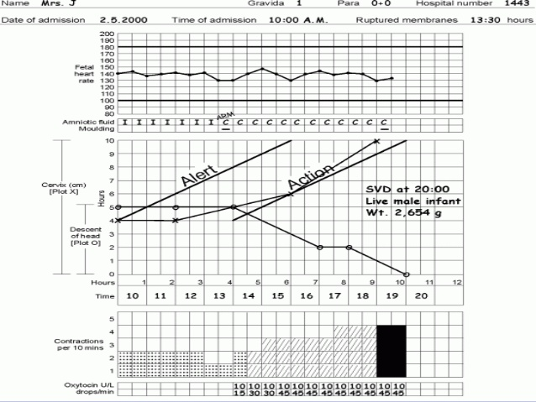
DIAGRAM OF A PARTOGRAPH

MANAGEMENT OF SECOND STAGE OF LABOUR
Second stage of labour begins from full dilatation of the cervix up to the birth of the baby.
Four factors determine whether the second stage is going on safely and theses must be carefully monitored.
- Uterine contractions: the strength, length and frequency of contractions should be assessed regularly by observation of maternal responses and by uterine palpation during this stage.
- Descent, rotation and flexion of the presenting part
- Fetal condition/suspicious or pathological changes of the fetal heart
- Maternal condition

During this stage the nurse should
- Continuously provide information, support and encouragement to the woman and her companion
- Encourage active pushing once the urge is present which encouragement to adot any position except supine which is dangerous.
- Listen frequently every 5 minutes to the fetal heart in between contractions to detect bradycardia
- Check maternal pulse and blood and blood pressure regularly
- Observe progressive descent and rotation of the presenting part
- Conduct the delivery with support for the perineum to avoid tears and use of episiotomy only where a tear is very likely
- Be ready to undertake instrumental vaginal delivery where indicated
- be ready to give Iv oxytocin where contractions have become infrequent.
CARE DURING THE SECOND STAGE OF LABOUR
Initiation of active pushing: a woman should encouraged to push when the cervix is fully dilated, the fetal condition, and engagement of the presenting part have been confirmed and the woman feels urge to push. Even when she feels the urge to push, pushing should be encouraged during a contraction.
Duration of active pushing: primiparous women should not be allowed to push for more than 2hours and multiparous women for more than 1hour, owing to increased risk of birth asphyxia and maternal infection
Maternal and fetal monitoring during this stage: maternal parameters should be monitored when this stage is confirmed and for specific indications such as a history of high blood pressure, prolonged labour, and abnormal fetal heart rate. The fetal heart should be monitored frequently. The best information about condition of the fetus can be assessed immediately after a contraction.
Position of the woman: There should be adequate space, equipment and skilled personnel’s for the woman to deliver in a position of her choice including upright position
Use of oxytocin: this should be administered according to health facility protocol. Where the contractions are poor and fetal presentation, position and fetal heart rate have been confirmed as normal; the use of oxytocin infusion may reduce the need for instrumental vaginal delivery.
MANAGEMENT OF THIRD STAGE OF LABOUR
The third stage of labour commences from the completed delivery of the fetus and ends with the completed delivery of the placenta and its attached membranes. Two methods are used during this stage. The expectant (physiological) care or active management.

Expectant or physiological management of third stage of labour
In expectant management, the normal physiological mechanisms of labour are supported and no routine actions such as administration of an uterotonic drug or clamping of the cord are carried out. It includes
- Maintain a calm quiet, warm environment. Use warmed bed sheets or blankets to wrap mother and baby together skin to skin
- Maintain the woman in a comfortable, semi upright position at least 45 degree angle to encourage placental separation
- Facilitate this time of parent-baby discovery and attachment by keeping quiet. Observing from a distance and not interfering.
- Watch and wait. If the mother is alert and happy, examining the baby and ensure she is not bleeding excessively or any need for intervention.
Active management of third stage of labour
This includes the routine prophylactic administration of a uterotonic agent either intravenously, intramuscularly or orally as a precautionary measure aimed at reducing the risk of postpartum haemorrhage. It is given regardless of the assessed obstetric risk status of the woman and is usually undertaken in conjunction with clamping of the umbilical cord shortly after birth of the baby and delivery of the placenta by use of control cord traction. For those women at higher of risk of postpartum haemorrhage, larger doses of uterotonics diluted in IV solutions may be administered over several hours following the birth.
Administration of uterotonics: uterotonic are drugs (syntometrine, syntocinon, ergometrine and prostaglandins that stimulate the smooth muscle of the uterus to contract. They may be administered with crowning of the baby’s head, at the birth of the anterior shoulder of the baby, after the birth of the baby but prior to placental expulsion or following the birth or delivery of the placenta and membranes.
- Ergometrine 0.25-0.5mg: this drug act within 45 seconds and is particularly useful in ensuring a rapid contraction where hypotonic uterine action results in haemorrhage
- Combined ergometrine and oxytocin (syntometrine): a 1ml ampoule contains 5IU of oxytocin and 0.5mg ergometrine administered intramuscularly. The oxytocin acts with 2 and half minutes and ergometrine within 6-7 minutes. The combination action results in a rapid uterine contraction enhanced by a stronger more sustained contraction lasting several hours
- Oxytocin a commonly used brand is syntocinon is a synthetic form of the natural oxytocin produced in the posterior pituitary and is safe to use. It can be gives IV or IM.

