NAME: FATIMEHIN TOLU BISHOP
MATRIC NUMBER: 18/MHS01/162
DEPARTMENT: PHYSIOLOGY
COURSE TITLE: BCH 204
QUESTION: DISCUSS THE 4 STEPS OF BETA OXIDATION AND SHOW PATHWAY WHERE NECESSARY

Beta oxidation is a metabolic process involving multiple steps by which fatty acid molecules are broken down to produce energy. More specifically, beta oxidation consists in breaking down long fatty acids that have been converted to acyl-CoA chains into progressively smaller fatty acyl-CoA chains. This reaction releases acetyl-CoA, FADH2 and NADH, the three of which then enter another metabolic process called citric acid cycle or Krebs cycle, in which ATP is produced to be used as energy. Beta oxidation goes on until two acetyl-CoA molecules are produced and the acyl-CoA chain has been completely broken down. In eukaryotic cells, beta oxidation takes place in the mitochondria, whereas in prokaryotic cells, it happens in the cytosol.
For beta oxidation to take place, fatty acids must first enter the cell through the cell membrane, then bind to coenzyme A (CoA), forming fatty acyl CoA and, in the case of eukaryotic cells, enter the mitochondria, where beta oxidation occurs.

Where Does Beta Oxidation Occur?
Beta oxidation occurs in the mitochondria of eukaryotic cells and in the cytosol of prokaryotic cells. However, before this happens, fatty acids must first enter the cell and, in the case of eukaryotic cells, the mitochondria. In cases where fatty acid chains are too long to enter the mitochondria, beta oxidation can also take place in peroxisomes.
First, fatty acid protein transporters allow fatty acids to cross the cell membrane and enter the cytosol, since the negatively charged fatty acid chains cannot cross it otherwise. Then, the enzyme fatty acyl-CoA synthase (or FACS) adds a CoA group to the fatty acid chain, converting it to acyl-CoA.
Depending on the length, the acyl-CoA chain will enter the mitochondria in one of two ways:
- If the acyl-CoA chain is short, it can freely diffuse through the mitochondrial membrane.
- If the acyl-CoA chain is long, it needs to be transported across the membrane by the carnitine shuttle. For this, the enzyme carnitine palmitoyltransferase 1 (CPT1)—bound to the outer mitochondrial membrane—converts the acyl-CoA chain to an acylcarnitine chain, which can be transported across the mitochondrial membrane by carnitine translocase (CAT). Once inside the mitochondria, CPT2—bound to the inner mitochondrial membrane—converts the acylcarnitine back to acyl-CoA. At this point, acyl-CoA is inside the mitochondria and can now undergo beta oxidation.
As mentioned above, if the acyl-CoA chain is too long to be processed in the mitochondria, it will be broken down by beta oxidation in the peroxisomes. Research suggests that very long acyl-CoA chains are broken down until they are 8 carbons long, after which they are transported and enter the beta oxidation cycle in the mitochondria. Beta oxidation in the peroxisomes yields H₂O₂ instead of FADH2 and NADH, producing heat as a result.

Beta Oxidation Steps
Beta oxidation takes place in four steps: dehydrogenation, hydration, oxidation and thyolisis. Each step is catalysed by a distinct enzyme.
Briefly, each cycle of this process begins with an acyl-CoA chain and ends with one acetyl-CoA, one FADH2, one NADH and water, and the acyl-CoA chain becomes two carbons shorter. The total energy yield per cycle is 17 ATP molecules (see below for details on the breakdown). This cycle is repeated until two acetyl-CoA molecules are formed as opposed to one acyl-CoA and one acetyl-CoA. The four steps of beta oxidation are described below and can be seen in the links to the figures at the end of each explanation.

Dehydrogenation
In the first step, acyl-CoA is oxidized by the enzyme acyl CoA dehydrogenase. A double bond is formed between the second and third carbons (C2 and C3) of the acyl-CoA chain entering the beta oxidation cycle; the end product of this reaction is trans-Δ²-enoyl-CoA (trans-delta 2-enoyl CoA). This step uses FAD and produces FADH2, which will enter the citric acid cycle and form ATP to be used as energy. (Notice in the following figure that the carbon count starts on the right side: the rightmost carbon below the oxygen atom is C1, then C2 on the left forming a double bond with C3, and so on.)

Hydration
In the second step, the double bond between C2 and C3 of trans-Δ²-enoyl-CoA is hydrated, forming the end product L-β-hydroxyacyl CoA, which has a hydroxyl group (OH) in C2, in place of the double bond. This reaction is catalyzed by another enzyme: enoyl CoA hydratase. This step requires water.

Oxidation
In the third step, the hydroxyl group in C2 of L-β-hydroxyacyl CoA is oxidized by NAD+ in a reaction that is catalyzed by 3-hydroxyacyl-CoA dehydrogenase. The end products are β-ketoacyl CoA and NADH + H. NADH will enter the citric acid cycle and produce ATP that will be used as energy

Thiolysis
Finally, in the fourth step, β-ketoacyl CoA is cleaved by a thiol group (SH) of another CoA molecule (CoA-SH). The enzyme that catalyses this reaction is β-ketothiolase. The cleavage takes place between C2 and C3; therefore, the end products are an acetyl-CoA molecule with the original two first carbons (C1 and C2), and an acyl-CoA chain two carbons shorter than the original acyl-CoA chain that entered the beta oxidation cycle

BETA OXIDATION PATHWAYS

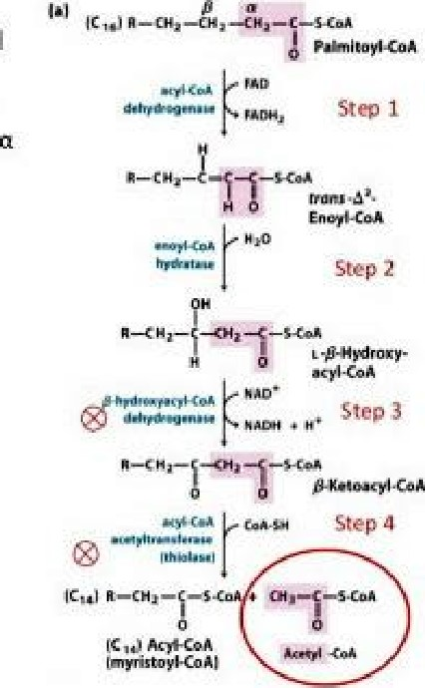
4 Steps of ß-oxidation
1. Dehyd rogenation of the fatty acyi.CoA to make a trans double bond between and ß carbon.
• Shorte medium, and long chain CaAdehydrogenases e-removed transferred to FAD 2. Hydration of the double bond
L Dehyd rogenation of the Ll.-hydroxyl group to a ketone
- removed transferred to NAD'
1. Acyl ation —addition of CoA and production of acetvI,CoA

