NAME; SAIDU MARYAM

DEPARTMENT; PHARMACY

COURSE; PHYSICS 102

MATRIC NO; 19/MHS11/130

COVID-19 PHYSICS ASSIGNMENT

1a. Charging by induction
Electric charges can be obtained on an object without touching it, by a process called elctrostatic induction.
Consider a negatively charged rubber rod brought near a neutral(uncharged) conducting sphere that is insulated so that there is no conducting path to ground as shown below. The repulsive force between the elctrons in the rod and those in the sphere causes a redistribution of charges on the sphere so that some electrons move to the side of the sphere farther away from the rod. The region of the sphere nearest the negatively charged rod has an excess of positive charges because of the migration of electrons away from from this location. If a grounded conducting wire is then connected to the sphere, some of the electron leave the sphere and travel to the earth. If the wire to ground is then removed, the conducting sphere is left with an excess of induced positive charge.
Finally, when the rubber rod is removed from vivinity of the sphere, the induced positive charge remins on the ungrounded sphere and becomes uniformly distributed over the surface of the sphere 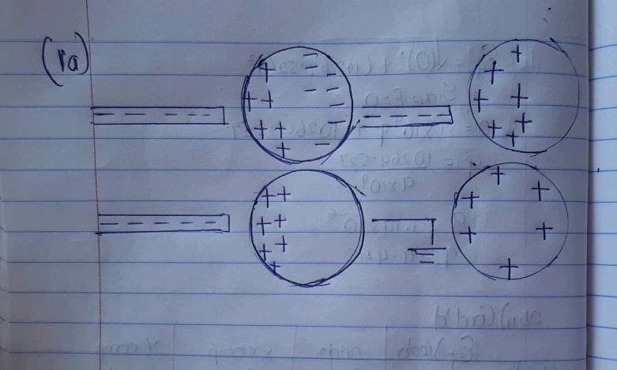

1b.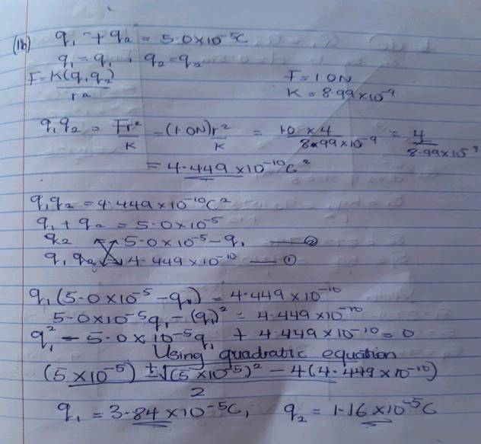

1c. 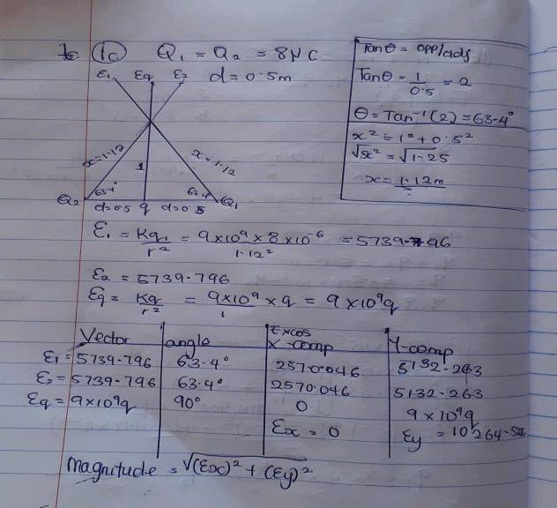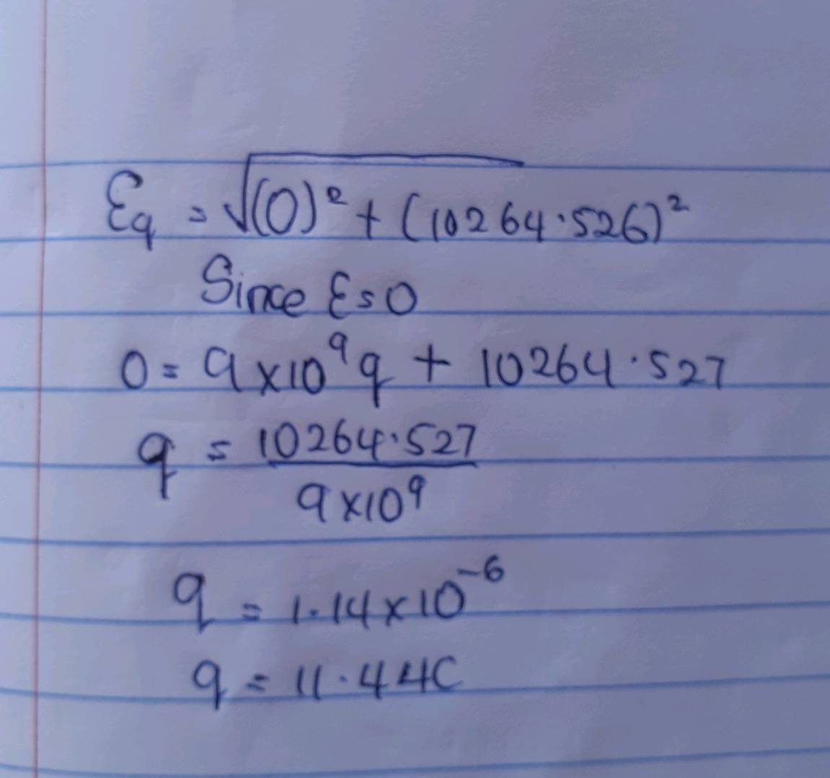

2a. Electric field is a region of space in which an electric charge will experience an electric force
WHILE
Electric field intensity is defined as the force per unit charge.
2b. 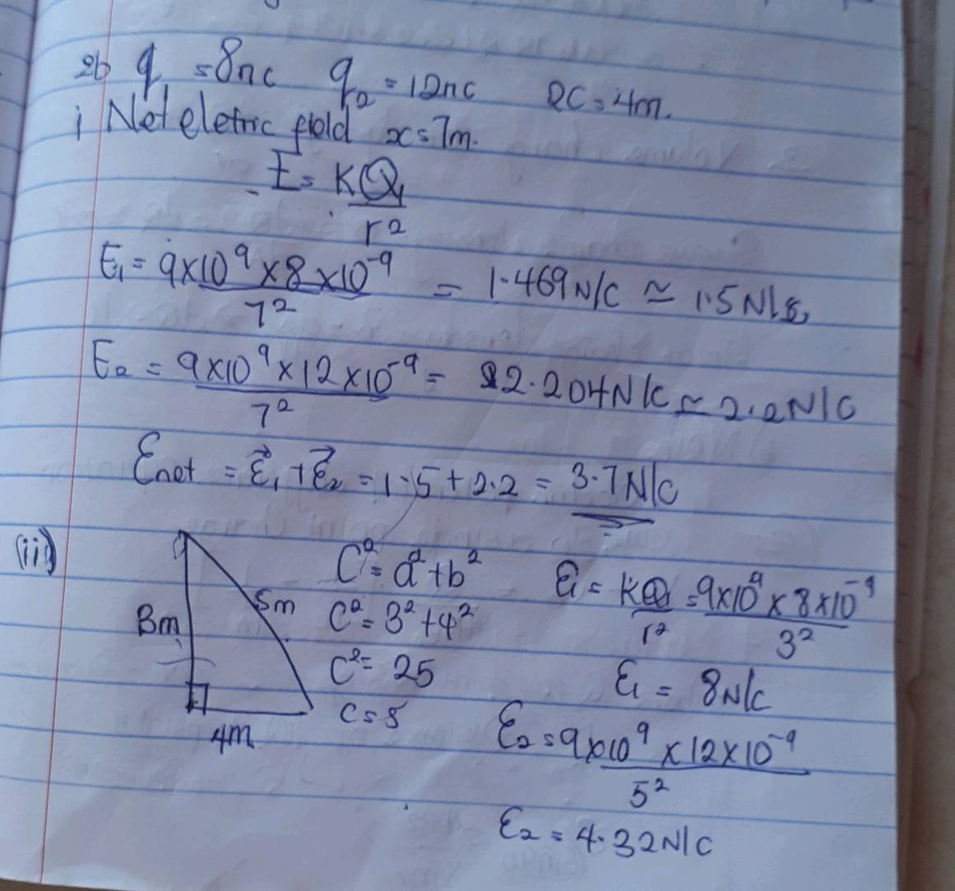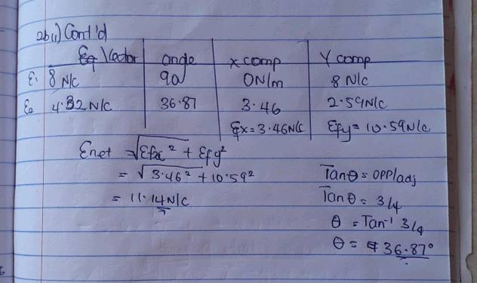

SECTION B
4a. Magnetic flux is a measurement of the total magnetic field which possess through a given area. It is a useful tool for helping describe the effects of the magnetic force on something occuping a given area.

4b. 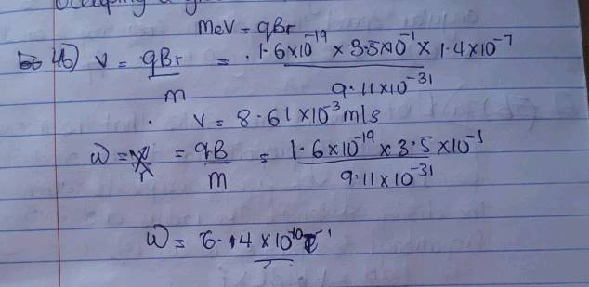

4c. the above question give paramiters such as the mass of the electron= 9.11×10^-31kg, a radius of 1.4×10^-7m, magnetic field of 3.5×10^-1㎡ and we were asked to find the cyclotron frequency
Angular speed ω= v/r= qB/m
Substituting = ω= v/r= qB/m = 1.6 x 10^19 x 3.5x10^-1
9.11 x 10^-31
qB/m = 6.14 x 10^-10T^-1.
And since the cyclotron frequency is equal to angular speed the cyclotron frequency is equal to 6.14 x 10^-10 having a unit as 1/T

5a. Biot-savart law states that the magnetic field is directly proportional to the product permeability of free space(µ) the current(i) the chage in length, the radius and inversely proportional to square of radius(r²)
dB= µ̥idl x r
4π x r²
Where µ̥ constant= permeability of free space µ̥=4πx10^-7T; m/A
Unit of B =weber/meter square

5b. 