NAME: ADETOKUNBO PRECIOUS ADEMIDE
DEPARTMENT: PHARMACY
MATRIC NO: 19/MHS11/015
PHYSICS ASSIGNMENT
1. (a) Explain with the aid of a diagram how you can produce a negatively charged sphere by method of induction
Consider a positively charged rubber rod brought near a neutral conducting sphere that is insulated so that there is no conducting path to ground as shown below. The repulsive force between the electrons in the rod and those in the ground as shown below. The repulsive force between the electrons in the rod and those in the sphere causes a redistribution of charges on the sphere so that some electrons move to the side of the sphere farthest away from the rod. The region of the sphere nearest the positively charged rod has an excess of negative charge because of the migration of electrons away from this location. If a grounded conducting wire is then connected to the sphere as in the figure below, some of the electrons leave the sphere and travel to the earth. If the wire to ground is then removed, the conducting sphere is left with an excess of induced positive charge.
Finally, when the rubber rod is removed from the vicinity of the sphere, the induced negative charge remains on the ungrounded sphere and becomes uniformly distributed over the surface of the sphere.

_ _ +
_ _ ++++
_ _ ++
+ + + + + + + + + +
++++++++++
++++++++++

(b) Each of two small spheres is charged positively, the combined charge being . If each sphere is repelled from the other by a force of 1.0N when the spheres are 2.0m apart, calculate the charge on each sphere.
q1 + q2 = 5.0*10⁻⁵C
F = 1.0N
r = 2m
F = kq1q2
R2
= 9*10⁹ q1q2
2²
= 4 = q1q2
9*10⁹
q1q2 = 4.44*10⁻¹⁰
q1 = 5.0*10⁻⁵ C – q2
(5.0*10⁻⁵ – q2) q2 = 4.44*10⁻¹⁰
5.0*10⁻⁵ q2 – q2² = 4.44*10⁻¹⁰
q2² - 5.0*10⁻⁵ q2 + 4.44*10⁻¹⁰ = 0
q1 = 3.36*10⁻⁵C or 1.14*10⁻¹⁰C
q2 = 1.14*10⁵C or 3.86*10⁻⁵C
(c) Three charges were positioned as shown in the figure below. If Q1 = Q2 = 8uc and d = 0.5m , determine if the electric field at P is zero.
P

2d

Q1 d d Q2
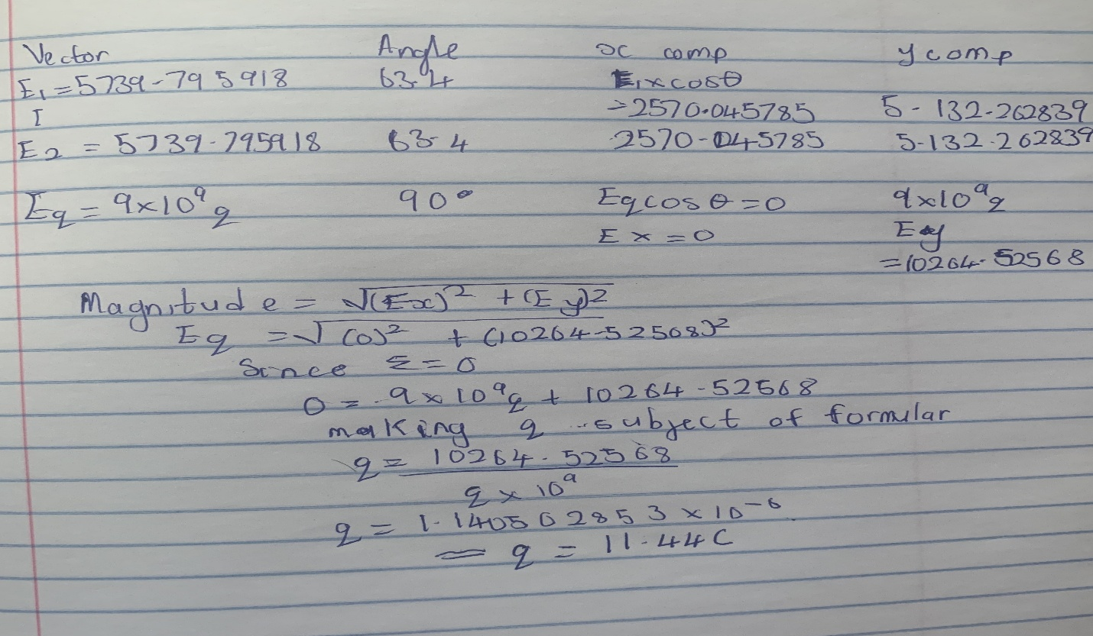
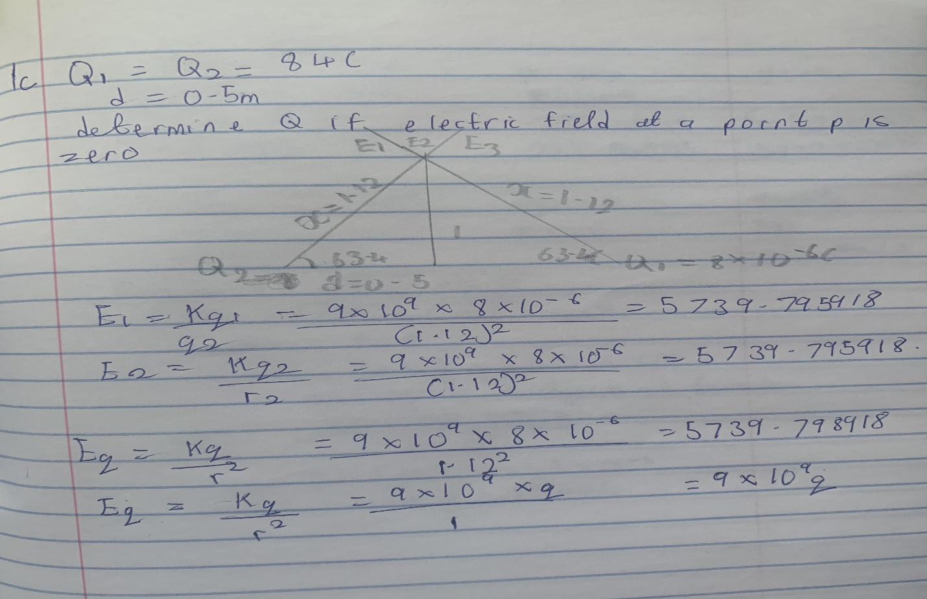

2. (a) Distinguish between the terms: electric field and electric field intensity.
Electric field is a region around a charge in which it exerts electrostatic force on another charges. While the strength of electric field at any point in space is called electric field intensity.
(b) A positive charge is at the origin, and a second positive charge is on the axis at . Find (i) the net electric field at a point P on the axis at . (ii) the electric field at a point Q on the axis at due to the charges.
Q

q1 q2 P
4 3
E = kq
r²
E1 = kq1 = (9*10⁹ )*(8* 10⁻⁴) = 1.5N/C
r² 7²
E2 = kq2 =( 9*10⁹)*(12*10⁻⁴ ) = 12N/C
r² 3²
- Enet = 12 + 1.5 = 13.5N/C
Ө | X component | Y component
90 | 0 | 8
36.87 | -3.46 | 2.59
 | -3.46 | 10.59
- Enet = √(3.46² + 10.59² )
= 11.14N/C

4 (a) What is Magnetic flux?
Magnetic flux is defined as the strength of the magnetic field represented by the line of force. It is represented by the sign Ф.
(b) An electron with a rest mass of 9.11 x 10 -31kg moves in a circular orbit of radius in a uniform magnetic field of 3.5 x 10 -1 Weber/meter square, perpendicular to the speed with which electron moves. Find the cyclotron frequency of the moving electron.
Solution
Angular speed is often referred to as cyclotron frequency
q = 1.6 *10⁻¹⁹ C
B = 3.5 * 10⁻⁵ weber/m²
m = 9.11 * 10⁻³¹kg
Therefore ω = qB = (1.6 *10⁻¹⁹ ) * ( 3.5 * 10⁻⁵ ) = 6.1471 *10⁶ rad/s
m_{p} 9.11 * 10⁻³¹
(c) Discuss your answer in 4b above.
In the question we were given certain parameters for mass of the electron, radius, and magnetic field and we where then asked to find the cyclotron frequency which is equal or the same thing as angular speed. It is called cyclotron frequency because it is a frequency of an accelerator called cyclotron
5. (a) State the Biot-Savart Law.
The biot-savart law is based on the following observations for the magnetic field dB at a point P associated with a length element dl of a wire carrying a steady current.
Observations of the biot-savart experiment
- The vector dB is perpendicular both to dl (which points in the direction of the current) and to the unit vector r directed from dl toward P.
- The magnitude of dB is inversely proportional to r^{2,} where r is the distance from dl to P.
- The magnitude of dB is proportional to the current I and to the magnitude of the element dl.
- The magnitude of dB is proportional to nӨ , where Ө is the angle between r and dl.

(b) Using the Biot-Savart Law, show that the magnitude of the magnetic field of a straight current-carrying conductor is given as

