NAME: MOTAJO OLAKUNLE OLUWATOSIN
MATRIC NO: 17/MHS01/190
DEPARTMENT: MEDICINE AND SURGERY
COURSE TITLE: HISTOLOGY OF SPECIAL SENSES AND NEUROHISTOLOGY
COURSE CODE: ANA 305

1) Write an essay on the histological importance of the eye in relation to their cellular functions.
Answer:
The eyes are highly developed photosensitive organs for analyzing the form, intensity, and colour of light reflected from objects and providing the sense of light. Each eye consists of three concentric layers:
i) A tough external fibrous layer consisting of the sclera and the transparent cornea. ii) A middle vascular layer that includes the choroid, ciliary body, and iris. iii) An inner sensory layer, the retina, which communicates with the cerebrum through the posterior optic nerve.
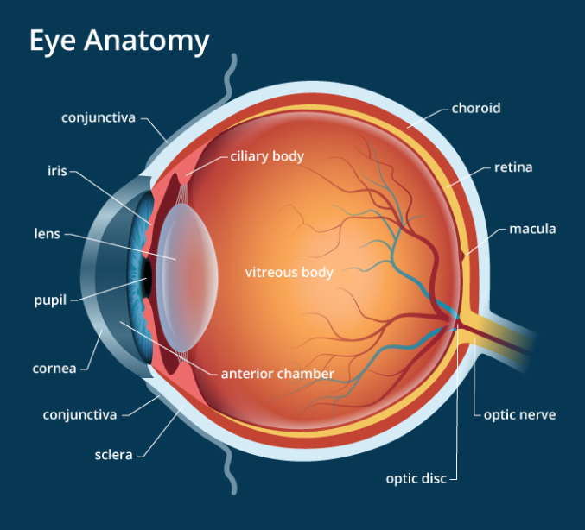

THE SCLERA
The sclera consists of dense connective tissue, with bundles of type 1 collagen intersecting in various directions. The sclera also consists of some elastic fibers. Externally the sclera is covered in its anterior part by ocular conjunctiva, and posteriorly by a fascial sheath ( or episclera). The deep surface of the Sclera is separated from the choroid by the perichoroidial space. Delicate connective tissue present in this space constitute the suprachoroid lamina ( lamina fusca). Anteriorly, the sclera becomes continuous with the cornea at the corneal junction or limbus. A circular channel called the sinus venosus sclerae is located in the sclera just behind the corneoscleral junction.
Histological importance of the sclera
i) The sclera (along with the cornea) collectively forms the fibrous tunic of the eyeball and provides protection to delicate structures within the eye. ii) It resists intraocular pressure and maintains the shape of the eyeball. iii) Its smooth external surface allows eye movements to take place with ease. iv) The sclera also provides attachment to muscles that moves the eyeball.
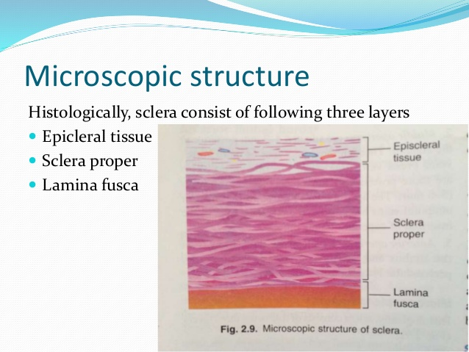

CORNEA
The cornea consists of type 1 collagen fibers oriented in a uniform parallel direction to maintain transparency. The cornea is made up of five layers: 1) Corneal epithelium: the outermost layer is of non-keratinized stratified epithelium. The cells in the deepest layer of the epithelium are columnar, the cells in the middle layers they are polygonal; and the cells in the superficial layers they are flattened. The superficial cells show projections either as mircovilli or folds of plasma membrane.
2) Bowman’s Membrane: this is a layer of Subepithelial basement membrane protecting the underlying stroma. It is composed of type 1 collagen, laminin, and several other heparan sulphate proteoglycans. There are no cells in this layer. Bowman’s membrane contributes greatly to the stability and strength of the cornea.
3) Corneal Stroma: most of the thickness of the cornea is formed by the corneal stroma (also called Substantia propria). It is made up of type 1 collagen fibers embedded in a ground substance containing sulphated glycosaminoglycans. Fibroblasts are present in the substantia propria. They are also keratocytes or corneal corpuscles
4) Descemet’s membrane: an acellular homogenous layer made up of fine type IV collagen that serves as a modified basement membrane of the corneal endothelium.
5) Corneal Endothelium: a one cell thick layer made up of either simple squamous or cuboidal cells. Cells in this region do not regenerate and have pumps that maintain fluid balance and prevent swelling of the stroma. When corneal endothelial cells are lost, neighbouring cells stretch to attempt to compensate these losses hence is responsible for maintaining the transparency of the cornea.
Histological importance of the cornea : 1) The cornea’s major function is to refract or bend light 2) the cornea is a transparent avascular tissue that acts as a structural barrier and protects the eye against infections. 3) Along with the tear film, it provides proper anterior refractive surface for the eye. 4) Cornea contributes to two-thirds of the refractive power of the eye. 5) the cornea tends to repair itself quickly from minor abrasions, however deeper abrasions may cause scars making the cornea lose its transparency

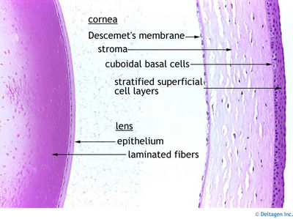

VASCULAR LAYER
The eye vascular middle layer, known as the ‘uvea’, consists of three parts, from posterior to anterior: the choroid, the ciliary body, and the iris
CHOROID: The choroid consists of loose, well-vascularized connective tissue and contains numerous melanocytes. Two layers make up the choroid: i) choroidocapillary layer: which has a rich microvasculature important for nutrition of the outer retinal layers. ii) Bruch membrane: which is a thin extracellular sheet, composed of collagen and elastic fibers surrounding the adjacent microvasculature and basal lamina of the retina’s pigmented layer.
Histological importance of the choroid The major function is to provide nourishment to the outer layers of the retina through blood vessels. It is part of the uveal tract.
CILIARY BODY: consists of the ciliary muscle and the ciliary epithelium. The ciliary muscle, via the lens zonules, controls the structure of the lens, which is vital for accommodation. Zonules are connective tissues fibers that connect the ciliary muscles and lens. The ciliary epithelium produces aqueous humour which fills the anterior compartement of the eye.
Histological importance of the ciliary body
1) Contraction and relaxation of the ciliary muscles changes the tension of the zonular fibers of the lens and this allows the lens to change shape, a process called accommodation. 2) The ciliary process are folds of connective tissues that are covered by two layers of epithelium. They is also a complex vasculature that cannot be seen easily, fluids from these vessels is processed and transported by the epithelial cells to the posterior chamber as aqueous humour. The epithelial cells also constitute the blood-aqueous barrier.
IRIS:
The iris is composed of a stroma of connective tissue containing numerous pigment cells, and in which are embedded blood vessels and smooth muscle. Some smooth muscles fibers are arranged circularly around the pupil and constrict it. They form the sphincter pupillae. Other fibers run radially and form the dilator papillae. The posterior surface of the iris is lined by a double layer of epithelium continuous with that over the ciliary body. The epithelium represents a forward continuation of the retina. The cells of this epithelium are deeply pigmented.
Histological importance of the Iris
The anterior surface of the iris contains loose, variably pigmented stroma. It is open to the circulating aqueous humour within the anterior chamber. Two layers of heavily pigmented epithelium cover the posterior surface of the iris. Note that the sphincter pupillae muscle can be easily seen near the pupil margin. It is smooth muscle controlled by parasympathetics. The dilator pupillae muscle is more difficult to identify, but it dilates the pupil upon sympathetic innervations.
INNERMOST LAYER: It consists of Lens, Vitreous, and Retina.
LENS: It seperates the aqueous and vitreous chambers. It consists of an outer capsule, a middle layer called cortex, and an inner layer called the nucleus. The capsule is the basement membrane of the lens epithelium which lies below. New lens cells differentiate from the lens epithelium and are incorporated peripherally, pushing older lens cells towards the middle.
Histological importance of the lens
The lens is a transparent and flexible biconvex structure in the eye that, along with the cornea, helps to refract light to be focused on the retina. The flexibility allows the lens to be easily manipulated by the ciliary muscles, by changing the curvature of the lens, one can focus the eye on objects at different distances from it.
VITREOUS: is a jelly-like space made up of type II collagen separating the retina and the lens. The vitreous humour is a transparent, colourless, gelatinous mass that fills the space in the eye between the lens and the retina. It is surrounded by a layer of collagen called the Vitreous membrane ( or hyaloid membrane or Vitreous cortex) separating it from the rest of the eye. It makes up four-fifths of the volume of the eyeball. The vitreous humour is fluid-like near the center, and gel-like near the edges.
Histological importance of the Vitreous body
The vitreous body provides physical support holding the retina in place next to the choroid ( Neural retina and choroid are only connected to each other at the disc and the ora serrata.)
RETINA: is the nervous tissue of the eye where photons of light convert to neurochemical energy via action potentials.
The retina serves a function analogous to that of the film or image sensor in a camera. The neural retina consists of several layers of neurons interconnected by synapses, and is supported by an outer layer of pigmented epithelial cells.

2) Corona virus can penetrate the body through eye and implicate the immune system, briefly discuss the layers of retina for information penetration.
Answer:
The retina is the innermost layer of the wall of the eye. It is in immediate contact with the vitreal cavity on one side and with the choroid (of the uveal layer) on the other side. The retina itself consists of ten different layers, each playing a specific role in creating and transmitting vision. Beginning from the external surface the layers are:.
1) Pigment cell layer: it is the outermost layer of retina which is separated from choroid by Bruch’s membrane. This consists of a single layer of low cuboidal cells containing melanin pigment. Processes from pigment cells extend into the next layer. This layer performs the following functions;
i) it absorbs and prevent the reflection of light that has passed through the neural layers of the retina. ii) the pigment cells phagocytose the shed membranous disc of the outer segment of rods and cones.
2) Layer of Rods and Cones: the rods are processes of rod cells, and cones are processes of cone cells. The peripheral process is rod shaped in the case of rod cells, and cone shaped in the case of cone cells.
3) Outer limiting layer: This is a poorly stained well-defined series of adherent junctions (zonula adherentes) between the photoreceptors and Muller cell.
4) External Nuclear layer: the external nuclear layer contains the cell bodies and nuclei of rod cells and of cone cells. These cells are photoreceptors that convert the stimulus of light into nervous impulses. Each rod cell is regarded as a neuron having a cell body, peripheral process and a central process. The nuclei of these cells are arranged in several layers in the form of external nuclear layer. Between the second and third layer there is the presence of a pink linear marking called the outer limiting membrane. This results because of zonula adherens of the glial cells (Muller cells) with the cell bodies of photoreceptor cells. The muller cells are supporting cells of retina. They have long slender body that is radially oriented in retina. The central process of each rod cells is an axon. It extends into the External plexiform layer where it synapses with dendrites of bipolar neuron.
5) External plexiform layer: also called outer synaptic zone consists of nerve fibers that form a plexus. The axons of rods and cones synapse here with dendrites of bipolar neurons and horizontal cells. This layer stains lightly.
6) Internal Nuclear layer: it contains the cell bodies and nuclei of three type of neurons:
i) Bipolar cells: they give off dendrites that enters the external plexiform layer to synapse with the axons of rod and cone cells; and axons that enter the internal plexiform layer where they synapse with dendrites of ganglion cells ii) horizontal cells: which gives off processes that run parallel to the retinal surface. These processes enter the outer plexiform layer and synapse with rods, cones and dendrites of bipolar cells. iii) Amacrine cells: also lie horizontally in the retina. Their processes enter the inner plexiform layer where they synapse with axons of bipolar cells and dendrites of ganglion cells Note: apart from these cells, the internal nuclear layer also contain of cells of Muller.
7) Internal Plexiform Layer: also called the inner synaptic zone. It consists of synapsing nerve fibers. The axons of bipolar cells synapse with dendrites of ganglion cells; and both these processes synapse with processes of amacrine cells. The internal Plexiform layer also contain some horizontally placed internal plexiform cells; and also a few ganglion cells.
8) Layer of Ganglion cells: the layer of ganglion cells contains the cell bodies of ganglion cells. We have seen that dendrites of these cells enter the internal plexiform layer to synapse with processes of bipolar cells and of amacrine cells. Each ganglion cell gives off an axon that forms a fiber of the optic nerve.
9) Layer of Optic Nerve Fibers: The layer of optic nerve fibers is made up of axons of ganglion cells. The fibers converge on the optic disc where they pass through foramina of the lamina cribrosa to enter the optic nerve.
10) Inner limiting Layer: consists of terminal expansions of Muller cell processes that cover the collagenous membrane of the vitreous body and form the inner surface of the retina. This layer seperates the retina from the Vitreous.

