NAME: ALEGBELEYE OLUWATOSIN OLUWAPELUMI
MATRIC NUMBER: 19/SCI01/015
DEPARTMENT: COMPUTER SCIENCE
COVID-19 HOLIDAY ASSIGNMENT
SECTION A
1a.
BY METHOD OF INDUCTION
Electric charges can be obtained on an object without touching it, by a process called electrostatic induction.
One common demonstration involves the induction charging of two metal spheres. The metal spheres are supported by insulating stands so that any charge acquired by the spheres cannot travel to the ground. The spheres are placed side by side (see diagram i. below) so as to form a two-sphere system. Being made of metal (a conductor), electrons are free to move between the spheres - from sphere A to sphere B and vice versa.
If a rubber balloon is charged negatively (perhaps by rubbing it with animal fur) and brought near the spheres, electrons within the two-sphere system will be induced to move away from the balloon. This is simply the principle that like charges repel. Being charged negatively, the electrons are repelled by the negatively charged balloon. And being present in a conductor, they are free to move about the surface of the conductor. Subsequently, there is a mass migration of electrons from sphere A to sphere B. This electron migration causes the two-sphere system to be polarized (see diagram ii. below). Overall, the two-sphere system is electrically neutral. Yet the movement of electrons out of sphere A and into sphere B separates the negative charge from the positive charge. Looking at the spheres individually, it would be accurate to say that sphere A has an overall positive charge and sphere B has an overall negative charge. Once the two-sphere system is polarized, sphere B is physically separated from sphere A using the insulating stand. Having been pulled further from the balloon, the negative charge likely redistributes itself uniformly about sphere B (see diagram iii. below). Meanwhile, the excess positive charge on sphere A remains located near the negatively charged balloon, consistent with the principle that opposite charges attract. As the balloon is pulled away, there is a uniform distribution of charge about the surface of both spheres (see diagram iv. below). This distribution occurs as the remaining electrons in sphere A moves across the surface of the sphere until the excess positive charge is uniformly distributed.
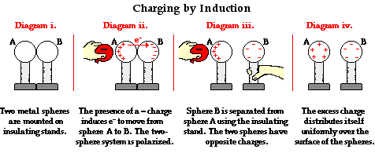

1b. and 1c.

QUESTION

(b) Each of two small spheres is charged positively, the combined charge being 5.0×10⁻⁵C. If each sphere is repelled from the other by a force of 1.0N when the spheres are 2.0m apart, calculate the charge on each sphere.
(C)Three charges were positioned as shown in the figure below. If Q1=Q2=8μC and d=0.5m, determine q if the electric field at is zero.

SOLUTION
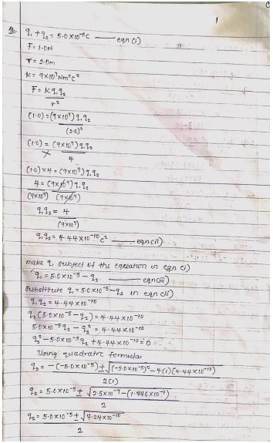Continuation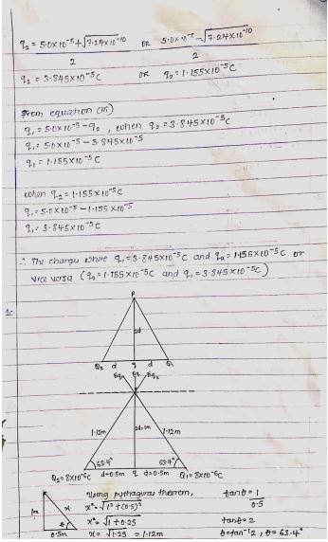Continuation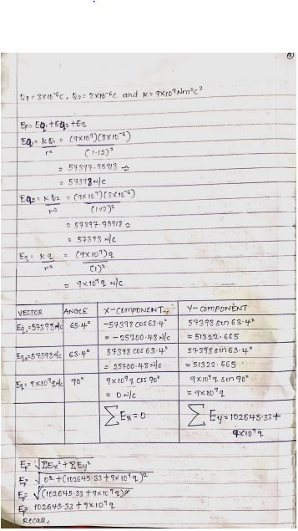 Continuation 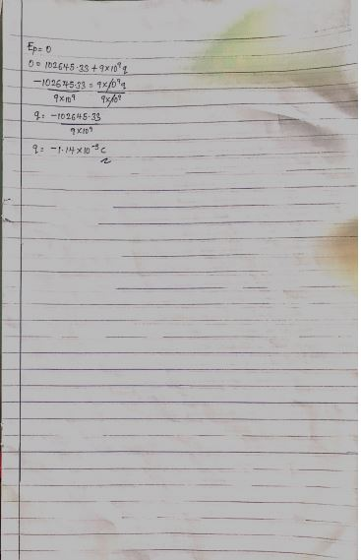

2a.
ELETRIC FIELD
An electric field is a region of space in which an electric charge will experience an electric force.
WHILE
ELECTRIC FIELD INTENSITY
Electric field intensity is also known as electric field strength which can be defined as the force per unit charge. Which is measured in Newton per coulomb (N/C).

2b.
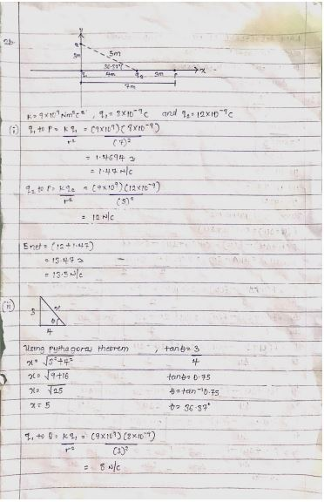Continuation 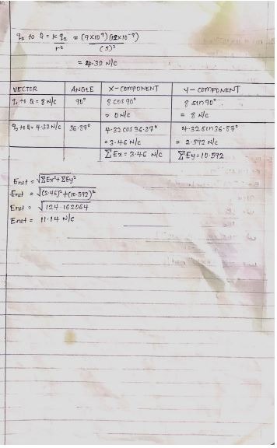

SECTION B
4a.
MAGNETIC FLUX
The magnetic flux is defined as the strength of magnetic field represented by lines of force. It is what generates the field around a magnetic material. It consist of photons, however, unlike the light we receive from the sun, it is at a much lower frequency, which makes it not visible to the naked eye. It can be denoted with Φ or Φ_{B}.
The SI unit of magnetic flux is the weber (Wb).
Φ = 𝐵⃗.𝑑𝐴⃗ … (1)
Where 𝑑𝐴⃗ is a vector that is perpendicular to the surface and has a magnitude equal to the area 𝑑𝐴. Hence, the total magnetic flux ɸ through the surface is
Φ = ∫𝐵⃗.𝑑𝐴⃗ … (2)
Equation (2) defines the magnetic flux through a plane lying in a magnetic field for which an arbitrary shaped surface is considered.
Equation (2) is a special case, suppose that the loop lies is an arbitrary shaped surface and that the magnetic field 𝐵⃗ makes an angle 𝜃 with area element 𝑑𝐴 perpendicular to the place. Therefore, the dot product in equation (2) becomes:
Φ_{B} = ∫𝐵⃗.𝑑𝐴⃗= 𝐵𝐴 cos 𝜃 … (3)

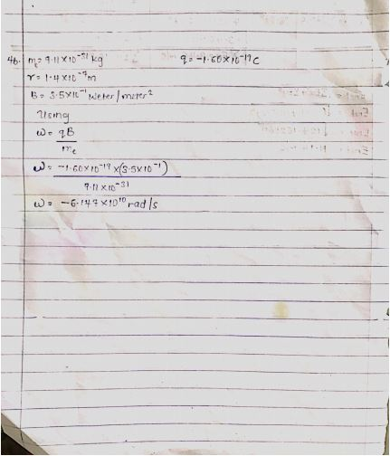
4b.

4c.
In the question we were given:
i.mass of the electron =9.11x10⁻³¹ kg
ii.A radius of 1.4x10⁻⁷m
iii.magnetic field of 3.5x10⁻¹ weber\meter²
We are to find the cyclotron frequency which is the same as angular speed. It is called cyclotron frequency because it is a frequency of an accelerator called cyclotron.
Recall, angular speed is given as ω=$\frac{v}{r}$=$\frac{qB}{m}$
ω=$\frac{qB}{m}$=-1.6×10⁻¹⁰×3.5×10⁻¹⁰
9.11×10⁻³¹

ω=$\frac{qB}{m}$=-6.147×10¹⁰rad/s
Note: Angular speed is the same as cyclotron frequency.
∴ Cyclotron frequency =-6.147×10¹⁰rad/s.

5a.
BIOT-SAVART LAW
Biot-savart law states that the magnetic field is directly proportional to the product permeability of free space (µ), the current (I), the magnitude of the length element ($d\vec{l}$) the unit vector ($\hat{r}$) and inversely proportional to r², where r is the distance from $d\vec{l}$ to P. It can be mathematically represented by
$$d\vec{B}= \frac{μ_{o}}{4π}\frac{I d\vec{l}×\hat{r}}{r^{2}}$$
Where $μ_{o}$a constant is called Permeability of free space.
$$μ_{o}=4π ×{10}^{-7} T.\frac{m}{A}$$

5b.
Magnetic Field of a Straight Current Carrying Conductor
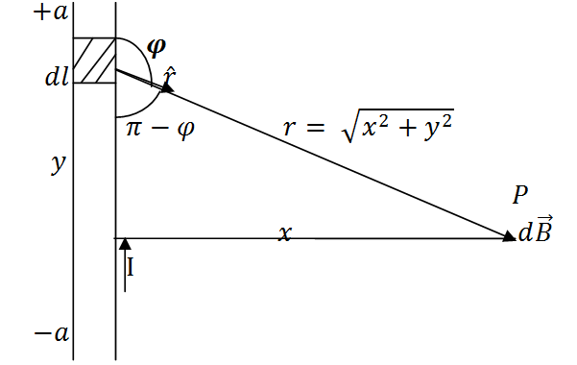
Applying the Biot-Savart law, we find the magnitude of the field $d\vec{B}$
$$B= \frac{μ_{o}I}{4π}\int_{-a}^{a}{\frac{dl\sin{φ}}{r^{2}}}$$
$$sin\left(π –φ\right)= sinθ$$
$$∴B= \frac{μ_{o}I}{4π}\int_{-a}^{a}{\frac{dlsin(π-φ)}{r^{2}}}$$
From diagram, $r^{2}=x^{2}+y^{2} (Pythagoras theorem)$
$$B= \frac{μ_{o}I}{4π}\int_{-a}^{a}{\frac{dlsin(π –φ)}{x^{2 }+ y^{2}}} … (*)$$
$$But sin\left(π-φ\right)= \frac{x}{\sqrt{x^{2 }+ y^{2}}}=\frac{x}{{\left(x^{2 }+ y^{2}\right)}^{1/2}} … (**)$$
Substituting $(**)$ into $(*)$, we have
$$B= \frac{μ_{o}I}{4π}\int_{-a}^{a}{dl}\frac{x}{{{(x}^{2}+ y^{2})\left(x^{2 }+y^{2 }\right)}^{1/2}}$$

$$B= \frac{μ_{o}I}{4π}\int_{-a}^{a}{dl}\frac{x}{{\left(x^{2 }+y^{2 }\right)}^{3/2}}$$
Recall $dl=dy$
$$B= \frac{μ_{o}I}{4π}\int_{-a}^{a}{\frac{x}{{\left(x^{2 }+y^{2 }\right)}^{3/2}}dy}$$
$$B=\frac{μ_{o}Ix}{4π}\int_{-a}^{a}{\frac{1}{{\left(x^{2 }+y^{2 }\right)}^{3/2}}dy} … (***)$$
Using special integrals:
$$\int{\frac{dy}{{{(x}^{2 }+ y^{2})}^{3/2}}}=\frac{1}{x^{2}}\frac{y}{{(x^{2 }+ y^{2})}^{1/2}}$$
$$\left(\frac{2a}{{\left(x^{2 }+ a^{2}\right)}^{1/2}}\right)$$
When the length $2a$ of the conductor is very great in comparison to its distance $x$ from point P, we consider it infinitely long. That is, when $a$ is much larger than$x$,
$${(x^{2 }+ a^{2})}^{1/2}≅a, as a→∞$$
$$∴B= \frac{μ_{o}I}{2πx}$$
In a physical situation, we have axial symmetry about the y- axis. Thus, at all points in a circle of radius$r$, around the conductor, the magnitude of B is
$$B= \frac{μ_{o}I}{2πr} … (\#)$$
Equation $(\#)$ defines the magnitude of the magnetic field of flux density B near a long, straight current carrying conductor.

