NAME: ISIRIMAH JULIET ULOMAH
MATRIC NO: 16/MHS02/021
COURSE CODE: 404
COURSE TITLE: MATERNAL HEALTH AND NORMAL MIDWIFERY 11
ASSIGNMENT TITLE:
- Use of partograph in the management of the first stage of labour
- Management of 2nd and 3rd stages of labour
ANSWER

The partograph is a tool for monitoring maternal and foetal wellbeing during the active phase of labour, and a decision-making aid when abnormalities are detected. It is designed to be used at any level of care.
Its central feature is a graph used to record the progress of cervical dilation, as determined by vaginal examination.
Start the graph at 5 cm of dilation, and 3 contractions every 10 minutes. In certain situations, e.g. induction of labour, it is started at 4 cm of dilation.

Indicators are plotted on the graph each time they are checked:
– Maternal indicators:
• Vital signs (heart rate, blood pressure and temperature)
• Time of spontaneous or artificial rupture of the membranes
• Uterine contractions (number per 10 minutes and duration)
• Urine output
• Drugs administered (oxytocin, antibiotics, etc.)
– Foetal indicators:
• Foetal heart rate
• Amniotic fluid (colour, odour and quantity)
• Descent of the foetal head and head moulding
Interpreting the WHO partograph
The WHO partograph has two diagonal lines: an alert line and an action line.
The alert line goes from 4 to 10 cm and corresponds to an average dilation rate of 1 cm per hour. If the labour curve crosses to the right of this alert line, this means that the dilation is less than 1 cm per hour. In this case, transfer to a CEmONC facility must be considered if the woman is at an outpatient clinic or a BEmONC facility. If the woman is at a CEmONC facility, closer monitoring is required.
The action line is located 4 hours to the right of the alert line. If the dilatation curve crosses this line, decisions must be made (augmentation of labour, artificial rupture of membranes, caesarean section, etc.).

Indicators are plotted on the graph each time they are checked:
– Maternal indicators:
• Vital signs (heart rate, blood pressure and temperature)
• Time of spontaneous or artificial rupture of the membranes
• Uterine contractions (number per 10 minutes and duration)
• Urine output
• Drugs administered (oxytocin, antibiotics, etc.)
– Foetal indicators:
• Foetal heart rate
• Amniotic fluid (colour, odour and quantity)
• Descent of the foetal head and head moulding

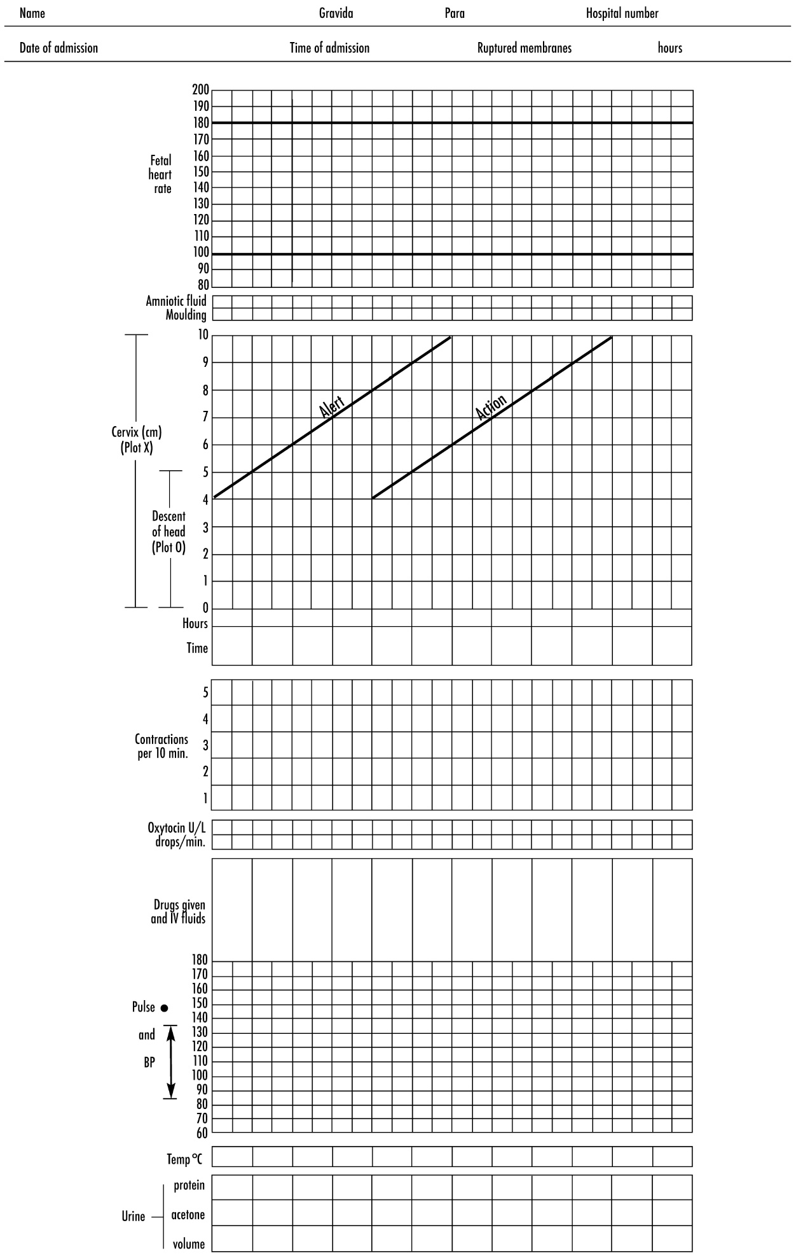

- The alert line. It represents a rate of cervical dilatation of 1 cm per hour. The alert line represents the minimum progress in cervical dilatation which is acceptable during the active phase of the first stage of labour

- Action line: Any patient whose graph of the cervical dilatation falls on or crosses the action line must have a complete examination by the doctor. Her further management must be under the doctor’s supervision and direction. If a patient is not already in hospital, she will need to be transferred into a hospital where there are facilities for instrumental delivery and Caesarean section. The progress of labour is very slow when the graph of cervical dilatation crosses or falls on this line. When this occurs, action must be taken in order to hasten the delivery of the infant.

. Recording the blood pressure, pulse and temperature
The maternal blood pressure, pulse and temperature should be recorded on the partogram.

B. Recording the urinary data
- Volume is recorded in ml.
- Protein is recorded as 0 to 4+.
- Ketones are recorded as 0 to 4+ (see figure 8C-2).

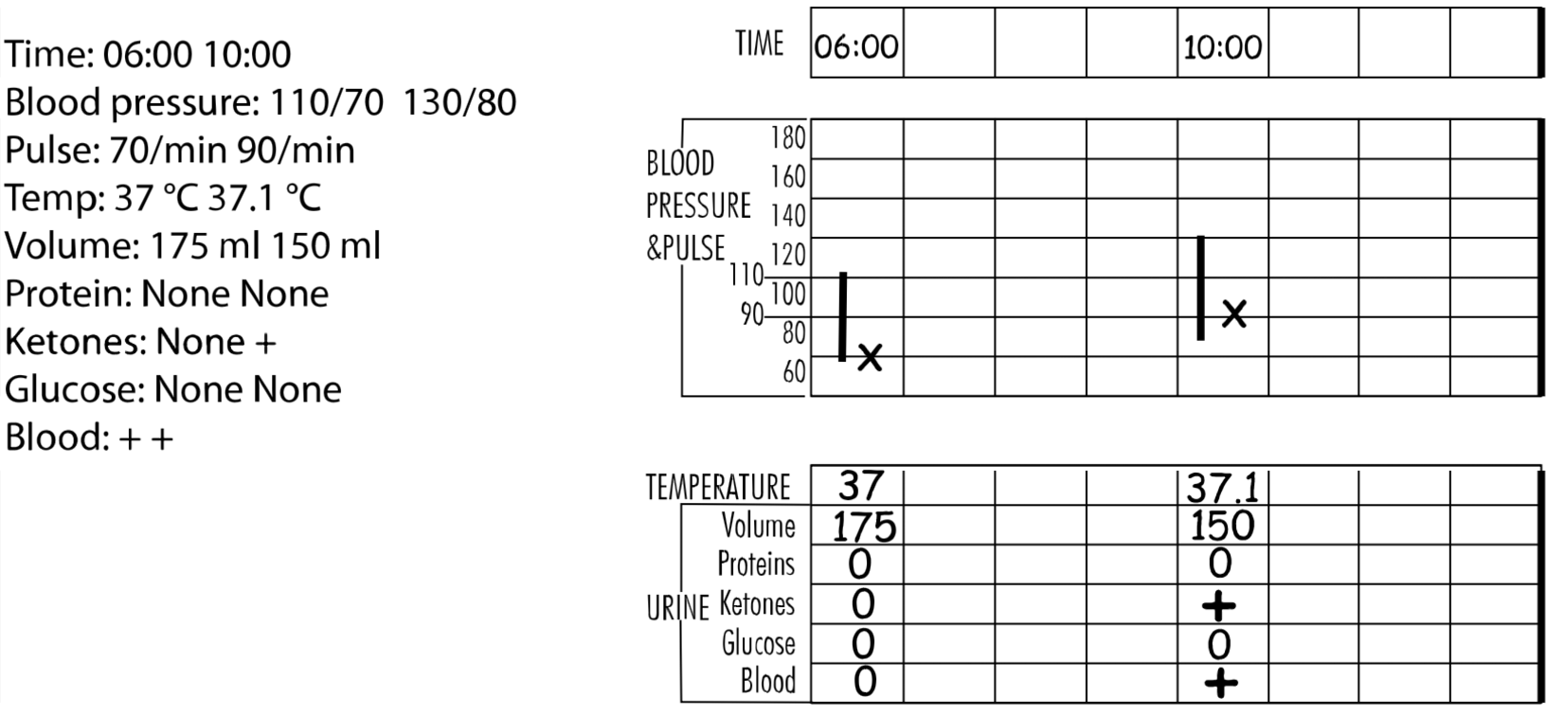

Recording the fetal heart rate pattern
The following two observations must be recorded on the partogram:
- The baseline heart rate.
- The presence or absence of decelerations. If decelerations are present, you must record whether they are early or late decelerations

Recording the liquor findings
Three symbols are used:
I = Intact membranes.
C = Clear liquor draining.
M = Meconium-stained liquor draining

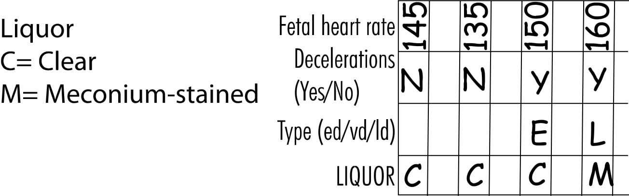

Recording the cervical dilatation
Cervical dilatation is measured in cm and then recorded by marking an ‘X’ on the partogram.

G. Recording the length of the cervix (effacement)
The length of the cervix is recorded by drawing a thick, vertical line on the same part of the chart that is used for the cervical dilatation. The length of the line drawn indicates the length of the endocervical canal in cm. It is drawn on the chart whenever the cervical dilatation is recorded. Alternatively, the length of the endocervical canal, measured in cm or mm, can be noted in the space provided.

H. Recording the amount of the head palpable above the brim of the pelvis (descent and engagement)
The findings are recorded by marking an ‘O’ on the partogram

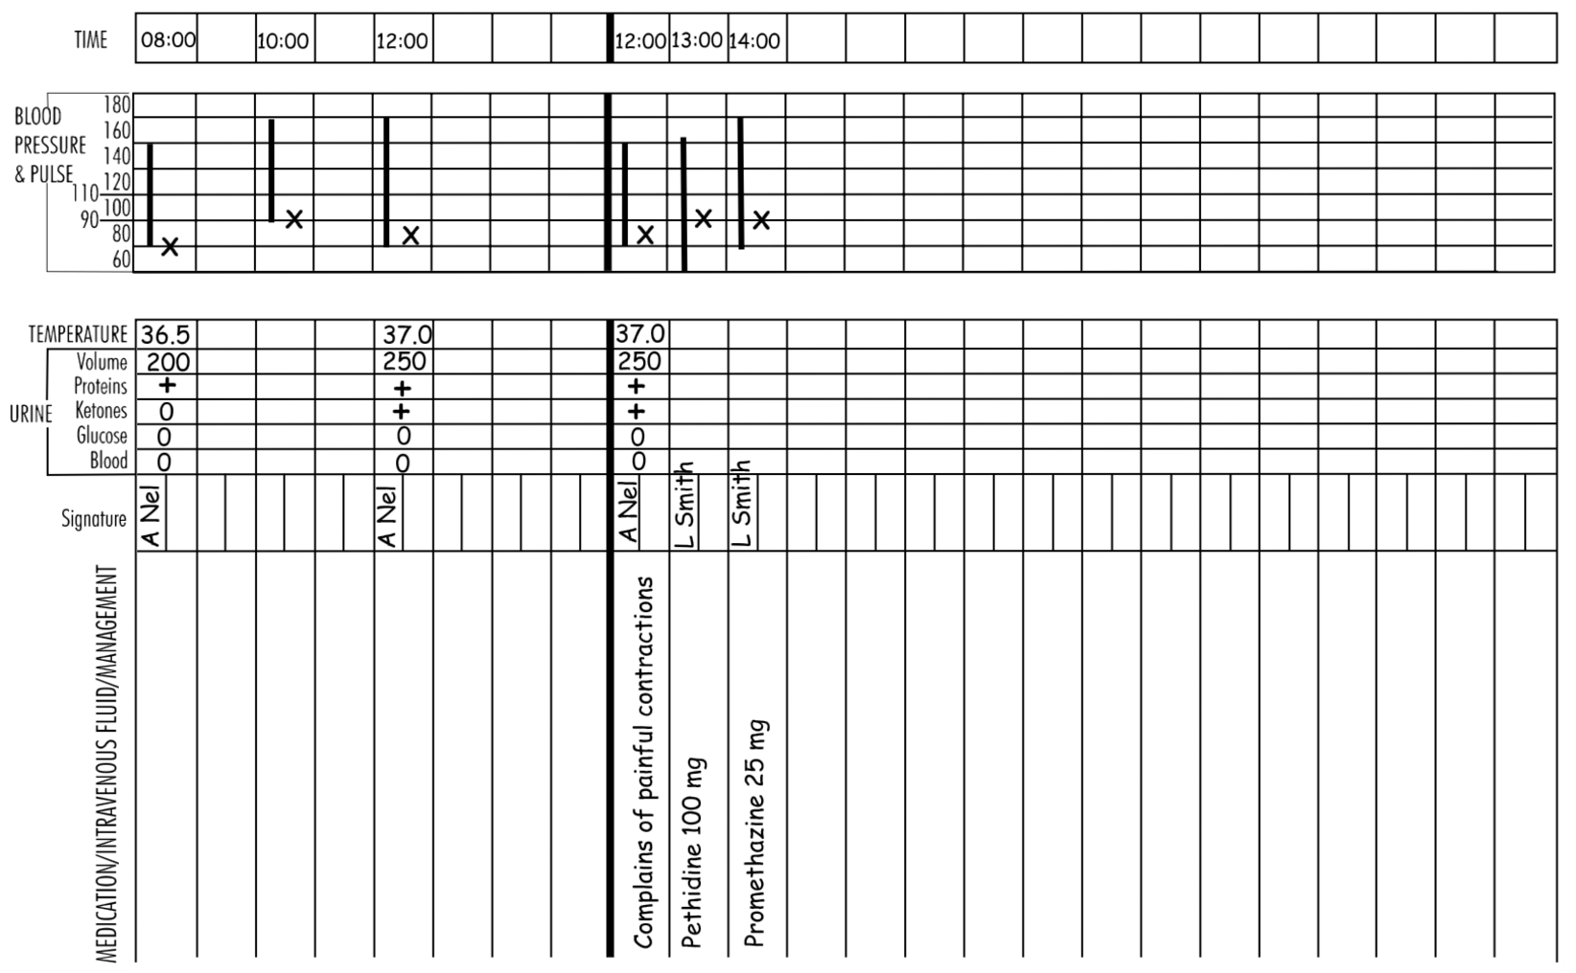

MANAGEMENT OF 2ND and 3rd STAGE OF LABOR

(1) Thoroughly dry the baby, assess its breathing and perform resuscitation if needed, and then place the baby in skin-to-skin contact with the mother:
(a) After birth of the baby, immediately dry the infant and assess its breathing. If the baby requires resuscitation, you may need to cut the cord immediately to care for the baby.
(b) Then place the reactive infant, prone, in skin-to-skin contact, on the mother. If the umbilical cord is long enough, place the baby directly on the mother’s chest. If the umbilical cord is short, place the baby on the mother’s abdomen until after cutting the cord. Be careful to leave some slack on the umbilical cord and do not unduly
stretch the cord.
(c) Remove the cloth used to dry the baby.
(d) Cover both the mother and infant with a dry, warm cloth or towel to prevent heat loss.
(e) Cover the baby’s head with a cap or cloth.
(2) Administer a uterotonic drug within 1 minute of the baby’s
(a) If another baby is not present, begin the procedure by giving the woman 10 IU of oxytocin by IM injection in the upper thigh. This should be done within 1 minute of childbirth. If available, a qualified assistant should give the injection by a similar infusion.
(3) Clamp and cut the umbilical cord:
(a) Place one clamp 4 cm from the baby’s abdomen after cord pulsations have ceased or approximately 2–3 minutes after birth of the baby, whichever comes first.
(b) Gently milk the cord towards the woman’s perineum and place a second clamp on the cord approximately 2 cm from the first clamp.
(c) Cut the cord using sterile scissors under cover of a gauze swab to prevent blood spatter. After mother and baby are safely cared for, tie the cord.
(d) Place the baby on the woman’s chest, in skin-to-skin contact, and encourage breastfeeding.
(4) Perform Controlled Cord Traction:
WHO, FIGO and ICM recommend that in the absence of a skilled provider, third stage should be managed by administering a uterotonic drug (oxytocin or misoprostol) without control cord Traction for the prevention of Post partum hemorrhage
(a) Place the clamp near the woman’s perineum to make control cord Traction easier.
(b) Hold the cord close to the perineum using a clamp.
(c) Place the palm of the other hand on the lower abdomen just above the woman’s pubic bone to assess for uterine contractions. If a clamp is not available, controlled cord Traction an be applied by encircling the cord around the hand.
(d) Wait for a uterine contraction. Only perform Controlled cord Traction when there is a contraction.
(e) When there is a contraction, apply external pressure on the uterus in an upward direction (toward the woman’s head) with the hand just above the pubic bone.
(f) At the same time with your other hand, pull with firm, steady tension on the cord in a downward direction (follow the direction of the birth canal). Avoid jerky or forceful pulling.
Note: If the placenta does not descend during
30–40 seconds of controlled cord Traction (i.e. there are no signs of
placental separation), do not continue to pull on the
cord:
(g) Gently hold the cord and wait until the uterus is well contracted again. If necessary, use a sponge forceps to clamp the cord closer to the perineum as it lengthens.
(h) With the next contraction, repeat controlled cord Traction with
counter traction.
(i) Do not release support on the uterus until the placenta is visible at the vulva. Deliver the placenta slowly and support it with both hands.
(j) As the placenta is delivered, hold and gently turn it with both hands until the membranes are twisted.
(k) Slowly pull to complete the delivery. Gently move membranes up and down until delivered.
(5) Massage the uterus:
(a) Massage the uterus immediately after delivery of the placenta and membranes until it is firm.
(b) After stopping massage, it is important that the uterus does not relax again.
(c) Palpate for a contracted uterus every 15 minutes and repeat uterine massage as needed during at least the first 2 hours after childbirth.
(6) Examine the placenta and membranes for completeness.
(7) Examine the genitalia and repair lacerations/ episiotomy if necessary.
(8) Evaluate blood loss.

