NAME: AIBANGBEE EFEOSA ANTHONIA
DEPARTMENT: PHARMACY
MATRIC NO: 19/MHS11/021
COURSE : PHY 102
ASSIGNMENT
1. (a) Explain with the aid of a diagram how you can produce a negatively charged sphere by method of induction
i. a positively charged rubber rod brought near a neutral conducting sphere that is insulated so that there is no conducting path to ground as shown below. The repulsive force between the positively charged rod and the electrons in the sphere causes a redistribution of charges at both ends of the sphere.
ii. The positive charges at the end of the sphere are allowed to earth while the rod is still close to the sphere to prevent redistribution
iii. The positively charged rod is removed and the negative charge left in the sphere spreads uniformly over the entire sphere
.

_ _ +
_ _ ++++
_ _ ++
i.
+ + + + + + + + + +
++++++++++
++++++++++

ii. iii.

(b) Each of two small spheres is charged positively, the combined charge being . If each sphere is repelled from the other by a force of 1.0N when the spheres are 2.0m apart, calculate the charge on each sphere.
q1 + q2 = 5.0*10⁻⁵C
F = 1.0N
r = 2m
F = kq1q2
R2
= 9*10⁹q1q2
2²
= 4 = q1q2
9*10⁹
q1q2 = 4.44*10⁻¹⁰
q1 = 5.0*10⁻⁵ C – q2
(5.0*10⁻⁵ – q2) q2 = 4.44*10⁻¹⁰
5.0*10⁻⁵ q2 – q2² = 4.44*10⁻¹⁰
q2² - 5.0*10⁻⁵ q2 + 4.44*10⁻¹⁰ = 0
q1 = 3.36*10⁻⁵C or 1.14*10⁻¹⁰C
q2 = 1.14*10⁵C or 3.86*10⁻⁵C
(c) Three charges were positioned as shown in the figure below. If Q1 = Q2 = 8uc and d = 0.5m , determine if the electric field at P is zero.
P

2d
d d
Q1 Q2

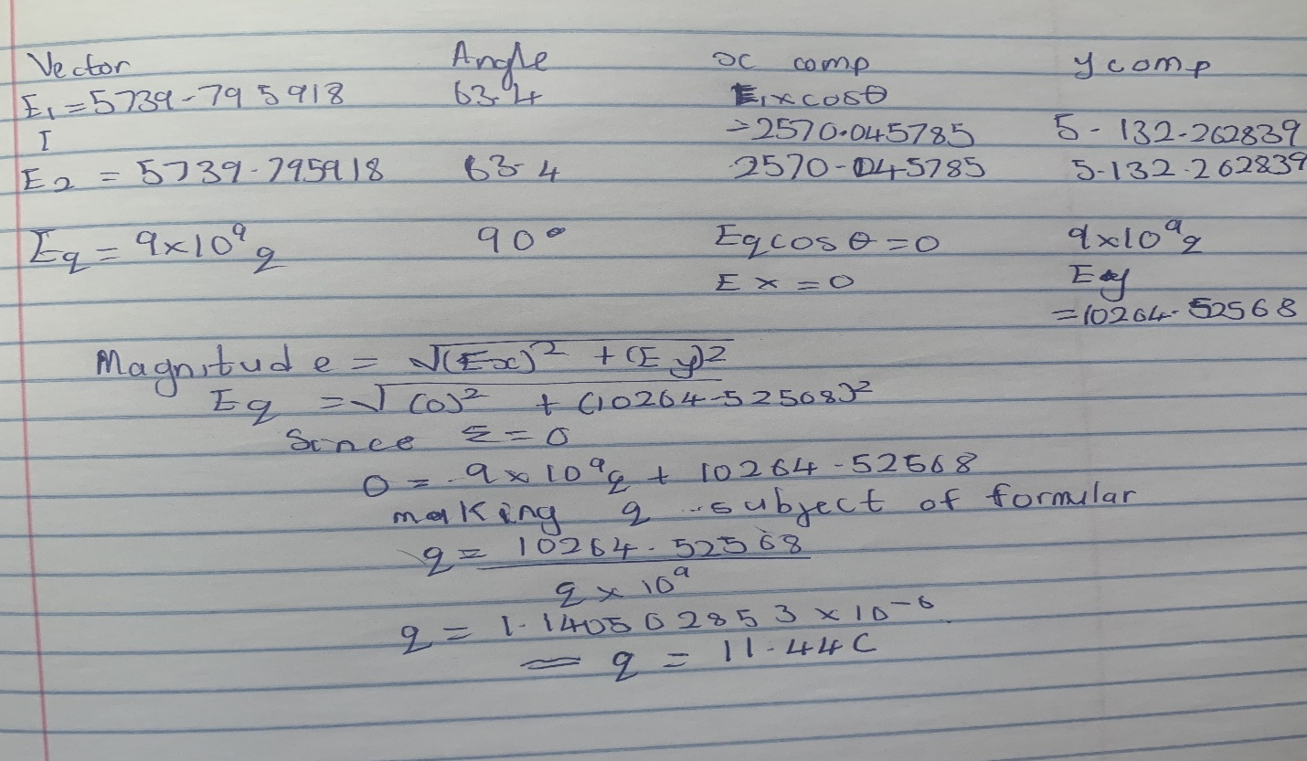
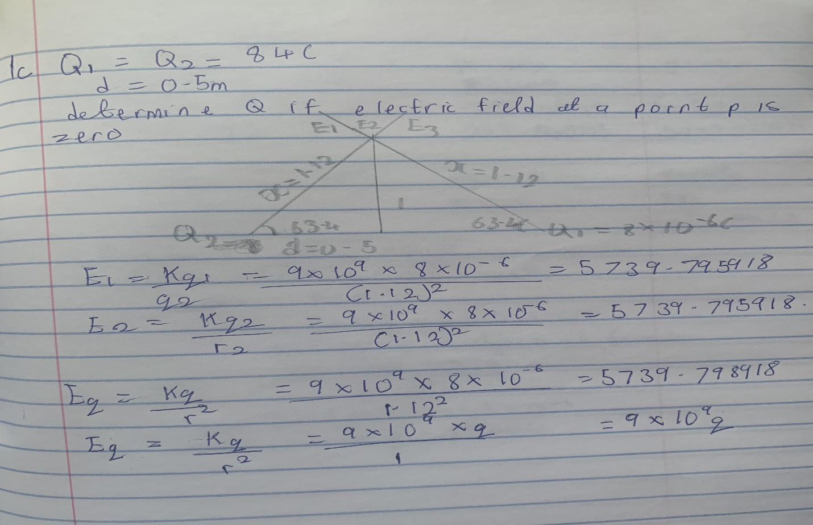

2. (a) Distinguish between the terms: electric field and electric field intensity.
Electric field is the region or space where the effect of electric force on other charges in the field by an electric charge is felt or detected while electric field intensity is the measure of the strength of electrical force per unit charge at any given point in the electric field.
(b) A positive charge q1=8uc is at the origin, and a second positive charge q2=12uc is on the x axis at x=4m Find (i) the net electric field at a point P on the axis at . (ii) the electric field at a point Q on the axis at due to the charges.
Q

q1 q2 P
4 3
E = kq
r²
E1 = kq1 = (9*10⁹)*(8* 10⁻⁴) = 1.5N/C
r²7²
E2 = kq2 =( 9*10⁹)*(12*10⁻⁴) = 12N/C
r² 3²
- Enet = 12 + 1.5 = 13.5N/C
Ө | X component | Y component
90 | 0 | 8
36.87 | -3.46 | 2.59
 | -3.46 | 10.59
- Enet = √(3.46² + 10.59² )
= 11.14N/C

4 (a) What is Magnetic flux?
Magnetic flux is defined as the strength of the magnetic field represented by the line of force. It is represented by the sign Ф.
(b) An electron with a rest mass of 9.11 x 10 -31kg moves in a circular orbit of radius in a uniform magnetic field of 3.5 x 10 -1 Weber/meter square, perpendicular to the speed with which electron moves. Find the cyclotron frequency of the moving electron.
Solution
Angular speed is often referred to as cyclotron frequency
q = 1.6 *10⁻¹⁹C
B = 3.5 * 10⁻⁵ weber/m²
m = 9.11 * 10⁻³¹kg
Therefore ω = qB = (1.6 *10⁻¹⁹)* (3.5 * 10⁻⁵ ) = 6.1471 *10⁶ rad/s
m_{p}9.11 * 10⁻³¹
(c) Discuss your answer in 4b above.
In the question we were given certain parameters for mass of the electron, radius, and magnetic field and we where then asked to find the cyclotron frequency which is equal or the same thing as angular speed. It is called cyclotron frequency because it is a frequency of an accelerator called cyclotron. 6.1471 *10⁶ rad/s is the frequency of the electron moving perpendicular to the electron of uniform magnetic field.

5. (a) State the Biot-Savart Law.
Biot – savart law states that the magnetic intensity is at any point due to a steady current in an infinitely long straight wire is directly proportional to the current and inversely proportional to the distance from the point of the wire.

(b) Using the Biot-Savart Law, show that the magnitude of the magnetic field of a straight current-carrying conductor is given as

