NAME: KOLAPO OLAJUMOKE JANET

DEPARTMENT: PHYSIOLOGY

COURSE CODE: PHY 102

MATRIC NO: 19/MHSO5/001

1a. Explain with the aid of a diagram how you can produce a negatively charged sphere by method of induction.

A positively charged rubber rod brought near a neutral (uncharged) conducting sphere that is insulated so that there is no conducting path to ground as shown below. The repulsive force between the protons in the rod and those in the sphere causes a redistribution of charges on the sphere so that some protons move to the side of the sphere farthest away from the rod. The region of the sphere nearest the positively charged rod has an excess of negative charge because of the migration of protons away from this location. If a grounded conducting wire is then connected to the sphere, some of the protons leave the sphere and travel to the earth. If the wire to ground is then removed, the conducting sphere is left with an excess of induced negative charge.

Then the rubber rod is removed from the vicinity of the sphere, the induced negatively charge remains on the ungrounded sphere and becomes uniformly distributed over the surface of the sphere.

Diagram:

(b) Each of two small spheres is charged positively, the combined charge being 0.00005C. If each sphere is repelled from the other by a force of 1.0N when the spheres are 2.0m apart, calculate the charge on each sphere.

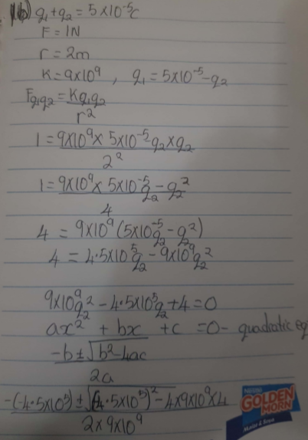

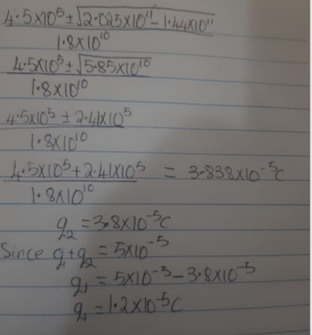

1c. three charges were positioned as shown in the figure below if Q1=Q2=8micro coulomb and d=0.5m, determine q if the electric field at p=0

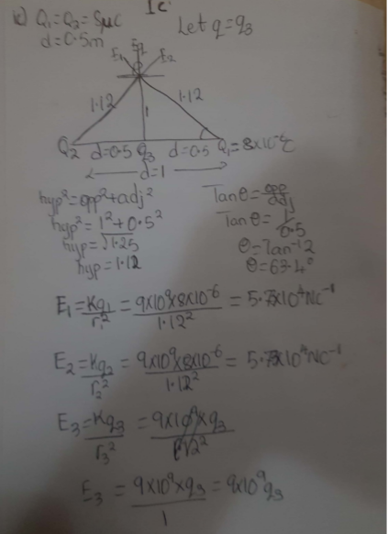

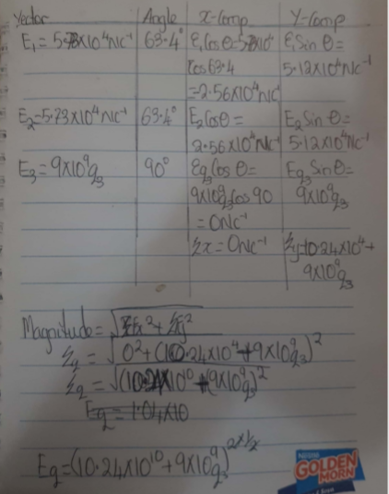

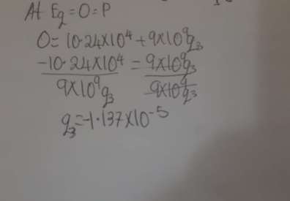

3. (a) State the formulation of the following identities of charges: (i) Volume Charge density (ii) Surface Charge density (iii) Linear Charge density

i. volume charge density: p=dQ/dV $dQ=ρdV$

ii. Surface charge density $→$: $σ=\frac{dQ}{dA}$ $dQ=σdA$

iii. Linear charge density, $λ=\frac{dQ}{dL} →dQ=λdL$

3 (b) Explain with appropriate equations, the electric potential difference

The electric potential difference between two points in an electric field can be defined as the work done per unit charge against electrical forces when a charge is transported from one point to the other. It is measured in Volt $(v)$ or Joules per Coulomb $(J/C)$. Electric potential difference is a scalar quantity.



Consider the diagram above, suppose a test charge $q_{o}$ is moved from point $A$ to point $B$ along an arbitrary path inside an electric field $E$. The electric field $E$ exerts a force $F=q_{o}E$ on the charge as shown in fig 3.1. To move the test charge from $A$ to $B$ at constant velocity, an external force of $F=-q_{o}E$ must act on the charge. Therefore, the elemental work done $dW$ is given as:

$$dW=F.dL … (1)$$

But $$F=-q_{0}E … (2)$$

Substituting equation $(2)$ in $(1)$ yields

$$dW=-q_{0}EdL … (3)$$

Then total work done in moving the test charge from $A$ to $B$ is:

$${W(A→B)}_{Ag}=-q_{0}\int_{A}^{B}{EdL} … (4)$$

From the definition of electric potential difference, it follows that:

$V_{B}-V_{A}=\frac{{W(A→B)}_{Ag}}{q_{0}} … (5)$

Putting equation $(4)$ in $(5)$ yields

$$V_{B}-V_{A}=-\int_{A}^{B}{EdL} … (6)$$

(c) Two point charges Q1 = 10µc and Q2 =2µc are arranged along the x-axis at x = 0 and x=4m respectively. Find the position along the x-axis where v = 0.

4 (a) what is Magnetic flux?

Magnetic flux is a measurement of the total magnetic field which passes through a given area. It is a useful tool for helping describe the effects of the magnetic force on something occupying a given area.

(b) An electron with a rest mass of 9.11 x 10 -31kg moves in a circular orbit of radius in a uniform magnetic field of 3.5 x 10 -1 Weber/meter square, perpendicular to the speed with which electron moves. Find the cyclotron frequency of the moving electron.

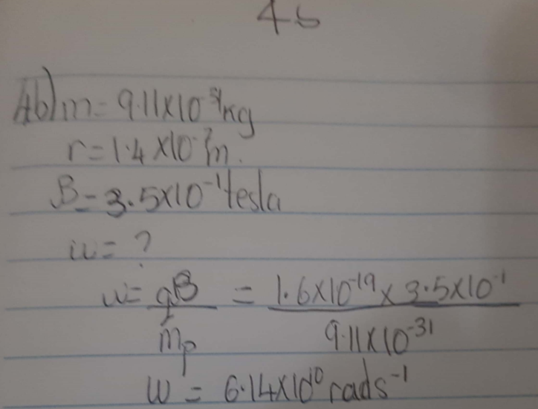

(c) Discuss your answer in 4b above:

The cyclotron frequency also known as angular speed ‘w’ is referred to as cyclotron frequency because the charge particle circulates at the angular frequency or angular speed in the type of accelerator called cyclotron.

Angular speed=w= v/r= Qb/m

Recall that w=Qb/m =

$\frac{qB}{m}=\frac{1.6×{10}^{-19}x3.5x10⌃-1}{9.11x10⌃-31}$**=62222222222.22222rad/s**

5. (a) State the Biot-Savart Law.

Biot-Savart law states how the value of the magnetic field at a specific point in space from one short segment of current-carrying conductor depends on each factor that influences the field. Biot-savart law states that the magnetic field is directly proportional to the product permeability of free space (µ),the current(I),the change in length, the radius and inversely proportional to square of radius (r2).

(b) Using the Biot-Savart Law, show that the magnitude of the magnetic field of a straight current-carrying conductor is given as

$$d\vec{B}= \frac{μ_{o}}{4π}\frac{I d\vec{l}×\hat{r}}{r^{2}}$$

**where $μ_{o}$ is a constant called Permeability of free space.**

$$μ_{o}=4π ×{10}^{-7} T.\frac{m}{A}$$

**The unit of $\vec{B}$ is weber\metre square**

**5b. Magnetic Field of a Straight Current Carrying Conductor**

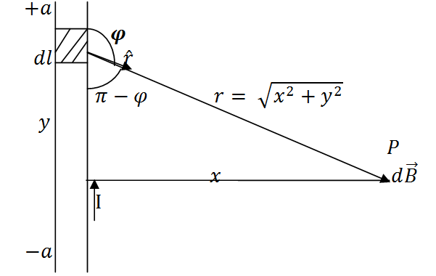

**Fig 1: A section of a Straight Current Carrying Conductor**

**Applying the Biot-Savart law, we find the magnitude of the field $d\vec{B}$**

$$B= \frac{μ_{o}I}{4π}\int_{-a}^{a}{\frac{dl\sin{φ}}{r^{2}}}$$

$$sin\left(π –φ\right)= sinθ$$

$$∴B= \frac{μ_{o}I}{4π}\int_{-a}^{a}{\frac{dlsin(π-φ)}{r^{2}}}$$

**From diagram, $r^{2}=x^{2}+y^{2} (Pythagoras theorem)$**

$$B= \frac{μ_{o}I}{4π}\int_{-a}^{a}{\frac{dlsin(π –φ)}{x^{2 }+ y^{2}}} … (*)$$

$$But sin\left(π-φ\right)= \frac{x}{\sqrt{x^{2 }+ y^{2}}}=\frac{x}{{\left(x^{2 }+ y^{2}\right)}^{1/2}} … (**)$$

**Substituting $(**)$ into $(*)$, we have**

$$B= \frac{μ_{o}I}{4π}\int_{-a}^{a}{dl}\frac{x}{{{(x}^{2}+ y^{2})\left(x^{2 }+y^{2 }\right)}^{1/2}}$$

$$B= \frac{μ_{o}I}{4π}\int_{-a}^{a}{dl}\frac{x}{{\left(x^{2 }+y^{2 }\right)}^{3/2}}$$

**Recall $dl=dy$**

$$B= \frac{μ_{o}I}{4π}\int_{-a}^{a}{\frac{x}{{\left(x^{2 }+y^{2 }\right)}^{3/2}}dy}$$

$$B=\frac{μ_{o}Ix}{4π}\int_{-a}^{a}{\frac{1}{{\left(x^{2 }+y^{2 }\right)}^{3/2}}dy} … (***)$$

**Using special integrals:**

$$\int{\frac{dy}{{{(x}^{2 }+ y^{2})}^{3/2}}}=\frac{1}{x^{2}}\frac{y}{{(x^{2 }+ y^{2})}^{1/2}}$$

**Equation $(***)$ therefore becomes**

$$B= \frac{μ_{o}Ix}{4π}{\left[\frac{y}{x^{2}{\left(x^{2 }+y^{2}\right)}^{1/2}}\right]}_{-a}^{a}$$

$$B=\frac{μ_{o}Ix}{4π}\left(\frac{2a}{x^{2}{\left(x^{2 }+ a^{2}\right)}^{1/2}}\right)$$

$$B=\frac{μ_{o}I}{4πx}\left(\frac{2a}{{\left(x^{2 }+ a^{2}\right)}^{1/2}}\right)$$

**When the length $2a$ of the conductor is very great in comparison to its distance $x$ from point P, we consider it infinitely long. That is, when $a$ is much largerthan $x$,**

$${(x^{2 }+ a^{2})}^{1/2}≅a, as a→∞$$

$$∴B= \frac{μ_{o}I}{2πx}$$

**In a physical situation, we have axial symmetry about the y- axis. Thus, at all points in a circle of radius $r$, around the conductor, the magnitude of B is**

$$B= \frac{μ_{o}I}{2πr} … (\#)$$

**Equation $(\#)$ defines the magnitude of the magnetic field of flux density B near a long, straight current carrying conductor.**