MATRIC NUMBER : 16/MHS01/069
COURSE CODE: NSC406
COURSE TITLE: MATERNAL HEALTH

MANAGEMENT OF THE FIRST STAGE OF LABOUR USING A PARTOGRAM.
The partogram:
It is the graphic recording of the course of labour including the following:
The mother:
>Pulse every 30 minutes,
>Blood pressure every 2 hour,
>Temperature every 4 hours,
>Uterine contractions: frequency, strength and duration every 30 minutes by manual palpation or better by tocography if available.
>Cervical dilation
>Fluid input and output
>Drugs including oxytocins

NB: The first oblique line on the partogram is called, The alert line. It represents a rate of cervical dilatation of 1 cm per hour.
The second oblique line is called, the action line. The progress of labour is very slow when the graph of cervical dilatation crosses or falls on this line. When this occurs, action must be taken in order to hasten the delivery of the infant

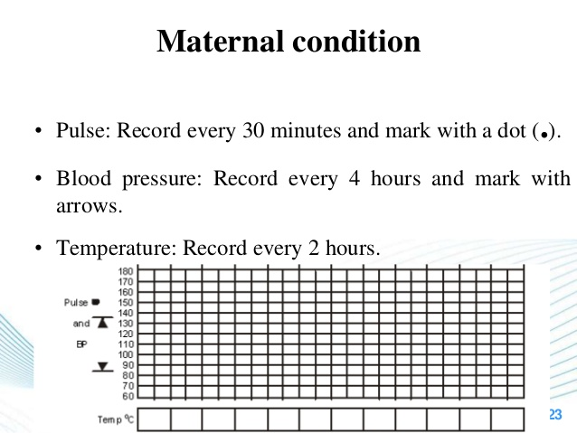

The foetus:
>FHR every 15 minutes by Pinard’s stethoscope or better by doptone.
>Descent of the presenting part,
>Degree of moulding
>Cardiotocography if available, is more valuable for continuous monitoring of both uterine contraction and FHR particularly in high risk pregnancy.
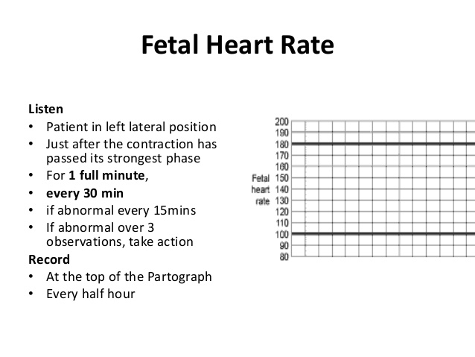

The advantages of partogram
>Allows right intervention in the proper time e.g. oxytocin usage, instrumental delivery or C.S. allows different staff shifts to manage the case successively.
>A document for labour events.

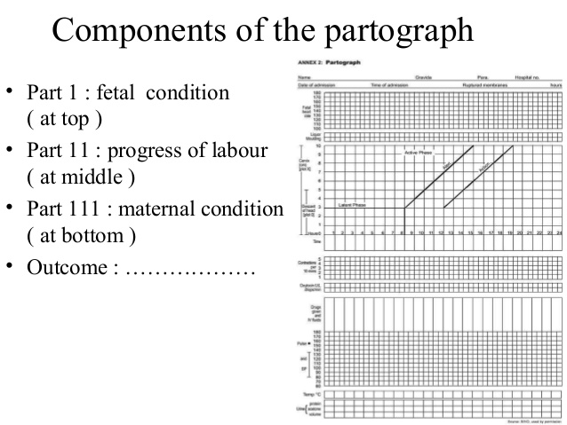

MANAGEMENT OF THE SECONG STAGE OF LABOUR:
Delivery room:
- The patient Is transferred on a wheel or trolley to the delivery room.
- Put her in the lithotomy position
- The lower abdomen, upper parts of the thighs, vulva and perineum are swabbed with antiseptic lotion.
- Sterile legs and towels are applied.
Bearing down:
-Ask patient to bear down during contraction and relax in between.
Delivery of the head:
-The main aim during delivery of the head is to prevent perineal lacerations through the following instructions :
Support the perineum:
When the labia start to separate by the head and a sterile pad is placed over the perineum and press on it with the right hand during uterine contractions. This is continued until crowning occurs to maintain flexion of the head.
Crowning:
- Is the permanent distension of the vulval ring by the foetal head like a crown on the head. The head does not recede back in between uterine contractions.
- This means that the biparietal diameter is just passed the vulval ring and the occipital prominence escapes under the symphysis pubis.
- After crowing, allow slow extension of the head so the vulva is distended by the suboccipito- frontal diameter 10cm.
- If the head is allowed to extend before crowing the vulva will be distended by the occipito-frontal 11,3cm increasing the incidence of perineal laceration.
- Ritgen manoeuvre: upward pressure on the perineum by the right hand and downward pressure on the occiput by the left hand to control the extension of the head.
Episiotomy: it is done at crowing when the perineum is stretched to the degree that it is about to tear.
Swab and aspirate: the mouth and nose once the head is delivered before respiration is initiated and the liquor, meconium or blood is inhaled.
Coils of the umbilical cord : if present around the neck are slipped over the head but if tight or multiple they cut between 2 clamps.
Delivery of the shoulder:
>Gentle downward traction is applied to the head till the anterior shoulder slips under the symphysis pubis. The head is lifted upwards to deliver the anterior shoulder.
Delivery of the remainder of the body:
>Usually slips without difficulty otherwise gentle traction is applied to complete delivery.
Clamping of the cord
The baby is held by its ankle with the head downwards at a lower level than its mother for few seconds. This is contraindicated in:
>Preterm babies
>Erythroblastosis foetalis
>Suspicion of the intracranial hemorrhage

Clamping the cord
This may be enhanced by milking the cord towards the baby, to add about 100ml of blood to its circulation.
The cord is divided between 2 clamps to avoid bleeding from a possible 2nd uniovular twin.

MANAGEMENT OF THIRD STAGE OF LABOUR
Delivery of the placenta
Conservative method.
- Put the ulnar border of the left hand just above the fundus at the level of the umbilicus to detect any bleeding inside the uterus known by rising level of the atonic uterus.
- Wait for signs of placental separation descent but do not massage the uterus
- As soon as they are detected massage the uterus to induce its contraction, ask the patient to bear downwards to deliver the placenta.
- Hold the placenta between the two hands and roll it to make the membranes like a rope in order not to miss a part of it.
- Give ergometrine 0.5mg or oxytocin 5 units IM after delivery of the placenta to help uterine contraction and minimize blood loss. These may be given before delivery of the placenta.

Signs of placental separation and descent:
- The body of the uterus becomes smaller, harder and globular.
- The fundal level rises as the upper segment overrides the lower uterine segment.
- Suprapubic bulge due ti prescence of the placenta in the lower uterine segment.
The active method (Brandt-Andrews method)
- With the delivery of the anterior shoulder,0.5mg ergometrine or syntometrine(0.5 mg ergometrine + 5 units oxytocin ) is given IM.
- When the uterus contracts, put the left hand suprapubic and push the uterus upwards while gentle downward and backward traction is applied on the cord by the right hand when the placenta is delivered it is rolled as in the conservation method.
- Advantage: reduction of the blood loss.
- Disadvantages:
>Constriction ring may occur with retention of the placenta.
>Avulsion of the cord if undue pressure is applied.
>Inversion of the uterus if fundus is pressed while the uterus is lax.

Routine examinations:
- Examination of the placenta and membranes:
>By exploring it on a plain surface to be sure that it is complete. If there us missed parts, exploration of the uterus is done under general anaesthesia.
>Explore the genital tract for any lacerations that should be immediately repaired.

