NAME: KALU RICHARD IHEANYICHUKWU

MATRIC NUMBER: 19/SCI01/057

DEPARTMENT: COMPUTER SCIENCE

COVID-19 HOLIDAY ASSIGNMENT

**SECTION A**

2a.

ELETRIC FIELD

An electric field is a region of space in which an electric charge will experience an electric force.

WHILE

ELECTRIC FIELD INTENSITY Electric field intensity is also known as electric field strength which can be defined as the force per unit charge. Which is measured in Newton per coulomb (N/C). 2b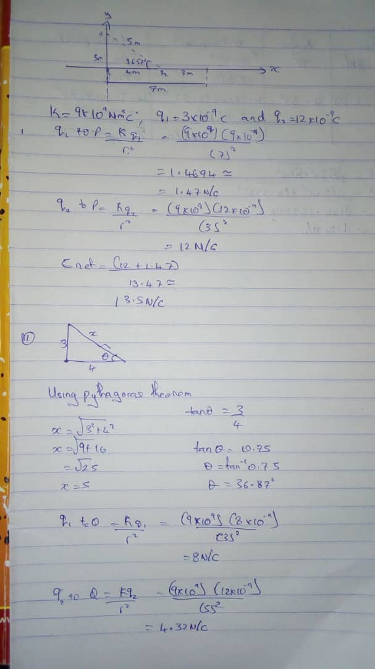

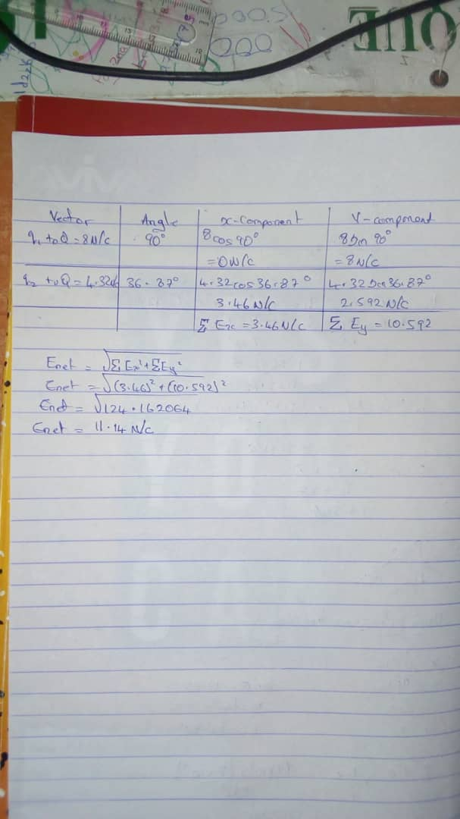

3a.

1. **Volume charge density, $ρ=\frac{dQ}{dV} →dQ=ρdV$**
2. **Surface charge density, $σ=\frac{dQ}{dA} →dQ=σdA$**
3. **Linear charge density, $λ=\frac{dQ}{dL} →dQ=λdL$**

**3b. ELECTRIC POTENTIAL DIFFERENCE**

**The electric potential difference between two points in an electric field can be defined as the work done per unit charge against electrical forces when a charge is transported from one point to the other. It is measured in Volt $(v)$ or Joules per Coulomb $(J/C)$. Electric potential difference is a scalar quantity.**



**Consider the diagram above, suppose a test charge $q_{o}$ is moved from point $A$ to point $B$ along an arbitrary path inside an electric field $E$. The electric field $E$ exerts a force $F=q_{o}E$ on the charge as shown in fig 3.1. To move the test charge from $A$ to $B$ at constant velocity, an external force of $F=-q_{o}E$ must act on the charge. Therefore, the elemental work done $dW$ is given as:**

$$dW=F.dL … (1)$$

**But $$F=-q_{0}E … (2)$$**

**Substituting equation $(2)$ in $(1)$ yields**

$$dW=-q_{0}EdL … (3)$$

**Then total work done in moving the test charge from $A$ to $B$ is:**

$${W(A→B)}_{Ag}=-q_{0}\int_{A}^{B}{EdL} … (4)$$

**From the definition of electric potential difference, it follows that:**

$V_{B}-V_{A}=\frac{{W(A→B)}_{Ag}}{q_{0}} … (5)$**Putting equation $(4)$ in $(5)$ yields**

$$V_{B}-V_{A}=-\int_{A}^{B}{EdL} … (6)$$

**SECTION B**

4a.

MAGNETIC FLUX

The magnetic flux is defined as the strength of magnetic field represented by lines of force. It is what generates the field around a magnetic material. It consist of photons, however, unlike the light we receive from the sun, it is at a much lower frequency, which makes it not visible to the naked eye. It can be denoted with Φ or ΦB.

The SI unit of magnetic flux is the weber (Wb).

Φ = 𝐵⃗.𝑑𝐴⃗ … (1)

Where 𝑑𝐴⃗ is a vector that is perpendicular to the surface and has a magnitude equal to the area 𝑑𝐴. Hence, the total magnetic flux ɸ through the surface is

Φ = ∫𝐵⃗.𝑑𝐴⃗ … (2)

Equation (2) defines the magnetic flux through a plane lying in a magnetic field for which an arbitrary shaped surface is considered.

Equation (2) is a special case, suppose that the loop lies is an arbitrary shaped surface and that the magnetic field 𝐵⃗ makes an angle 𝜃 with area element 𝑑𝐴 perpendicular to the place. Therefore, the dot product in equation (2) becomes:

ΦB = ∫𝐵⃗.𝑑𝐴⃗= 𝐵𝐴 cos 𝜃 … (3)

4b.

ω==-1.6×10-10×3.5×10-10

9.11×10-31

ω==-6.147×1010rad/s

4c.

In the question we were given:

i.mass of the electron =9.11x10-31 kg

ii.A radius of 1.4x10-7m

iii.magnetic field of 3.5x10-1 weber\meter2

We are to find the cyclotron frequency which is the same as angular speed. It is called cyclotron frequency because it is a frequency of an accelerator called cyclotron.

Recall, angular speed is given as **ω==**

ω==-1.6×10-10×3.5×10-10

9.11×10-31

ω==-6.147×1010rad/s

Note: Angular speed is the same as cyclotron frequency.

∴ Cyclotron frequency =-6.147×1010rad/s.

5a.

BIOT-SAVART LAW

Biot-savart law states that the magnetic field is directly proportional to the product permeability of free space (µ), the current (I), the magnitude of the length element ($d\vec{l}$) the unit vector ($\hat{r}$) and inversely proportional to r2, where r is the distance from $d\vec{l}$ to P. It can be mathematically represented by

$$d\vec{B}= \frac{μ_{o}}{4π}\frac{I d\vec{l}×\hat{r}}{r^{2}}$$

Where $μ_{o}$ a constant is called Permeability of free space.

$$μ_{o}=4π ×{10}^{-7} T.\frac{m}{A}$$

5b.

Magnetic Field of a Straight Current Carrying Conductor

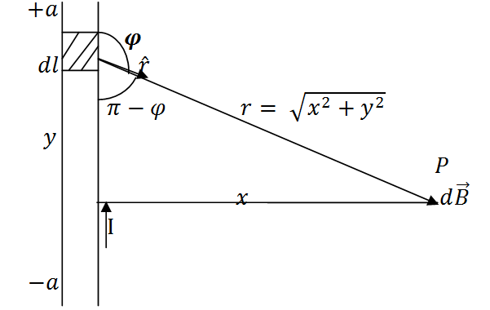

**Applying the Biot-Savart law, we find the magnitude of the field $d\vec{B}$**

$$B= \frac{μ_{o}I}{4π}\int_{-a}^{a}{\frac{dl\sin{φ}}{r^{2}}}$$

$$sin\left(π –φ\right)= sinθ$$

$$∴B= \frac{μ_{o}I}{4π}\int_{-a}^{a}{\frac{dlsin(π-φ)}{r^{2}}}$$

**From diagram, $r^{2}=x^{2}+y^{2} (Pythagoras theorem)$**

$$B= \frac{μ_{o}I}{4π}\int_{-a}^{a}{\frac{dlsin(π –φ)}{x^{2 }+ y^{2}}} … (*)$$

$$But sin\left(π-φ\right)= \frac{x}{\sqrt{x^{2 }+ y^{2}}}=\frac{x}{{\left(x^{2 }+ y^{2}\right)}^{1/2}} … (**)$$

**Substituting $(**)$ into $(*)$, we have**

$$B= \frac{μ_{o}I}{4π}\int_{-a}^{a}{dl}\frac{x}{{{(x}^{2}+ y^{2})\left(x^{2 }+y^{2 }\right)}^{1/2}}$$

$$B= \frac{μ_{o}I}{4π}\int_{-a}^{a}{dl}\frac{x}{{\left(x^{2 }+y^{2 }\right)}^{3/2}}$$

**Recall $dl=dy$**

$$B= \frac{μ_{o}I}{4π}\int_{-a}^{a}{\frac{x}{{\left(x^{2 }+y^{2 }\right)}^{3/2}}dy}$$

$$B=\frac{μ_{o}Ix}{4π}\int_{-a}^{a}{\frac{1}{{\left(x^{2 }+y^{2 }\right)}^{3/2}}dy} … (***)$$

**Using special integrals:**

$$\int{\frac{dy}{{{(x}^{2 }+ y^{2})}^{3/2}}}=\frac{1}{x^{2}}\frac{y}{{(x^{2 }+ y^{2})}^{1/2}}$$

$$\left(\frac{2a}{{\left(x^{2 }+ a^{2}\right)}^{1/2}}\right)$$

**When the length $2a$ of the conductor is very great in comparison to its distance $x$ from point P, we consider it infinitely long. That is, when $a$ is much larger than $x$,**

$${(x^{2 }+ a^{2})}^{1/2}≅a, as a→∞$$

$$∴B= \frac{μ_{o}I}{2πx}$$

**In a physical situation, we have axial symmetry about the y- axis. Thus, at all points in a circle of radius $r$, around the conductor, the magnitude of B is**

$$B= \frac{μ_{o}I}{2πr} … (\#)$$

**Equation $(\#)$ defines the magnitude of the magnetic field of flux density B near a long, straight current carrying conductor.**