NAME: Obinatu Victoria
MATRIC NO: 16/MHS01/159
COURSE CODE: 404
COURSE TITLE: MATERNAL HEALTH AND NORMAL MIDWIFERY 11
ASSIGNMENT TITLE:
- Use of partograph in the management of the first stage of labour
- Management of 2nd and 3rd stages of labour
ANSWER

The partograph is a tool for monitoring maternal and foetal wellbeing during the active phase of labour, and a decision-making aid when abnormalities are detected. It is designed to be used at any level of care.
Its central feature is a graph used to record the progress of cervical dilation, as determined by vaginal examination.
Start the graph at 5 cm of dilation, and 3 contractions every 10 minutes. In certain situations, e.g. induction of labour, it is started at 4 cm of dilation.

Indicators are plotted on the graph each time they are checked:
– Maternal indicators:
• Vital signs (heart rate, blood pressure and temperature)
• Time of spontaneous or artificial rupture of the membranes
• Uterine contractions (number per 10 minutes and duration)
• Urine output
• Drugs administered (oxytocin, antibiotics, etc.)
– Foetal indicators:
• Foetal heart rate
• Amniotic fluid (colour, odour and quantity)
• Descent of the foetal head and head moulding
Interpreting the WHO partograph
The WHO partograph has two diagonal lines: an alert line and an action line.
The alert line goes from 4 to 10 cm and corresponds to an average dilation rate of 1 cm per hour. If the labour curve crosses to the right of this alert line, this means that the dilation is less than 1 cm per hour. In this case, transfer to a CEmONC facility must be considered if the woman is at an outpatient clinic or a BEmONC facility. If the woman is at a CEmONC facility, closer monitoring is required.
The action line is located 4 hours to the right of the alert line. If the dilatation curve crosses this line, decisions must be made (augmentation of labour, artificial rupture of membranes, caesarean section, etc.).

Indicators are plotted on the graph each time they are checked:
– Maternal indicators:
• Vital signs (heart rate, blood pressure and temperature)
• Time of spontaneous or artificial rupture of the membranes
• Uterine contractions (number per 10 minutes and duration)
• Urine output
• Drugs administered (oxytocin, antibiotics, etc.)
– Foetal indicators:
• Foetal heart rate
• Amniotic fluid (colour, odour and quantity)
• Descent of the foetal head and head moulding

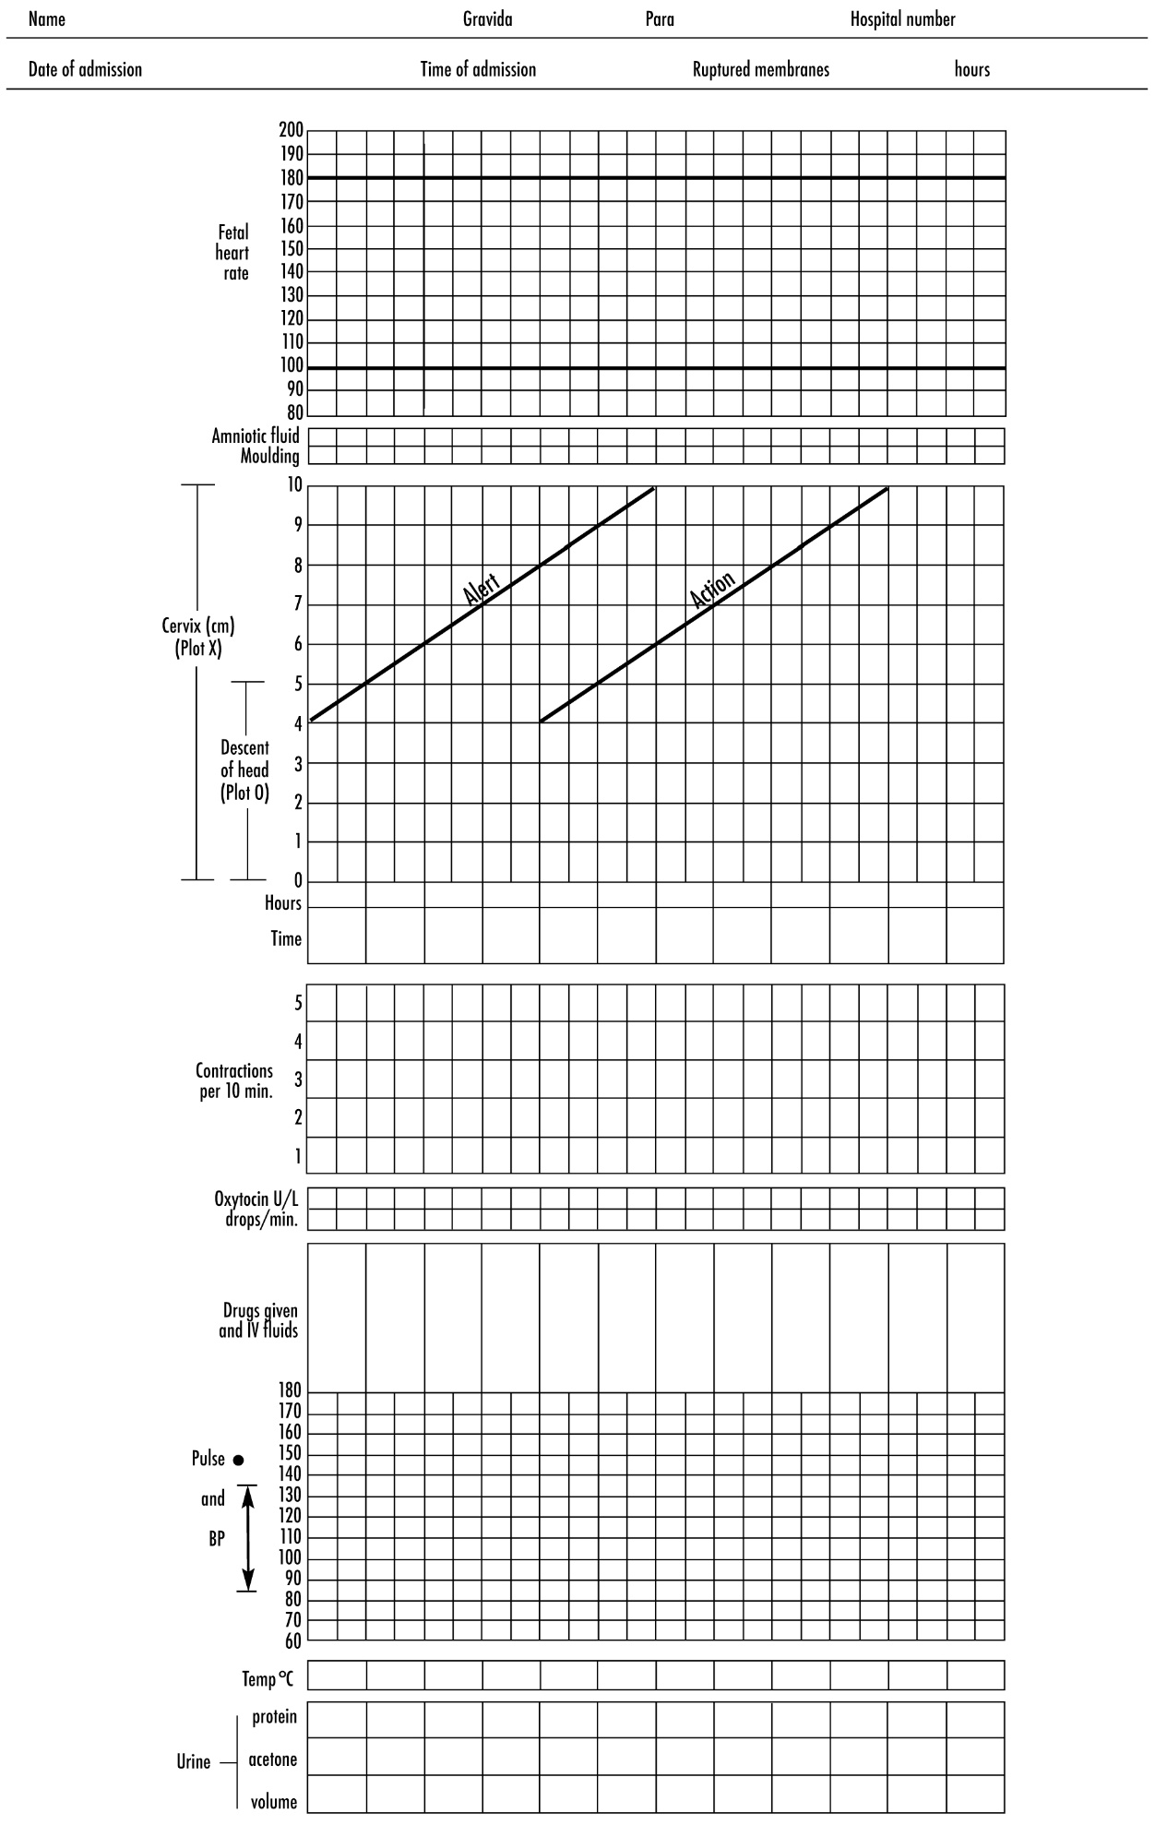

- The alert line. It represents a rate of cervical dilatation of 1 cm per hour. The alert line represents the minimum progress in cervical dilatation which is acceptable during the active phase of the first stage of labour

- Action line: Any patient whose graph of the cervical dilatation falls on or crosses the action line must have a complete examination by the doctor. Her further management must be under the doctor’s supervision and direction. If a patient is not already in hospital, she will need to be transferred into a hospital where there are facilities for instrumental delivery and Caesarean section. The progress of labour is very slow when the graph of cervical dilatation crosses or falls on this line. When this occurs, action must be taken in order to hasten the delivery of the infant.

. Recording the blood pressure, pulse and temperature
The maternal blood pressure, pulse and temperature should be recorded on the partogram.

B. Recording the urinary data
- Volume is recorded in ml.
- Protein is recorded as 0 to 4+.
- Ketones are recorded as 0 to 4+ (see figure 8C-2).

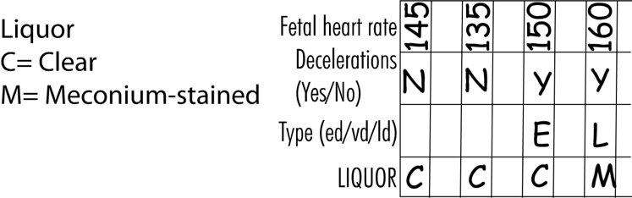
Recording the fetal heart rate pattern
The following two observations must be recorded on the partogram:
- The baseline heart rate.
- The presence or absence of decelerations. If decelerations are present, you must record whether they are early or late decelerations

Recording the liquor findings
Three symbols are used:
I = Intact membranes.
C = Clear liquor draining.
M = Meconium-stained liquor draining

Recording the cervical dilatation
Cervical dilatation is measured in cm and then recorded by marking an ‘X’ on the partogram.

G. Recording the length of the cervix (effacement)
The length of the cervix is recorded by drawing a thick, vertical line on the same part of the chart that is used for the cervical dilatation. The length of the line drawn indicates the length of the endocervical canal in cm. It is drawn on the chart whenever the cervical dilatation is recorded. Alternatively, the length of the endocervical canal, measured in cm or mm, can be noted in the space provided.

H. Recording the amount of the head palpable above the brim of the pelvis (descent and engagement)
The findings are recorded by marking an ‘O’ on the partogram

