MATRIC NUMBER: 16/MHS02/009
NAME : AKANMODE TEMILOLUWA
COURSE CODE: NSC 404
LEVEL: 400 LEVEL
NORMAL MIDWIFERY II
ASSIGNMENT
READING ASSIGNMENT
- USE OF PARTOGRAPH IN MANAGEMENT OF FIRST STAGE OF LABOUR
- MANAGEMENT OF 2ND AND 3RD STAGE OF LABOUR
ANSWER
USE OF PARTOGRAPH IN MANAGEMENT OF FIRST STAGE OF LABOUR
DEFINITION: Partograph is a basic tool or chart where all labor observations are recorded in a clear way and these observations are interpreted to detect abnormality at a glance. Partograph can also be defined as a tool for assessing the progress of labor that offers normal progress or an early warning for complications such as fetal distress, prolonged or obstructed labor.
Partographs may not be used in all conditions. Women who are not eligible for partograph include:
Cervical dilatation of 9-10cm
Emergency caesarian section
Elective caesarian section
Gestational age less than 30 weeks
Ante-partum haemorrhage
Severe pregnancy included hypertension(PIH), eg, severe pre-eclampsia
Confirmed cephalo-pelvic disproportion

CHARTING ON A PARTOGRAPH
- Patient’s information: full name, gravida, parity, hospital number, date and time of admission, are written at the top of the graph.
- Time is recorded using the time of admission as zero-time. The actual time of the day is recorded below the hour line
- The maternal condition: temperature and respiration are recorded on the time line at which the observations are made at the bottom of the partograph ( every 4 hours)
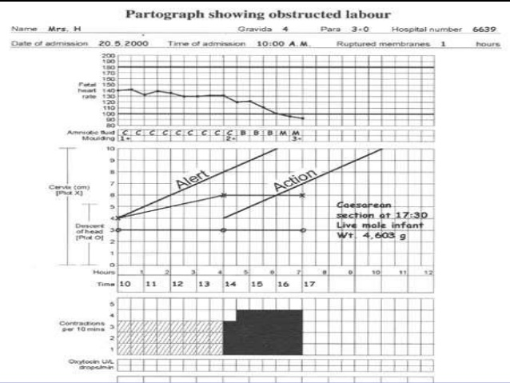

MANAGEMENT OF 2ND STAGE OF LABOR
- Hourly check of vital signs; temperature, blood pressure and pulse( palpate simultaneously with FHR)
- Abdominal palpation for presentation and position of the baby
- Ensure bladder is emptied 4hrly
- Urinalysis must be done
- Assessment of progress should include maternal behavior , effectiveness of pushing and fetal well being
- Document effectiveness of pushing
- Assess patient’s pain, discussing her preferred coping strategies and supporting her wishes
- Discourage woman from lying supine or semi-supine in second stage of labor
- Inform the woman that in the second stage she should be guided by her own urge to push
- Follow the general principles for transfer of care described in the guideline entitled “Transfer of mothers and babies to different care settings”

MANAGEMENT OF 3RD STAGE OF LABOR
- After administering the oxytocin, clamp and cut the cord
- Do not clamp the cord earlier than 1 minute from birth of the baby
- Clamp the cord before 5 minutes in order to perform controlled cord traction as part of active management
- After cutting the cord, use controlled cord traction
- Record the timing the cord clamping in both active and physiological management
- Do not use either umbilical oxytocin infusion or prostaglandin routinely in the third stage of labor. If retained placenta is diagnosed
- Observations in the third stage of labor should include: Estimating the amount of vaginal blood loss; Assessing the general condition of the mother e.g., her respirations, color and her own report of how she feels; Where hemorrhage, retained placenta or maternal collapse is diagnosed
- Documentation

