NAME: LESSO KENAN ENARI
MATRIC NUMBER: 18/SMS03/020
DEPARTMENT: BUSINESS ADMINISTRATION
COURSE CODE: BUS 208
COURSE TITLE: CONSUMER BEHAVIOUR
ASSIGNMENT
Question:
In not less than 2000 words, Explain explicitly how the Pandemic (COVID 19) has affected consumer buying behaviour.

What is Consumer behaviour?
Consumer behaviour is the study of individuals, groups, or organizations and all the activities associated with the purchase, use and disposal of goods and services, including the consumer's emotional, mental and behavioural responses that precede or follow these activities. It examines how emotions, attitudes and preferences affect buying behaviour. Characteristics of individual consumers such as demographics, personality lifestyles and behavioural variables such as usage rates, usage occasion, loyalty, brand advocacy, willingness to provide referrals, in an attempt to understand people's wants and consumption are all investigated in formal studies of consumer behaviour.
What is COVID-19?
Coronavirus disease (COVID-19) is an infectious disease caused by a newly discovered coronavirus. Most people who fall sick with COVID-19 will experience mild to moderate symptoms and recover without special treatment.
How the Virus affects consumer buying behaviour.
The challenges facing the world right now are shaking up global economies, pushing healthcare systems to their limits, and upheaving people’s daily lives.
Currently, more than one-third of the world’s population is under some form of lockdown. To put it simply: there isn’t a business, government, or person that hasn’t felt the effects of coronavirus, even to some degree.
One very noticeable impact of the outbreak is its influence on how and what people purchase. This is having a knock-on effect on various industries and key groups.
Different Researches on the effect of COVID-19 on Consumer Behaviour
Research by Global Web Index
A latest COVID-19 research by global web index, conducted between 16th-20th March among 12,845 internet users across 13 markets, shows how consumer behaviors are changing amid the crisis and what this means for brands:
Travel purchases are taking the brunt.
More expensive purchases, and those that involve travel, are the most likely to be delayed while the outbreak is still ongoing.
For example, 41% of global consumers have delayed purchasing vacations and holidays.
This rises to 53% in China, a country that has been in lockdown for over 6 weeks and is only starting to re-emerge on the other side.
Among travel enthusiasts (those who express an interest in travel), around half say they are delaying purchasing a vacation and close to 1 in 3 are delaying purchasing a flight.
On the other hand, only 9% of Japanese internet users say they’re delaying purchasing flights and just 14% say they’re delaying booking a vacation or holiday – the lowest of all countries they’ve tracked.
Additionally, 61% of consumers in Japan selected “none of these” as an option, suggesting that they’re not delaying purchases on the same scale as other countries.

Luxury is taking a backseat – especially in China.
The luxury market is also taking a hit, with 15% of consumers delaying purchases of luxury items.
Among an audience of affluent, luxury buyers in China, around 2 in 5 say they’re delaying purchases of luxury items.
For brands operating in China, this presents a serious blow as this country currently dominates the luxury purchases market and in fact, is expected to account for 41% share of the global luxury market by 2025. On Singles Day last year, Alibaba saw revenues of $38.4 billion.
In addition, the global research found that 65% of Chinese consumers say they try to buy the premium version of a product, compared to 55% of global internet users. This underlines the challenges facing brands in the luxury sector that rely heavily on Chinese consumers.
Age is also a strong influencer for delaying purchases. We found that Gen Z is most likely to be delaying purchases in several categories, no doubt in part to their lower average income levels.
Notably, over 20% of Gen Z says they’re delaying buying technology devices such as smartphones. This is important because Gen Zs are the biggest users of mobiles, spending an average of 4 hours and 9 minutes globally per day on their smartphone.
Purchases could be delayed for quite some time.
It’s clear that purchasing habits could take a long time to return to normal.
Over 40% of consumers say they will buy major purchases only when the outbreak decreases or ends in their country.
But close to 20% say they will wait until the outbreak decreases or is over globally.
Chinese consumers are most likely to say they’ll resume purchasing when the outbreak decreases or ends on a national level (52%). In comparison, Singaporean consumers would prefer to wait until this happens globally (35%).
Younger generations are also more inclined to wait until the outbreak improves on a national level. Similarly, the top income groups are most open to making their purchases once the national situation begins to improve.
All categories risk being affected significantly until the crisis is over. Looking at the breakdown, around half of consumers who are delaying purchases of flights and technology devices say they will buy these only when the outbreak is over in their country or globally.
And 53% of those who are delaying purchases of vacations or tickets to sporting events say the same – increasing to 56% among sports fans.
Consumers aren’t just delaying purchases either; when it comes to travel, many are abandoning their plans entirely.
Consumers are struggling to buy essentials.
Many of us are now familiar with the sight of empty supermarket shelves, devoid of the essentials we usually buy. Fear has undoubtedly taken over consumer’s usual shopping behaviors. Pasta, toilet rolls, hand sanitizer, and other long-life foods are just some of the products that consumers have been loading up on in recent weeks.
45% of consumers globally say they’ve purchased extra food and drink supplies.
While 43% say they have purchased extra household supplies such as toilet rolls, tissues, and cleaning supplies.
According to Helen Dickinson, Head of the British Retail Consortium, “There’s £1bn more food in people’s houses than there was three weeks ago”. Retailers are facing the level of demand that’s typically seen around Christmas time, which unlike now, is expected and they have time to plan for.
Many retailers say they have enough food supplies, but they’re struggling to get items into stores as fast as consumers are purchasing them.
This has left many supermarkets in the UK, such as Tesco and Waitrose, with no option but to limit the amount of items a person can purchase. And the UK government is urging consumers to shop responsibly and to be considerate of others.
Many UK retailers have also implemented dedicated shopping hours for elderly, vulnerable groups, and NHS medical staff to allow them to get the items they need.

We’re certainly seeing the impact of this excessive behavior across markets.
Their data shows that Australians are struggling the most to buy fundamental household and food items.
Two-thirds of Australian consumers say they’re struggling to buy essential household items like toilet rolls, compared to just 8% in China and 7% in Italy.
Also, just over a third of Australians are also having a difficult time purchasing food and drink items (globally just 11% say the same). This is partly because of supply issues from countries Australia relies on for trade, such as China.
There also seems to be an information gap in South Africa. For example, 29% of South Africans have the biggest issue with getting up-to-date information about the situation in their local area and 22% struggle to get up-to-date information about the situation in their country.
This highlights just how important accurate, timely, and trustworthy news is at this time.
PPE and medical supplies are in high demand.
Face masks (45%) and hand sanitizer gel (30%) are the top items globally that consumers are struggling to purchase.
By country, Japan sees the highest struggle to buy face masks at 78%, while the Philippines struggles the most to purchase hand sanitizer gel at 70%. This is a common occurrence across most countries.
Google searches for hand sanitizer have skyrocketed, while many pharmacies and stores have sold out. With the increased demand, some sellers like Amazon and Walmart sellers have been criticized for price gouging.

Research by Criteo
The widespread outbreak of coronavirus, which causes the disease COVID-19, is now a global pandemic. At Criteo, they’ve been analyzing data from past several weeks to understand how retail and consumer spending is affected as the virus spreads. According to Criteo, data includes insights drawn from across 80+ countries and two billion active monthly shoppers spending around $900 billion annually across approximately 20,000 ecommerce sites. From that massive data set, they were able to see trends happening globally as well as across regions—Asia-Pacific, Europe, and the Americas.
Amid all the uncertainty and calls for social distancing, some industries are be affected more than others. Restaurants and bars are particularly vulnerable, as well as event spaces and retail stores. At the same time, consumers are shifting their spending habits and some companies and product categories are actually growing.
While circumstances continue to evolve each day, according to the Criteo research, more than half (52%) of Americans say they will shop online more in the next two weeks as a result of COVID-19, and 51% say they’ll buy more groceries online.
Here’s what their data is showing right now:
1. Grocery sales are going up.
In the US online purchases of shelf-stable grocery items have grown substantially in the last few days, including Rice (+432%), Flour (+423%), Canned & Jarred Vegetables (+337%), Canned & Prepared Beans (+433%), and Canned & Dry Milk (+378%) compared to the first four weeks of January.
And it makes sense: These items are made for tough times when people may need to hunker down. They have a long shelf life, are versatile, and are frequently offered in large formats, making it easy to stock up on ingredients that last.
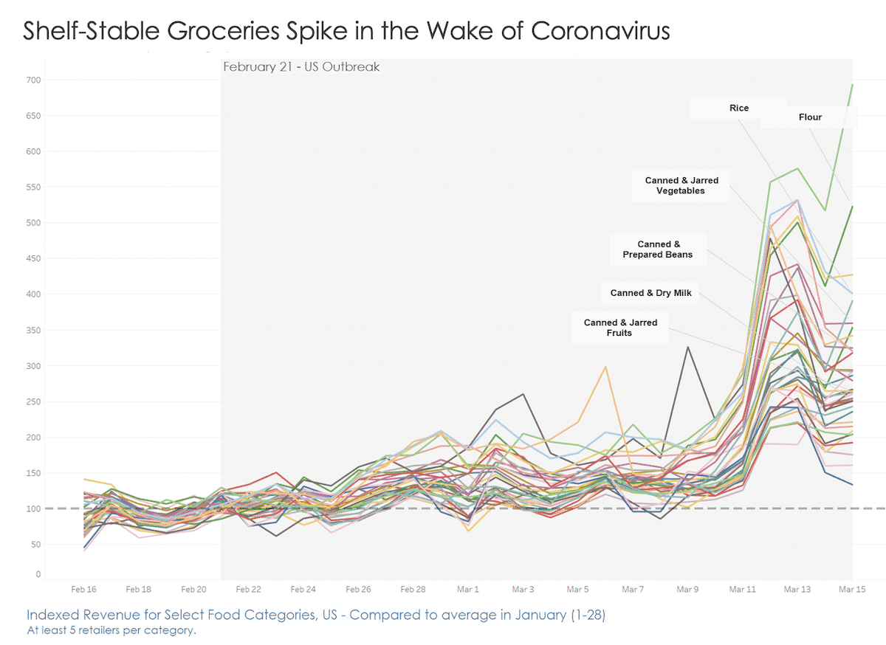
Sales of facemasks and household cleaning supplies, which can be used to reduce the chance of contracting or spreading the virus, also shot up in early March compared to the first week in January—before running out of stock.
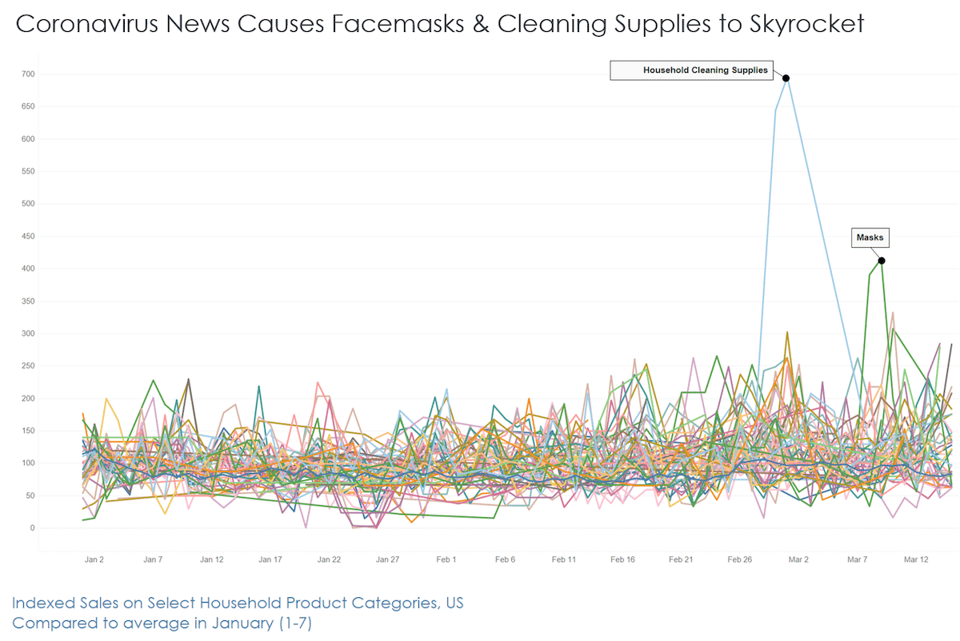
2. In Southern Europe, sales of medical supplies are soaring.
In Italy, people prepared to take good care of themselves at home after a partial lockdown on February 25th. Sales of medical supplies spiked by +286% in early March.
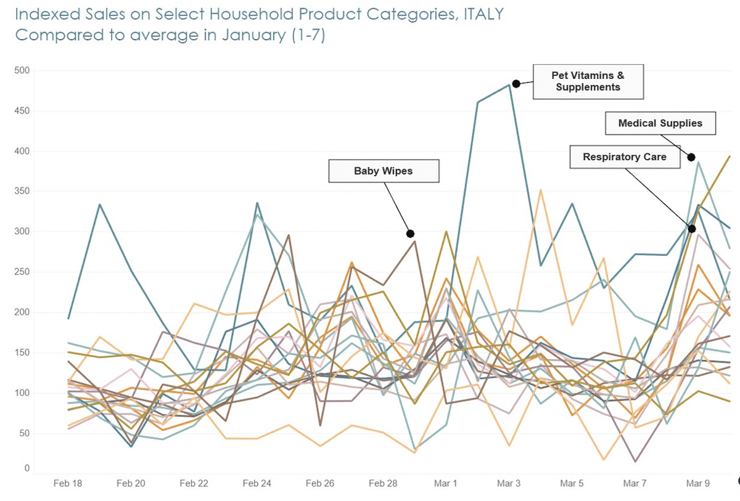
France, which has enacted a country-wide quarantine, saw sales of medical supplies outpace even food products in early March, rising by nearly +600%.
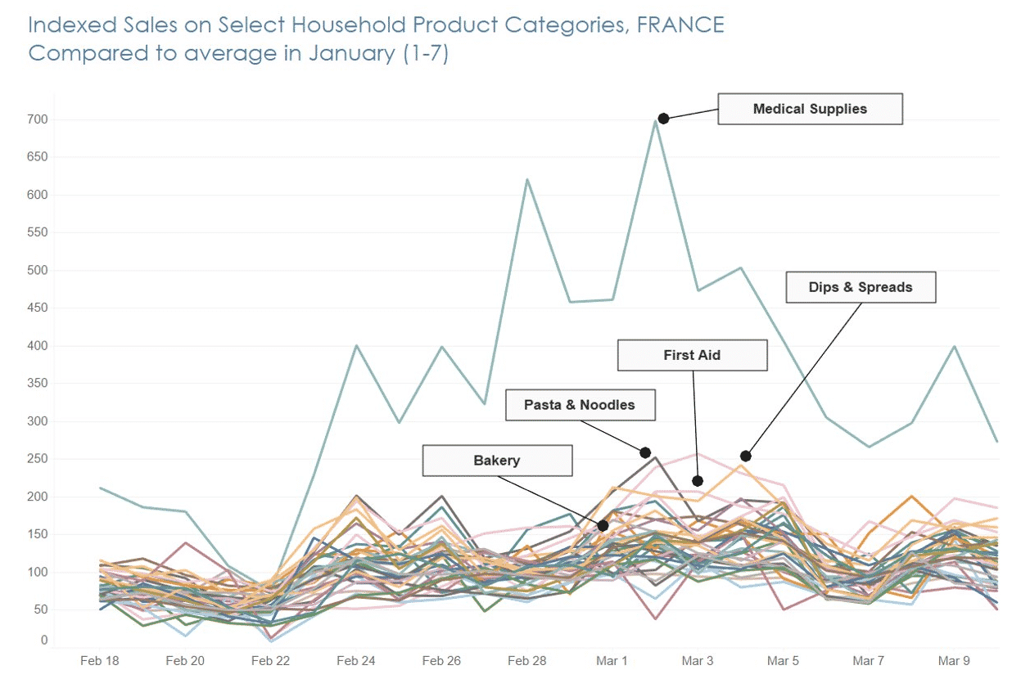
3. The United Kingdom favors non-perishable milk and fruit.
In the UK, sales of Canned & Dry Milk spiked by more than +350% last week, while Canned & Jarred Fruits were up by +297%. Flour sales skyrocketed to +623%.
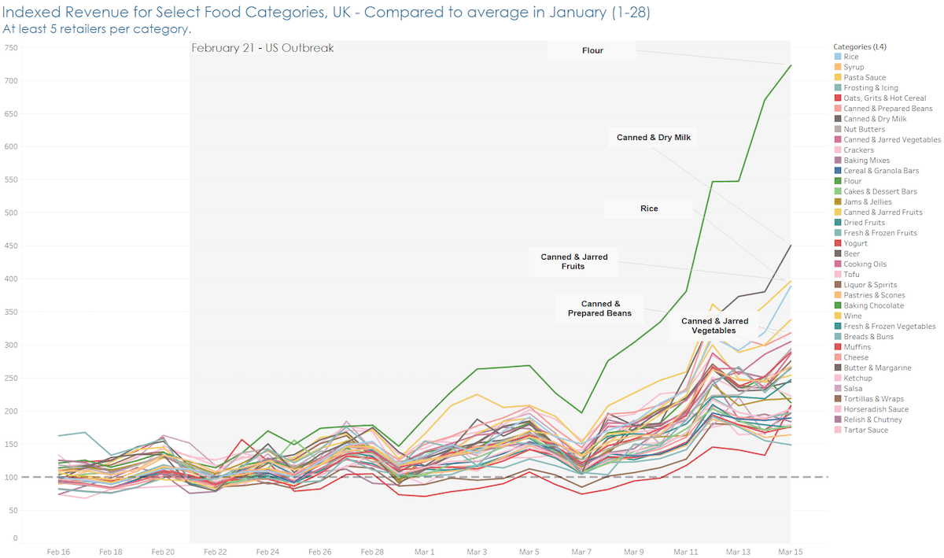

4. Online transactions in Fashion & Luxury remain above 2019.
Since the top of the year, online transactions in the Fashion & Luxury category—which includes items like designer clothes, watches, jewelry, and handbags—have largely stayed above their 2019 numbers. The growth trend that we saw in January 2020 continues unabated, even in the face of a worsening COVID-19 outbreak in the US.
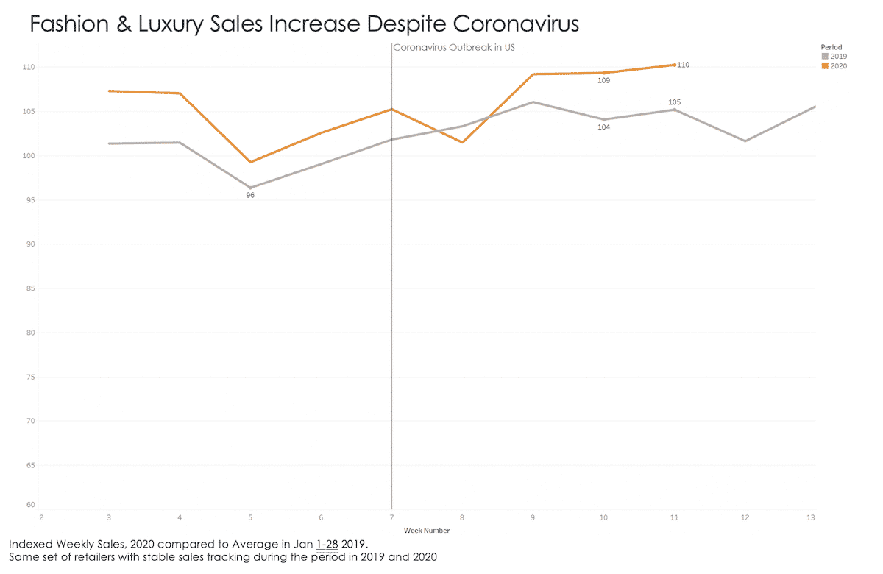

5. Home furnishing sales stay high.
As offices close and employees are encouraged to work from home, many may be outfitting their spaces with items that let them work comfortably and efficiently. In the US, sales of home improvement, gardening, and interior design products—which includes things like office furniture, lamps, and area rugs—were up +13% in early March and still up by +8% last week, compared to January 2019.
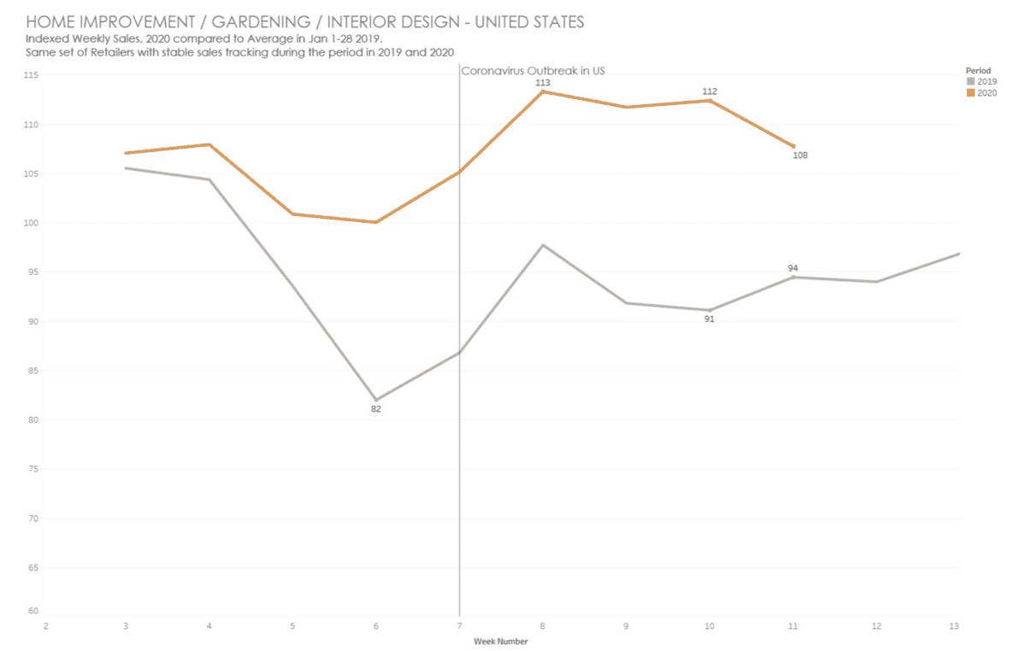
* Pictures can be expanded for better viewing
This research shows that in countries heavily impacted by COVID-19, consumers are stockpiling food and other essential items, while isolating themselves from crowds.

Research by the Nielson Company
Another research conducted by Nielson, to find out how and when consumers started showing behavioral changes, by monitoring consumer trends as COVID-19 news reached the general public, showed that consumers go through six behavioral stages based on their awareness of the COVID-19 spread in their communities:
1. Proactive health-minded buying: Increased interest in the acquisition of products that maintain well-being or health.
2. Reactive health management: Prioritization of products for infection containment (e.g. face masks).
3. Pantry preparation: Higher purchases of shelf-safe products and increased store visits.
4. Quarantined living preparation: Increased online shopping, decreased store visits and first signs of strain on the supply chain.
5. Restricted living: Possible price gouging due to limited supplies and deterred online fulfillment.
6. Living a new normal: Increased health awareness even as people return to their typical daily activities.
The study also found out that consumers typically moved from one stage to another in a period of two weeks in areas close to the initial outbreak. However, this happened much faster in other countries where the outbreak started later, such as Italy and the US.
Currently, the only country where consumers are starting to transition to the sixth stage is China, while the US has begun to move towards restricted living.
More so, consumers have now found novel ways to shop. When consumers are faced with shopping restrictions, they find and adopt newer ways to shop through technology. This is especially true when it comes to health and essential items. In 2019, the online grocery shopping market generated about $28.68 billion or a 20% increase from 2018. Despite this growth, food and beverage were still one of the smallest e-commerce categories. Last year, it was mostly the younger population segment that tried online grocery shopping, with 55% of 25 to 34-year-olds considering themselves likely to purchase groceries online, in contrast to only 35% of 45 to 54-year-olds expressing the same sentiment.
However, due to the pandemic, older generations are starting to see online shopping as a valid and safe option to obtain groceries. For example, Alibaba reported that in China, online grocery orders placed by people born in the 1960s were four times higher than normal during the Spring Festival or the period were China was still discovering new cases of COVID-19 each day.
With so many consumers entering restricted living situations, there has been a spike in other categories, especially in entertainment and media. That’s not surprising given that staying home increases the amount of content people watch by 60%. Video games and video-game internet traffic have seen a 75% increase since restrictions were imposed in the US. Of course, not everyone is seeing increases in traffic or purchases; in fact travel sites are experiencing the opposite.
So, do these changes signal a shift into how consumers will behave in the long term? If the holidays are any indicator, even short-term adjustments in behavior can have long term effects. For example, during holidays, there’s an increase in the number of consumers purchasing online or on their mobile devices. We then see this behavior being sustained as new holiday seasons roll in, which means new habits have been established.
As the population of most countries starts to move from quarantine preparations to restricted living, online fulfillment will be challenging due to strains in the supply chain. This has prompted many consumers to turn to Direct to Consumer (D2C) manufacturers to order and receive goods within a normal timeframe.
These D2C manufactures are a growing segment that caters directly to consumers by bypassing standard distribution channels, effectively gaining direct access to consumers. Several of these manufacturers have seen a significant boost in sales due to the pandemic. For example, Peach, a brand that manufactures high-end bath tissue saw new customers increase by 279% over the last two weeks compared to the two weeks prior.
Another change in consumer behaviour and spending as shown by Emarketer is that as the stock market continues to fluctuate, consumers will be wary of investing and flock to savings options. Stock markets have been highly volatile in the past few weeks, largely due to the coronavirus, while many fear a global recession. And the Federal Reserve has already implemented an emergency rate cut—marking the biggest one-time cut in the US since the financial crisis—indicating that the virus is already impacting the economy. Amid such volatility, consumers may be less keen to invest their savings in the stock market, impacting digital wealth managers that conventionally make money by charging customers fees that are a percentage of assets under management. On the flip side, more consumers might seek out savings options for their money, as a less risky way to build their wealth.
These are all different trends shown by consumers and how they behave/spend during the pandemic as shown by different researchers(r)s.

References:
- https://en.wikipedia.org/w/index.php?title=Consumer_behaviour&oldid=951458225
- https://www.nielsen.com/us/en/insights/article/2020/key-consumer-behavior-thresholds-identified-as-the-coronavirus-outbreak-evolves/
- https://www.emarketer.com/content/the-biggest-business-impacts-of-the-coronavirus-pandemic-according-to-business-insider-intelligence
- https://blog.globalwebindex.com/trends/coronavirus-impact-buying-behaviors/
- https://www.criteo.com/insights/coronavirus-consumer-behavior/
- https://www.who.int/emergencies/diseases/novel-coronavirus-2019
- https://www.contentserv.com/en/blog/how-covid-19-pandemic-is-influencing-consumer-behavior/

