NAME: EGBUNU KHADIJAT OCHONIYA

MATRIC NUMBER: 16/MHS01/075

DEPARTMENT: ANATOMY

LEVEL: 400

COURSE CODE: ANA 404 (HISTOPATHOLOGY)

TOPIC: COMPREHENSIVE REVIEW OF THE AETIOLOGY OF COVID-19, ITS PATHOGENESIS, HISTOPATHOLOGICAL FEATURES AND THE CURRENT POTENTIAL THERAPIES TO ADRESS IT. THE FUTURE OF COVID-19 ON PUBLIC HEALTH.

LECTURER: MR EDEM EDEM

**AETIOLOGY OF CORONA VIRUS**

**Virology**

* Severe acute respiratory syndrome coronavirus 2 (SARS-CoV-2) is a previously unknown betacoronavirus that was discovered in bronchoalveolar lavage samples taken from clusters of patients who presented with pneumonia of unknown cause in Wuhan City, Hubei Province, China, in December 2019 (Ren LL *et al*, 2020). Coronaviruses are a large family of enveloped RNA viruses, some of which cause illness in people (e.g., common cold, severe acute respiratory syndrome [SARS], Middle East respiratory syndrome [MERS]), and others that circulate among mammals and birds. Rarely, animal coronaviruses can spread to humans and subsequently spread between people, as was the case with SARS and MERS.
* SARS-CoV-2 belongs to the *Sarbecovirus* subgenus of the *Coronaviridae* family, and is the seventh coronavirus known to infect humans. The virus has been found to be similar to SARS-like coronaviruses from bats, but it is distinct from SARS-CoV and MERS-CoV(Zhu N *et al*, 2020.). The full genome has been determined and published in GenBank.
* A preliminary study suggests that there are two major types (or strains) of the SARS-CoV-2 virus in China, designated L and S. The L type was found to be more prevalent during the early stages of the outbreak in Wuhan City and may be more aggressive (although this is speculative), but its frequency decreased after early January. The relevance of this finding is unknown at this stage and further research is required(Tang X *et al, 2020)*.

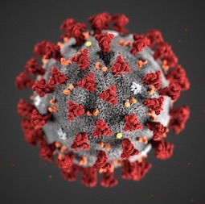*Illustration revealing ultrastructural morphology exhibited by severe acute respiratory syndrome coronavirus 2 (SARS-CoV-2) when viewed with electron microscopicallyCenters for Disease Control and Prevention.*

Origin of virus

* A majority of patients in the initial stages of this outbreak reported a link to the Huanan South China Seafood Market, a live animal or ‘wet’ market, suggesting a zoonotic origin of the virus.
* While the potential animal reservoir and intermediary host(s) are unknown at this point, studies suggest they may derive from a recombinant virus between the bat coronavirus and an origin-unknown coronavirus; however, this is yet to be confirmed. Pangolins have been suggested as an intermediate host as they have been found to be a natural reservoir of SARS-CoV-2-like coronaviruses.

**Symptoms of corona virus**

The symptoms of COVID-19 infection appear after an incubation period of approximately 5.2 days (Q. Li *et al,* 2020). The period from the onset of COVID-19 symptoms to death ranged from 6 to 41 days with a median of 14 days (W. Wang *et al,* 2020). This period is dependent on the age of the patient and status of the patient's immune system. It was shorter among patients>70-years old compared with those under the age of 70 (W. Wang *et al,* 2020). The most common symptoms at onset of COVID-19 illness are fever, cough, and fatigue, while other symptoms include sputum production, headache, haemoptysis, diarrhoea, dyspnoea, and lymphopenia.



**PATHOGENESIS OF CORONA VIRUS**

SARS-CoV-2 is transmitted predominantly via respiratory droplet, contact, and potential in fecal-oral (GNATCM, 2020). Primary viral replication is presumed to occur in mucosal epithelium of upper respiratory tract (nasal cavity and pharynx), with further multiplication in lower respiratory tract and gastrointestinal mucosa (Xiao, F. *et al*, 2020), giving rise to a mild viremia. Few infections are controlled at this point andremain asymptomatic. Some patients have also exhibited non-respiratory symptoms such as; acute liver and heart injury, kidney failure, diarrhea (Cheng, Y. *et al*, 2020), implying multiple organ involvement. ACE2 is broadly expressed in nasal mucosa, bronchus, lung, heart, esophagus, kidney, stomach, bladder, and ileum, and these human organs are all vulnerable to SARS-CoV-2 (Zou, X. *et al*, 2020). Recently, potential pathogenicity of the SARS-CoV-2 to testicular tissues has also been proposed by clinicians, implying fertility concerns in young patients (Fan, C. *et al*, 2020). The postulated pathogenesis of SARS-CoV-2 infection is graphed below

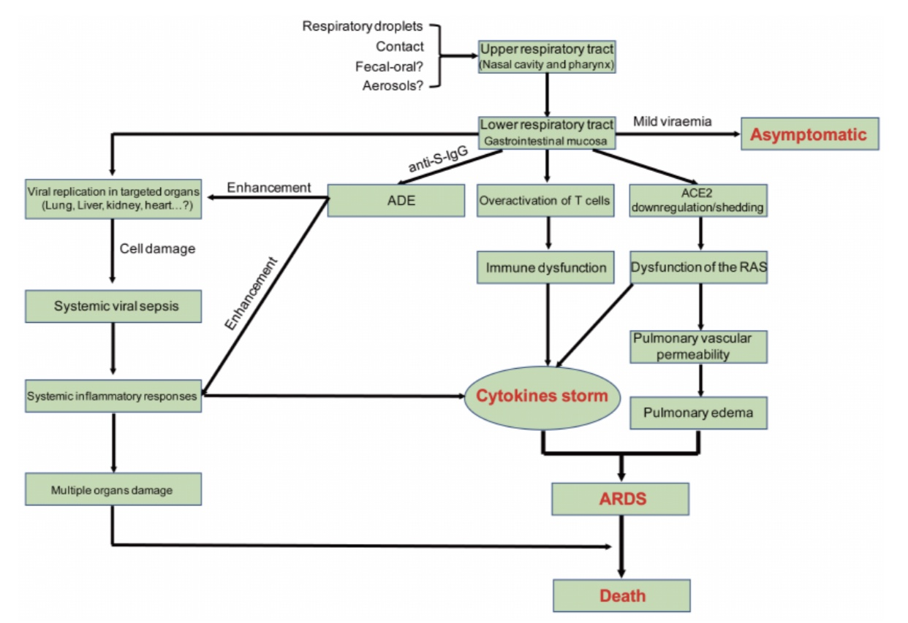

*Postulated pathogenesis of SARS-CoV-2 infection. Antibody-dependent enhancement (ADE);*

*ACE2: angiotensin-converting enzyme 2; RAS: renin-angiotensin system; ARDS: acute respiratory distress syndrome. Red words represent the important turning points in SARS-CoV-2 infection.*

**HISTOPATHOLOGICAL FEATURES OF CORONA VIRUS**

The histopathologic changes seen on postmortem transthoracic needle biopsies from a patient with COVID-19 who had respiratory failure and radiographic bilateral ground-glass opacities are consistent with diffuse alveolar damage. Although such nonspecific findings may be seen in response to several conditions that result in respiratory failure, its demonstration in the setting of COVID-19 helps to inform the clinical course of disease.

**TREATMENT/ THERAPEUTICS OF CORONA VIRUS**

The person-to-person transmission of COVID-19 infection led to the isolation of patients that were administered a variety of treatments. At present, there are no specific antiviral drugs or vaccine against COVID-19 infection for potential therapy of humans. The only option available

is using broad-spectrum antiviral drugs like Nucleoside analogues andalso HIV-protease inhibitors that could attenuate virus infection until the specific antiviral becomes available (H. Lu, *et a*, 2020). The treatment that have so far been attempted showed that 75 patients were administrated existing antiviral drugs. The course of treatment included twice a day oral administration of 75 mg oseltamivir, 500 mg lopinavir, 500 mg ritonavir and the intravenous administration of 0·25 g ganciclovir for 3–14 days (N. Chen, *ae al,* 2020).

Along those lines, until more specific therapeutics become available, it is reasonable to consider more broad-spectrum antivirals that provide drug treatment options for COVID-19 infection include Lopinavir/Ritonavir, Neuraminidase inhibitors, peptide (EK1), RNA synthesis inhibitors(H.A Rothan *et al*, 2020).

**FUTURE OF COVID-19 ON PUBLIC HEALTH**

Extensive measures to reduce person-to-person transmission of COVID-19 are required to control the current outbreak. Special attention and efforts to protect or reduce transmission should be applied in susceptible populations including children, health care providers, and elderly people. The early death cases of COVID-19 outbreak occurred primarily in elderly people, possibly due to a weak immune system that permits faster progression of viral infection. The public services and facilities should provide decontaminating reagents for cleaning hands on a routine basis. Physical contact with wet and contaminated objects should be considered in dealing with the virus, especially agents such as faecal and urine samples that can potentially serve as an alternative route of transmission. Epidemiological changes in COVID-19 infection should be monitored taking into account potential routes of transmission and subclinical infections, in addition to the adaptation, evolution, and virus spread among humans and possible intermediate animals and reservoirs.

**REFERENCES**

**Ren** LL, Wang YM, et al. identification of a novel coronavirus causing severe pneumonia in human: a descriptive study. Chin Med J (Engl). 2020 Jan 30.

Zhu N, Zhang D, Wang W, et al. A novel coronavirus from patients with pneumonia in china, 2019. N Engl J Med. 2020 feb 20;382(8):727-33.

Tang X, Wu C, Li X et al. on the origin and continuing evaluation of SARS-CoV-2. Nat Sci Review. 2020 Mar 3.

Q. Li, X. Guan, P. Wu, X. Wang, L. Zhou, Y. Tong, et al., Early transmission dynamics

in wuhan, China, of novel coronavirus-infected pneumonia, N. Engl. J. Med.

(2020), <https://doi.org/10.1056/NEJMoa2001316>.

W. Wang, J. Tang, F. Wei, Updated understanding of the outbreak of 2019 novel

coronavirus (2019-nCoV) in Wuhan, China, J. Med. Virol. 92 (4) (2020) 441–447,

<https://doi.org/10.1002/jmv.25689>.

General O_ce of National Health Commission; General O_ce of National Administration of Traditional Chinese Medicine. Diagnostic and treatment protocol for Novel Coronavirus Pneumonia; (Trial version 6). Available online: http://www.nhc.gov.cn/yzygj/s7653p/202002/8334a8326dd94d329df351d7da8aefc2.shtml:

(accessed on 20 February 2020).

Xiao, F.; Tang, M.; Zheng, X.; Li, C.; He, J.; Hong, Z.; Huang, S.; Zhang, Z.; Lin, X.; Fang, Z.; et al. Evidence for gastrointestinal infection of SARS-CoV-2. medRxiv **2020**. [CrossRef] [PubMed]

Cheng, Y.; Luo, R.; Wang, K.; Zhang, M.; Wang, Z.; Dong, L.; Li, J.; Yao, Y.; Ge, S.; Xu, G. Kidney impairment is associated with in-hospital death of COVID-19 patients. medRxiv **2020**. [CrossRef]

Zou, X.; Chen, K.; Zou, J.; Han, P.; Hao, J.; Han, Z. The single-cell RNA-seq data analysis on the receptor ACE2 expression reveals the potential risk of di_erent human organs vulnerable to Wuhan 2019-nCoV infection. Front. Med. **2020**, 1–8. [CrossRef]

Fan, C.; Li, K.; Ding, Y.; Lu,W.L.;Wang, J. ACE2 Expression in Kidney and Testis May Cause Kidney and Testis Damage After 2019-nCoV Infection. medRxiv **2020**. [CrossRef]

H. Lu, Drug treatment options for the 2019-new coronavirus (2019-nCoV), Biosci.

Trends (2020), <https://doi.org/10.5582/bst.2020.01020>.

H.A. Rothan and S.N. Byrareddy. The epidemiology and pathogenesis of coronavirus disease (COVID-19) Outbreak. Article *in* Journal of Autoimmunity · February 2020. DOI: 10.1016/j.jaut.2020.102433