Name: Teyei Dusu
Matric no: 18/sms09/031
Course title: Elements of Contemporary Global Studies
Assignment Title: Covid-19 and the Global Economy

As people and economies around the world reel from the impact of the novel coronavirus (COVID-19), one thing is clear: facts are at a premium. The value of trusted data has never been more in evidence than in the months since the onset of COVID-19 in China at the end of 2019, and its rapid spread around the world.
I have been struck time and time again by how much my colleagues want to contribute to finding solutions to the COVID-19 crisis. Yet, we are not qualified to develop a vaccine or to treat those who are suffering. However, economists at the University of Chicago, with their grounding in rigorous research and commitment to public policy, are uniquely positioned to offer insights into the ongoing economic challenges occasioned by this historic health crisis.
The WTO predicted a drop in world trade by 13–32 percent due to effects of the pandemic, giving a wide range to its forecast because the pandemic’s long-term effects are difficult to discern.

The Economy is greatly affected
- Direct impact on production. Chinese production has already been substantially affected by the shutdown in Hubei province and other areas. Some other countries are also beginning to feel a direct impact as their authorities put in place similar measures.
The slowdown in China has effects on exporters to China. China’s largest sources of imports are Korea, Japan, and other Asian countries, according to the World Bank.² Thus, even without new outbreaks of the disease, these areas will likely experience slow growth in the first half of 2020.
- Supply chain and market disruption. Many manufacturing firms rely on imported intermediate inputs from China and other countries affected by the disease. Many companies also rely on sales in China to meet financial goals. The slowdown in economic activity—and transportation restrictions—in affected countries will likely have an impact on the production and profitability of specific global companies, particularly in manufacturing and in raw materials used in manufacturing. For companies that rely on intermediate goods from affected regions, and that are not able to easily switch sourcing, the size of the impact may depend on how quickly the outbreak fades. Small and medium-sized firms may have greater difficulty surviving the disruption. Businesses tied to travel and tourism are facing losses that are likely not recoverable.
- Financial impact on firms and financial markets. Temporary disruptions of inputs and/or production might stress some firms, particularly those with inadequate liquidity. Traders in financial markets may or may not correctly anticipate or understand which firms might be vulnerable. The resulting rise in risk might reveal that one or more key financial market players have taken investment positions that are unprofitable under current conditions, further weakening trust in financial instruments and markets. A possible (likely low-probability) event would be a significant financial market disruption as participants become concerned about counterparty risk. A somewhat more likely possibility is a significant decline in equity markets and corporate bond markets, with investors preferring to hold government securities (particularly US treasuries) because of the uncertainty created by the pandemic.
The extent of the damage will depend on how quickly the virus is contained, the steps authorities take to contain it, and how much economic support governments are willing to deploy during the epidemic’s immediate impact and aftermath.
Early indications of COVID-19’s impact on the Chinese economy are worse than initially forecast. Surveys of China’s manufacturing and services sector plunged to record lows in February, automobile sales sank a record 80 percent, and China’s exports fell 17.2 percent in January and February. The official data confirmed a widespread slowdown in economic activity foreshadowed in low pollution levels and depressed shipping traffic, among other informal barometers. Analysts have sharply revised down estimates of Chinese growth, with many now predicting a drop in first quarter GDP, the first contraction since China began reporting quarterly data in 1992. As COVID-19 spreads, China’s economic recovery will be challenged as demand from other countries drops as they cope with the virus.
Although the outbreak appears to have slowed in China, COVID-19 and its impacts have gone global. Infections are mounting in Europe, South Korea, Iran, the United States, and elsewhere, with authorities implementing increasingly restrictive measures to contain the virus. Europe and Japan are likely already in recession territory given their weak fourth quarter performance and high reliance on trade. While the United States entered the crisis with a tailwind, some analysts are forecasting a contraction in U.S. GDP in the second quarter. Estimates of the global impact vary: early last week, the Organization for Economic Co-operation and Development (OECD) predicted that COVID-19 will lower global GDP growth by one-half a percentage point for 2020 (from 2.9 to 2.4 percent); Bloomberg Economics warns that full-year GDP growth could fall to zero in a worst-case pandemic scenario.
The COVID-19 outbreak has generated both demand and supply shocks reverberating across the global economy. Among major economies outside of China, the OECD forecasts the largest downward growth revisions in countries deeply interconnected to China, especially South Korea, Australia, and Japan. Major European economies will experience dislocations as the virus spreads and countries adopt restrictive responses that curb manufacturing activity at regional hubs, including in Northern Italy. As a result of depressed activity, the United Nations projects that foreign direct investment flows could fall between 5 and 15 percent to their lowest levels since the 2008-2009 global financial crises.
At the sectoral level, tourism and travel-related industries will be among the hardest hit as authorities encourage “social distancing” and consumers stay indoors. The International Air Transport Association warns that COVID-19 could cost global air carriers between $63 billion and $113 billion in revenue in 2020, and the international film market could lose over $5 billion in lower box office sales. Similarly, shares of major hotel companies have plummeted in the last few weeks, and entertainment giants like Disney expect a significant blow to revenues. Restaurants, sporting events, and other services will also face significant disruption. Industries less reliant on high social interaction, such as agriculture, will be comparatively less vulnerable but will still face challenges as demand wavers.

EFFECTS OF THE LOCKDOWN
With the COVID-19 pandemic, we are facing an unprecedented situation on a global level. Entire countries are in lockdown, and people everywhere are being asked to stop or minimize their physical (social) interactions. Our broadband connections are becoming our lifelines – figuratively and literally: we are using them to get news, connect to our work environments (now all virtual), and for entertainment too.
The wave of special emergency measures continues across countries and continents. Let’s take a look at the first effects of this global pandemic on network traffic. In a way, this may be the “shape of things to come” for all other networks.
We analyzed data from several networks in Western Europe from the week of March 9, 2020. We looked at the traffic volumes and patterns. While we were still in the early days of the new reality introduced with special measures, we were able to spot some network anomalies and trends.
Some countries in Western Europe have declared lockdown measures – Day 1 in our analysis is the day the lockdown was enforced. We also continued looking at the situation over the following weekend after the lockdown was declared – which we refer to as Weekend 1 (or Sunday 1, the Sunday in Weekend 1). To provide a better comparison, we looked at day-to-day (workday and weekend day) comparisons against the previous week.
Social media and messaging
On Day 1 and Sunday 1, we saw a significant increase in popular messaging and social media applications. One of the most popular, WhatsApp, exhibited an increase of 117–217% during Day 1, with apparent spikes in the morning hours on the first day of the school lockdown. We also saw a six fold (or 500%) traffic increase on Sunday 1. Even with these spikes, the overall WhatsApp traffic (in Gbps) remained manageable in both cases – from the perspective of the total traffic volume in the network.
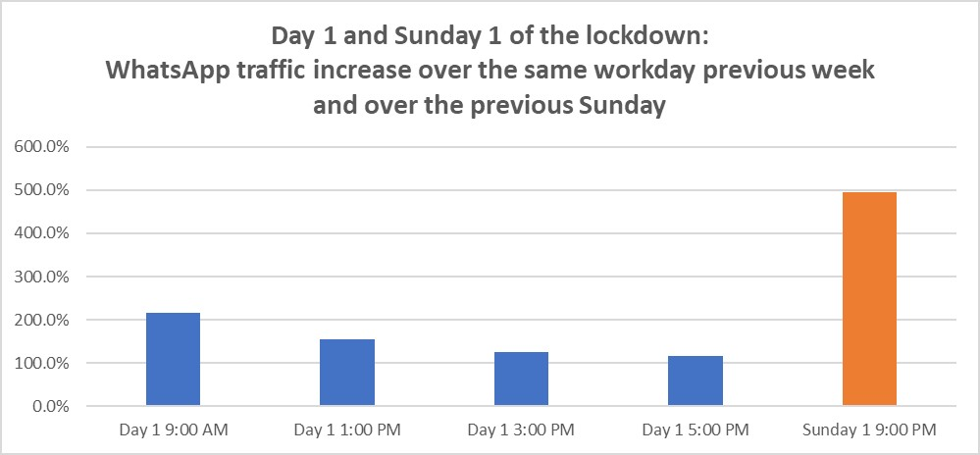
Netflix
On the online entertainment front, the increase in Netflix traffic showed that people started streaming earlier in the day (morning hours and early afternoon hours). While the evening traffic volumes remained within a +20% range compared to typical values, the overall increase of traffic during the day ranged from 97% (morning) to 27%–42% (early afternoon), significantly contributing to the total network traffic.
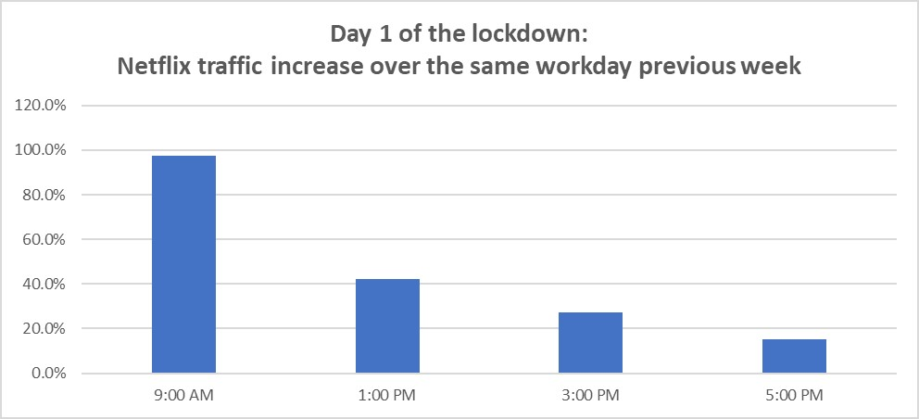
A look at the Netflix traffic on the weekend brought much more concerning stats. Volumes rose between 54% and 75% (in peak viewing hours) compared to the previous weekend, with substantial contributions to the overall traffic. Knowing that weekend evenings are the peak traffic hours for most networks, Weekend 1 brought more stress to the network – in relative and absolute terms (terabit range).
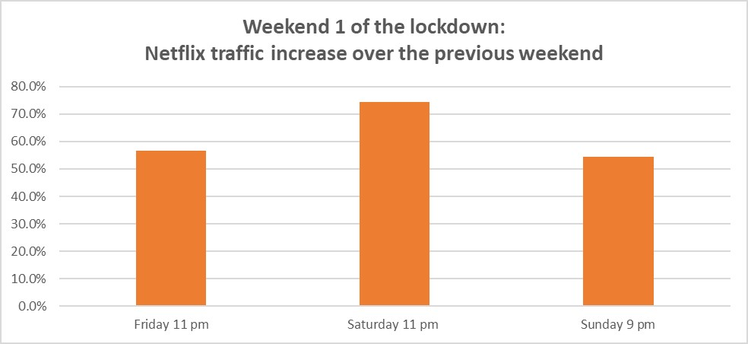
Total network traffic
Day 1 brought an increase in the overall traffic of anywhere between 30% (5 p.m.) and 80% (9 a.m.), with boosts between 50% and 70% for most of the day.
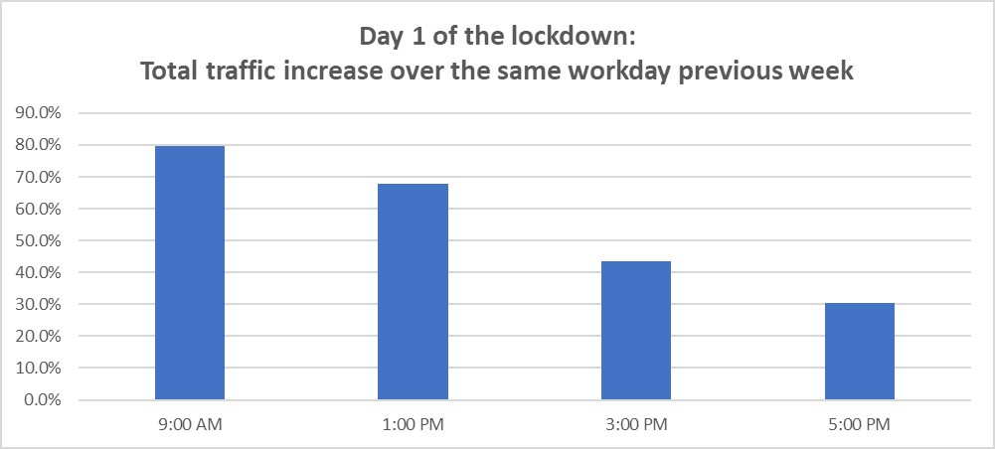
The Weekend 1 Sunday traffic rose between 34% and 97% during the day, bringing additional terabit-levels of traffic volumes to the network at times. While “normal” weekends (because of a lot of online streaming and gaming) can be used as a solid baseline and benchmark to check whether there is enough capacity to address these peaks, it seems that Weekend 1 additionally stress-tested the network and in a significant way. The good news is that networks were able to absorb this peak without degrading the quality of service. The bad news is that this may be a new trend. The future will tell.
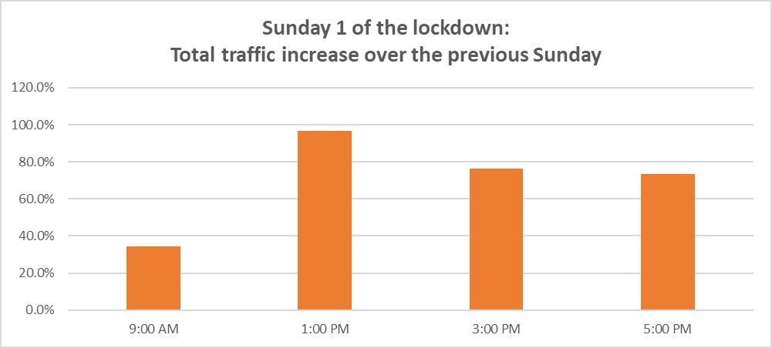
Final thoughts
What conclusions can we draw from Day 1 and Weekend 1 snapshots? What are the new broadband realities that we may be seeing, locally and globally, in the coming weeks or months?

