BADEJO SAHADAT OYINKANSOLA
MEXHANICAL ENGINEERING
19/ENG06/012
PHY 102
SECTION A
1a.ChargingbyInduction:
Electric charges can be obtained ,by a process calledelectrostaticinduction.
Considerapositivelychargedrubberrodbroughtnearaneutral(uncharged)conductingsphere thatisinsulatedsothatthereisnoconductingpathtogroundasshownbelow.Therepulsiveforce betweentheprotonsintherodandthoseinthespherecausesaredistributionofchargesonthe spheresothatsomeprotonsmovetothesideofthespherefarthestawayfromtherod.The regionofthespherenearestthepositivelychargedrodhasanexcessofnegativechargebecause ofthemigrationofprotonsawayfromthislocation.Ifagroundedconductingwireisthen connectedtothesphere,asin(fig.1.3b),someoftheprotonsleavethesphereandtraveltothe earth.Ifthewiretogroundisthenremoved,theconductingsphereisleftwithanexcessof inducednegativecharge.
Finally,whentherubberrodisremovedfromthevicinityofthesphere,the inducednegativelychargeremainsontheungroundedsphereandbecomes uniformlydistributedoverthesurfaceofthesphere.
Diagram:

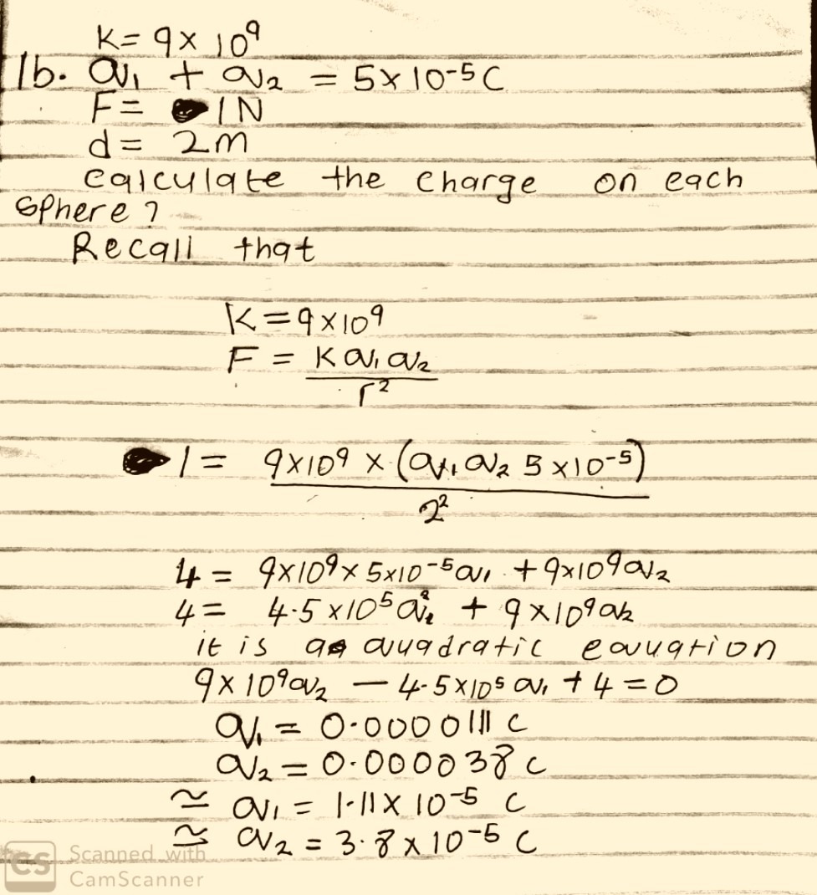
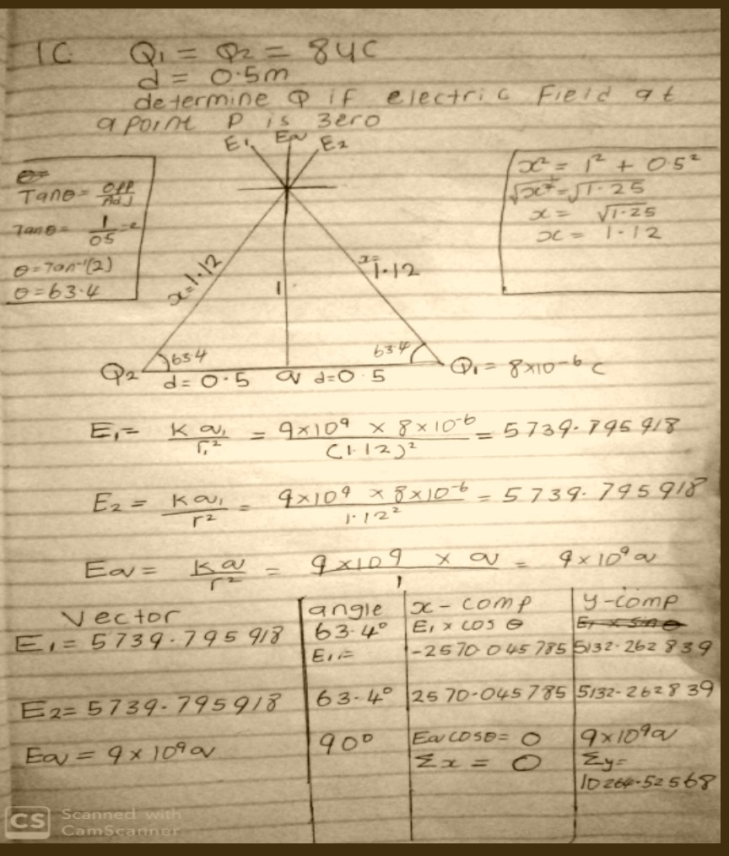
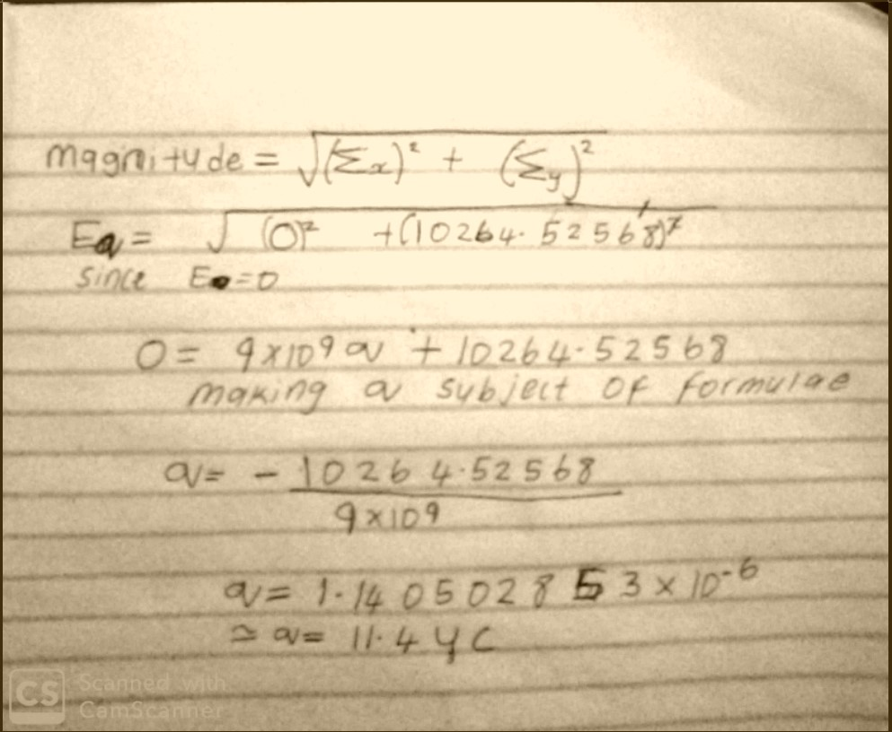

3a.
dQ→dQ=ρdV (i) Volumechargedensity,ρ= dV
dQ→dQ=σdA
(ii) Surfacechargedensity,σ= dA
dQ→dQ=λdL
(iii)Linearchargedensity,λ=
dL

3b.ELECTRICPOTENTIALDIFFERENCE
Theelectricpotentialdifferencebetweentwopointsinanelectricfieldcanbe definedastheworkdoneperunitchargeagainstelectricalforceswhenachargeis transportedfromonepointtotheother.ItismeasuredinVolt(v)orJoulesper Coulomb(J/C).Electricpotentialdifferenceisascalarquantity.
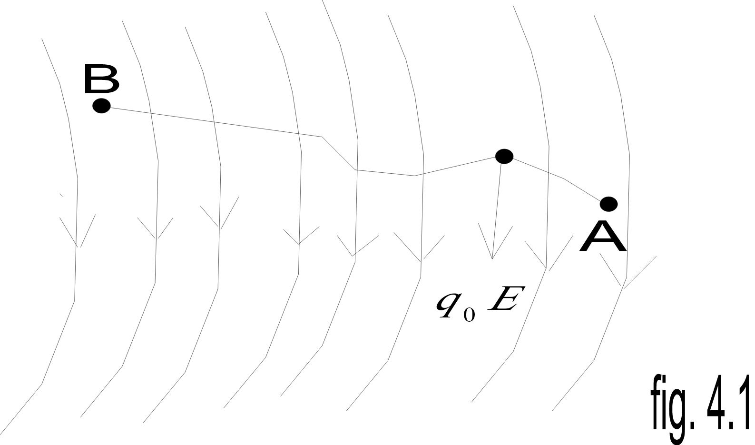
Considerthediagramabove,supposeatestchargeq_{o}ismovedfrompointAto pointBalonganarbitrarypathinsideanelectricfieldE.TheelectricfieldE exertsaforceF=q_{o}Eonthechargeasshowninfig3.1.Tomovethetestcharge fromAtoBatconstantvelocity,anexternalforceofF=-q_{o}Emustactonthe charge.Therefore,theelementalworkdonedWisgivenas:
dW=F.dL…  But | (1)
F=-q₀E… | (2)
Substitutingequation(2)in(1)yields
dW=-q₀EdL… (3)
ThentotalworkdoneinmovingthetestchargefromAtoBis:
W(A→B)_{Ag}=-q₀∫^{B}EdL… (4)
A
Fromthedefinitionofelectricpotentialdifference,itfollowsthat:
W(A→B)_{Ag}
V_{B}-V_{A}= q0 … (5)Puttingequation(4)in(5)yields
B
V_{B}-V_{A}=-EdL… (6)
∫
A
SECTIONB.
4a.magneticfluxisdefinedasthestrengthofthemagneticfield whichcanberepresentedbylineofforces.Itisrepresentedby thesymbolΦ.mathematicallygivenasΦ=B.dA 4b.
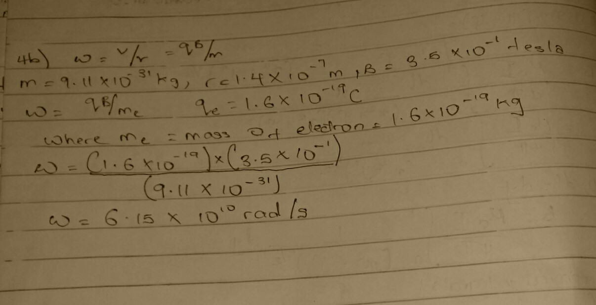
4c.Inthequestionweweregivenparamiterssuchas i.massoftheelectron=9.11x10⁻³¹kg ii.Aradiusof1.4x10⁻⁷m iii.magneticfieldof3.5x10⁻¹weber\metersquare andyouareaskedtofindthecyclotronfrequencywhichisequalor thesamethingasangularspeed.itiscalledcyclotronfrequency becauseitisafrequencyofanacceleratorcalledcyclotron.
Recallthatangularspeedisgivenasω=^{v}=^{qB}
rm
Substitutingwehaveω=^{v}=^{qB}=1.6x10-10x3.5x10-10
rm
9.11x10-31
qB⁼1.6×10-19x3.5x10 -1=6.15×1010rad/s ^{m} 9.11x10 -31
SOsincecyclotronfrequencyisequaltoangularspeedthe cyclotronfrequencyisequalto6.15×1010rad/s
,havingaunitas1\Twhichisequaltotheunitoffrequency dimensionally.
5a.Biot-savartlawstatesthatthemagneticfieldisdirectly proportionaltotheproductpermeabilityoffreespace(µ),the current(I),thechangeinlength,theradiusandinversely proportionaltosquareofradius(r²).Itcanberepresented mathematicallyby
μ_{o}Idl×̂r
dB=4π r₂
whereμ_{o}isaconstantcalledPermeabilityoffreespace.
μ_{o}=4π×10⁻⁷T.^{m}
A
TheunitofBisweber\metresquare
5b.MagneticFieldofaStraightCurrentCarryingConductor
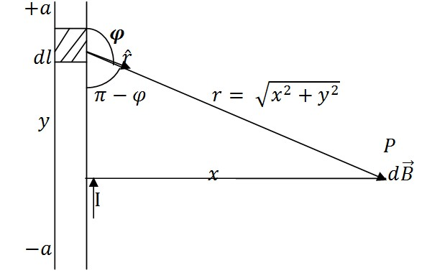
Fig1:AsectionofaStraightCurrent
CarryingConductor
ApplyingtheBiot-Savartlaw,wefindthe magnitudeofthefielddB
B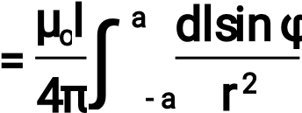
sin(π–φ)=sinθ
∴_{B=}μ4oπI∫ª-adlsin(rπ2-φ)
Fromdiagram,r²=x²+y²(Pythagorastheorem)
μ_{o}Iªdlsin(π–φ)
B=4π∫-ax2_{+y}2… (*)
Butsin(π-φ)=x^{2x}+y²=(x₂+^{x}y2₎1₂… (**)
Substituting(**)into(*),wehave
B=μ4oπI∫a^{-a}dl(x2+y2)(xx2+y2)1/2
μoIa x
B=4π∫-adl(x2+y2)3/2 Recalldl=dy
B o 2dy
=
I
μ
4
π
∫
a
-
a
x
(
+
x
2
y
2
)
3
B 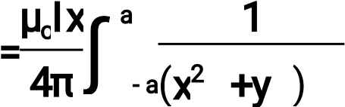₂3_{/2}dy… (***)
Usingspecialintegrals:
dy 1 y
=
∫(x²+y²)3/2 x2_{(x}2_{+y}2₎1/2
Equation(***)thereforebecomes
μ_{o}Ix y ª
B=4π[x2(x2+y2)12]-a
B=μ4oπIx(x2(x22+aa2)12)
B=4μπoIx((x2₊2a_{a}2₎12)
Whenthelength2aoftheconductorisverygreatincomparisontoitsdistancex frompointP,weconsideritinfinitelylong.Thatis,whenaismuchlargerthan,x (x²+a²)^{1/2}≅a,asa→
∴
B
=
I
μ
o
2
π
x
Inaphysicalsituation,wehaveaxialsymmetryaboutthey-axis.Thus,atallpoints inacircleofradius,aroundtheconductor,themagnitudeofBisr
B=μ^{oI}… (#)
2πr
Equation(#)definesthemagnitudeofthemagneticfieldoffluxdensityBneara long,straightcurrentcarryingconductor.

