NAME: OGUNDIPE IFEOLUWA ABISOLA
19/MHSO1/297
PHYSICS 102 ASSIGNMENT
Answer 1
Charging by induction
Electric charges can be obtained without touching it, by a process called electrostatic induction.
Consider a positively charged rubber rod brought near a neutral (uncharged) conducting a sphere that is insulated so that there is no conducting path to the ground as shown below. The repulsive force between the electrons in the rod and those in the sphere causes a redistribution of charges on the sphere so that some electrons move farthest away from the rod. The region of the sphere nearest the positively charged rod has an excess negative charge because of the migration of electrons away from this location. If a grounded conducting wire is then connected to the sphere; some of the electrons leave the sphere and travel to the earth. If the wire to the ground is removed, the conducting sphere is left with an excess of induced negative charge.
Finally, when the rubber rod is removed from the variety of the sphere, the induced negative charge remains on the underground sphere and becomes uniformly distributed over the surface of the sphere.

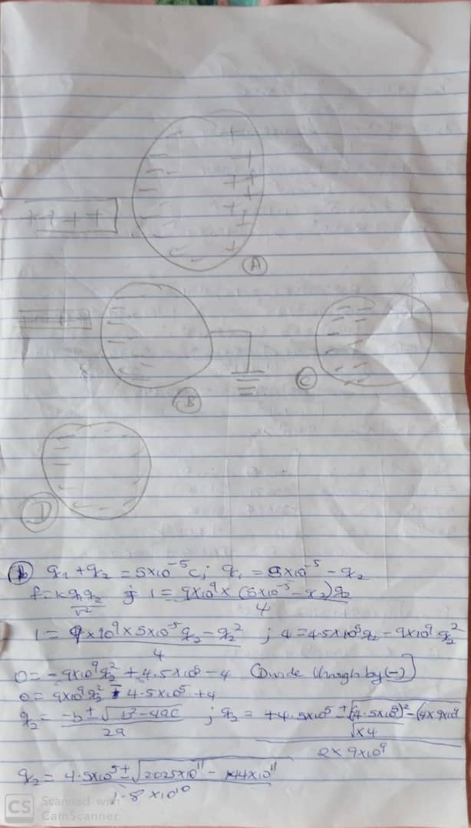

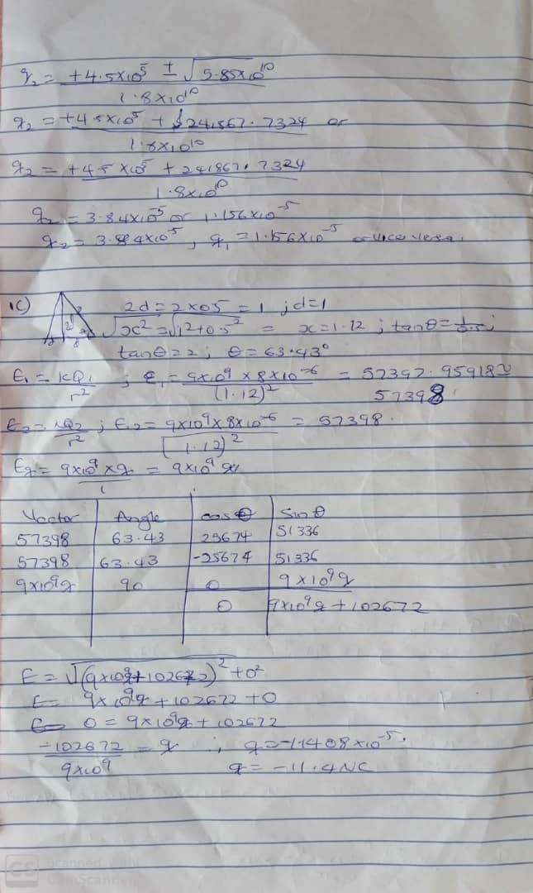

answer2
2a) An electric field is a region of space in which an electric charge will experience an electric force while electric field intensity is per unit charge unexperienced by a charge in an electric field
2b)
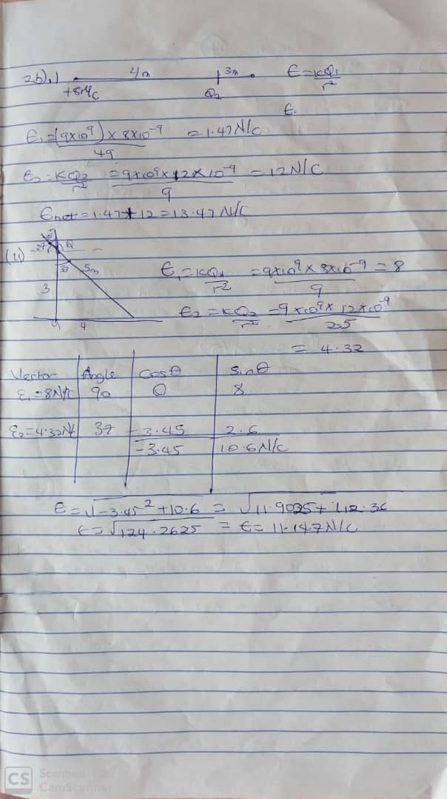

Answer 4
The magnetic flux is defined as the strength of a magnetic field represented by lines of force.

