A comprehensive review of the aetiology of COVID-19, its pathogenesis, histopathological features and the current potential therapies to address it, also on the future of COVID-19 on public health.
By
Martins Jane
(16/MHS01/135)
An assignment submitted to the
Department of Anatomy
Faculty of Basic Medical Sciences,
College of Medicine and Health Sciences,
Afe Babalola University, Ado-Ekiti.

- Introduction
The name “coronavirus,” coined in 1968, is derived from the “corona”-like or crown-like morphology observed for these viruses in the electron microscope (Tyrell et al., 1968). Coronavirus disease 2019 (COVID-19) originated in the city of Wuhan, Hubei Province, Central China, and has spread quickly to 72 countries to date. COVID-19 is caused by a novel coronavirus, named severe acute respiratory syndrome coronavirus 2 (SARS-CoV-2) [previously provisionally known as 2019 novel coronavirus (2019-nCoV)] (Li et al., 2020).
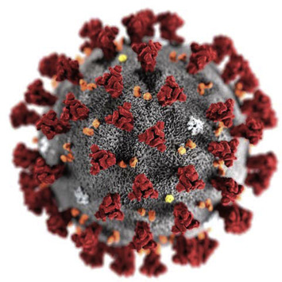
FIG 1.0: Illustration of the SARS-CoV-2 virion (The Harvard Gazette 2020)
Firstly, Viruses are small obligate intracellular parasites, which by definition contain either a RNA or DNA genome surrounded by a protective, virus-coded protein coat. Viruses may be viewed as mobile genetic elements, most probably of cellular origin and characterized by a long co-evolution of virus and host. For propagation viruses depend on specialized host cells supplying the complex metabolic and biosynthetic machinery of eukaryotic or prokaryotic cells. A complete virus particle is called a virion. The main function of the virion is to deliver its DNA or RNA genome into the host cell so that the genome can be expressed (transcribed and translated) by the host cell. The viral genome, often with associated basic proteins, is packaged inside a symmetric protein capsid. The nucleic acid-associated protein, called nucleoprotein, together with the genome, forms the nucleocapsid. In enveloped viruses, the nucleocapsid is surrounded by a lipid bilayer derived from the modified host cell membrane and studded with an outer layer of virus envelope glycoproteins (Gelderblom, 1996).
In 1975, the Coronaviridae family was established by the International Committee on the Taxonomy of Viruses. Recently, at the 10th International Nidovirus Symposium in Colorado Springs, Colo., in June 2005, it was proposed that the Coronaviridae family be divided into two subfamilies, the coronaviruses and the toroviruses, the latter of which cause enteric diseases in cattle and possibly in humans(Cowley et al., 2000). The Coronaviridae family, along with the Arteviridae and Roniviridae families, form the Nidovirales order. The Arteviridae family includes swine and equine pathogens, and the Roniviridae family is composed of invertebrate viruses (Enjuanes et al., 2000).
Coronaviruses (CoVs) belong to the subfamily Orthocoronavirinae in the family Coronaviridae, Order Nidovirales. There are four genera within the subfamily Orthocoronavirinae, namely Alphacoronavirus (α-CoV), Betacoronavirus (β-CoV), Gammacoronavirus (γ-CoV) and Deltacoronavirus (δ-CoV) (Banerjee et al., 2019; Yang and Leibowitz, 2015). The CoV genome is an enveloped, positive-sense, single-stranded RNA with a size varying between 26 kb and 32 kb, the largest genome of known RNA viruses. Both α- and β-CoV genera are known to infect mammals, whilst δ- and γ-CoVs infect birds (Song et al., 2019). Two recent outbreaks of viral pneumonia caused by β-CoVs are severe acute respiratory syndrome (SARS) and Middle East respiratory syndrome (MERS). In 2002, an outbreak of SARS was first reported in China and then spread quickly worldwide, resulting in hundreds of deaths with an 11% mortality rate (Graham et al., 2013). In 2012, MERS first emerged in Saudi Arabia and subsequently spread to other countries, with a fatality rate of 37% (Zumla et al., 2015; Hui et al., 2018; Su et al., 2015). In both of these epidemics, the viruses likely originated from bats and then infected humans through other intermediate animal hosts, e.g. the civet (Paguma larvata) for SARS-CoV and the camel for MERS-CoV (Reusken et al., 2013; de Wit et al., 2016; Lu et al., 2015).
Beginning in December 2019, a number of patients with pneumonia of unknown aetiology emerged in Wuhan City, Hubei Province, Central China. Genome sequencing has demonstrated that this pneumonia, named coronavirus disease 2019 (COVID-19), is caused by a novel CoV, namely severe acute respiratory syndrome coronavirus 2 (SARS-CoV-2), previously known as 2019 novel coronavirus (2019-nCoV) (Xu et al., 2020; Wong et al., 2020; Li et al., 2020). Like SARS-CoV and MERS-CoV, this newly emerged SARS-CoV-2 virus belongs to the B lineage of the β-CoVs.
To date, COVID-19 has spread rapidly in 72 countries, causing >90 000 confirmed cases and over 2946 deaths as of 3 March 2020. Considering the global threat, the World Health Organization (WHO) has declared COVID-19 a public health emergency of international concern (PHEIC). However, there are no vaccines against SARS-CoV-2 or specific therapeutic drugs for this communicable disease. Thus, a better understanding of SARS-CoV-2 is essential for exploring effective vaccines and drugs. In this review, we summarise recent progress in SARS-CoV-2 to provide a framework for the prevention and treatment of COVID-19 (Li et al., 2020).
Coronaviruses infect many species of animals, including humans (Bailey et al., 1949). Coronaviruses have been described for more than 50 years; the isolation of the prototype murine coronavirus strain JHM, for example, was reported in 1949 (Cheever et al., 1949).The molecular mechanisms of replication as well as the pathogenesis of several coronaviruses have been actively studied since the 1970s. Some of the animal viruses, such as porcine transmissible gastroenteritis virus (TGEV), bovine coronavirus (BCoV), and avian infectious bronchitis viruses (IBV), are of veterinary importance. The murine coronavirus mouse hepatitis virus (MHV) is studied as a model for human disease. This family of viruses remained relatively obscure, probably because there were no severe human diseases that could definitely be attributed to coronaviruses; human coronaviruses caused only the common cold. However, in the spring of 2003, when it became clear that a new human coronavirus was responsible for severe acute respiratory syndrome (SARS), coronaviruses became much more recognized. With the occurrence of the SARS epidemic, coronaviruses may now be considered “emerging pathogens.” The origin of the SARS coronavirus (SARS-CoV) poses interesting questions about coronavirus evolution and species specificity. Since the SARS epidemic, two new human respiratory coronaviruses have been described(Weiss and Navas-Martin, 2005).
1.1 Structure of SARS-CoV-2.
The SARS-CoV-2 genome (30 kb in size) encodes a large, non-structural polyprotein (ORF1a/b) that is further proteolytically cleaved to generate 15/16 proteins, 4 structural proteins and 5 accessory proteins (ORF3a, ORF6, ORF7, ORF8 and ORF9) (Ramaiah and Arumugaswami, 2020; Chan et al., 2020; Wu et al., 2020). The four structural proteins consist of the spike (S) surface glycoprotein, the membrane (M) protein, the envelope (E) protein and the nucleocapsid (N) protein, which are essential for SARS-CoV-2 assembly and infection. The spike surface glycoprotein plays a key role in its attachment to host cells and can be further cleaved by host proteases into an N-terminal S1 subunit and a membrane-bound C-terminal S2 region (Yuan et al., 2017). Binding of the S1 subunit to a host receptor can destabilise the prefusion trimer, leading to shedding of the S1 subunit and transition of the S2 subunit into a highly stable postfusion conformation (Walls et al., 2019).In order to engage a host receptor, the receptor-binding domain (RBD) of the S1 subunit undergoes hinge-like conformational movements, which transiently hide or expose the determinants of receptor binding (Wrapp et al., 2020; Li, 2016). These two states of the S1 subunit can be regarded as the ‘down’ conformation and the ‘up’ conformation. The former represents an inaccessible state of the receptor, whereas the latter corresponds to an accessible state (Wrapp et al., 2020; Gui et al., 2017). Therefore, understanding the structure and function of the spike protein can help to develop monoclonal antibody drugs and to guide the design and development of vaccines.
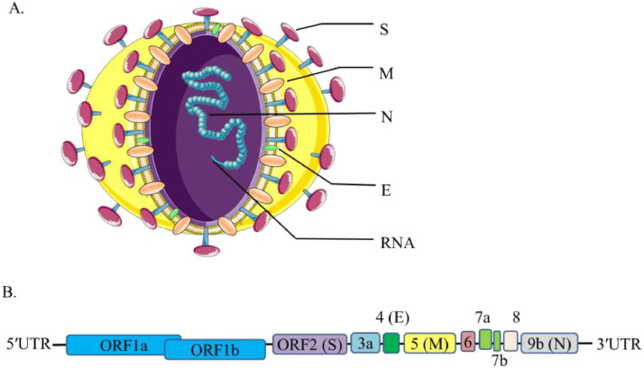
FIG 1.1: Structure and genome of severe acute respiratory syndrome coronavirus 2 (SARS-CoV-2). (A) There are four structural proteins as follows: spike (S) surface glycoprotein (purple); membrane (M) protein (orange); nucleocapsid (N) protein (blue); and envelope (E) protein (green). Genomic RNA is shown encased in the N protein. (B) The SARS-CoV-2 genome is arranged in the order of 5′-replicase (ORF1a/b)–structural proteins [spike (S)–envelope (E)–membrane (M)–nucleocapsid (N)]−3′ (Li et al., 2020).

- Aetiology of COVID-19
SARS-CoV-2 is the seventh member of the family of CoVs that infect humans. Four human CoVs (HCoV-229E, HCoV-NL63, HCoV-OC43 and HCoV-HKU1) are able to cause a wide range of upper respiratory tract infections (common cold), whereas SARS-CoV and MERS-CoV are responsible for atypical pneumonia (Paules et al., 2020S). The causes of different infection sites are likely related to the presence of dipeptidyl peptidase 4 (DPP4) and angiotensin-converting enzyme 2 (ACE2) in the lower respiratory tract, which are the major human receptors for the surface spike (S) glycoprotein of MERS-CoV and SARS-CoV, respectively (Raj et al., 2013; Kuba et al., 2005). The genetic sequence of SARS-CoV-2 is ≥70% similar to that SARS-CoV, and SARS-CoV-2 is capable of using the same cell entry receptor (ACE2) as SARS-CoV to infect humans (Hui et al., 2020; Zhou et al., 2020) . However, there are more differences in the key S proteins that the viruses use to interact with host cells. SARS-CoV-2 spike binds to human ACE2 with approximately 10–20-fold higher affinity than the SARS-CoV spike (Wrapp et al., 2020), making it easier to spread from human to human.
CoVs are positive-stranded RNA viruses with a crown-like appearance under an electron microscope (coronam is the Latin term for crown) due to the presence of spike glycoproteins on the envelope. The subfamily Orthocoronavirinae of the Coronaviridae family (order Nidovirales) classifies into four genera of CoVs: Alphacoronavirus (alphaCoV), Betacoronavirus (betaCoV), Deltacoronavirus (deltaCoV), and Gammacoronavirus (gammaCoV). Furthermore, the betaCoV genus divides into five sub-genera or lineages (Chan et al., 2013). Genomic characterization has shown that probably bats and rodents are the gene sources of alphaCoVs and betaCoVs. On the contrary, avian species seem to represent the gene sources of deltaCoVs and gammaCoVs (Cascella et al., 2020).
Members of this large family of viruses can cause respiratory, enteric, hepatic, and neurological diseases in different animal species, including camels, cattle, cats, and bats. To date, seven human CoVs (HCoVs) — capable of infecting humans — have been identified. Some of HCoVs were identified in the mid-1960s, while others were only detected in the new millennium.
In general, estimates suggest that 2% of the population are healthy carriers of a CoV and that these viruses are responsible for about 5% to 10% of acute respiratory infections (Chen et al., 2020).
- Common human CoVs: HCoV-OC43, and HCoV-HKU1 (betaCoVs of the A lineage); HCoV-229E, and HCoV-NL63 (alphaCoVs). They can cause common colds and self-limiting upper respiratory infections in immunocompetent individuals. In immunocompromised subjects and the elderly, lower respiratory tract infections can occur.
- Other human CoVs: SARS-CoV, SARS-CoV-2, and MERS-CoV (betaCoVs of the B and C lineage, respectively). These cause epidemics with variable clinical severity featuring respiratory and extra-respiratory manifestations. Concerning SARS-CoV, MERS-CoV, the mortality rates are up to 10% and 35%, respectively.
Thus, SARS-CoV-2 belongs to the betaCoVs category. It has round or elliptic and often pleomorphic form, and a diameter of approximately 60–140 nm. Like other CoVs, it is sensitive to ultraviolet rays and heat. Furthermore, these viruses can be effectively inactivated by lipid solvents including ether (75%), ethanol, chlorine-containing disinfectant, peroxyacetic acid and chloroform except for chlorhexidine.
In genetic terms, Chan et al. have proven that the genome of the new HCoV, isolated from a cluster-patient with atypical pneumonia after visiting Wuhan, had 89% nucleotide identity with bat SARS-like-CoVZXC21 and 82% with that of human SARS-CoV(Chan et al., 2020). For this reason, the new virus was called SARS-CoV-2. Its single-stranded RNA genome contains 29891 nucleotides, encoding for 9860 amino acids. Although its origins are not entirely understood, these genomic analyses suggest that SARS-CoV-2 probably evolved from a strain found in bats. The potential amplifying mammalian host, intermediate between bats and humans, is, however, not known. Since the mutation in the original strain could have directly triggered virulence towards humans, it is not certain that this intermediary exists (Cascella et al., 2020).
- Pathogenesis of COVID-19
The severe symptoms of COVID-19 are associated with an increasing numbers and rate of fatalities specially in the epidemic region of China. On January 22, 2020, the China National Health Commission reported the details of the first 17 deaths and on January 25, 2020 the death cases increased to 56 deaths (Wang et al., 2020). The percentage of death among the reported 2684 cases of COVID-19 was approximately 2.84% as of Jan 25, 2020 and the median age of the deaths was 75 (range 48–89) years (Wang et al., 2020).
On December 30, 2019, a cluster of patients with pneumonia of unknown etiology was observed in Wuhan, China, and reported to the World Health Organization (WHO)’s China bureau in Beijing. On January 7, 2020, a new coronavirus (SARS-CoV-2) was isolated from these patients. The virus was initially referred to as “novel coronavirus 2019” (2019-nCoV) by the WHO – but, on February 11, 2020, was given the official name of SARS-CoV-2 by the International Committee on Taxonomy of Viruses (Del Rio and Malani, 2020).
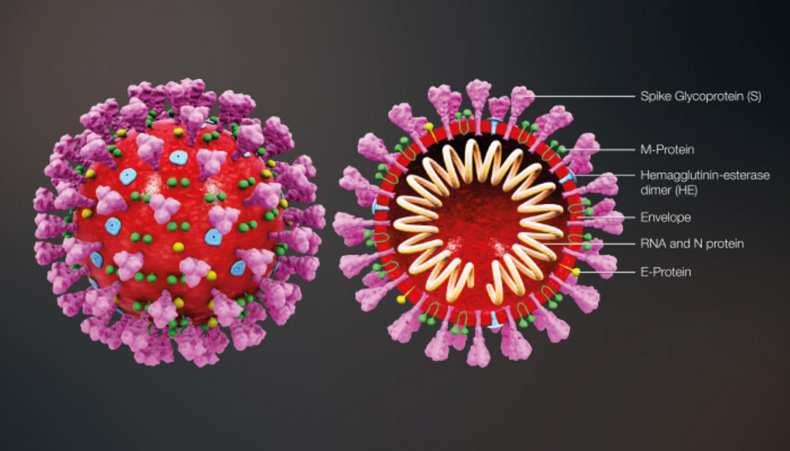
FIG 3.0: The structure of SARS-CoV-2. (Credit: Scientific Animations™, 2020).
SARS-CoV-2 is a betacoronavirus that shares 79 percent of its genetic sequence with SARS-CoV and has 96 percent homology with two coronaviruses in chrysanthemum bats. The pangolin is thought to the intermediate host between bats and humans. The virion contains four proteins (spike, envelope, membrane, and nucleocapsid) and single-stranded RNA
Upon entry into alveolar epithelial cells, SARS-CoV-2 replicates rapidly and triggers a strong immune response, resulting in cytokine storm syndromes and pulmonary tissue damage (Villar et al., 2019). Cytokine storm syndromes, also known as hypercytokinaemia, are a group of disorders characterised by the uncontrolled production of pro-inflammatory cytokines and are important causes of acute respiratory distress syndrome (ARDS) and multiple organ failure (Channappanavar and Perlman, 2017; Wang and Ma, 2007). Analysis of the first 99 confirmed cases of SARS-CoV-2 infection revealed that cytokine storm syndromes occurred in patients with severe COVID-19; 17 patients (17%) had ARDS, among whom 11 (11%) deteriorated within a short period of time and died of multiple organ failure (Chen et al., 2020) In addition, the numbers of total T-cells, CD4⁺ T-cells and CD8⁺ T-cells are decreased in patients with SARS-CoV-2 infection, and the surviving T-cells are functionally exhausted (Diao et al., 2020) , suggesting a decreased immune function in SARS-CoV-2-infected patients. ARDS, decreased immune function and secondary infection further worsens respiratory failure.
Patients infected with COVID-19 showed higher leukocyte numbers, abnormal respiratory findings, and increased levels of plasma pro-inflammatory cytokines. One of the COVID-19 case reports showed a patient at 5 days of fever presented with a cough, coarse breathing sounds of both lungs, and a body temperature of 39.0 °C. The patient's sputum showed positive real-time polymerase chain reaction results that confirmed COVID-19 infection (Lei et al., 2020). The laboratory studies showed leucopenia with leukocyte counts of 2.91 × 10^9 cells/L of which 70.0% were neutrophils. Additionally, a value of 16.16 mg/L of blood C-reactive protein was noted which is above the normal range (0–10 mg/L). High erythrocyte sedimentation rate and D-dimer were also observed (Lei et al., 2020). The main pathogenesis of COVID-19 infection as a respiratory system targeting virus was severe pneumonia, RNAaemia, combined with the incidence of ground-glass opacities, and acute cardiac injury (Huang et al., 20200. Significantly high blood levels of cytokines and chemokines were noted in patients with COVID-19 infection that included IL1-β, IL1RA, IL7, IL8, IL9, IL10, basic FGF2, GCSF, GMCSF, IFNγ, IP10, MCP1, MIP1α, MIP1β, PDGFB, TNFα, and VEGFA. Some of the severe cases that were admitted to the intensive care unit showed high levels of pro-inflammatory cytokines including IL2, IL7, IL10, GCSF, IP10, MCP1, MIP1α, and TNFα that are reasoned to promote disease severity (Huang et al., 2020).
The RNA genome consists of 29,900 nucleotides – larger than most other RNA viruses. One-third of the genome consists of genes for the four structural proteins and eight genes for accessory proteins that inhibit host defenses. Most of the remainder of the genome consists of the replicase gene, which encodes two large polyproteins that are cleaved into 15 or 16 nonstructural proteins (NSP) that assist in replicating and proofreading the viral genome (Plapp 2020).
3.1 Transmission
Because the first cases of the CoVID-19 disease were linked to direct exposure to the Huanan Seafood Wholesale Market of Wuhan, the animal-to-human transmission was presumed as the main mechanism. Nevertheless, subsequent cases were not associated with this exposure mechanism. Therefore, it was concluded that the virus could also be transmitted from human-to-human, and symptomatic people are the most frequent source of COVID-19 spread. The possibility of transmission before symptoms develop seems to be infrequent, although it cannot be excluded. Moreover, there are suggestions that individuals who remain asymptomatic could transmit the virus. This data suggests that the use of isolation is the best way to contain this epidemic (Cascella et al., 2020).
As with other respiratory pathogens, including flu and rhinovirus, the transmission is believed to occur through respiratory droplets from coughing and sneezing. Aerosol transmission is also possible in case of protracted exposure to elevated aerosol concentrations in closed spaces. Analysis of data related to the spread of SARS-CoV-2 in China seems to indicate that close contact between individuals is necessary. The spread, in fact, is primarily limited to family members, healthcare professionals, and other close contacts (Cascella et al., 2020).
Based on data from the first cases in Wuhan and investigations conducted by the China CDC and local CDCs, the incubation time could be generally within 3 to 7 days and up to 2 weeks as the longest time from infection to symptoms was 12.5 days (95% CI, 9.2 to 18) (Li et al., 2020). This data also showed that this novel epidemic doubled about every seven days, whereas the basic reproduction number (R0 - R naught) is 2.2. In other words, on average, each patient transmits the infection to an additional 2.2 individuals. Of note, estimations of the R0 of the SARS-CoV epidemic in 2002-2003 were approximately 3 (Bauch et al., 2005).
It must be emphasized that this information is the result of the first reports. Thus, further studies are needed to understand the mechanisms of transmission, the incubation times and the clinical course, and the duration of infectivity (Cascella et al., 2020).
SARS-CoV-2 virions attach to human cells with their densely glycosylated spike protein and bind with high affinity to the angiotensin-converting enzyme 2 receptor on human alveolar type II cells. Once the virus has attached to these receptors, the TMPRSS2 protease cleaves the spike protein to expose a fusion peptide. Virions are then able to release their RNA into infected cells, where it is replicated and translated into new viral proteins. Nucleocapsid proteins bind to RNA molecules and are then covered by the envelope and membrane proteins. Infected cells can produce 100 to 1,000 virions per day (Plapp, 2020).
- Histopathological features of COVID-19
(Tian et al.., 2020) and others reported histopathological data obtained on the lungs of two patients who underwent lung lobectomies for adenocarcinoma and retrospectively found to have had the infection at the time of surgery. Apart from the tumors, the lungs of both 'accidental' cases showed edema and important proteinaceous exudates as large protein globules. The authors also reported vascular congestion combined with inflammatory clusters of fibrinoid material and multinucleated giant cells and hyperplasia of pneumocytes.
Recently, Xu et al. reported the pathological features of the first patient known to have died from SARS-CoV-2 infection (Xu et al., 2020). Biopsy samples were obtained from lung tissue of the patient and it was found that the pathological features of COVID-19 are related to ARDS. For example, evident desquamation of pneumocytes and hyaline membrane formation were seen in the lung tissue, indicating ARDS. Moreover, interstitial mononuclear inflammatory infiltration was observed in lung tissue. Multinucleated giant cells with atypical enlarged pneumocytes characterised by large nuclei, prominent nucleoli and amphophilic granular cytoplasm were observed in the intra-alveolar spaces, suggesting viral cytopathic-like change (Xu et al., 2020). These pathological characteristics of COVID-19 are highly similar to those seen in SARS-CoV and MERS-CoV infection (Ng et al., 2016; Chung et al., 2020) Taken together, understanding the pathological characteristics of this severe case of COVID-19 could help to provide new insights into the pathogenesis of SARS-CoV-2-infected pneumonia, which may help physicians to formulate a timely strategy for the treatment of similar severe patients and to decrease mortality.
The virus (see Figure 4.0 ) appears to be transmitted primarily through large droplets, but it has also been found in stool and blood, raising questions about other potential modes of transmission. The incubation period was originally thought to range from one to 14 days with a median of five to six days, but recent case reports suggest that it may be as long as 24 days. Patients with COVID-19 have a median age of 59 years. They present with fever, dry cough, fatigue, myalgia, and shortness of breath. Patients may develop pneumonia towards the end of the first week of infection. The mean interval from onset of illness to hospitalization is between 9.1 and 12.5 days. Approximately 25 percent of patients have a severe course requiring intensive care, and approximately 10 percent require mechanical ventilation. The most severe cases develop pneumonia and acute respiratory distress syndrome. Children and younger adults have more benign disease
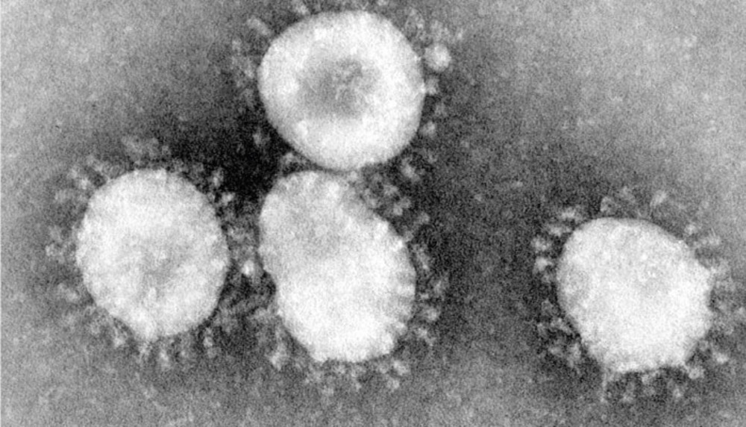
FIG 4.0: A coronavirus viewed under an electron microscope. (Credit: CDC/Fred Murphy, 2020).
One histopathological study of the lungs of a deceased patient reported the presence of hyaline membrane formation (see Figure 8), interstitial mononuclear inflammatory infiltrates, and multinucleated giant cells. These findings were consistent with acute respiratory distress syndrome.
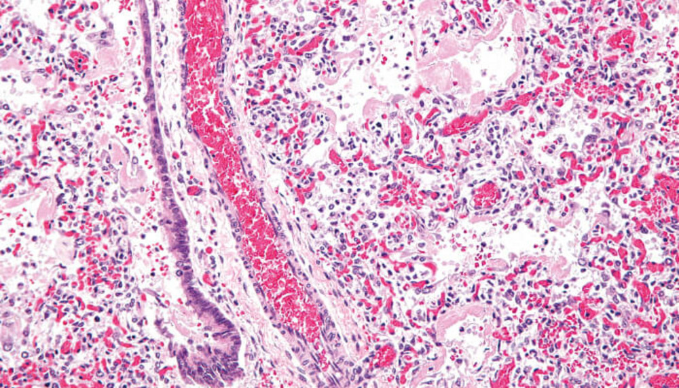
FIG 4.1: Hyaline membrane formation in diffuse alveolar damage, the histological correlate of acute respiratory distress syndrome. (Credit: Wikimedia user Nephron, 2020).
There is no doubt that pathological examination is very important to elucidate the pathological changes, pathogenesis and the cause of death of COVID-19. However, up to now, its clinical pathology remains largely unknown (Xu et al., 2020).
The following is a research conducted by (Luo et al., 2020) in which the whole lungs of surgical critical patient of COVID-19 was described, therefore for the first time, described the main pathological changes of patient with critical type.
Pathological tissues of the whole lung organ were collected in P3 laboratory, fix all tissues with 4% neutral buffered formaldehyde (pH = 7.0) for 24h. Dehydrate the fixed tissues in an ethanol series (100%, 95%, 80% and 75%) for 1 min in each percentage, clear in xylene and then embed in paraffin wax. Finally, cut the slices and incubate for 40 min in 70℃ oven. Special histochemical stains, for example, Masson staining was used to detect pulmonary interstitial fibrosis, periodic acid Schiff (PAS) staining and silver methenamin staining were used to identify bacterial and fungal infections. Masson kit (iron hematoxylin, bright red acid fuchsin working fluid, aniline blue, phosphomolybdic acid). Periodic acid Schiff and sliver methenamine kit (periodate, borax solution, silver nitrate hexamethylenetetramine powder) (Luo et al., 2020).
Immunohistochemical staining
The procedure of IHC was done as previously described.9 In brief, parafﬁn-embedded sections were deparafﬁnized in xylenes for 20 min and rehydrated in an ethanol gradient. The sections were submerged into EDTA buffer and boiled for 2 mins with high-pressure for antigenic retrieval. After natural cooling, the slides were treated with 3% H2O2 to quench endogenous peroxidase activity, followed by incubation with 1% bovine serum albumin (BSA). The slides were incubated with the primary antibodies including CD3, CD20, CD79a, CD4, CD8, CD5, CD68, CD38, CD31, TTF1, CK5/6, CK7, CK19, SMA, F VIII and Collagen IV (working dilution, Zymed, San Francisco, CA) overnight at 4 °C. The sections were reacted with the biotinylated secondary antibody (Zymed, San Francisco, CA) and visualized with 3,3′-diaminobenzidine (DAB) under the microscop(Luo et al., 2020)
Special staining
Special staining includes Masson staining, sirius red staining, reticular fibers staining and PAS staining. According to Masson staining, the tissues were fixed immediately in 10% formalin after dissection, paraffin-embed and section at 1.5 µm thickness. The slices were deparaffinized in dimethylbenzene, oxidize the slices with 1% periodate for 30 min and rinse with distilled water. Fix the tissues with 3% sodium thiosulfate for 1 min, replenish by the bouin's solution (37℃ water bath for 4 h) and wash the sections by distilled water for 5 min. The sections was dyed by Mayer hematoxylin and put into hot water (45℃) for 30s. Stain the specimens by Masson solution (100 μl) for 30 min. Differentiate the sections by 1% phosphomolybdic acid (100μl). Remove phosphomolybdic acid and add the sections with 1% aniline blue (100 μl). Rinse the sections with distilled water, add 1% acetic acid. Dehydrate the sections lastly by 95% and 100% alcohol (10 s and 1 min, respectively) and seal (Luo et al., 2020).
The results are as follows:
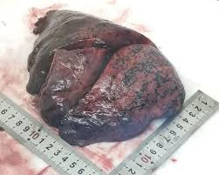
FIG 4.2: Gross morphology of the right lung. Haemorrhagic necrosis is obvious in the outer edge of pulmonary right lobe(Luo et al., 2020).
The results include;
Histopathological findings showed the main pulmonary pathological patterns were that extensive pulmonary interstitial fibrosis with partly hyaline degeneration, and pulmonary hemorrhagic infarct (figure 4.3A-C). Small vessels showed severe congestion, vessel wall thickening, and lumen stenosis and occlusion (figure 4.3D-E). Microthrombosis formations were present in the lumen (figure 4.3F-G). Focal interstitial infiltration of inflammatory cells including lymphocytes, plasma cells, macrophage and mononuclear cells (figure 2H-I)
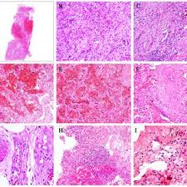
FIG 4.3: Pulmonary interstitial histopathological changes. (A) The whole slide imaging (WSI) by HE staining. Extensive pulmonary hemorrhagic changes and focal hemorrhagic Infarction (B) Massive pulmonary interstitial fibrosis. (C) Pulmonary interstitial fibrosis accompanied with partly hyaline degeneration. (D) Vascular wall thickening, lumen stenosis and hemorrhagic changes. (E) Boangiitis obliterans are surround by inflammatory cells. (F and G) Microthrombosis formation. (H) Focal inflammatory cells in the interstitium (square indicates). (I) Interstitial plasma cells infiltrating (square indicates).

There was necrotizing bronchiolitis manifested necrosis of bronchiolar wall and epithelial cells were present in the lumen. Alveolitis with atrophy, proliferation, desquamation and various changes of squamous metaplasia of alveolar epithelial cells were observed (mainly typeⅡ) (figure 4.4A-D). The remaining pulmonary alveoli showed thickened septum, necrosis and desquamation of alveolar epithelial cells (figure 4.4E-F). In addition, massive fibrinous exudate, multinucleate giant cells and intracytoplasmic viral inclusion bodies were observed (figure 4.4G-I).
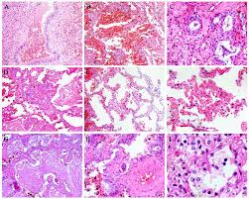
FIG 4.4: Pulmonary alveoli changes. (A) Necrotizing bronchiolitis, necrotic bronchial epithelial cells are present in the lumen. (B) Atrophy of alveolar epithelial cells and diffuse alveolar hemorrhage. (C) Squamous metaplasia of bronchiole epithelial cells (D) Squamous metaplasia of alveolar cells. (E) Widened alveolar septum. (F) Necrosis and desquamation of alveolar epithelial cells. (G) Inflammatory cells and massive fibrinous exudate in the lumen. (H) Multinucleate giant cell. (I) Intracytoplasmic viral inclusion body in alveolar epithelial cell (square frame indicates).

Special stain
On the other side, pulmonary interstitial fibrosis, as well as thickening of the vessel wall and fibrinous exudate were displayed by Masson staining (figure 4.5A-E). Enlarged and ruptured alveolar septum, massive pulmonary hemorrhage in alveolar cavity were found (figure 4.5F). In addition, extensive pulmonary interstitial fibrosis was also confirmed by
other special stains including sirius red staining (figure 4.5G), reticular fibers staining
(figure 4.5H) and PAS staining (figure 4.5I). No other bacterial and fungal infections were
detected by special staining.
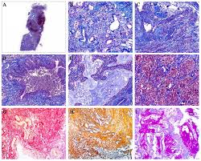
FIG 4.5: Pulmonary changes by special stain. (A) The whole slide imaging (WSI) by Masson staining. (B) Interstitial fibrosis by Masson stain. (C) The thickening of the vessel wall by Masson staining. (D) Fibrotic walls of dilated bronchioles by Masson staining. Desquamation of epithelial cells and inflammatory cells including macrophages in the lumen. (E) Massive fibrinous exudate in the bronchiole lumen. (F) Enlarged alveolar septum, and partly ruptured septum. Massive pulmonary hemorrhage in alveolar cavity. (G) Interstitial fibrosis by sirius red staining. (H) Interstitial fibrosis by reticular fibers staining. (I) Fibrinous transudation by PAS staining.

Immunohistochemistry
Immunohistological findings showed positive for immunologic cells including CD3
(figure 4.6A), CD4 (figure 4.6B), CD8 (figure 4.6C), CD20 (figure 4.6D), CD79a (figure 4.6E), CD5 (figure 4.6F) and CD38 (figure 4.6G). Notably, we found that the positive expressions of immunologic cells were present focally in lung interstitium and near blood vessels. In addition, CD31, TTF1, CK5/6, CK7 (figure 4.6H), CK19, SMA, F VIII and Collagen IV (figure 4.6I) also exhibited positive (some data not shown). The HE image of these serial immunohistological sections as shown in figure 2H.
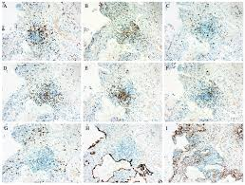
FIG 4.6: Immunohistological results in severe COVID-19. Serial sections showed the positive expressions of CD3 (A), CD4 (B), CD8 (C), CD20 (D), CD79a (E), CD5 (F), CD38 (G), CK7 (H) and collagen IV (I).
From the above research conducted it was further discovered that in this study, the surgical patient was diagnosed as critical case with COVID-19, and developed respiratory failure. In contrast, hyaline membrane formation was not detected, indicative of severe-phase ARDS and consistency with clinical diagnosis (Ding et al., 2004).
It was reported that the virus homology was over 85% between novel coronavirus pneumonia and severe acute respiratory syndrome (SARS). It means that the pathological changes of COVID-19 might be similar to SARS patient (Ding et al., 2003). With regard to the pulmonary pathology of SARS, Ding and other research groups had found the pulmonary changes including localized haemorrhage and necrosis, pulmonary alveolitis and bronchitis, desquamation of alveolar epithelial cells (Nicholls et al., 2020).
Results also showed the general pulmonary damages including alveolar edema with hemorrhage and bronchiolitis and alveolitis accompanied with inflammatory injury of epithelial cells. In the present study, one of the main pathological changes of critical COVID-19 was diffuse pulmonary interstitial fibrosis, suggestive of changes in late-stage disease. In addition, vascular wall thickening, lumen stenosis and occlusion occurred frequently under the microscopy, which might explain why some critical patients have pulmonary hypertension in later stage. However, the cause about vascular wall thickening and lumen stenosis need to be further investigated. Microthrombosis formation was also detected. These major changes might explain why late stage of critical patients develop severe hypoxaemia and respiratory failure (Zhou et al., 2020). On the other side, gross detection found that haemorrhagic necrosis existed predominantly in outer edge of the right lower lung lobe. This observation brings us two following hints:
1) It could be one of the main causes of fatal death about critical patients.
2) The main lesions of COVID-19 might firstly originate from here.
Recent study indicates that SARS-CoV-2 has the same cell entry receptor ACE2 as SARS-CoV (Li et al., 2003). Generally, ACE2 protein is expressed in alveolar cells, bronchial epithelium and vascular endothelium, therefore SARS-CoV-2 protein binds to ACE2 would result in acute lung injury and pulmonary edema (Puellman et al., 2006). It was observed that abundant pulmonary edema and hemorrhage, desquamated bronchial and alveolar epithelial cells (Harrison, 2010; Alcaraz-Quiles et al., 2018)
On the other side, cytokine storm links to an excessively exaggerated immune response, and uncontrolled proinflammatory responses, which causes severe organ diseases including lung damages. Several representative cytokines have been identified including IL-1β, IL-18, TNF-α, IL-6, IL-8 and IL-10, which are produced and regulated by various immunological cells including CD4 T cells and CD8 T cells (Savarin and Bergmann, 2018). Interestingly, we observed that lymphocytes including CD3 T cells 4 T cells and CD8 T cells , monocytes and plasma cells infiltrating into pulmonary interstitium, and these various types of inflammatory cells were confirmed by immunohistological method. It should be noted that local haemorrhagic necrosis occurred preferentially in outer edge of the right lower lung on gross detection. We suggest that the cytokine storm released by these inflammatory cells including CD4 and CD8 T cells could eventually lead to hemorrhagic necrosis, and ultimately result in severe and even fatal respiratory dysfunction of patients. More rigorous studies including experimental tests are needed to prove this prediction (Luo et al., 2020).
- Current potential therapies to address COVID-19

There is no specific antiviral treatment recommended for COVID-19, and no vaccine is currently available. The treatment is symptomatic, and oxygen therapy represents the major treatment intervention for patients with severe infection. Mechanical ventilation may be necessary in cases of respiratory failure refractory to oxygen therapy, whereas hemodynamic supsport is essential for managing septic shock(Cascella et al., 2020).

1)General treatments
General treatment strategies include bed rest and supportive treatments, ensuring sufficient energy intake, maintaining a constant internal environment (water, electrolytes and other internal environment factors) and monitoring vital signs (heart rate, pulse, blood pressure, oxygen saturation, respiratory rate, etc.).

2)Antiviral therapy

a) Interferon-alpha (IFNα): IFNα is a member of the family of type I IFNs that plays an important role in host resistance to viral infection. IFNα suppresses viral infection by directly interfering with replication of the virus and by promoting both innate and adaptive immune responses (Ströher et al., 2004). In vitro experiments showed that IFNα effectively inhibits the replication of SARS-CoV (Zorzitto et al., 2006). It has also been reported that cynomolgus monkeys are protected from infection with SARS CoV by treatment with IFNα (Haagmans et al., 2006). Moreover, the therapeutic benefit of synthetic recombinant IFNα for patients with SARS was demonstrated in a pilot clinical trial (Loutfy et al., 2003). Thus, IFNα should be considered a candidate drug for COVID-19 therapy.

b) Lopinavir/ritonavir (Kaletra): Lopinavir/ritonavir was first known as a protease inhibitor that interferes with the replication and synthesis of human immunodeficiency virus (HIV), leading to the production of immature, non-infectious virus particles (Walmsley et al., 2003; Pulido et al., 2008). It has been reported that ritonavir and lopinavir can bind to the endopeptidase C30 of SARS-CoV-2 protease as evaluated by molecular models (Lin et al., 2020). This suggests that lopinavir/ritonavir may exert an antiviral effect by inhibiting protein synthesis of SARS-CoV-2 (Chu et al., 2004). In addition, several lines of evidence showed that treatment with lopinavir/ritonavir alone or in combination with other antiviral drugs was shown to improve the outcome of severe patients with SARS or MERS by ameliorating ARDS (Sheahan et al., 2020; Zumla et al., 2016). Given that SARS-CoV-2 is similar to these two viruses, lopinavir/ritonavir may have a beneficial effect on COVID-19. Future studies are needed to test this possibility.

c) Ribavirin: Ribavirin is a nucleoside analogue with broad antiviral activity. It can prevent the replication of RNA and DNA viruses by suppressing the activity of inosine monophosphate dehydrogenase, which is required for the synthesis of guanosine triphosphate (GTP) (Wenzel and Edmond, 2003). Ribavirin was widely used to treat SARS patients with or without concomitant use of steroids during the outbreak of SARS in Hong Kong (Jones et al., 2004; Peiris et al., 2003). Thus, ribavirin could be considered as a treatment option for COVID-19 patients.

d) Chloroquine: Chloroquine is a widely used antimalarial and autoimmune disease drug. Recently, chloroquine has been reported as a potential broad-spectrum antiviral drug(Savarino et al., 2006; Yan et al., 2013). Wang et al. found that chloroquine effectively suppresses the recently emerged novel CoV (SARS-CoV-2) in vitro (Wang et al., 2020). Chloroquine is a cheap and safe drug that has been used for more than 70 years and thus it is potentially clinically applicable against COVID-19.

e) Arbidol (umifenovir): Arbidol is an antiviral drug against influenza infection that is widely used in Russia and China. Arbidol and arbidol mesylate were shown to have a potent inhibitory effect in reducing the reproduction of SARS-CoV in vitro (Khamitov et al., 2008).Low-level evidence including a retrospective cohort study, case reports and case series revealed that arbidol alone or combined with antiviral drugs produced certain benefits in the treatment of COVID-19 pneumonia (Wang et al., 2020; Zhang et al., 2020; Xu et al., 2020).Currently, many randomised clinical controlled trials are being carried out studying the efficacy of Arbidol on COVID-19 pneumonia in China.

f)Remdesivir: The nucleoside analogue remdesivir (GS-5734) was reported to inhibit SARS-CoV and MERS-CoV in vivo (de Wit et al., 2020; Agostini et al., 2018; Hammer et al., 2018). More recently, an in vitro study showed that remdesivir potently blocked SARS-CoV-2 infection at low-micromolar concentrations and showed a high selectivity index (Wang et al., 2020).In addition, the first case of SARS-CoV-2 infection in the USA was treated with intravenous remdesivir when the patient's condition deteriorated (Holshue et al 2020).Although remdesivir has some benefits for the treatment of COVID-19 pneumonia, randomised controlled trials are still required to determine its efficacy and safety.
Taken together, these antiviral drugs may be promising treatment options for the treatment of COVID-19. However, there are also a few points worth noting here: (i) the potential interaction of these antiviral drugs with other therapeutic drugs should be considered; (ii) adverse reactions caused by lopinavir/ritonavir, such as diarrhoea, nausea, vomiting and liver damage, should be also considered; (iii) it is not recommended to use three or more antiviral drugs at the same time, and the use of related drugs should be stopped when there are intolerable side effects; and (iv) further evaluation of the efficacy of current antiviral drugs in clinical applications is needed(Li et al., 2020).

3)Cellular therapy

a)Natural killer (NK) cells: NK cells are important immune cells necessary for defence against microbe-infected, stressed or malignant cells. Human NK cells lyse antibody-coated virus-infected cells via the process of antibody-dependent cellular cytotoxicity (ADCC) (Hammer et al., 2018). In this way, NK cells are specific to almost all virus-infected cells. Several studies have shown that NK cells can exert antiviral activity by mediating ADCC against SARS-CoV, herpes simplex virus type 1 (HSV-1), cytomegalovirus and HIV (Dai and Caligiuri 2018; Arase et al 2002). Umbilical cord blood is a promising source of allogeneic NK cells. Recently, Sorrento and Celularity have announced the launch of a clinical collaboration aimed at extending the use of CYNK-001, an allogeneic, off-the-shelf, umbilical cord blood-derived NK cell therapy, to the treatment of the newly emerged SARS-CoV-2 infection. Whilst developing new drugs, new vaccines or clinical trials of old drugs, carrying out NK cell therapy to enhance immunity is currently a very feasible strategy for the treatment and prevention of COVID-19 pneumonia (Li et al., 2020).

b) Mesenchymal stem cells (MSCs): It is well known that MSCs have strong anti-inflammatory and immunomodulatory functions (Ortiz et al., 2007). Umbilical cord blood and placenta are good sources of MSCs (Gupta et al., 2007). Numerous studies have shown that treatment with MSCs can ameliorate acute/chronic lung injury and ARDS by suppressing the infiltration of immune cells to pulmonary tissues and pro-inflammatory cytokine secretion (Moodley et al., 2007; Matthay et al., 2007). In addition, MSCs contribute to reducing lung fibrosis and enhancing tissue repair (Kumamoto et al., 2009; El Agha et al., 2017). Besides routine antiviral treatment, it is important to treat cytokine storm syndromes, ARDS and acute lung injury in patients with severe COVID-19 to prevent progression of the disease and to reduce mortality. Thus, MSCs may be a promising therapeutic option.

4) Immunotherapy

a)Convalescent plasma therapy: Antiviral antibodies (IgG, IgA, IgM, IgE and IgD) found in convalescent plasma from recovered patients can effectively treat patients with viral infections (Zhou et al., 2017). Convalescent plasma therapy has been widely used in infectious diseases such as poliomyelitis, influenza A (H5N1) and Ebola (van Griensven wt al., 2016; Rinaldo, 2005). In addition, such passive immunisation can also be achieved by using convalescent plasma from patients with SARS-CoV infection (Cheng et al., 2005). It has been reported that a small number of SARS-CoV-infected patients in Taiwan and Hong Kong received treatment with convalescent plasma during the early course of the disease with certain clinical benefits, including a reduction of plasma viral load from ~10⁵ copies/mL to undetectable levels 24 h after plasma transfusion(Wong and Yuen, 2008; Yeh et al., 2005). Thus, convalescent plasma could, theoretically, be a promising option for the treatment and prevention of SARS-CoV-2 infection, although this has not been tested clinically.

b) Monoclonal antibodies: Remission of the SARS-CoV-2 epidemic may depend on the development of monoclonal antibodies (ter Meulen et al., 2004). Previous studies have identified a number of effective monoclonal antibodies that target the SARS-CoV spike protein to prevent the virus from entering host cells (ter Meulen et al., 2006; Traggiai et al., 2004). The 193-amino acid (residues 318–510) receptor-binding domain (RBD) of the spike protein is the key target of neutralising monoclonal antibodies (Wong et al., 2004). The SARS-CoV neutralising monoclonal antibodies CR3014 and CR3022 were found to bind non-competitively to the SARS-CoV RBD and neutralised the virus in a synergistic manner (ter Meulen et al., 2006). A recent study showed that CR3022 could combine effectively with SARS-CoV-2 RBD (K_{D} of 6.3 nM) (Tian et al.,2020 ). Moreover, the epitope of CR3022 does not overlap with the binding site of ACE2 in the SARS-CoV-2 RBD (Tian et al., 2020). Thus, CR3022 could be a promising therapeutic candidate, alone or in combination with other neutralising monoclonal antibodies, for the treatment of COVID-19 pneumonia.

5) Chinese medicine: Glycyrrhizin, an active component of liquorice roots used in Chinese medicine, could effectively inhibit the replication of SARS-associated CoV in vitro (Cinatl et al., 2006; Hoever et al., 2005). Furthermore, high doses of glycyrrhizin have been used in clinical trials and the compound was reported to be clinically effective for the treatment of SARS at that time (Lu et al., 2006; Wu et al., 2004). Recently, glycyrrhizin was predicted to have the ability to bind ACE2 with potential anti-COVID-19 effects (Chen and Du, 2020). Hesperetin, a well-known traditional Chinese medicine, is a natural predominant flavonoid found in citrus fruits. Hesperetin dose-dependently suppresses the cleavage activity of the 3C-like protease (3CLpro) of SARS-CoV in cell-free and cell-based assays (Lin et al., 2005). Hesperetin was also reported to have the potential to inhibit ACE2 and therefore block infection with SARS-CoV-2 (Chen and Du, 2020). Baicalin, another traditional Chinese herbal medicine, is a flavone isolated from Scutellaria baicalensis. It has been shown that baicalin has antiviral activity against 10 clinical isolates of SARS-CoV by neutralisation tests (Chen et al., 2004).In addition, quercetin is a plant flavone that is widely used in traditional Chinese medicine and botanical medicine. Quercetin was reported to exert antiviral effects by inhibiting the 3CLpro of SARS-CoV (Chen et al., 2006) and blocking the entry of SARS-CoV into host cells (Yi et al., 2004 ). Therefore, these studies suggest that Chinese medicine also plays a key role in the prevention and treatment of COVID-19 pneumonia.

As of January 22, 2020, a total of 571 cases of the 2019-new coronavirus (2019-nCoV) have been reported in 25 provinces (districts and cities) in China. At present, there is no vaccine or antiviral treatment for human and animal coronavirus, so that identifying the drug treatment options as soon as possible is critical for the response to the 2019-nCoV outbreak. Three general methods, which include existing broad-spectrum antiviral drugs using standard assays, screening of a chemical library containing many existing compounds or databases, and the redevelopment of new specific drugs based on the genome and biophysical understanding of individual coronaviruses, are used to discover the potential antiviral treatment of human pathogen coronavirus. Lopinavir /Ritonavir, Nucleoside analogues, Neuraminidase inhibitors, Remdesivir, peptide (EK1), abidol, RNA synthesis inhibitors (such as TDF, 3TC), anti-inflammatory drugs (such as hormones and other molecules), Chinese traditional medicine, such ShuFengJieDu Capsules and Lianhuaqingwen Capsule, could be the drug treatment options for 2019-nCoV. However, the efficacy and safety of these drugs for 2019- nCoV still need to be further confirmed by clinical experiments(Lu, 2020).

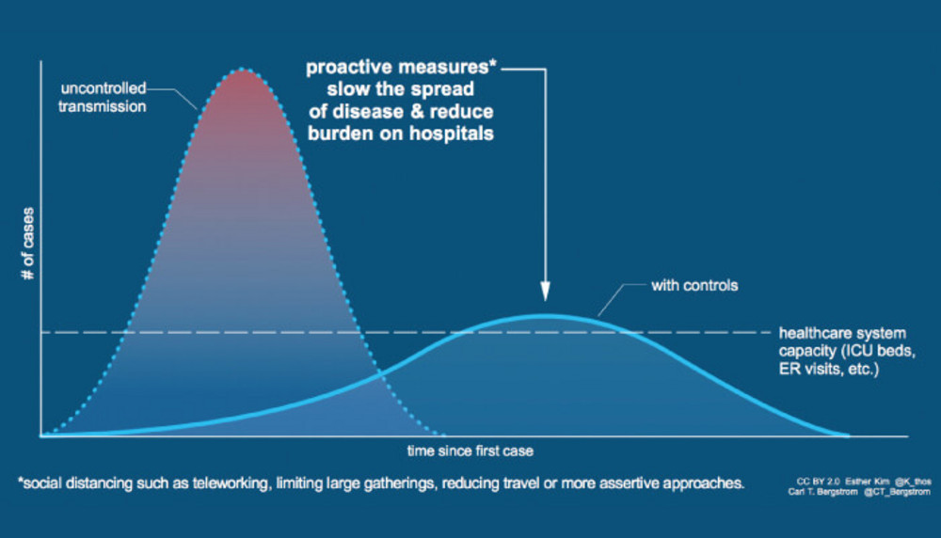

FIG 5.0: “Flattening the curve,” a mitigation approach to lower and delay the epidemic peak. (Credit: Esther Kim and Carl T. Bergstrom, 2020).

- Future of COVID-19 on public health
The onset of the novel Coronavirus Disease 2019 (COVID-19) out-break in Wuhan, China, suggests animal-to-person spread and laterperson-to-person spread. . The complete clinical picture following COVID-19 infection is not yet fully understood.
The WHO's declaration of COVID-19 to be a Public Health Emergency of International Concern is attributable to the high case fatality rates in China and the global economic effect of COVID-19,which may compound the current ongoing influenza epidemic Furthermore, there is the potential for higher death rates in countries with vulnerable health systems in resource limited regions (WHO, 2020). The ability to control local transmission depends on the application of the principles of rapid identification, prevention, and control, followed by patient isolation, rapid diagnosis, and contact tracing. Some countries remain ill equipped with limited diagnostic capacity, resulting in delays from suspected case identification to vector confirmation and patient isolation, which increases the risk of disease transmission (Gilbert et al., 2020). Though, 74% of countries in Africa have an influenza pandemic preparedness plan; however, most are outdated and inadequate to deal with a global pandemic such as COVID-19 (Sambala et al., 2018).

Conclusion
According to the World Health Organization (WHO), viral diseases continue to emerge and represent a serious issue to public health. In the last twenty years, several viral epidemics such as the severe acute respiratory syndrome coronavirus (SARS-CoV) in 2002 to 2003, and H1N1 influenza in 2009, have been recorded. Most recently, the Middle East respiratory syndrome coronavirus (MERS-CoV) was first identified in Saudi Arabia in 2012(Cascella et al., 2020).
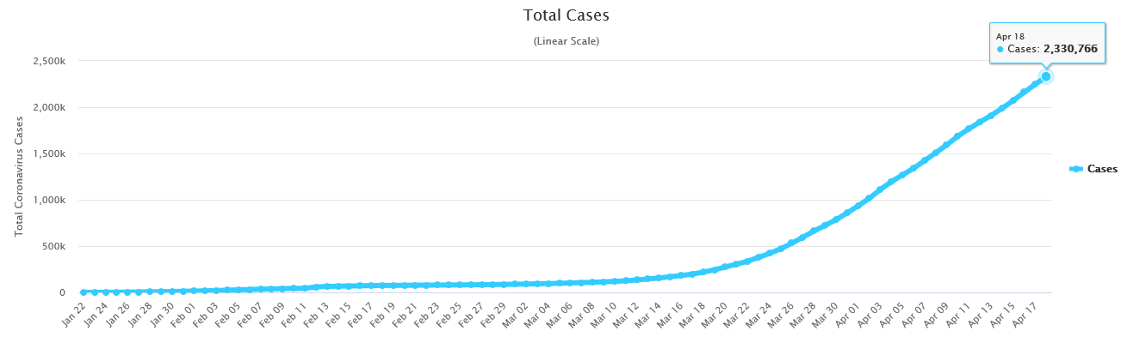
-A linear scale showing total cases of COVID-19 as of April 18, (WHO, 2020)
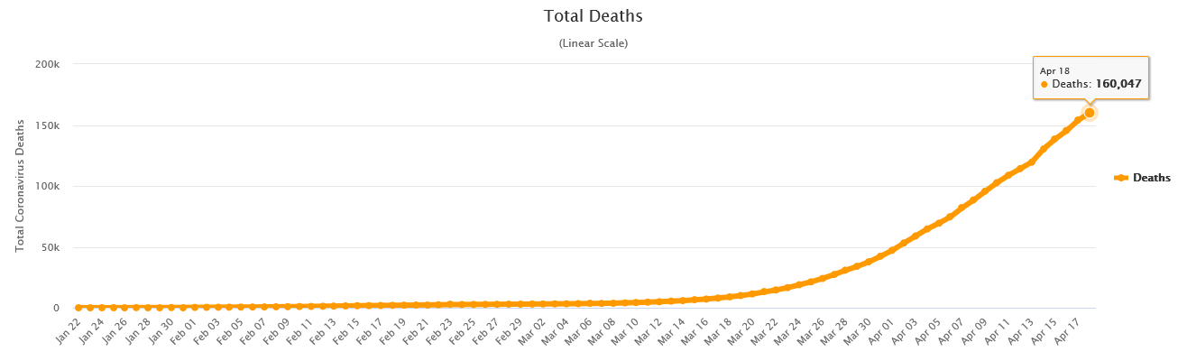
-A linear scale showing total number of deaths of COVID-19 as of April 18, (WHO, 2020)
The 2019 novel coronavirus pneumonia was officially named by the World Health Organization (WHO) as COVID-19. COVID-19 caused by SARS-CoV-2 was firstly emerged in December 2019, Wuhan city, and resulted in other cities including Shenzhen in China and other counties (Chen et al., 2020;Wu et al., 2020). The world is experiencing a global viral epidemic of COVID-19. Reports regarding epidemiological and clinical characteristics of COVID-19 are accumulating (Zhu et al., 2020; Li et al., 2020; Wang et al., 2020).
SARS-CoV first appeared in 2002 and rapidly spread to 32 countries and regions, after which the world then experienced the outbreak of MERS-CoV in 2012(Zhang et al., 2020). Recently, the newly emerged SARS-CoV-2 is undoubtedly a warning (Chai et al., 2020). It has been confirmed that SARS-CoV-2 enters lung cells by binding to ACE2 (Li et al., 2020). Besides pulmonary tissue, ACE2 is also highly expressed in other tissues including bile duct, liver, gastrointestinal organs (small intestine, duodenum), oesophagus, testis and kidney(Fan et al., 2020).
Although there are several theories about how COVID-19 came to be, any of them is still yet to be proved.

Reference
Agostini ML, Andres EL, Sims AC, Graham RL, Sheahan TP, Lu X. Coronavirus susceptibility to the antiviral remdesivir (GS-5734) is mediated by the viral polymerase and the proofreading exoribonuclease. mBio. 2018;9 pii: e00221-18.
Alcaraz-Quiles J, Casulleras M, Oettl K, et al. Oxidized Albumin Triggers a Cytokine Storm in Leukocytes Through P38 Mitogen-Activated Protein Kinase: Role in Systemic Inflammation in Decompensated Cirrhosis. Hepatology. 2018;68(5):1937-1952.
Arase H, Mocarski ES, Campbell AE, Hill AB, Lanier LL. Direct recognition of cytomegalovirus by activating and inhibitory NK cell receptors. Science. 2002;296:1323–1326.
Bailey, O. T., A. M. Pappenheimer, F. Sargent, M. D. Cheever, and J. B. Daniels. 1949. A murine virus (JHM) causing disseminated encephalomyelitis with extensive destruction of myelin. II. Pathology. J. Exp. Med. 90:195-212.
Banerjee A, Kulcsar K, Misra V, Frieman M, Mossman K. Bats and coronaviruses. Viruses. 2019;11 pii: E41.
Bauch CT, Lloyd-Smith JO, Coffee MP, Galvani AP. Dynamically modeling SARS and other newly emerging respiratory illnesses: past, present, and future. Epidemiology. 2005 Nov;16(6):791-801.
C. Huang, Y. Wang, X. Li, L. Ren, J. Zhao, Y. Hu, et al.Clinical features of patients infected with 2019 novel coronavirus in Wuhan, China Lancet, 395 (10223) (2020), pp. 497-506, 10.1016/S0140-6736(20)30183-5.
Cascella M, Rajnik M, Cuomo A, et al. Features, Evaluation and Treatment Coronavirus (COVID-19) [Updated 2020 Apr 6]. In: StatPearls [Internet]. Treasure Island (FL): StatPearls Publishing; 2020 Jan-. Available from: https://www.ncbi.nlm.nih.gov/books/NBK554776/
Chai X, Hu L, Zhang Y, Han W, Lu Z, Ke A. Specific ACE2 expression in cholangiocytes may cause liver damage after 2019-nCoV infection. bioRxiv. 2020 Feb 4.
Chan JF, To KK, Tse H, Jin DY, Yuen KY. Interspecies transmission and emergence of novel viruses: lessons from bats and birds. Trends Microbiol. 2013 Oct;21(10):544-55.
Chan JF, Kok KH, Zhu Z, Chu H, To KK, Yuan S, Yuen KY. Genomic characterization of the 2019 novel human-pathogenic coronavirus isolated from a patient with atypical pneumonia after visiting Wuhan. Emerg Microbes Infect. 2020;9(1):221-236.
Channappanavar R, Perlman S. Pathogenic human coronavirus infections: causes and consequences of cytokine storm and immunopathology. Semin Immunopathol. 2017;39:529–539.
Cheever, F. S., J. B. Daniels, A. M. Pappenheimer, and O. T. Baily. 1949. A murine virus (JHM) causing disseminated encephalomyelitis with extensive destruction of myelin. I. Isolation and biological properties of the virus. J. Exp. Med. 90:181-194.
Chen F, Chan KH, Jiang Y, Kao RY, Lu HT, Fan KW. In vitro susceptibility of 10 clinical isolates of SARS coronavirus to selected antiviral compounds. J Clin Virol. 2004;31:69–75.
Chen H, Du Q. Potential natural compounds for preventing 2019-nCoV infection. Preprints. 2020
Chen L, Li J, Luo C, Liu H, Xu W, Chen G. Binding interaction of quercetin-3-β-galactoside and its synthetic derivatives with SARS-CoV 3CL(pro): structure–activity relationship studies reveal salient pharmacophore features. Bioorg Med Chem. 2006;14:8295–8306.
Chen N, Zhou M, Dong X, et al. Epidemiological and clinical characteristics of 99 cases of 2019 novel coronavirus pneumonia in Wuhan, China: a descriptive study. Lancet. 2020. pii: S0140-6736(20)30211-7.
Chen N, Zhou M, Dong X, Qu J, Gong F, Han Y. Epidemiological and clinical characteristics of 99 cases of 2019 novel coronavirus pneumonia in Wuhan, China: a descriptive study. Lancet. 2020;395:507–513.
Chen Y, Liu Q, Guo D. Emerging coronaviruses: Genome structure, replication, and pathogenesis. J. Med. Virol. 2020 Apr;92(4):418-423.
Cheng Y, Wong R, Soo YO, Wong WS, Lee CK, Ng MH. Use of convalescent plasma therapy in SARS patients in Hong Kong. Eur J Clin Microbiol Infect Dis. 2005;24:44–46.
Chu CM, Cheng VC, Hung IF, Wong MM, Chan KH, Chan KS. Role of lopinavir/ritonavir in the treatment of SARS: initial virological and clinical findings. Thorax. 2004;59:252–256.
Cinatl J, Morgenstern B, Bauer G, Chandra P, Rabenau H, Doerr HW. Glycyrrhizin, an active component of liquorice roots, and replication of SARS-associated coronavirus. Lancet. 2003;361:2045–2046.
Cowley, J. A., C. M. Dimmock, K. M. Spann, and P. J. Walker. 2000. Gill-associated virus of Penaeus monodon prawns: an invertebrate virus with ORF1a and ORF1b genes related to arteri- and coronaviruses. J. Gen. Virol. 81:1473-1484
Dai HS, Caligiuri MA. Molecular basis for the recognition of herpes simplex virus type 1 infection by human natural killer cells. Front Immunol. 2018;9:183.
De Wit E, Feldmann F, Cronin J, Jordan R, Okumura A, Thomas T. Prophylactic and therapeutic remdesivir (GS-5734) treatment in the rhesus macaque model of MERS-CoV infection. Proc Natl Acad Sci U S A. 2020;117:6771–6776.
De Wit E, van Doremalen N, Falzarano D, Munster VJ. SARS and MERS: recent insights into emerging coronaviruses. Nat Rev Microbiol. 2016;14:523–534.
Diao B, Wang C, Tan Y, Chen X, Liu Y, Ning L. Reduction and functional exhaustion of T cells in patients with coronavirus disease 2019 (COVID-19) medRxiv. 2020 Feb 20.
Ding Y, He L, Zhang Q, et al. Organ distribution of severe acute respiratory syndrome (SARS) associated coronavirus (SARS-CoV) in SARS patients: implications for pathogenesis and virus transmission pathways. J Pathol. 2004;203(2):622-30.
Ding Y, Wang H, Shen H, Li Z, Geng J, Han H. The clinical pathology of severe acute respiratory syndrome (SARS): a report from China. J Pathol. 2003;200:282–289.
El Agha E, Kramann R, Schneider RK, Li X, Seeger W, Humphreys BD. Mesenchymal stem cells in fibrotic disease. Cell Stem Cell. 2017;21:166–177.
Enjuanes, L., D. Cavanagh, K. Holmes, M. M. C. Lai, H. Laude, P. Masters, P. Rottier, S. G. Sidell, W. J. M. Spaan, F. Taguchi, and P. Talbot. 2000. Coronaviridae, p. 835-849.
E.Z.Sambala,T.Kanyenda,C.J.Iwu,C.D.Iwu,A.Jaca,C.S.Wiysonge,PandemicinfluenzapreparednessintheWHOAfricanregion:arewereadyyet?BMCInfect.Dis.18(1)(2018Dec1)567
Fan C, Li K, Ding Y, Lu WL, Wang J. ACE2 expression in kidney and testis may cause kidney and testis damage after 2019-nCoV infection. medRxiv. 2020 Feb 13.
Gelderblom HR. Structure and Classification of Viruses. In: Baron S, editor. Medical Microbiology. 4th edition. Galveston (TX): University of Texas Medical Branch at Galveston;1996.Chapter41.Availablefrom:https://www.ncbi.nlm.nih.gov/books/NBK8174/
Graham RL, Donaldson EF, Baric RS. A decade after SARS: strategies for controlling emerging coronaviruses. Nat Rev Microbiol. 2013;11:836–848.
Gui M, Song W, Zhou H, Xu J, Chen S, Xiang Y. Cryo-electron microscopy structures of the SARS-CoV spike glycoprotein reveal a prerequisite conformational state for receptor binding. Cell Res. 2017;27:119–129.
Gupta N, Su X, Popov B, Lee JW, Serikov V, Matthay MA. Intrapulmonary delivery of bone marrow-derived mesenchymal stem cells improves survival and attenuates endotoxin-induced acute lung injury in mice. J Immunol. 2007;179:1855–1863.
Haagmans BL, Kuiken T, Martina BE, Fouchier RA, Rimmelzwaan GF, van Amerongen G. Pegylated interferon-α protects type 1 pneumocytes against SARS coronavirus infection in macaques. Nat Med. 2004;10:290–293.
Hammer Q, Ruckert T, Romagnani C. Natural killer cell specificity for viral infections. Nat Immunol. 2018;19:800–808.
Harrison C. Sepsis: calming the cytokine storm. Nat Rev Drug Discov. 2010;9(5):360-1.

Hoever G, Baltina L, Michaelis M, Kondratenko R, Baltina L, Tolstikov GA. Antiviral activity of glycyrrhizic acid derivatives against SARS-coronavirus. J Med Chem. 2005;48:1256–1259.
Hui DS, I Azhar E, Madani TA, Ntoumi F, Kock R, Dar O. The continuing 2019-nCoV epidemic threat of novel coronaviruses to global health—the latest 2019 novel coronavirus outbreak in Wuhan, China. Int J Infect Dis. 2020;91:264–266.
Hui DS, Azhar EI, Kim YJ, Memish ZA, Oh MD, Zumla A. Middle East respiratory syndrome coronavirus: risk factors and determinants of primary, household, and nosocomial transmission. Lancet Infect Dis. 2018;18:e217–e227.
J. Lei, J. Li, X. Li, X. QiCT imaging of the 2019 novel coronavirus (2019-nCoV) pneumoniaRadiology (2020), p. 200236.
Jones BM, Ma ES, Peiris JS, Wong PC, Ho JC, Lam B. Prolonged disturbances of in vitro cytokine production in patients with severe acute respiratory syndrome (SARS) treated with ribavirin and steroids. Clin Exp Immunol. 2004;135:467–473.
Khamitov RA, Loginova S, Shchukina VN, Borisevich SV, Maksimov VA, Shuster AM. Antiviral activity of arbidol and its derivatives against the pathogen of severe acute respiratory syndrome in the cell cultures [in Russian] Vopr Virusol. 2008;53:9–13.
Kuba K, Imai Y, Rao S, Gao H, Guo F, Guan B. A crucial role of angiotensin converting enzyme 2 (ACE2) in SARS coronavirus-induced lung injury. Nat Med. 2005;11:875–879.
Kumamoto M, Nishiwaki T, Matsuo N, Kimura H, Matsushima K. Minimally cultured bone marrow mesenchymal stem cells ameliorate fibrotic lung injury. Eur Respir J. 2009;34:740–748.
Li F. Structure, function, and evolution of coronavirus spike proteins. Annu Rev Virol. 2016;3:237–261.
Li, H., Liu, S. M., Yu, X. H., Tang, S. L., & Tang, C. K. (2020). Coronavirus disease 2019 (COVID-19): current status and future perspectives. International journal of antimicrobialagents,105951.Advanceonlinepublication. https://doi.org/10.1016/j.ijantimicag.2020.105951
Li Q, Guan X, Wu P, et al. Early Transmission Dynamics in Wuhan, China, of Novel Coronavirus-Infected Pneumonia. N Engl J Med. 2020. doi: 10.1056/NEJMoa2001316.
Li Q, Guan X, Wu P, Wang X, Zhou L, Tong Y. Early transmission dynamics in Wuhan, China, of novel coronavirus-infected pneumonia. N Engl J Med. 2020;382:1199–1207.
Li Q, Guan X, Wu P, Wang X, Zhou L, Tong Y, Ren R, Leung KSM, Lau EHY, Wong JY, Xing X, Xiang N, Wu Y, Li C, Chen Q, Li D, Liu T, Zhao J, Liu M, Tu W, Chen C, Jin L, Yang R, Wang Q, Zhou S, Wang R, Liu H, Luo Y, Liu Y, Shao G, Li H, Tao Z, Yang Y, Deng Z, Liu B, Ma Z, Zhang Y, Shi G, Lam TTY, Wu JT, Gao GF, Cowling BJ, Yang B, Leung GM, Feng Z. Early Transmission Dynamics in Wuhan, China, of Novel Coronavirus-Infected Pneumonia. N. Engl. J. Med. 2020 Mar 26;382(13):1199-1207.s
Li W, Moore MJ, Vasilieva N, et al. Angiotensin-converting enzyme 2 is a functional receptor for the SARS coronavirus. Nature. 2003;426(6965):450-4.
Li Z, Wu M, Yao J, Guo J, Liao X, Song S. Caution on kidney dysfunctions of 2019-nCoV patients. medRxiv. 2020 Mar 27.
Lin CW, Tsai FJ, Tsai CH, Lai CC, Wan L, Ho TY. Anti-SARS coronavirus 3C-like protease effects of Isatis indigotica root and plant-derived phenolic compounds. Antiviral Res. 2005;68:36–42.
Lin S, Shen R, Guo X. Molecular modeling evaluation of the binding abilities of ritonavir and lopinavir to Wuhan pneumonia coronavirus proteases. bioRxiv. 2020 Feb 3.
Loutfy MR, Blatt LM, Siminovitch KA, Ward S, Wolff B, Lho H. Interferon alfacon-1 plus corticosteroids in severe acute respiratory syndrome: a preliminary study. JAMA. 2003;290:3222–3228.
Lu G, Wang Q, Gao GF. Bat-to-human: spike features determining ‘host jump’ of coronaviruses SARS-CoV, MERS-CoV, and beyond. Trends Microbiol. 2015;23:468–478.
Lu H. (2020). Drug treatment options for the 2019-new coronavirus (2019-nCoV). Bioscience trends, 14(1), 69–71. https://doi.org/10.5582/bst.2020.01020.
Lu H, Huo N, Wang G, Li H, Nie L, Xu X. Clinical observation of therapeutic effect of compound glycyrrhizin on SARS. China Pharmacy. 2003;10.
M.Gilbert,G.Pullano,F.Pinotti,E.Valdano,C.Poletto,P.Y.Boëlle,E.D’Ortenzio,Y.Yazdanpanah,S.P.Eholie,M.Altmann,B.Gutierrez,PreparednessandvulnerabilityofAfricancountriesagainstimportationsofCOVID19:amodellingstudy,Lancet(2020Feb20),https://doi.org/10.1016/S0140-6736(20)30411-6S0140-6736(20)30411-6.
Matthay MA, Goolaerts A, Howard JP, Lee JW. Mesenchymal stem cells for acute lung injury: preclinical evidence. Crit Care Med. 2010;38(10 Suppl):S569–S573.
Moodley Y, Atienza D, Manuelpillai U, Samuel CS, Tchongue J, Ilancheran S. Human umbilical cord mesenchymal stem cells reduce fibrosis of bleomycin-induced lung injury. Am J Pathol. 2009;175:303–313.
Ng DL, Al Hosani F, Keating MK, Gerber SI, Jones TL, Metcalfe MG. Clinicopathologic, immunohistochemical, and ultrastructural findings of a fatal case of Middle East respiratory syndrome coronavirus infection in the United Arab Emirates, April 2014. Am J Pathol. 2016;186:652–658.
Nicholls JM1, Poon LL, Lee KC, et al. Lung pathology of fatal severe acute respiratory syndrome. Lancet. 361(9371):1773-8.
Novel Coronavirus (2019-nCoV) situation reports - World Health Organization (WHO).
Ortiz LA, Dutreil M, Fattman C, Pandey AC, Torres G, Go K. Interleukin 1 receptor antagonist mediates the antiinflammatory and antifibrotic effect of mesenchymal stem cells during lung injury. Proc Natl Acad Sci U S A. 2007;104:11002–11007.
Paules CI, Marston HD, Fauci AS. Coronavirus infections—more than just the common cold. JAMA. 2020 Jan 23
Peiris JS, Lai ST, Poon LL, Guan Y, Yam LY, Lim W. Coronavirus as a possible cause of severe acute respiratory syndrome. Lancet. 2003;361:1319–1325.
Puellmann K, Beham AW, Kaminski WE. Cytokine storm and an anti-CD28 monoclonal antibody. N Engl J Med. 2006;355(24):2592-3.
Pulido F, Arribas JR, Delgado R, Cabrero E, González-García J, Pérez-Elias MJ. Lopinavir–ritonavir monotherapy versus lopinavir–ritonavir and two nucleosides for maintenance therapy of HIV. AIDS. 2008;22:F1–F9.
Ramaiah A, Arumugaswami V. Insights into cross-species evolution of novel human coronavirus 2019-nCoV and defining immune determinants for vaccine development. bioRxiv. 2020 Jan 30.
Raj VS, Mou H, Smits SL, Dekkers DH, Müller MA, Dijkman R. Dipeptidyl peptidase 4 is a functional receptor for the emerging human coronavirus-EMC. Nature. 2013;495:251–254.
Reusken CB, Haagmans BL, Müller MA, Gutierrez C, Godeke GJ, Meyer B. Middle East respiratory syndrome coronavirus neutralising serum antibodies in dromedary camels: a comparative serological study. Lancet Infect Dis. 2013;13:859–866.
Rinaldo CR., Jr. Passive immunization against poliomyelitis: the Hammon gamma globulin field trials, 1951–1953. Am J Public Health. 2005;95:790–799.
Savarino A, Di Trani L, Donatelli I, Cauda R, Cassone A. New insights into the antiviral effects of chloroquine. Lancet Infect Dis. 2006;6:67–69.
Savarin C, Bergmann CC. Fine Tuning the Cytokine Storm by IFN and IL-10 Following Neurotropic Coronavirus Encephalomyelitis. Front Immunol. 2018;9:3022.
Sheahan TP, Sims AC, Leist SR, Schäfer A, Won J, Brown AJ. Comparative therapeutic efficacy of remdesivir and combination lopinavir, ritonavir, and interferon beta against MERS-CoV. Nat Commun. 2020;11:222.
Song Z, Xu Y, Bao L, Zhang L, Yu P, Qu Y. From SARS to MERS, thrusting coronaviruses into the spotlight. Viruses. 2019;11 pii: E59.
Sorrento and Celularity to initiate emergency allogeneic natural killer (NK) cell therapy development for coronavirus infection. https://seekingalpha.com/pr/17762358-sorrento-and-celularity-to-initiate-emergency-allogeneic-natural-killer-nk-cell-therapy[accessed 1 April 2020].
Ströher U, DiCaro A, Li Y, Strong JE, Aoki F, Plummer F. Severe acute respiratory syndrome-related coronavirus is inhibited by interferon-alpha. J Infect Dis. 2004;189:1164–1167.
Su S, Wong G, Liu Y, Gao GF, Li S, Bi Y. MERS in South Korea and China: a potential outbreak threat? Lancet. 2015;385:2349–2350.
ter Meulen J, Bakker AB, van den Brink EN, Weverling GJ, Martina BE, Haagmans BL. Human monoclonal antibody as prophylaxis for SARS coronavirus infection in ferrets. Lancet. 2004;363:2139–2141.
ter Meulen J, van den Brink EN, Poon LL, Marissen WE, Leung CS, Cox F. Human monoclonal antibody combination against SARS coronavirus: synergy and coverage of escape mutants. PLoS Med. 2006;3:e237.
Tian S, Hu W, Niu L, Liu H, Xu H, Xiao SY. Pulmonary Pathology of Early-Phase 2019 Novel Coronavirus (COVID-19) Pneumonia in Two Patients With Lung Cancer. J Thorac Oncol. 2020 Feb 28;
Tian X, Li C, Huang A, Xia S, Lu S, Shi Z. Potent binding of 2019 novel coronavirus spike protein by a SARS coronavirus-specific human monoclonal antibody. Emerg Microbes Infect. 2020;9:382–385.
Traggiai E, Becker S, Subbarao K, Kolesnikova L, Uematsu Y, Gismondo MR. An efficient method to make human monoclonal antibodies from memory B cells: potent neutralization of
SARS coronavirus. Nat Med. 2004;10:871–875.
TheHarvardGazetteCoronavirusCasesHit17,400andAreLikelytoSurge(2020)https://news.harvard.edu/gazette/story/2020/02/as-confirmed-cases-of-coronavirus-surge-path-growsuncertain/
The involvement of natural killer cells in the pathogenesis of severe acute respiratory syndrome. Am J Clin Pathol. 2004;121:507–511.
Tyrrel, D. A. J., J. D. Almedia, D. M. Berry, C. H. Cunningham, D. Hamre, M. S. Hofstad, L. Malluci, and K. McIntosh. 1968. Coronavirus. Nature 220:650.
van Griensven J, Edwards T, de Lamballerie X, Semple MG, Gallian P, Baize S. Evaluation of convalescent plasma for Ebola virus disease in Guinea. N Engl J Med. 2016;374:33–42.
Villar J, Zhang H, Slutsky AS. Lung repair and regeneration in ARDS: role of PECAM1 and Wnt signaling. Chest. 2019;155:587–594.
W. Wang, J. Tang, F. WeiUpdated understanding of the outbreak of 2019 novel coronavirus (2019-nCoV) in Wuhan, ChinaJ. Med. Virol., 92 (4) (2020), pp. 441-447.
Walls AC, Xiong X, Park YJ, Tortorici MA, Snijder J, Quispe J. Unexpected receptor functional mimicry elucidates activation of coronavirus fusion. Cell. 2019;176 1026–39.e15.
Walmsley S, Bernstein B, King M, Arribas J, Beall G, Ruane P. Lopinavir–ritonavir versus nelfinavir for the initial treatment of HIV infection. N Engl J Med. 2002;346:2039–2046.
Wang D, Hu B, Hu C, et al. Clinical Characteristics of 138 Hospitalized Patients With 2019 Novel Coronavirus-Infected Pneumonia in Wuhan, China. JAMA. 2020. doi: 10.1001/jama.2020.1585.

Wang H, Ma S. The cytokine storm and factors determining the sequence and severity of organ dysfunction in multiple organ dysfunction syndrome. Am J Emerg Med. 2008;26:711–715.
Wang M, Cao R, Zhang L, Yang X, Liu J, Xu M. Remdesivir and chloroquine effectively inhibit the recently emerged novel coronavirus (2019-nCoV) in vitro. Cell Res. 2020;30:269–271.
Wang Z, Chen X, Lu Y, Chen F, Zhang W. Clinical characteristics and therapeutic procedure for four cases with 2019 novel coronavirus pneumonia receiving combined Chinese and Western medicine treatment. Biosci Trends. 2020;14:64–68.
Weiss, S. R., & Navas-Martin, S. (2005). Coronavirus pathogenesis and the emerging pathogen severe acute respiratory syndrome coronavirus. Microbiology and molecular biology reviews : MMBR, 69(4), 635–664. https://doi.org/10.1128/MMBR.69.4.635-664.2005
Wenzel RP, Edmond MB. Managing SARS amidst uncertainty. N Engl J Med. 2003;348:1947–1948.
Wong JEL, Leo YS, Tan CC. COVID-19 in Singapore—current experience: critical global issues that require attention and action. JAMA. 2020 Feb 20.
Wong SK, Li W, Moore MJ, Choe H, Farzan M. A 193-amino acid fragment of the SARS coronavirus S protein efficiently binds angiotensin-converting enzyme 2. J Biol Chem. 2004;279:3197–3201.
Wong SS, Yuen KY. The management of coronavirus infections with particular reference to SARS. J Antimicrob Chemother. 2008;62:437–441
WorldHealthOrganization,WHOEmergencyCommitteeStatementontheSecondMeetingoftheInternationalHealthRegulations(2005)EmergencyCommitteeRegardingtheOutbreakofNovelCoronavirus(COVID-19),WHO,Geneva,2020https://www.who.int/news-room/detail/30-01-2020-statement-on-the-second-meeting-of-the-international-health-regulations-(2005)-emergency-committee-regarding-the-outbreak-of-novel-coronavirus-(COVID-19).
Wrapp D, Wang N, Corbett KS, Goldsmith JA, Hsieh CL, Abiona O. Cryo-EM structure of the 2019-nCoV spike in the prefusion conformation. Science. 2020;367:1260–1263.
Wu A, Peng Y, Huang B, Ding X, Wang X, Niu P. Genome composition and divergence of the novel coronavirus (2019-nCoV) originating in China. Cell Host Microbe. 2020;27:325
Wu C, Xu X, Lu H. Analysis of the chest X-ray manifestations in SARS patients treated with compound glycyrrhizin. China Pharmacy. 2004;1.
Wu JT, Leung K, Leung GM. Nowcasting and forecasting the potential domestic and international spread of the 2019-nCoV outbreak originating in Wuhan, China: a modelling study. Lancet. 2020. pii: S0140-6736(20)30260-9.
Xu X, Chen P, Wang J, Feng J, Zhou H, Li X. Evolution of the novel coronavirus from the ongoing Wuhan outbreak and modeling of its spike protein for risk of human transmission. Sci China Life Sci. 2020;63:457–460.
Xu X-W, Wu X-X, Jiang X-G, Xu KJ, Ying LJ, Ma CL. Clinical findings in a group of patients infected with the 2019 novel coronavirus (SARS-Cov-2) outside of Wuhan, China: retrospective case series. BMJ. 2020 368m606.
Xu Z, Shi L, Wang Y, Zhang J, Huang L, Zhang C. Pathological findings of COVID-19 associated with acute respiratory distress syndrome. Lancet Respir Med. 2020 Feb 18
Yan Y, Zou Z, Sun Y, Li X, Xu KF, Wei Y. Anti-malaria drug chloroquine is highly effective in treating avian influenza A H5N1 virus infection in an animal model. Cell Res. 2013;23:300–302.
Yang D, Leibowitz JL. The structure and functions of coronavirus genomic 3′ and 5′ ends. Virus Res. 2015;206:120–133.
Yeh KM, Chiueh TS, Siu LK, Lin JC, Chan PK, Peng MY. Experience of using convalescent plasma for severe acute respiratory syndrome among healthcare workers in a Taiwan hospital. J Antimicrob Chemother. 2005;56:919–922.
Yi L, Li Z, Yuan K, Qu X, Chen J, Wang G. Small molecules blocking the entry of severe acute respiratory syndrome coronavirus into host cells. J Virol. 2004;78:11334–11339.
Yuan Y, Cao D, Zhang Y, Ma J, Qi J, Wang Q. Cryo-EM structures of MERS-CoV and SARS-CoV spike glycoproteins reveal the dynamic receptor binding domains. Nat Commun. 2017;8:15092.
Zhang H, Kang Z, Gong H, Xu D, Wang J, Li Z. The digestive system is a potential route of 2019-nCov infection: a bioinformatics analysis based on single-cell transcriptomes. bioRxiv. 2020 Jan 31.
Zhang J, Zhou L, Yang Y, Peng W, Wang W, Chen X. Therapeutic and triage strategies for 2019 novel coronavirus disease in fever clinics. Lancet Respir Med. 2020;8:e11–e12.
Zhou B, Zhong N, Guan Y. Treatment with convalescent plasma for influenza A (H5N1) infection. N Engl J Med. 2007;357:1450–1451.
Zhou P, Yang XL, Wang XG, et al. A pneumonia outbreak associated with a new coronavirus of probable bat origin. Nature. 2020. doi: 10.1038/s41586-020-2012-7.
Zhou P, Yang XL, Wang XG, Hu B, Zhang L, Zhang W. A pneumonia outbreak associated with a new coronavirus of probable bat origin. Nature. 2020;579:270–273.
Zhu N, Zhang D, Wang W, et al. A Novel Coronavirus from Patients with Pneumonia in China, 2019. N Engl J Med. 2020. doi: 10.1056/NEJMoa2001017.
Zorzitto J, Galligan CL, Ueng JJ, Fish EN. Characterization of the antiviral effects of interferon-α against a SARS-like coronavirus infection in vitro. Cell Res. 2006;16:220–229.
Zumla A, Chan JF, Azhar EI, Hui DS, Yuen K. Coronaviruses—drug discovery and therapeutic options. Nat Rev Drug Discov. 2016;15:327–347.
Zumla A, Hui DS, Perlman S. Middle East respiratory syndrome. Lancet. 2015;386:995–1007.

