NAME: ADEBOYE GRACIOUS ADEOLA

MATRIC NO: 18/LAW01/007

COLLEGE: LAW

LEVEL: 200

COURSE TITLE: CONSUMER BEHAVIOUR

INRODUCTION
The emergence of the novel COVID-19 virus has caused a shift in all aspects of human behavior. This pandemic has changed all aspects of human endeavor from its social interaction (man to man, man and environment), to businesses, education, entertainment and commerce.
Consumers have also had to adapt in the face of this virus, by changing their buying and consumption behaviors. People have been pushed to create new structures or shift their attention to an existing structure in order to access the goods and services they need to navigate this strange waters and survive this pandemic.
Consumer buying behavior can be described as the study of individuals, groups or organizations and all the activities associated with the purchase, use and disposal of goods and services, including the costumer’s emotional, mental and behavioral responses that precede or follow the activities.
CONSUMER BUYING BEHAVIOUR ANALYSIS
The effect of the COVID-19 virus on consumer buying behavior shall be analyzed under various categories and sub categories:
- On size or quantity of goods and commodities purchased
- On commodity type
- On brand or company activity
- On shopping medium
- On product shelf life

- BASED ON SIZE OR QUANTITY OF GOODS AND COMMODITIES PURCHASED
- Panic buying
The amount of goods and commodities consumers purchase during shopping activities can be caused to shift in the upward or downward direction by numerous factors. A viral outbreak is one of those factors. Numerous studies and statistical reports have shown the shift in size of consumer purchases upon the outbreak of the COVID-19 virus. Consumer purchase size has seen an upward shift or movement, consumers have increased the number of goods and commodities they purchase, and this increment is due to the fear of collapsing economies and markets during the pandemic or in order to reduce their chances of contracting the virus from public spaces by reducing the number of times they need to step out of their homes in search of a particular good or commodity.
As more cities are going under lockdowns, nonessential businesses are being ordered to close, and customers are generally avoiding public places. Limiting shopping for all but necessary essentials is becoming a new normal. Brands are having to adapt and be flexible to meet changing needs. As news of COVID-19 spread and as it was officially declared a pandemic by the World Health Organization, people responded by stocking up. They bought out medical supplies like hand sanitizer and masks and household essentials like toilet paper and bread. Soon, both brick-and-mortar and online stores were struggling to keep up with demand, and price gouging for supplies became rampant.
Humans respond to crises in different ways. When faced with an uncertain, risky situation over which we have no control, we tend to try whatever we can to feel like we have some control.
Paul Marsden, a consumer psychologist at the University of the Arts London was quoted by CNBC as saying: “Panic buying can be understood as playing to our three fundamental psychology needs.” These needs are autonomy (or the need to feel in control of your actions), relatedness (the need to feel that we are doing something to benefit our families), and competence (the need to feel like smart shoppers making the correct choice).
- BASED ON COMMODITY TYPE

- Consumer buying behavior to food and beverages.
At the early onset of the virus, studies show that there was a spree of panic purchases in affected areas. There was an immediate upsurge in the purchase of pantry or food items. Consumers rushed to hoard basic necessities that they felt would guarantee them survival in isolation. Goods such as toilet paper, vegetables, milk, canned goods and all other forms of food items were bought in unusually large quantities by panicking consumers who didn’t understand the nature of the virus nor how they were going to survive it, so would rather buy as much of the food available as possible enabling them to hunker down without having to expose themselves to the possibility of contacting the virus in order to secure food.
In order to reduce risk of exposure human behavior towards the acquisition of food and beverages have also changed. For example, in an effort to avoid crowds at supermarkets, many people are choosing BOPIS (buy-online-pick-up-in-store) or delivery options. Downloads of apps like Instacart and Shipt that allow people to hire personal shoppers to prepare and in some cases deliver their grocery orders have increased by between 124% (for Shipt) and 218% (for Instacart). People are also choosing to buy these items from online stores more than they did prior.
Shipbob, a shipping and fulfillment partner for ecommerce stores, gathered data from 3,000+ of their merchants and is tracking the data. While the chart below shows some fluctuations, the month-over-month increase in online sales for food and beverage is 18.8%.
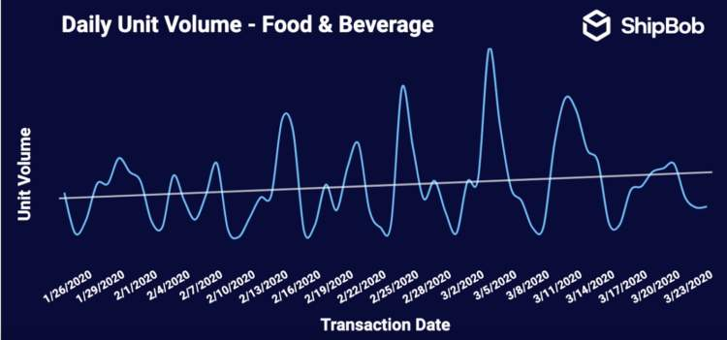
Fig1: graph showing the fluctuation in consumer purchase of food and beverage items
The hoarding behavior in consumers started to recede and decline after a week or two in isolation when people noticed that they did not have enough storage capacity for the commodities they had acquired in the moment of manic purchase and had to dispose of bad perishables.
Shops and retailers put restrictions on the quantity of the commodities an individual can purchase in order to curb the hoarding behavior and ensure that the available resources was served a wider range of customers.
The more time people have spent holed up indoors has also brought to their attention things they would otherwise have missed or overlooked. The increased time spent indoors has made individuals and families thoroughly observe their surroundings and this observations have led to renovations, reorganization and redecoration of their individual environments. Consumers have decide to make their time indoors as pleasurable as possible and this has led to the increase in the purchase of household funitures, decorations, carpets and other upholstery
- Consumer buying behavior to petrochemical products.
Governments all over the world has put containment measures in place in order to curb the spread of the virus (flatten the curve). One of such measures is the restriction of human movement, an embargo has been placed of the mass gathering of people encouraging everyone to stay in isolation. This law has exponentially reduced human locomotion from one place to the other as only essential workers such as healthcare personnel, media house staff and staff of basic amenities.

According to the IEA (International Energy Agency) February 2020 Oil Market Report, global oil demand has been hit hard by Covid-19 and the extensive closure of China’s economy. As per the report, demand is expected to fall by 435kb/d year-on-year in the first quarter of 2020, the first quarterly contraction in more than 10 years. The IEA has cut its 2020 growth forecast by 365kb/d to 825 kb/d, the lowest since 2011. The IEA has also revised down the outlook for global refinery runs. Chinese crude throughputs for the first quarter of 2020 have been cut by 1.1mb/d and are now expected to contract by 0.5mb/d year-on-year. As a result, global runs are forecast to expand by just 0.7mb/d in 2020.

- Consumer buying behavior to healthcare goods and products
Health organizations have been lauding the need for hygienic and healthy behaviors in order to push back the spread of the virus. This sensitization has pushed families and individual to try to attain the highest possible level of cleanliness for their bodies and environments thus increasing the purchase of healthcare products such as alcohol based hand sanitizers and antibacterial or antiviral lathering agents.
People with existing medical conditions have also been grounded by the virus. This has prompted such individuals to stock up on prescription drugs and other necessary medical supplies so as to effectively observe the isolation and social distancing protocols put in place without suffering or worsening their conditions.
The inability for people to go about their normal day to day activities has led to the increased purchase of home exercising equipment in various households. Individuals are trying to stay as healthy as possible whilst they adhere to the isolation and social distancing protocols, so that whenever they air clears up and restrictions to human activity have been relaxed, they can get right back into the flow of things.
According to data from Nielsen, items like hygienic and medical mask sales are up by more than 300%.
- Consumer buying behavior to entertainment products
The cancelation of televised sporting activities, music festivals, theatre shows and other forms of human entertainment has forced people to look for other activities that would occupy their time. The need for entertainment has led to increased purchase of home friendly or indoor
Streaming services worldwide have also noticed an upward movement in the number of subscribers, this is not surprising given that staying at home increases the amount of content people watch by 60%. It comes as no surprise that as people are homebound and no longer pursuing external entertainment options that there is an increase in digital streaming services. In addition to streaming services like Netflix, Amazon, Hulu, and Disney+ seeing atypical gains in subscribers in the first quarter of 2020, non-traditional streaming services like movie studios are releasing media streaming, on-demand, sometimes earlier than projected release. Video games and video-game internet traffic have seen a 75% increase since restrictions were imposed in the US.
- Consumer buying behavior to luxury goods
With priorities being placed on survival and preservation of life, people have dedicated their resources to essentials, turning away from luxury goods for the time being.
Vogue Business projects a potential loss as great as $10 billion for this industry in 2020 due to COVID-19. This is in part because luxury goods rely heavily on the Asian market’s purchasing power, where the pandemic has been affecting consumers since January.
Omnichannel sellers are seeing big losses, in part because they’re closing the retail arms of their businesses all together. People are understandably not interested in shopping for clothes in person. Department stores like Macy’s and JCPenney, large chains like Abercrombie & Fitch and Nike, and DTC brands with some storefronts like Rothys and Everlane are all closing their physical stores and experiencing losses. Some stores like Patagonia are halting even their online stores to protect all workers in their supply chain.
Even online apparel sales are down as people are putting more of their budgets into daily essentials. The chart below is again from Shipbob’s data of their 3,000+ merchants. This shows an overall 20% decrease in sales month-over-month.
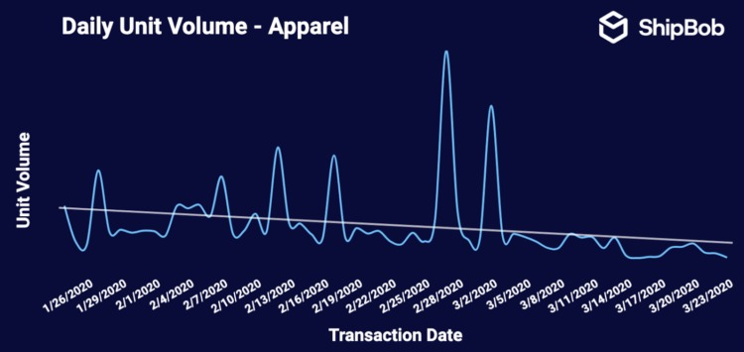
Fig2: graph showing the changes in consumer purchase of luxury clothing.
- BASED ON BRAND OR COMPANY ACTIVITY
Psychological studies show that human beings tend to favor brands or companies whose values are the same or similar to theirs. Emotional product or patronage motive comes to play here, where the consumer favors a particular product on the basis of emotions. These kind of purchases are to satisfy pride, sense of ego, urge to initiate others or desire to be unique.
Consumers have been closely monitoring the response of various brands and service providers to the uprising of the COVID-19 virus. Brands and companies who have in one way or the other assisted the government, healthcare workers or community in stemming the tide of the virus have seen an increase in customers during this pandemic. This increase in patronage is a response of the consumers to the acts of their brands and companies, consumers have chosen to invest their money in community conscious establishments because it creates the sense of participation, the sense that they have in one way or the other contributed to the fight against the pandemic by purchasing more of a particular brand that made a donation or set up structures to fight the pandemic.
- BASED ON SHOPPING MEDIUM
Restriction to human movement, locomotion and gathering has placed a strain on the traditional model retail shops. People are advised to avoid mass gatherings and these includes our supermarkets, retail stores and shops, eateries, restaurants and other market establishments. In compliance to these safety measures, consumers have turned to businesses that offer online shopping options and doorstep delivery.
When consumers are faced with shopping restrictions, they find and adopt newer ways to shop through technology. This is especially true when it comes to health and essential items. In 2019, the online grocery shopping market generated about 28.68 billion dollars or a 20% increase from 2018. Despite this growth, food and beverage were still one of the smallest e-commerce categories. Last year, it was mostly the younger population segment that tried online grocery shopping, with 55% of 25to 34 years olds considering themselves likely to purchase groceries online, in contrast to only 35% of 45 to 54 years olds expressing the same sentiments.
However, due to the pandemic, older generation are starting to see online shopping as a valid and safe option to obtain groceries. For example, Alibaba reported that in China, online grocery orders placed by people born in the 1960’s were four times higher than normal during the Spring festival or the period where China was still discovering new cases of COVID-19 each day
- BASED ON PRODUCT SHELF LIFE
Another category of consumer packaged goods that is booming is shelf-stable items. These fit into the category of people planning for long-term quarantine. According to Nielsen, products like shelf-stable milk and milk substitutes (particularly oat milk) are up by more than 300% in dollar growth. Other items seeing increases are things like dried beans and fruit snacks that have a long shelf life.

CONCLUSION
In countries heavily impacted by COVID-19, like China, United Kingdom, Spain, Italy, Nigeria etc. consumers are stockpiling food and other essential items, while isolating themselves from the crowds. In order to find out how and when consumers started showing these behavioral changes Nielsen conducted shopper behavior research that started during the beginning of the pandemic in China and extended to other countries that have been affected. They monitored consumer trends, as COVID 19 news reached the general public and found out that consumers go through six behavioral stages based on their awareness of the COVID-19 spread in their communities:
- PROACTIVE HEALTH- MINDED BUYING:
The first stage was connected to an increased interest in the acquisition of products that maintain well- being or health e.g Face mask, hand sanitizers, anti-biotics etc.

- REACTIVE HEALTH MANAGEMENT:
At the second stage there began to emerge the prioritization of products for effection containment [e.g. face masks]

- PANTRY PREPARATION:
This stage was connected with higher purchases of shelf- safe products and increased store visits e.g. there was an increase in the purchase of canned foods.

- QUARANTINED LIVING PREPARATION:
Increased online shopping, decreased store visits and first signs of strain on the supply chain. This stage was coupled with panic buying.

- RESTRICTED LIVING:
Possible price gouging due to limited supplies and deterred online fulfillment.

- LIVING A NEW NORMAL:
Increased health awareness even as people return to their typical daily activities.
The study also found out that consumers typically moved from one stage to another in a period of two weeks in areas close to the initial outbreak. However, this happens much faster in other countries where the outbreak started later, such as Italy and the US.
Currently the only country where consumers are starting to transition to the sixth stage is China, while the US has begun to move towards restricted living.

REFRENCES
https://www.bigcommerce.com
https://www.numerator.com
https://www.contentserv.com
https://www.agilitypr.com

