UZO-NWOSU MMACHUKWU
19/SMS04/052
MEDIA AND COMMUNICATION STUDIES
CMS 106 ASSIGNMENT

- NATURE:
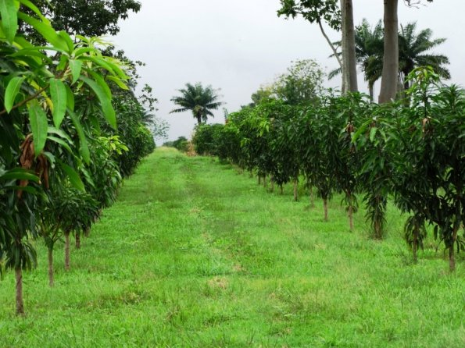
- MARINE LIFE:
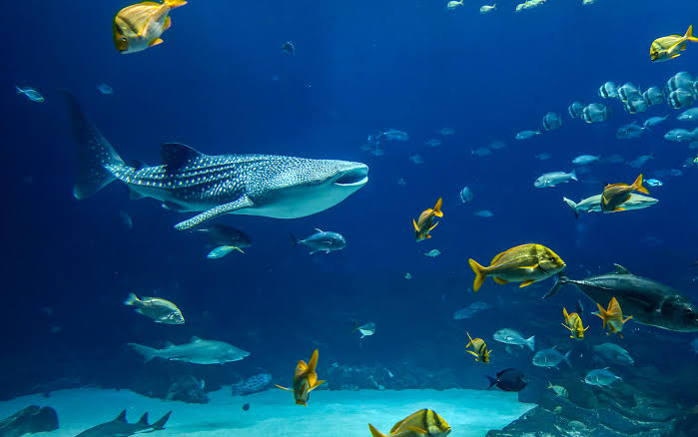
- MODEL:
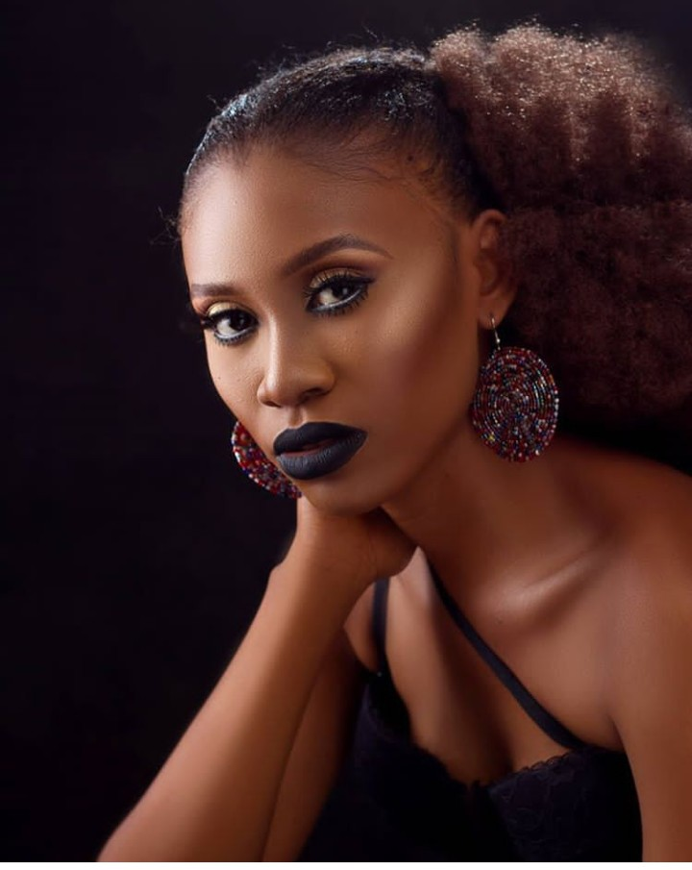
- EVENT:
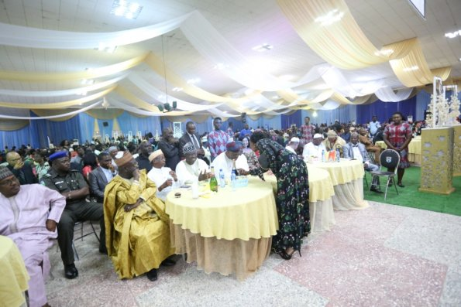
- SPORTS:
