Name : Ayodele Victoria Jesuseun
Course : MAT204
Date : 18-04-2020
Matric NO : 19/sci01/093
Question
Given the following matrices A=(1,-3,6), (4,0,2), (8,5,1) B=(1,1,2), (1,-2,1), (0,3,-4) C=(0,4,3), (6,-7,1), (1,-3,2)
Find :
(I). Rank of A
(ii). Rank of B transpose
(iii). Rank of (A+C)transpose
(iv). Rank of (B+C)
(v). Rank of (A+B+C)
(I) Rank of matrrix A
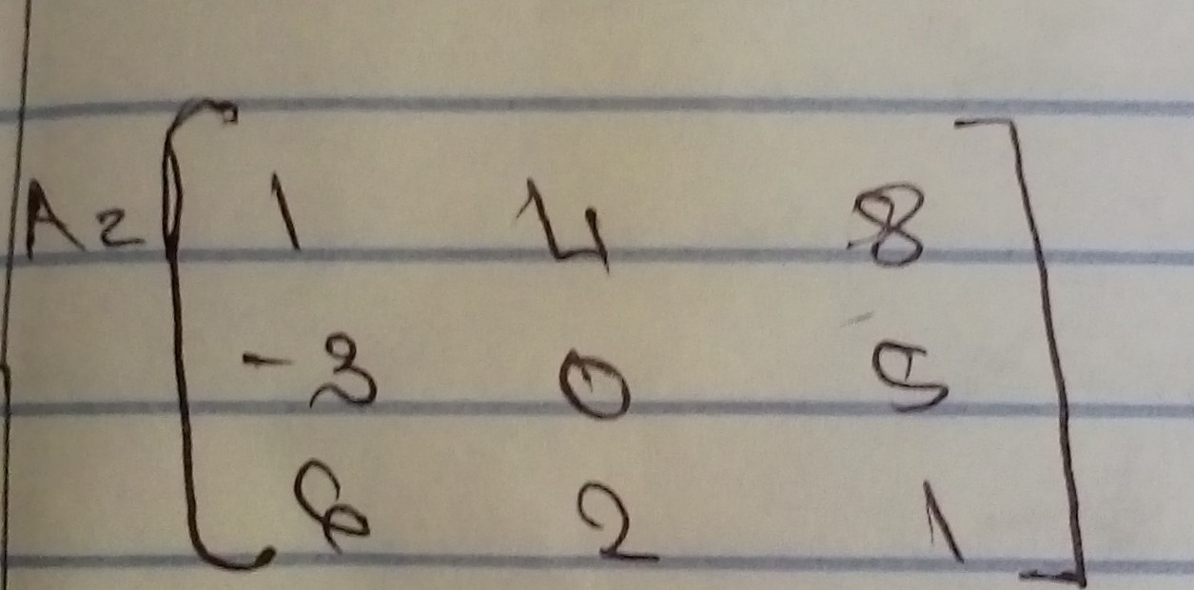
To find rank we find determinant
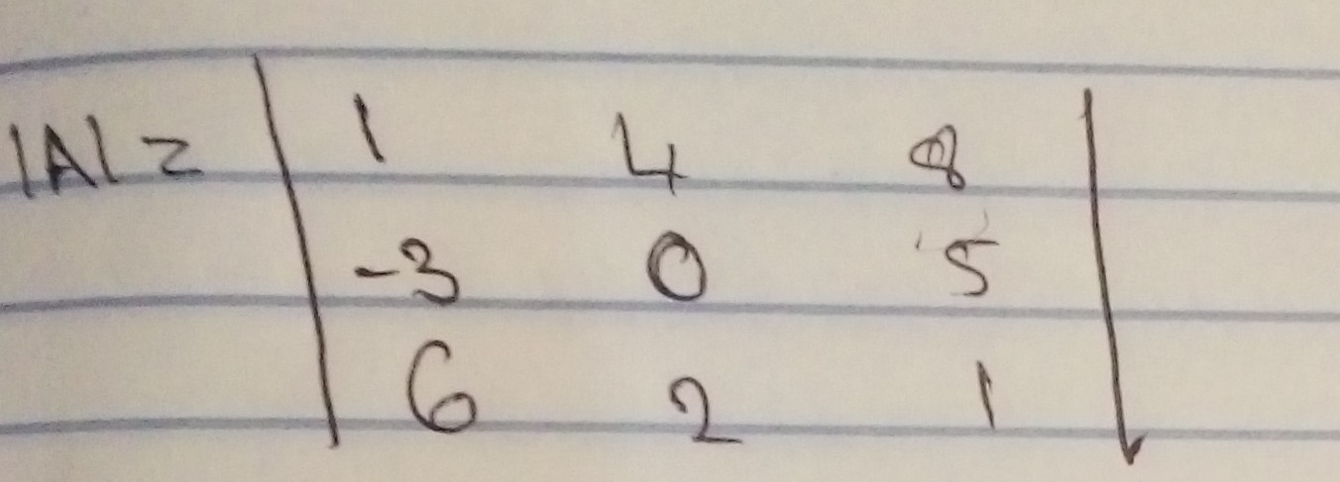
Rank of A (R) less the or equal to 3
|A| = 1((0*1)-(2*5)) - 4((-3*1)-(6*5))
+ 8((-3*2)-(6*0))
= 1(0-10) - 4(-3-30) + 8(-6-0)
= 1(-10) - 4(-33) + 8(-6)
= -10 + 132 - 48
|A| = 74
There fore since the |A| is not equal to zero
Rank of A is 3
(ii) Rank of B transpose
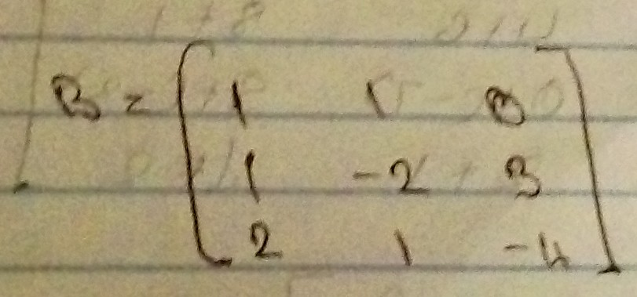

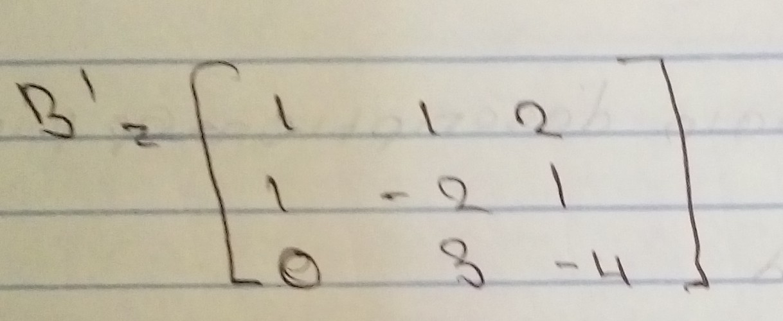
Therefore we find |B|
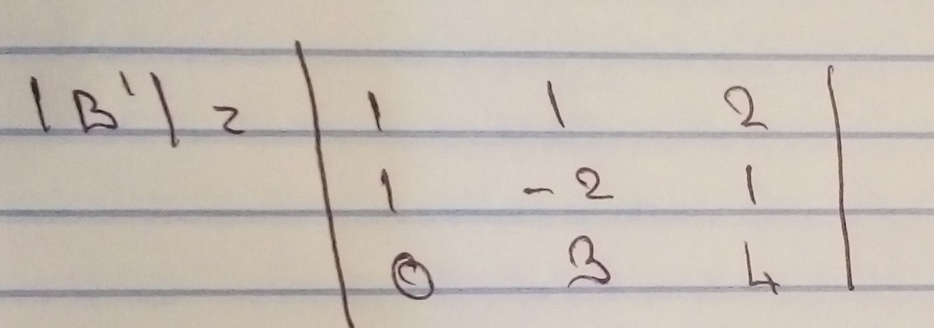
|B'| = 1((-2*4)-(3*1)) - 1((1*4)-(0*1))
+ 2((1*3)-(0*-2))
= 1(-8-3) - 1(4-0) + 2(3-0)
= 1(-11) - 1(4) + 2(3)
= -11 - 4 + 6
= -9
Therefore since |B| is not equal to zero
Rank of matrix |B| is 3
(iii) Rank of natrix (A+C) transpose

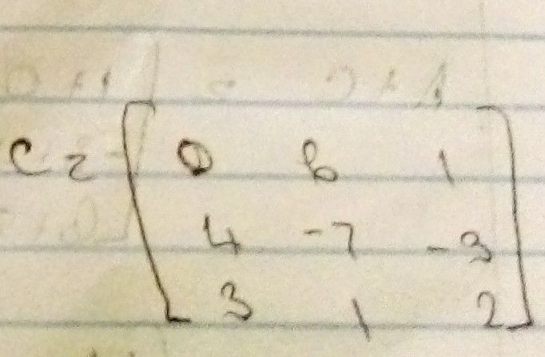
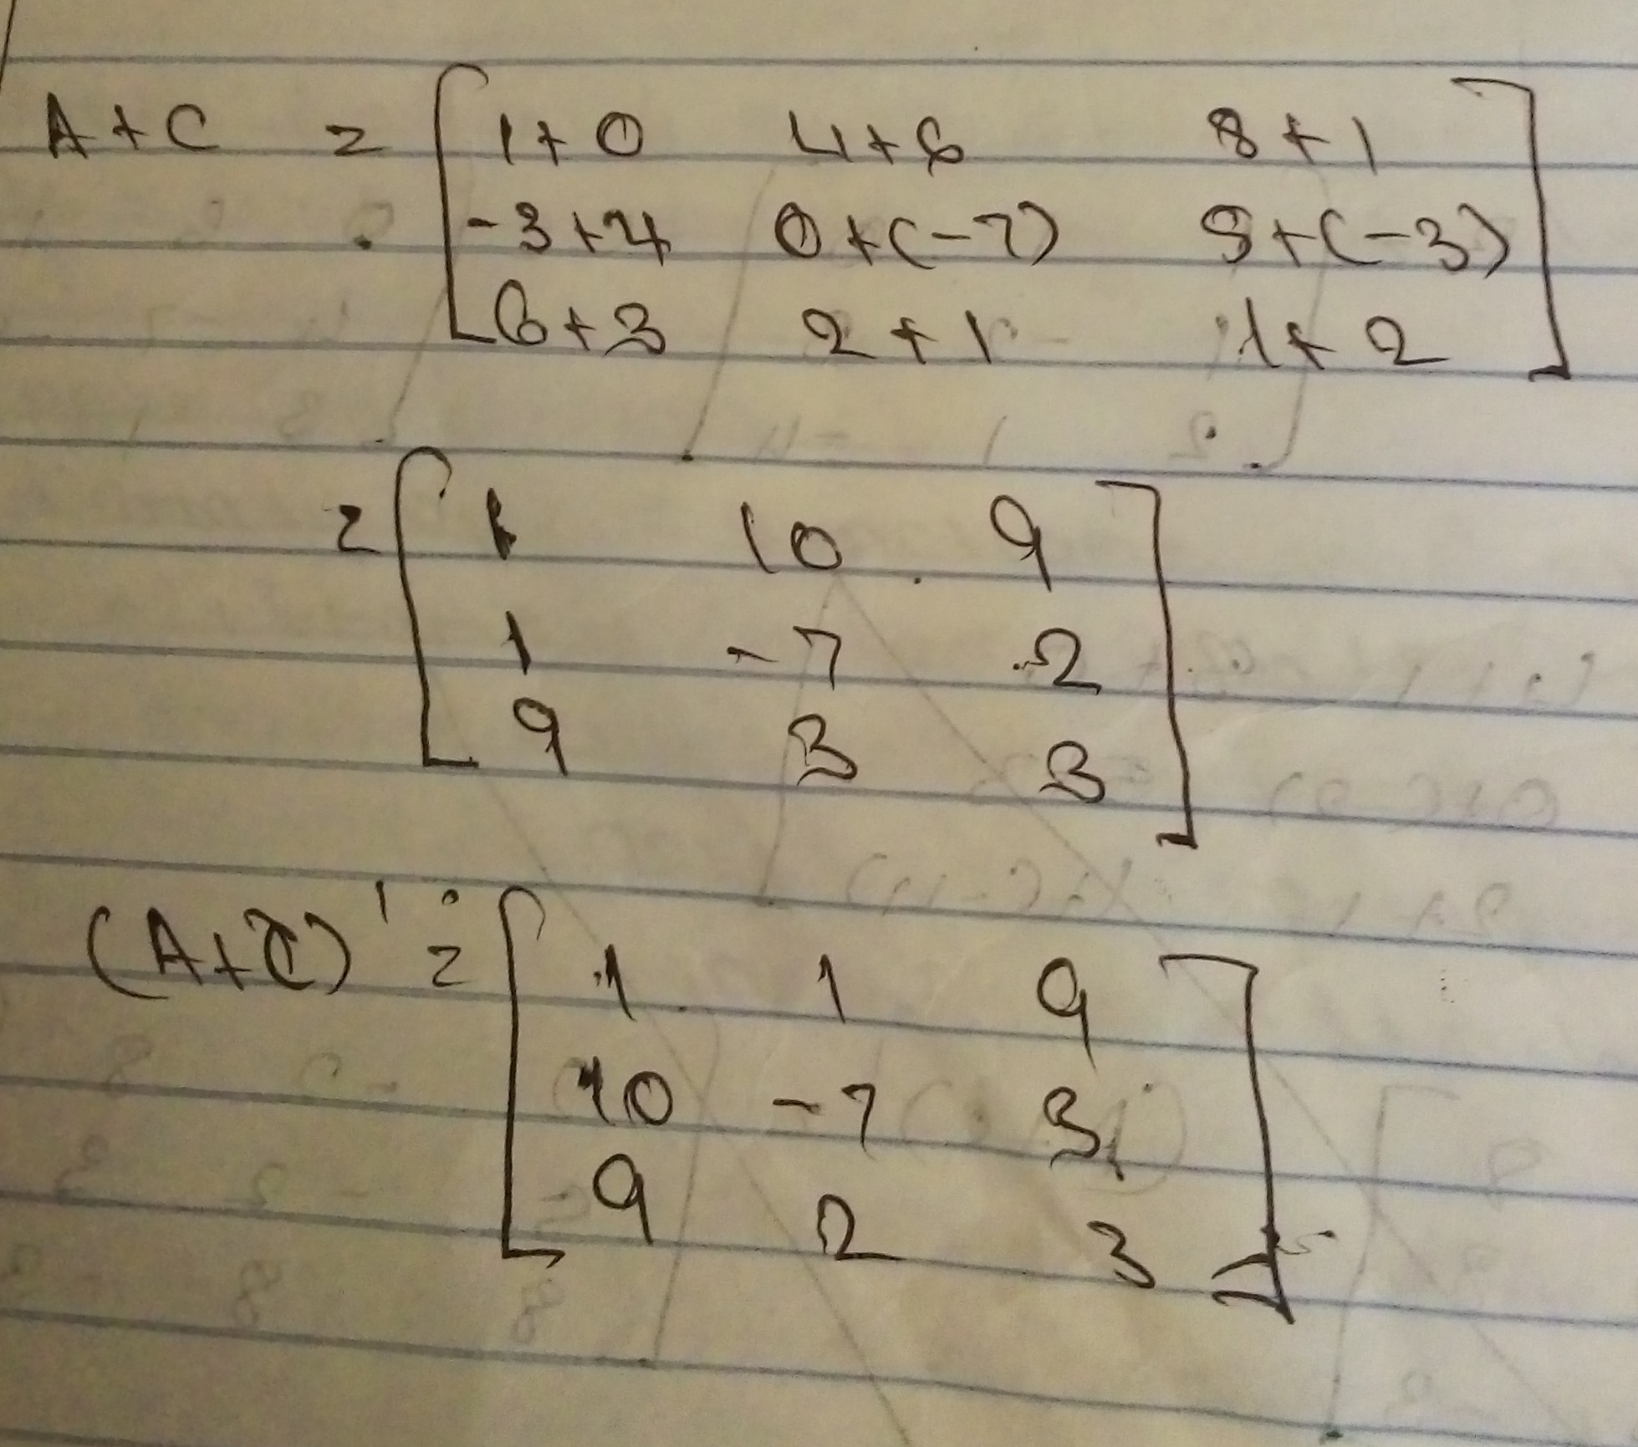
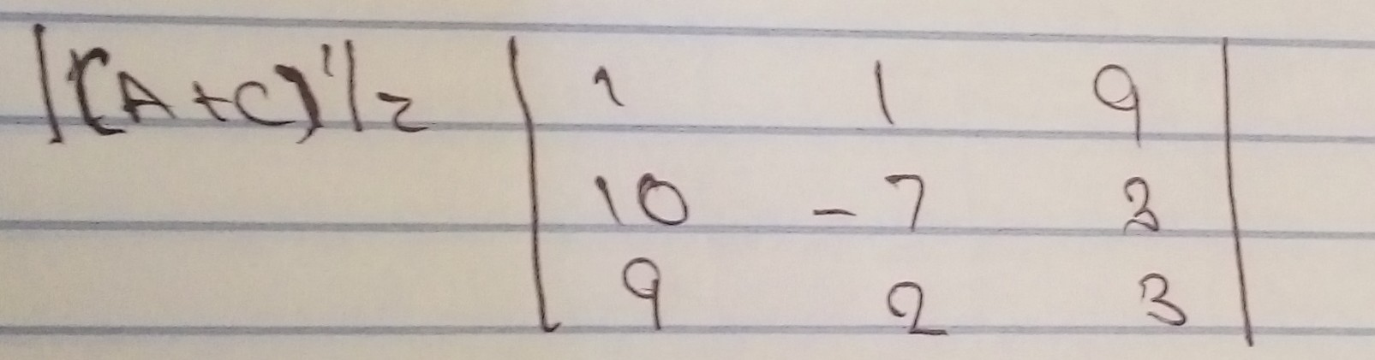
|(A+C)'| = 1((-7*3)-(2*3)) - 1((10*3)-(9*3))
+ 9((10*2)-(9*-7))
= 1(-21-6) - 1(30-27) + 9(20+63)
= 1(-27) - 1(3) + 9(83)
= -27 - 3 + 747
= 717
Therefore since |(A+C)| us not equal to zero
Rank of (A+C) is 3
(iv) Rank of matrix (B+C)
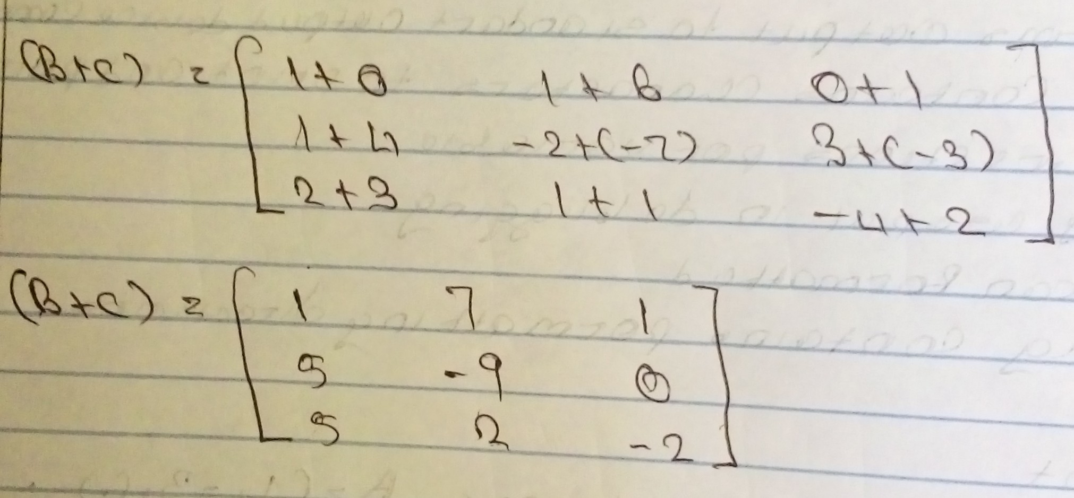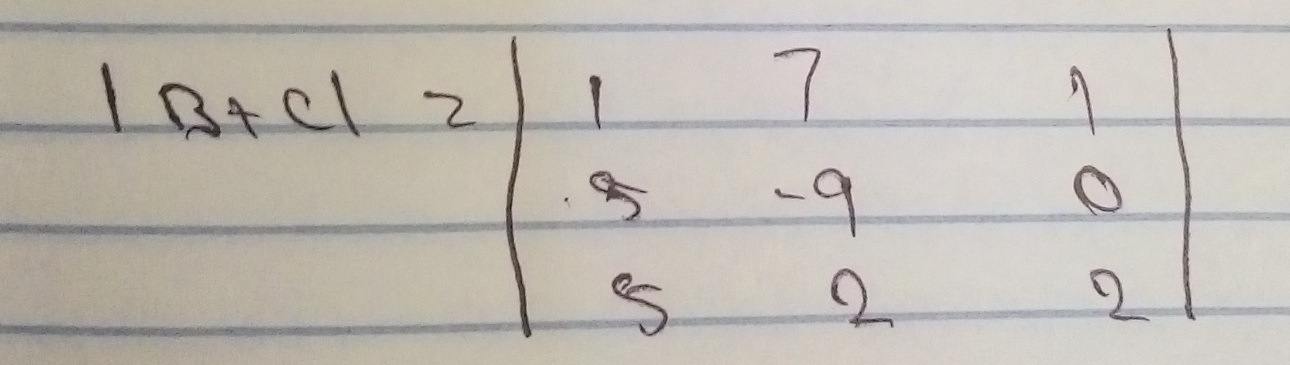
|B+C| = 1((-9*2)-(2*0)) - 7((5*2)-(5*0))
+ 1((5*2)-(5*-9))
= 1(-18-0) - 7(10-0) + 1(10+45)
= 1(-18) - 7(10) + 1(55)
= -18 - 70 + 55
= -33
Therefore since |B+C| is not equal to zero
Rank of matrix B+C is 3
(v) Rank of matrix A+B+C
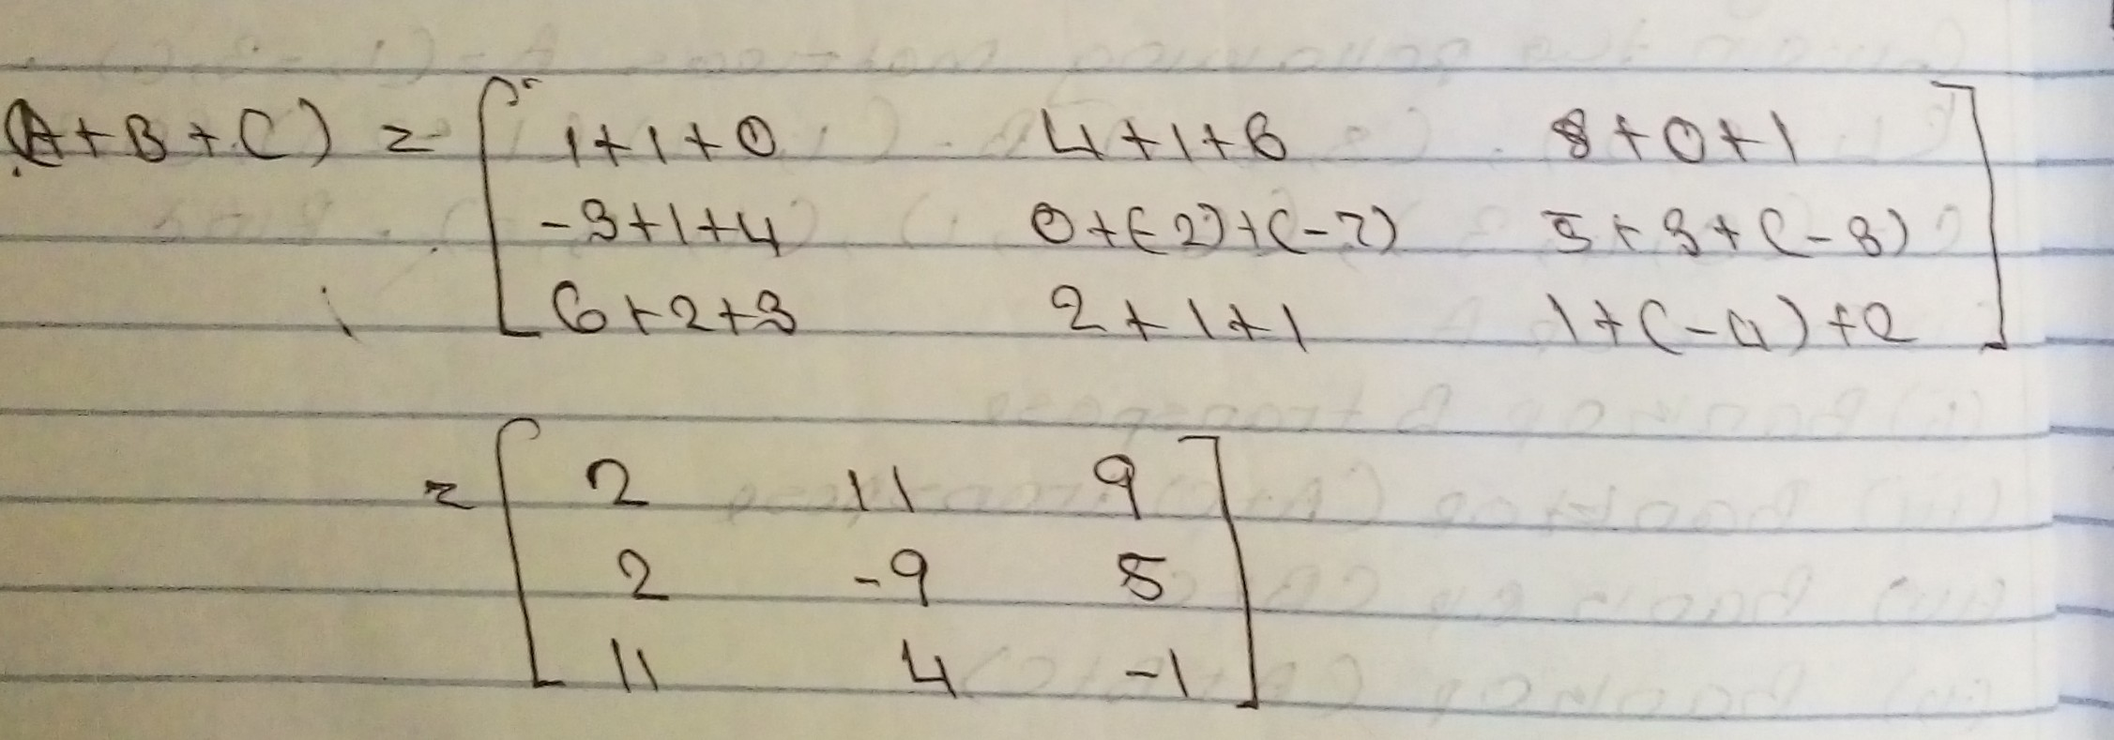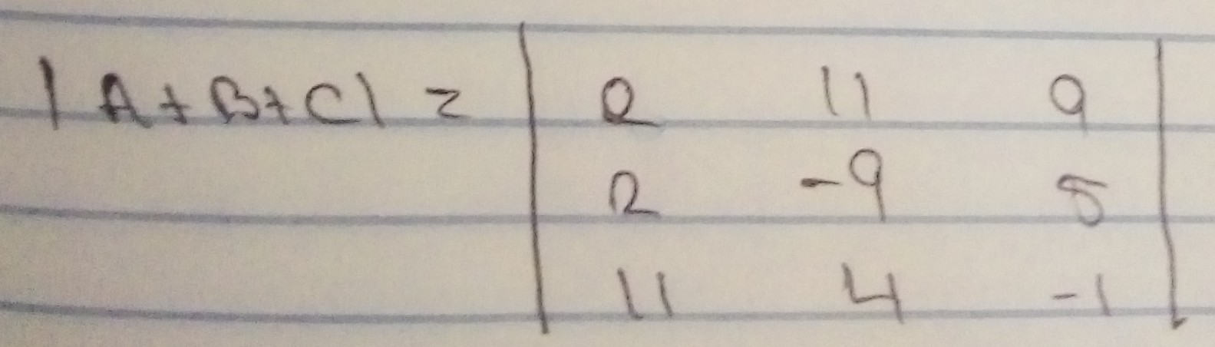
|A+B+C| = 2((-9*-1)-(4*5) - 11((2*-1)-(11*5)) + 9((2*4)-(11*-9))
= 2(9-20) - 11(-2-55) + 9(8+99)
= 2(-11) - 11(-57) + 9(107)
= -22 + 627 + 963
= 1568
There fore since |A+B+C| is not equal to zero
Rank of matrix A+B+C is 3

