COURSE TITLE: MATERNAL HEALTH AND NORMAL MIDWIFERY II
COURSE CODE: NSC 404
MATRIC NUMBER: 17/MHS02/101

QUESTION
1. Use of partograph in the management of first stage of labour.
2. Management of 2nd and 3rd stages of labour.

ANSWER
The partograph/ partogram is an integral part of intra-partum record keeping. It is a graphical representation of events through which maternal and foetal condition is assessed simultaneously in a single sheet. The charts are usually designed to allow for recordings at 15minutes interval.

IMPORTANCE OF THE PARTOGRAPH
- It aids in assessment/identification of deviation from the normal labour
- It aids in assessing the duration of the first stage and early labour or prolonged labour.
- It is necessary for maintaining a continuous care of patient(hand over procedure)
- It informs decision-making in the management of labour

COMPONENTS OF THE PARTOGRAPH AND THEIR KEY FEATURES
S/N | COMPONENTS | KEY FEATURES
 | Patients’ profile/ information | - Name  - Age  - Gestational period  - Gravid or Para  - Hospital number  - Date/time of admission  - Time of rupture of membrane  - Short antenatal history
 | Fetal condition | - Fetal heart rate  - Colour of amniotic fluid  - Degree of caput succedaneum/ moulding
 | Progress of the labour | - Uterine contractions every 10 minutes  - Descent of the presenting part  - Cervical effacement and dilatation
 | Medications | - Oxytocin  - Pain relief (e.g Pethidine)
 | Maternal condition | - Maternal temperature, pulse and blood pressure  - Fluid balance  - Urine analysis

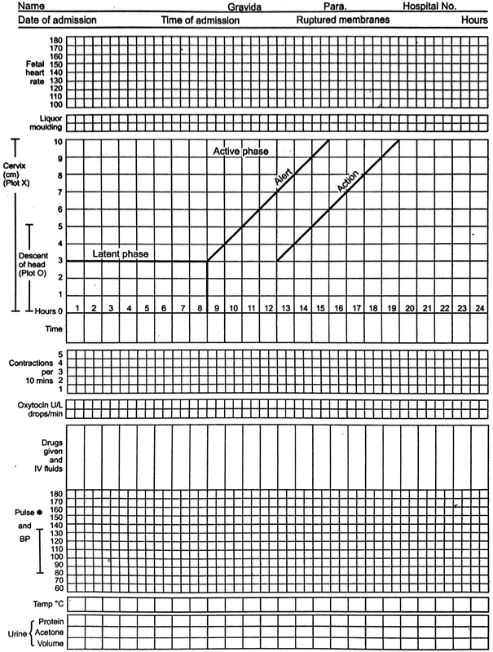

Fig 1. A pictograph
KEY FEATURES IN THE PARTOGRAPH
- Fetal heart rate: it is recorded at every 30 minutes interval
- Membrane status: denoted as (I) if its intsct and (R) if ruptured. The date and time of the rupture can be noted as this has implication for sepsis.
- Colour of amniotic fluid: (C) if its clear, (M) if it has meconium and (B) if its blood stained. Done at every vaginal examination
- Degree of caput succedaneum/ moulding: show the extent to which the fetal skull overlaps. Moulding can be recorded as; 0 (no moulding), 1+ (touching bones), 2+ (overlapping but can be separated), 3+ (overlapping but inseperable).
- Uterine contraction: the frequency and strength of contractions should be noted every half an hour (i.e 30mins) by counting the number of contractions at 10 minutes intervals according to intensity and duration. The number of boxes corresponding with the number of contractions within 10 minutes should be filled with shadings.The duration can be noted with depth of the shades where mild( <20 secs),moderate(20-40secs) and severe(>40secs)
- Descent of the presenting part: This can be gotten by abdominal palpation. Descent of the fetal head can either be recorded as 5/5(shows that its not engaged and it is still above the pelvic brim, 4/5, 3/5, 2/5, 1/5 and 0/5(shows full descent and engaged of the skull). It is marked with an O.
- Cervical effacement and dilatation: Dilatation occurs at 1cm/1hour. This is marked with an X. The first dilatation is usually started with 4cm as long as the patient is in first labour.
- Oxytocin: record the amount and the volume of IV fluid it was added to with the drops/ mins noted and recorded at the start and at every 30mins.
- Pain relief (e.g Pethidine)
- Maternal vital signs: temperature(every 2hours) pulse rate( at every 30 mins) and blood pressure(every 4hours)
- Fluid balance: maternal output
- Urine analysis: check for the volume and presence of acetone, glucose or protein.

- Partograph is started when the cervix is 4cm dilated(active phase of labour) which is noted by carrying out a vaginal examination(should be done at every 4 hours)
- Two lines are drawn diagonally with the top indicating the alert line(normal progress of labour which is 4cm and at the rate of 1cm/hour dilatation) and the line below(it lies parallel and 4 hours from the alert line) indicates abnormal progress of labour for which extra care is given or C-S(Caesarian Section) is performed
NB: First plot should be placed on the alert line e.g dilatation of 6cm can also be recorded on the alert line
NB: If after 4 hours a woman is not following the expected course as in normal labour then the line will begin to approach the action line which signals the need to take extra actions.
- A graph of dilatation of the cervix and the descent of the fetal head is plotted against the alert and action line.
- The time at which each measurement is taken should be recorded.

2. CARE IN TRANSITION OF THE SECOND STAGE
Care of the parents
Frequent explanation of events should be done/ given since the woman and her companion feel both excited and anxious at such a time. This is done by using a calm approach to keep the woman in control and confident.
The midwife should praise and congratulate the woman for her efforts at every step
The midwife should make sure that the patients’ dignity and privacy are protected.
Careful assessment for the request of analgesics should be made especially if it was formally stated (antenatally) that she (the patient) did not want pain relief in labour
Supportive actions which can be used to replace pharmacologic analgesic may include; praise and reassurance about progress, changes in position and scenery, massage and appropriate nutrition, complementary therapies and fetal positioning may be done if the midwife is competent to undertake them.
The midwife should also have regards for the well being of the woman’s partner/ birth companion and to respect the meaning that the birth will have for them.

MANAGEMENT OF THE SECOND STAGE OF LABOUR
It is a continuation of responsibilities included in management of first stage of labour and some additional responsibilities for preparation for delivery and management of delivery
- Evaluation of the maternal well being: These includes;
- Vital signs: temperature, pulse and respiration are to be evaluated every hour and the blood pressure should be taken between contractions
- Bladder care: catheterization may be done toward the end of labour and this is done after the woman is scrubbed and drapped brfore any other procedure.
- Hydration: It is affected during the second stage of labour by fluid loss through the skin (perspiration) as effort of pushing. IV fluid is given if advised.
- Analgesia and anesthesia: Analgesia during this stage is usually the continuation of analgesia give during the first stage. Anesthesia is generally achieved by local infiltration of perineal body when episiotomy is planned.
- Perineal integrity: Perineal length, thickness and distensibility are evaluated so as to determine if a delivery can possibly occur over and intact perineum or if episiotomy was needed.

- Evaluation of fetal well being: It’s a continuation of the first stage which onsists of normalcy of fetal presentation, attitude and position, fetal adaptation to the pelvis, fetal heart rate pattern and progress of the mechanism of labour.

- Evaluation of progress of labour: Evaluation of second stage of labour and detection of progress of descent includes;

- Lower location of back pain and of fetal heart tones
- Change in the station of the presenting parts noted during vaginal examination
- Rectal and perineal bulging

- Preparation for delivery: The usual positions in a hospital delivery room are Lithotomy and Dorsal recumbent position and the woman should be positioned likewise. Delivery room should be warm with a spotlight available so that the perineum can be easily observed.
- A sterile delivery pack should be kept ready and a clean area should be kept prepared to receive a baby
- Neonatal resuscitation equipment must be kept available

- Conducting delivery: management of the delivery includes; delivery of the baby, immediate care of the newborn and management of records and other supportive cares.
- Delivery of the baby: The woman should be instructed to gently push between contractions so that the baby’s head will come out easily with least amount of trauma to the baby and the woman. After delivery of the head and the axillary crease is seen, the head and trunk are guided in an upward curve to allow the posterior shoulder to escape over the perineum, the baby is then grasped around the chest to aid birth of the trunk and the baby is lifted toward the mother’s abdomen.
- Clamping and cutting of the umbilical cord; it’s done by placing two instrumental clamps on the cord at about 8-10cm from the umbilicus with enough room between them to allow for easy cutting.
- Immediate care of the newborn: Baby is dried and warmly wrapped to prevent cooling. Baby must be grossly examined for any deformities or congenital abnormalities.
- Record: The midwife conducting the delivery should complete the labour record including details of any drugs administered, duration and progress of the labour and episiotomy if performed and repaired as well as the birth register.

MANAGEMENT OF THE THIRD STAGE OF LABOUR
The third stage is a period that starts immediately after delivery of infant and ends with the completed delivery of the placenta and its membranes. It usually lasts between 5-15mins. There are significant risks of hemorrhage in this stage.
Placental separation may include;
- Shultz mechanism: It is common 80% 0f cases and it occurs centrally
- Duncan mechanism: it occurs at the side and may retain placenta and lead to more bleeding than the first mechanism.

- ACTIVE MANAGEMENT OF THE THIRD STAGE OF LABOUR.
- Administer oxytocin after delivery of anterior shoulder (5-10 IU Oxytocin slow IV or IM or Egometrine 0.5mg slow IV or IM)
- Clamping the cord early after giving the uterotonic
- Controlling cord traction (Brandt- Andrew maneuver): It is done during contraction with counter pressure to the uterus with the hand placed on the abdomen). If the placenta is separated the cord is found to elongate and gush of blood occurs.
- When placenta appears at the vulva, hold it between two hands and roll it so as to make a rope of membrane in order to avoid missing parts of membrane. Inspect the placenta and membranes to ensure completeness and if fragment is missing, manually remove under anaesthesia.
- Uterine massage to help retraction of the uterus.
- Inspect external genitalia and perineum for any laceration that should be repaired. Wash areas with antiseptic solution, dry and put sterile pad.

- EXPECTANT OR CONSERVATIVE MANAGEMENT
- After the infant is delivered, there’s a period of rest without contraction that lasts an average of 10minutes. Use this time to take care of the neonate and watch the mother carefully for any sign of post partum hemorrhage which can occur at any time.
- Then contraction resume, the placenta separates spontaneously. Palpate the abdomen and notice signs of placental separation and descent.
- Hold and inspect the placenta and membrane for any missing parts.
- Give oxytocin slowly IV or IM: 5-10 IU at the end of placental delivery if needed.

