Write a comprehensive review of the aetiology of COVID-19, its pathogenesis, histopathological features and the current potential therapies to address it. Also, comment on the future of COVID-19 on public health.
NAME: TOSIN FATUNDIMU
MATRIC NO: 17/MHS03/031
ANA 404
Mr EDEM .E. EDEM

Coronavirus is one of the major pathogens that primarily targets the human respiratory system. Previous outbreaks of coronaviruses (CoVs) include the severe acute respiratory syndrome (SARS)-CoV and the Middle East respiratory syndrome (MERS)-CoV which have been previously characterized as agents that are a great public health threat.
The coronavirus disease (COVID-19) has been identified as the cause of an outbreak of respiratory illness in Wuhan, Hubei Province, China beginning in December 2019. As of 31 January 2020, this epidemic had spread to 19 countries with 11 791 confirmed cases, including 213 deaths. The World Health Organization has declared it a Public Health Emergency of International Concern.
What is COVID-19?
COVID- 19 is a mild to severe respiratory illness that is caused by a coronavirus (Severe acute respiratory syndrome coronavirus 2 of the genus Betacoronavirus), is transmitted chiefly by contact with infectious material (such as respiratory droplets), and is characterized especially by fever, cough, and shortness of breath and may progress to pneumonia and respiratory failure.

Epidemiology
On 29 December 2019, the first four cases of an acute respiratory syndrome of unknown etiology were reported in Wuhan City, Hubei Province, China among people linked to a local seafood market. It appeared that most of the early cases had some sort of contact history with the original seafood market. Soon, a secondary source of infection was found to be human-to-human transmission via close contact. There was an increase of infected people with no history of exposure to wildlife or visiting Wuhan, and multiple cases of infection were detected among medical professionals. It became clear that the COVID-19 infection occurs through exposure to the virus, and both the immunosuppressed and normal population appear susceptible.
At the beginning of February 2020, almost 10,000 cases of COVID-19 were confirmed in China and 100+ cases were detected outside of China (WHO: Novel Coronavirus (2019-nCoV). The disease spread rapidly and became a global outbreak approaching 1 million cases and 50,000 deaths at the start of April 2020 (WHO: Coronavirus Disease 2019 (COVID-19)
Symptoms
The symptoms of COVID-19 infection appear after an incubation period of approximately 5.2 day. The period from the onset of COVID-19 symptoms to death ranged from 6 to 41 days with a median of 14 days.. This period is dependent on the age of the patient and status of the patient's immune system. It is shorter among patients >70-years old compared with those under the age of 70. The most common symptoms at onset of COVID-19 illness are fever, cough, and fatigue, while other symptoms include sputum production, headache, hemoptysis, diarrhoea, dyspnoea, and lymphopenia. COVID-19 exhibits both systemic disorders and respiratory disorders. The image (figure 1) below shows the symptoms that can be noticed.
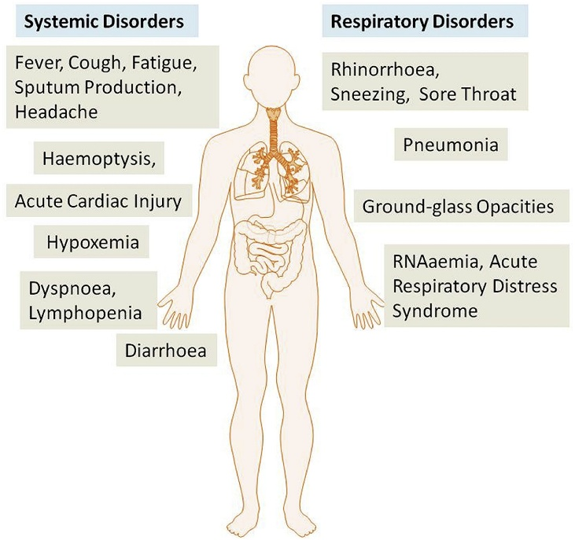

There are general similarities in the symptoms between COVID-19 and previous betacoronavirus. However, COVID-19 showed some unique clinical features that include the targeting of the lower airway as evident by upper respiratory tract symptoms like rhinorrhoea, sneezing, and sore throat.

Pathogenesis
The severe symptoms of COVID-19 are associated with an increasing numbers and rate of fatalities specially in the epidemic region of China. On January 22, 2020, the China National Health Commission reported the details of the first 17 deaths and on January 25, 2020 the death cases increased to 56 deaths (Wang, Tang, & Wei, 2020, p. 443). The percentage of death among the reported 2684 cases of COVID-19 was approximately 2.84% as of Jan 25, 2020 and the median age of the deaths was 75 (range 48–89) years
(Wang, Tang, & Wei, 2020, p. 443). Patients infected with COVID-19 showed higher leukocyte numbers, abnormal respiratory findings, and increased levels of plasma pro-inflammatory cytokines. One of the COVID-19 case reports showed a patient at 5 days of fever presented with a cough, coarse breathing sounds of both lungs, and a body temperature of 39.0 °C. The patient's sputum showed positive real-time polymerase chain reaction results that confirmed COVID-19 infection. The laboratory studies showed leucopenia with leukocyte counts of 2.91 × 10^9 cells/L of which 70.0% were neutrophils. Additionally, a value of 16.16 mg/L of blood C-reactive protein was noted which is above the normal range (0–10 mg/L). (Lei, Li, Li, & Qi, 2020, p. 18). The main pathogenesis of COVID-19 infection as a respiratory system targeting virus was severe pneumonia, RNAaemia, combined with the incidence of ground-glass opacities, and acute cardiac injury. Significantly high blood levels of cytokines and chemokines were noted in patients with COVID-19 infection that included IL1-β, IL1RA, IL7, IL8, IL9, IL10, basic FGF2, GCSF, GMCSF, IFNγ, IP10, MCP1, MIP1α, MIP1β, PDGFB, TNFα, and VEGFA.As said by (Huang et al., 2020, p. 500)

Histopathology of COVID-19
Biopsy samples were taken from lung, liver, and heart tissue of a COVID-19 patient. Histological examination showed bilateral diffuse alveolar damage with cellular fibromyxoid exudates (figure 2A, B). The right lung showed evident desquamation of pneumocytes and hyaline membrane formation, indicating acute respiratory distress syndrome (ARDS; figure 2A). The left lung tissue displayed pulmonary edema with hyaline membrane formation, suggestive of early-phase ARDS (figure 2B). Interstitial mononuclear inflammatory infiltrates, dominated by lymphocytes, were seen in both lungs. Multinucleated syncytial cells with atypical enlarged pneumocytes characterized by large nuclei, amphophilic granular cytoplasm, and prominent nucleoli were identified in the intra-alveolar spaces, showing viral cytopathic-like changes. No obvious intranuclear or intracytoplasmic viral inclusions were identified.
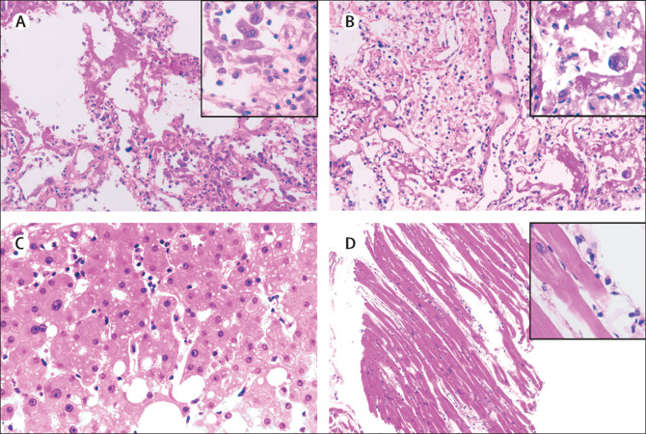
Pathological manifestations of right (A) and left (B) lung tissue, liver tissue (C), and heart tissue (D) in a patient with severe pneumonia caused by SARS-CoV-2

The pathological features of COVID-19 greatly resemble those seen in SARS and Middle Eastern respiratory syndrome (MERS) coronavirus infection.
In addition, the liver biopsy specimens of the patient with COVID-19 showed moderate microvesicular steatosis and mild lobular and portal activity (figure 2C), indicating the injury could have been caused by either SARS-CoV-2 infection or drug-induced liver injury. There were a few interstitial mononuclear inflammatory infiltrates, but no other substantial damage in the heart tissue (figure 2D).

Therapeutics/treatment options
According to(Lu, 2020, p. 69). The person-to-person transmission of COVID-19 infection led to the isolation of patients that were administered a variety of treatments. At present, there are no specific antiviral drugs or vaccine against COVID-19 infection for potential therapy of humans. The only option available is using broad-spectrum antiviral drugs like Nucleoside analogues and also HIV-protease inhibitors that could attenuate virus infection until the specific antiviral becomes available.
According to new research(Chen et al., 2020, p. 509). The treatment that have so far been attempted showed that 75 patients were given existing antiviral drugs. The course of treatment included twice a day oral administration of 75 mg oseltamivir, 500 mg lopinavir, 500 mg ritonavir and the intravenous administration of 0·25 g ganciclovir for 3–14 days. One other report showed that the broad-spectrum antiviral remdesivir and chloroquine are highly effective in the control of 2019-nCoV infection in vitro. These antiviral compounds have been used in human patients with a safety track record. Thus, these therapeutic agents can be considered to treat COVID-19 infection (M. Wang et al., 2020, p. 269). Other investigation show that there are a number of other compounds that are in development. According to (Toots et al., 2019), these include the clinical candidate EIDD-2801 compound that has shown high therapeutic potential against seasonal and pandemic influenza virus infections and this represents another potential drug to be considered for the treatment of COVID-19 infection.
Home management is recommended for patients with mild symptoms. Optimal duration of home isolation is under investigation but virus is shed for an average of approximately 14 - 20 days after disease onset in hospitalized patients.
Patients with severe disease require hospital care may need oxygenation support, ranging from low dose oxygen supplement to invasive ventilation and extracorporeal membrane oxygenation (ECMO). WHO recommend NOT to use glucocorticoids unless indicated otherwise as this has been associated with increased risk of death.

Future of COVID-19 on Public Health
This particular strain if corona virus is on that has shook the world on a global scale in the sense that it went from an outbreak to an epidemic and from an epidemic it became a pandemic. This essentially means that it can be contacted anywhere in the world and everybody is a potential victim. It is a virus that has shutdown the world from itself, which has never happened in this modern and technological era. What does the future hold for COVID-19 on Public Health? Preventive measures are already being carried out worldwide against the virus and with time there could be a breakthrough and a permanent, reliable solution in the combat of COVID-19.
The epidemiology of Covid-19 is rapidly evolving. But the core logic is similarly simple. People mix together and spread infections. This happens in households, and in workplaces, and on the journeys people make. Reducing this mixing is likely to reduce person-to-person transmission and lead to fewer cases overall.
We must also think about the possibility of the introduction and development of new technology and medications or vaccines hat have the capability of tackling any other future outbreaks

References

Wang, W., Tang, J., & Wei, F. (2020). Updated understanding of the outbreak of 2019 novel coronavirus (2019‐nCoV) in Wuhan, China. Journal of Medical Virology, 92(4), 441–447. https://doi.org/10.1002/jmv.25689
Lei, J., Li, J., Li, X., & Qi, X. (2020). CT Imaging of the 2019 Novel Coronavirus (2019-nCoV) Pneumonia. Radiology, 295(1), 18. https://doi.org/10.1148/radiol.2020200236
Huang, C., Wang, Y., Li, X., Ren, L., Zhao, J., Hu, Y., … Cao, B. (2020). Clinical features of patients infected with 2019 novel coronavirus in Wuhan, China. The Lancet, 395(10223), 497–506. https://doi.org/10.1016/s0140-6736(20)30183-5
Lu, H. (2020). Drug treatment options for the 2019-new coronavirus (2019-nCoV). BioScience Trends, 14(1), 69–71. https://doi.org/10.5582/bst.2020.01020
Chen, N., Zhou, M., Dong, X., Qu, J., Gong, F., Han, Y., … Zhang, L. (2020). Epidemiological and clinical characteristics of 99 cases of 2019 novel coronavirus pneumonia in Wuhan, China: a descriptive study. The Lancet, 395(10223), 507–513. https://doi.org/10.1016/s0140-6736(20)30211-7
Wang, M., Cao, R., Zhang, L., Yang, X., Liu, J., Xu, M., … Xiao, G. (2020). Remdesivir and chloroquine effectively inhibit the recently emerged novel coronavirus (2019-nCoV) in vitro. Cell Research, 30(3), 269–271. https://doi.org/10.1038/s41422-020-0282-0
Toots, M., Yoon, J.-J., Cox, R. M., Hart, M., Sticher, Z. M., Makhsous, N., … Plemper, R. K. (2019). Characterization of orally efficacious influenza drug with high resistance barrier in ferrets and human airway epithelia. Science Translational Medicine, 11(515), eaax5866. https://doi.org/10.1126/scitranslmed.aax5866
Xu, Z., Shi, L., Wang, Y., Zhang, J., Huang, L., Zhang, C., … Wang, F.-S. (2020). Pathological findings of COVID-19 associated with acute respiratory distress syndrome. The Lancet Respiratory Medicine, 8(4), 420–422. https://doi.org/10.1016/s2213-2600(20)30076-x

