Questions.
1. Write an essay on the histological importance of eye in relation to their cellular functions.
2. Corona virus can penetrate the body through eye and implicate the immune system, briefly discuss the layers of retina for information penetration.

Answers:
- A histological understanding of the layers of the eye is essential for appreciating disease pathophysiology and also understanding certain therapeutic approaches. Broadly, from an anatomical perspective, the eye can be viewed as a series of overlapping layers of tissue.
External structures of the eye include the eyelashes, lids, muscles, accessory glands, and conjunctiva.
The internal structures of the eye consist of three layers of tissue arranged concentrically:
- The sclera and cornea make up the exterior layers.
- The uvea is the vascular layer in the middle, subdivided into the iris, ciliary body, and choroid.
- The retina constitutes the innermost layer and is made up of nervous tissue.
All of these layers can further subdivide and undergo histological classification:
External Structures of the Eye:
1. Conjunctiva
- The conjunctiva lines the inner part of the eyelids.
- The tarsal plate lies beneath the conjunctiva and contains meibomian glands, which secrete an oily substance to decrease the evaporation of the tear film.
2. Tear film: The tear film consists of aqueous, mucus, and oily secretions.
3. Accessory glands: Apocrine glands of Moll, meibomian glands, lacrimal glands.
4. Muscles: Orbicularis oculi, levator palpebrae superioris, superior tarsal muscle.
5. Eyelid: The eyelid, likewise known as the cover of the eye, a mobile layer made up of skin and also muscular tissue and also covers the eyeball.
Internal Structures of the Eye: The innermost structures of the eye are organized in the three layers as follows
(A) Outermost Layer: Sclera and Cornea:
1. The sclera (white of the eye):
- The sclera is dense connective tissue made of mainly type 1 collagen fibers, oriented in different directions. The lack of parallel orientation of collagen fibers gives the sclera its white appearance, as opposed to the transparent nature of the cornea. However, the collagen of the sclera and cornea are continuous.
- The four layers of the sclera from external to internal are episclera, stroma, lamina fusca, endothelium.
- The episclera is the external surface of the sclera. It is connected to the Tenon capsule by thin collagen fibers. At the corneoscleral junction, also known as the limbus, the Tenon capsule contacts stroma of the conjunctiva.
2. Cornea (transparent front layer of the eye):
- Consists of type I collagen fibers oriented in a uniform parallel direction to maintain transparency
- Consists of five layers: epithelium (non-keratinized, stratified squamous epithelium), Bowman layer, stroma (also called substantia propria), Descemet’s membrane, corneal endothelium.
- Corneal epithelium: fast growing, regenerating multicellular layer which interacts directly with the tear film.
- Bowman layer: This is a layer of subepithelial basement membrane protecting the underlying stroma. It is composed of type 1 collagen, laminin, and several other heparan sulfate proteoglycans.
- Stroma: The largest layer of the cornea, the stroma has collagen fibers arranged in a regular pattern. Keratocytes maintain the integrity of this layer. The function of this layer is to maintain transparency, which occurs by the regular arrangement, and lattice structure of the fibrils, whereby scatter from individual fibrils gets canceled by destructive interference, and the spacing of less than 200 nm allows for transparency.
- Descemet’s membrane: an acellular layer made of type IV collagen that serves as a modified basement membrane of the corneal endothelium
- Corneal endothelium: a one cell thick layer made of either simple squamous or cuboidal cells. Cells in this region do not regenerate and have pumps that maintain fluid balance and prevent swelling of the stroma. When corneal endothelial cells are lost, neighboring cells stretch to attempt to compensate these losses.
(B) Middle Layer: Uvea (Iris, Ciliary Body, Choroid):
1. Iris:
- Consists of (1) stromal layer with pigmented, fibrovascular tissue and (2) pigmented epithelial cells beneath the stroma
- The sphincter pupillae and dilator pupillae muscles connect to the stroma
- The pigmented layer of cells blocks rays of light and ensures that light must move through the pupil to reach the retina
- The angle formed by the iris and cornea contains connective tissue with endothelial channels called the trabecular meshwork, which drains aqueous humor in the anterior chamber into the venous canal of Schlemm. From here, fluid drains into episcleral veins.
2. Ciliary Body: The tissue that divides the posterior chamber and vitreous body
- Consists of the ciliary muscle and the ciliary epithelium
- The ciliary muscle, via the lens zonules, controls the structure of the lens, which is vital for accommodation. Zonules are connective tissue fibers that connect the ciliary muscle and lens.
- The ciliary epithelium produces aqueous humor which fills the anterior compartment of the eye.
3. Choroid:
- Consists of a dense network of blood vessels supplying nourishment to structures of the eye, housed in loose connective tissue.
- The choriocapillary layer is located in the innermost part of the choroid and supplies the retina
- The Bruch membrane is an extracellular matrix layer situated between the retina and choroid and has significance in age-related macular degeneration, where an accumulation of lipid deposits prevent diffusion of nutrients to the retina.
(C) Innermost layer: Lens, Vitreous, Retina:
1. Lens: separates the aqueous and vitreous chambers
- Consists of an outer capsule, a middle layer called cortex, and an inner layer called the nucleus.
- The capsule is the basement membrane of the lens epithelium which lies below
- New lens cells differentiate from the lens epithelium and are incorporated peripherally, pushing older lens cells towards the middle.
2. Vitreous: a jelly-like space made of type II collagen separating the retina and the lens
3. Retina: nervous tissue of the eye where photons of light convert to neurochemical energy via action potentials
Moreover, the retina itself is divided into various layers as follows:
Retinal pigment epithelium: made of cuboidal cells containing melanin which absorbs light. These cells also establish a blood-retina barrier through tight junctions.
Rod and cone cells: the layer of cells with photoreceptors and glial cells. Rods are located peripherally and are more sensitive to light and motion than cones. Cones have higher visual acuity and specificity for color vision.
- Outer limiting membrane: a layer of Muller cells and rod/cone junctions which serves to separate the photosensitive regions of the retina from the areas that transmit the electrical signals.
- Outer nuclear layer: This layer consists of nuclei of rod and cone cells.
- Outer plexiform layer: This layer contains synaptic processes of rod and cone cells.
- Inner nuclear layer: This layer contains the cell body of glial, amacrine, bipolar, and horizontal cells
- Inner plexiform layer: This layer relays information from cells of the inner nuclear layer. Thus, this layer has axons of amacrine, bipolar, and glial cells and dendrites of retinal ganglion cells.
- Ganglion cell layer: This layer contains nuclei of retinal ganglion cells.
- Nerve fiber layer: This layer contains axons of retinal ganglion cells and the astroglia which support them. Collectively, these axons constitute the optic nerve.
- Internal limiting membrane: A thin layer of Muller glial cells and basement membrane which demarcates the vitreous anteriorly from the retina posteriorly.

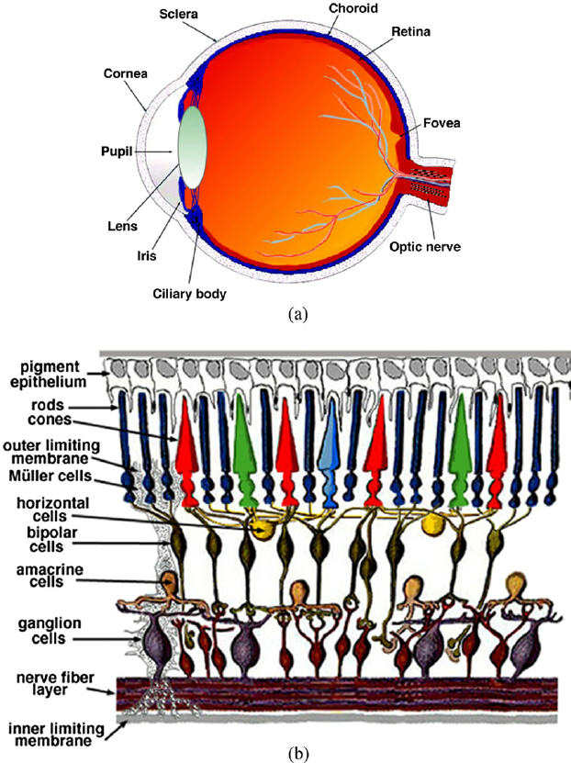

DIAGRAM SHOWING THE LAYERS OF THE EYE.
FUNCTIONS:
- The layers of the eye perform distinct functions which coalesce to create a unified, perceptual experience. The essential role of the external eye structures is to protect the delicate tissue of the internal eye. The eyelid prevents foreign bodies from entering the inner eye and helps refresh and distribute the tear film by blinking. Eyelashes are finely sensitive to touch and warn the eye of possible debris and particles that may cause injury.
- Internal parts of the eye have primarily structural and visual functions. The cornea serves a protective role and is responsible for two-thirds of the refractive properties of the eye. The remaining one-third of refraction is performed by the lens, which is functionally adjustable through the action of the zonular fibers and ciliary muscles. At the end of the visual process, as rays of light bend through the cornea and lens, photon energy is converted to neurochemical action potentials by cells of the retina, which then send these impulses to the brain, via the optic nerve.
- The uvea of the eye is a crucial mediator of nutrition and gas exchange, as blood vessels course through the ciliary body and iris, while the choriocapillaris in the posterior eye help support the retina. This abundant blood supply is implicated in uveitis, as inflammatory mediators enter the eye through this vascular network.
CLINICAL SIGNIFICANCE:
Several of the most common diseases of the eye are manifestations of pathology within specific histological layers. Below are examples of common eye conditions, and the layers of the eye implicated.
- Chalazion: A sterile lump often in the upper eyelid caused by obstruction of the meibomian oil glands.
- Conjunctivitis: Inflammation of the transparent conjunctiva that may be caused by bacterial or viral infections, allergies, or exposure to certain chemicals.
- Cataracts: A sclerotic nuclear cataract is the most common and is due to opacification in the central nucleus of the lens. Cortical cataracts are due to opacifications in the cortex and have a distinct wedge-shaped appearance. Posterior subcapsular cataracts arise from behind the sac-like structure of the lens.
- Glaucoma: Refers to optic nerve damage related to increased intraocular pressure. Drainage of aqueous humor through the trabecular meshwork is often implicated.
- Age-related macular degeneration: A progressive eye disease causing damage to the macula or central portion of the retina. Accumulation of drusen, or lipid-laden deposits in Bruch’s membrane of the retina, is associated with disease severity.
- Fuchs Dystrophy: A disease of the corneal endothelium, that causes accumulation of excess edema in the corneal stroma. Progression of the disease often causes blisters in the eye, also referred to as bullous keratopathy.
- Floaters: The sensation of floaters is due to changes that occur in the jelly-like vitreous layer of the eye.
- Retinal detachment: It occurs when the outer pigment epithelial layer separates from the inner neurosensory layer consisting of rods and cones; this is a vision-threatening condition as the neurosensory layer is unable to receive nutrients from the underlying choriocapillaris and retinal pigment epithelium.

- The retina is the innermost, light-sensitive layer of tissue of the eye of most vertebrates and some molluscs. The optics of the eye create a focused two-dimensional image of the visual world on the retina, which translates that image into electrical neural impulses to the brain to create visual perception. The retina serves a function analogous to that of the film or image sensor in a camera.
The vertebrate retina has ten distinct layers. From closest to farthest from the vitreous body:
- Inner limiting membrane – basement membrane elaborated by Müller cells.
- Nerve fibre layer – axons of the ganglion cell bodies (note that a thin layer of Müller cell footplates exists between this layer and the inner limiting membrane).
- Ganglion cell layer – contains nuclei of ganglion cells, the axons of which become the optic nerve fibres, and some displaced amacrine cells.
- Inner plexiform layer – contains the synapse between the bipolar cell axons and the dendrites of the ganglion and amacrine cells.
- Inner nuclear layer – contains the nuclei and surrounding cell bodies (perikarya) of the amacrine cells, bipolar cells, and horizontal cells.
- Outer plexiform layer – projections of rods and cones ending in the rod spherule and cone pedicle, respectively. These make synapses with dendrites of bipolar cells and horizontal cells. In the macular region, this is known as the Fiber layer of Henle.
- Outer nuclear layer – cell bodies of rods and cones.
- External limiting membrane – layer that separates the inner segment portions of the photoreceptors from their cell nuclei.
- Inner segment / outer segment layer – inner segments and outer segments of rods and cones. The outer segments contain a highly specialized light-sensing apparatus.
- Retinal pigment epithelium – single layer of cuboidal epithelial cells (with extrusions not shown in diagram). This layer is closest to the choroid, and provides nourishment and supportive functions to the neural retina, The black pigment melanin in the pigment layer prevents light reflection throughout the globe of the eyeball; this is extremely important for clear vision.
Six major cell types form the various layers within the human retina:
- Photoreceptors (rods and cones) - form the outer nuclear layer
- Synapse with bipolar cells at the outer plexiform layer
- Rods deal predominantly with peripheral and night vision
- Cones deal mainly with central vision
- Bipolar cells - make up the inner nuclear layer
- Synapse with amacrine cells and ganglion cells at the inner plexiform layer
- Amacrine cells
- Inhibitory cells which interact with bipolar cells and retinal ganglion cells
- Retinal ganglion cells - form the ganglion cell layer (innermost layer, furthest from the photoreceptors)
- Axons tract towards the back of the eye and form the optic nerve
- Horizontal cells
- Assist in operations such as contrast enhancement and preservation of spatial information.
- Muller cells
- glial cells which support metabolism and homeostasis of the retina.
FUNCTIONS:
- Photoreceptors (rods and cones): The detection of light begins at the deepest cell layer in the retina, the photoreceptors, located in the outer nuclear layer. Rods are very light sensitive and are responsible for dim-light vision. Cones, on the other hand, are not very light sensitive but are specific for a particular wavelength of light. Thus, cones are responsible for high acuity color vision.
- Bipolar cells: Photoreceptors use the neurotransmitter, glutamate, to communicate at the synapse with bipolar cells within the outer plexiform layer. Bipolar cell bodies are just shallow to this layer at the inner nuclear layer. At the inner plexiform layer, bipolar cells are responsible for transmitting an impulse to retinal ganglion cells.
- Retinal ganglion cells: These are the final receivers and transmitters of the initial stimulus. They send the information they receive down their axons, which eventually form the optic nerve and project to higher brain centers.
- Amacrine cells: Amacrine cells modulate the excitation of the retinal ganglion cells through contact with ganglion cell dendrites or bipolar cell axon terminal bulbs, using the neurotransmitters GABA and glycine.
- Horizontal cells: These cells function to modulate the communication between photoreceptors and bipolar cells. Bipolar cells contact ganglion and amacrine cells at the inner plexiform layer.
- Müller cells: These are cells are of glial origin and are essential for proper retinal function. They contact almost every cell type in the retina, spanning the entire width from the photoreceptors to the inner retina. They serve to recycle neurotransmitters, prevent glutamate toxicity, and regulate nutrient homeostasis in the retina.
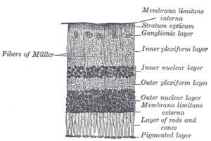

DIAGRAM SHOWING THE LAYERS OF THE RETINA.

