Rufus Jegede Opemipo
17/MHS01/289
Nursing Department
NSC 306

- Explain the Role of the Immune System:- The immune system is made up of special organs, cells and chemicals that fight infection (microbes). The main parts of the immune system are: white blood cells, antibodies, the complement system, the lymphatic system, the spleen, the thymus, and the bone marrow. These are the parts of your immune system that actively fight infection.
The immune system keeps a record of every microbe it has ever defeated, in types of white blood cells (B- and T-lymphocytes) known as memory cells. This means it can recognize and destroy the microbe quickly if it enters the body again, before it can multiply and make you feel sick.
Some infections, like the flu and the common cold, have to be fought many times because so many different viruses or strains of the same type of virus can cause these illnesses. Catching a cold or flu from one virus does not give you immunity against the others.

PARTS OF A IMMUNE SYSTEM
The main parts of the immune system are:
white blood cells
antibodies
complement system
lymphatic system
spleen
bone marrow
thymus.

- Describe the two types of Immunity:- Immunity is the ability of the body to protect against all types of foreign bodies like bacteria, virus, toxic substances, etc. which enter the body.
Immunity is also called disease resistance. The lack of immunity is known as susceptibility.

TYPES OF IMMUNITY
There are two major types of immunity: innate or natural or nonspecific and acquired or adaptive.
(A) Innate or Natural or Nonspecific Immunity (L. innatus = inborn):
Innate immunity is inherited by the organism from the parents and protects it from birth throughout life. For example humans have innate immunity against distemper, a fatal disease of dogs.
As its name nonspecific suggests that it lacks specific responses to specific invaders. Innate immunity or nonspecific immunity is well done by providing different barriers to the entry of the foreign agents into our body. Innate immunity consists of four types of barriers— physical, physiological, cellular and cytokine barriers.
(B) Acquired Immunity (= Adaptive or Specific Immunity):
The immunity that an individual acquires after the birth is called acquired or adaptive or specific immunity. It is specific and mediated by antibodies or lymphocytes or both which make the antigen harmless.
It not only relieves the victim of the infectious disease but also prevents its further attack in future. The memory cells formed by В cells and T cells are the basis of acquired immunity. Thus acquired immunity consists of specialized В and T lymphocytes and Antibodies.

- Explain the different types of antibodies and their roles:- Human antibodies are classified into five isotypes (IgM, IgD, IgG, IgA, and IgE) according to their H chains, which provide each isotype with distinct characteristics and roles.

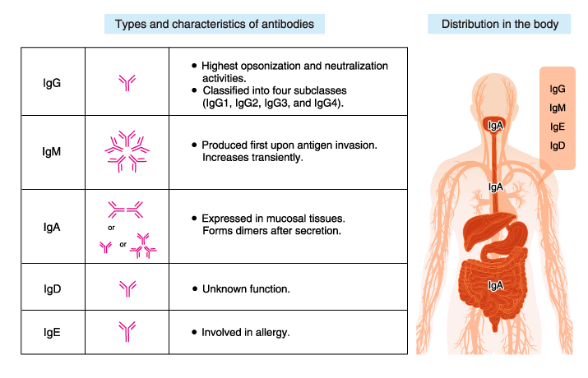
IgG
IgG is the most abundant antibody isotype in the blood (plasma), accounting for 70-75% of human immunoglobulins (antibodies). IgG detoxifies harmful substances and is important in the recognition of antigen-antibody complexes by leukocytes and macrophages. IgG is transferred to the fetus through the placenta and protects the infant until its own immune system is functional.
IgM
IgM usually circulates in the blood, accounting for about 10% of human immunoglobulins. IgM has a pentameric structure in which five basic Y-shaped molecules are linked together. B cells produce IgM first in response to microbial infection/antigen invasion.
Although IgM has a lower affinity for antigens than IgG, it has higher avidity for antigens because of its pentameric/hexameric structure. IgM, by binding to the cell surface receptor, also activates cell signaling pathways.
IgA
IgA is abundant in serum, nasal mucus, saliva, breast milk, and intestinal fluid, accounting for 10-15% of human immunoglobulins. IgA forms dimers (i.e., two IgA monomers joined together). IgA in breast milk protects the gastrointestinal tract of neonates from pathogens.
IgE
IgE is present in minute amounts, accounting for no more than 0.001% of human immunoglobulins. Its original role is to protect against parasites. In regions where parasitic infection is rare, IgE is primarily involved in allergy.
IgD
IgD accounts for less than 1% of human immunoglobulins. IgD may be involved in the induction of antibody production in B cells, but its exact function remains unknown.

