NAME: SADIKU DAVID JESUFERANMI
MATRI NO: 18/sci01/082

- write a c program to check whether a year is leap or not
Solution
#include <stdio.h>
int main()
{
int year;
printf("Enter a year \n");
scanf("%d", &year);
if(year%4 == 0){
if (year%100 == 100){
if (year%400 == 0)
printf("\n it is Leap Year. ");
else
printf("\n it is not a Leap year. ");
}
` else {
printf("\n it is a leap year. ");
}
}
else
printf("\n it is not a Leap Year ");
return 0;
}
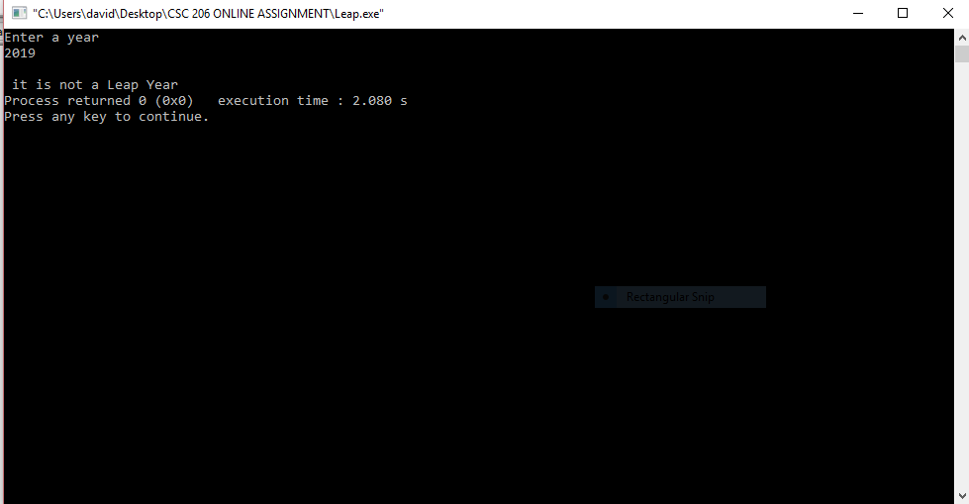
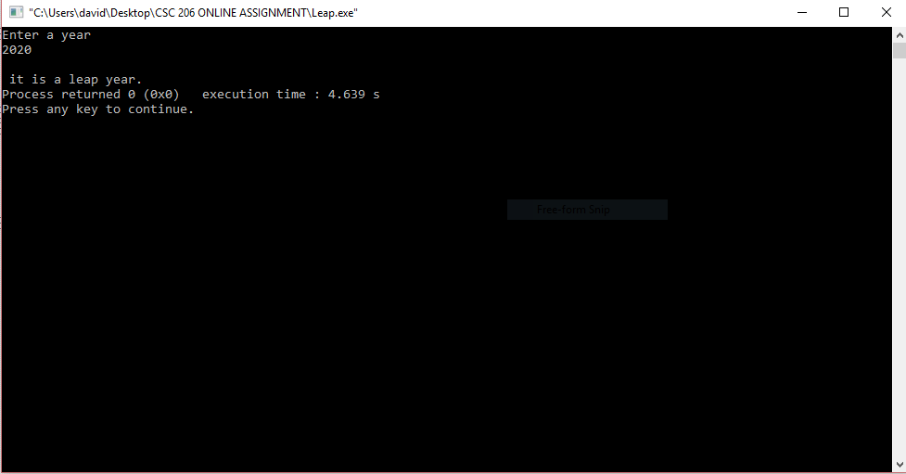
- write a c program to find the maximum between 3 numbers.
Solution
#include <stdio.h>
void main()
{
int A,B,C;
printf(" Enter the values of A,B and C \n");
scanf("%d %d %d", &A, &B, &C);
printf("A= %d\tB= %d\tC = %d\n", A,B ,C);
if (A > B)
{
if (A > C){
printf("A is the maximum among the three numbers \n ");
}
else
{
printf("C is the maximum among the three numbers \n");
}
}
else if (B > C)
printf("B is the maximum among the three numbers \n");
else
printf("C is the maximum among the three numbers \n");
}
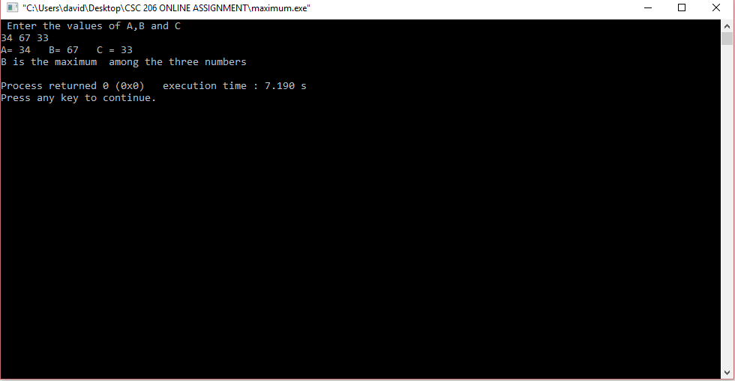

3. write a c program that calculates percentage, GPA and grade of a student. your program should prompt the user to enter total mark(s) and Mark(s) obtained in 7 subjects. then program will calculate percentage and GPA for each student based on entering total and obtained marks and will display the result.
hint on how to calculate the GPA:
a) find the sum of credits of all the subjects
b) find the sum of product of credit and the grade point for all subjects. store the result in total
c) divide total by sum of credits of all the subjects.
solution
#include<stdio.h>
int main()
{
int English,Maths,Geography,CSC206,French,Physics,Chemistry,totalmarks,sum;
float per;
totalmarks=700;
printf("Enter score for English out of 100= ");
scanf("%d",&English);
printf("Enter score for Maths out of 100= ");
scanf("%d",&Maths);
printf("Enter score for Geography out of 100= ");
scanf("%d",&Geography);
printf("Enter score for CSC206 out of 100= ");
scanf("%d",&CSC206);
printf("Enter score for French out of 100= ");
scanf("%d",&French);

printf("Enter score for Physics out of 100= ");
scanf("%d",&Physics);
printf("Enter score for Chemistry out of 100= ");
scanf("%d",&Chemistry);
printf("Maximum Marks= %d",totalmarks);
sum=English + Maths + Geography + CSC206 + French + Physics + Chemistry;
printf("\nObtained marks=%d",sum);
per=(sum*100)/700;
printf("\nPercentage= %0.2f",per);

if(per>=90 && per<=100)
{
printf("\nGPA=5.0");
printf("\nA+");
}
else if(per>=85 && per<=89)
{
printf("\nGPA=4.5");
printf("\nA");
}
else if(per>=80 && per<=84)
{
printf("\nGPA=4.0");
printf("\nB+");
}
else if(per>=75 && per<=79)
{
printf("\nGPA=3.5");
printf("\nB");
}
else if(per>=70 && per<=74)
{
printf("\nGPA=3.0");
printf("\nB-");
}
else if(per>=65 && per<=69)
{
printf("\nGPA=2.5");
printf("\nC+");
}
else if(per>=60 && per<=64)
{
printf("\nGPA=2.0");
printf("\nC-");
}
else if(per>=55 && per<=59)
{
printf("\nGPA=1.7");
printf("\nD+");
}
else if(per>=45 && per<=54)
{
printf("\nGPA=1.3");
printf("\nD-");
}
else if(per>=0 && per<=44)
{
printf("\nGPA=0.0");
printf("\nF");
}
return 0;
getchar();
}

