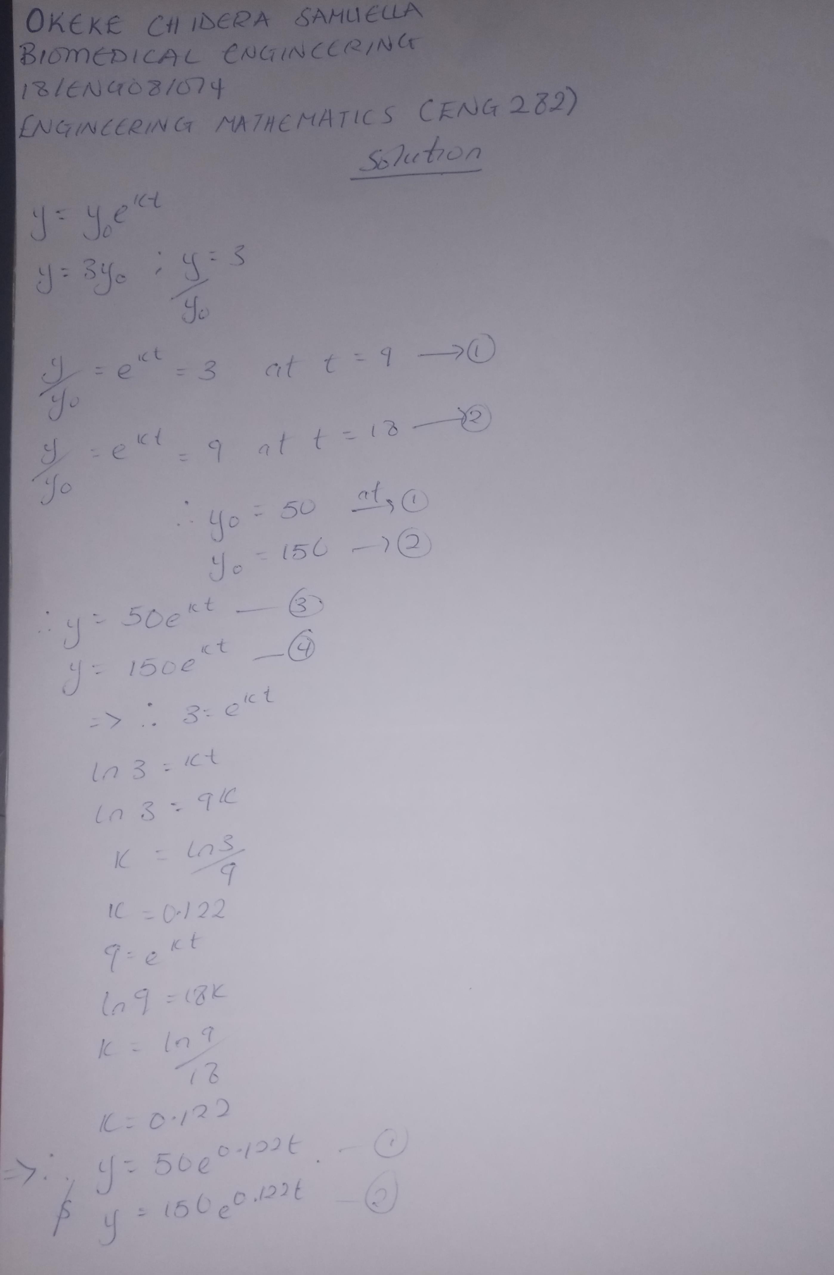
OKEKE CHIDERA SAMUELLA. 18/ENG08/014. BIOMEDICAL ENGINEERING
