NAME: BASHIR AL-AMIN MOHAMMED

COURSE CODE/NAME: BCH 204/ BIOCHEMISTRY II

DEPARTMENT: PHYSIOLOGY

MATRIC NUMBER: 18/MHS01/108

ASSIGNMENT

Describe the three (3) stages of beta oxidation. (Show pathways where necessary)

INTRODUCTION
Fatty acid beta-oxidation can be defined as a major metabolic pathway that is responsible for the mitochondrial breakdown of long-chain acyl-CoA to acetyl-CoA. It is also the catabolic process by which fatty acid molecules are broken down in the cytosol in prokaryotes and in the mitochondria in eukaryotes to generate acetyl-CoA, which enters the citric acid cycle, and NADH and FADH2, which are co-enzymes used in the electron transport chain. Simply put, is the process by which fatty acids are broken down to produce energy.
They include the four main enzymes involved in β-oxidation are: acyl-CoA dehydrogenase, enoyl-CoA hydratase, hydroxyl acyl-CoA dehydrogenase, and ketoacyl-CoA thiolase.
There are four distinct stages in the oxidation of fatty acids. Fatty acid degradation takes place within the mitochondria and requires the help of several different enzymes. The stages are as follows:
STAGES OF BETA OXIDATION OF FATTY ACIDS

- Dehydrogenation by FAD: The first step is the oxidation of the fatty acid by Acyl-CoA-Dehydrogenase. The enzyme catalyzes the formation of a double bond between the C-2 and C-3.
- ENZYME: acyl CoA dehydrogenase
- END PRODUCT: trans-Δ²-enoyl-CoA.
- DIAGRAM
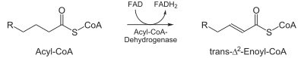

- Hydration: The next step is the hydration of the bond between C-2 and C-3. The reaction is stereospecific, forming only the L isomer.
- ENZYME: enoyl CoA hydratase
- END PRODUCT: L-β-hydroxyacyl CoA.
- DIAGRAM:
- NOTE: THE NUMBER “3” IN THE DIAGRAM REFERS TO “β” AS IN BETA-HYDRXYACYL….
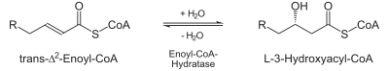

- Oxidation by NAD⁺: The third step is the oxidation of L-β-hydroxyacyl CoA by NAD⁺ .This converts the hydroxyl group into a keto group
- ENZYME: 3-hydroxyacyl-CoA dehydrogenase.
- END PRODUCT: β-ketoacyl CoA.
- DIAGRAM: NOTE: THE NUMBER “3” IN THE DIAGRAM REFERS TO “β” AS IN BETA-HYDROXYACYL….
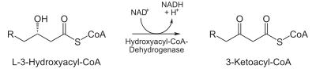

- Thiolysis: The final step is the cleavage of β-ketoacyl CoA by the thiol group of another molecule of Coenzyme A. The thiol is inserted between C-2 and C-3.
- ENZYME: β-ketothiolase
- END PRDOUCT: An acetyl-CoA molecule, and an acyl-CoA molecule that is two carbons shorter
- DIAGRAM:
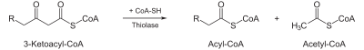

NOTE:“3” IN THE DIAGRAM REFERS TO “β” AS IN BETA-KETOACYL.

