Name: Nzegwu chinwe raluchukwu
College: Medicine and Health Sciences
Department: Dentistry
Matric no:19/mhs09/016
Course: Physics 102
Covid-19 Holiday Assignment.
Section A

1a. Charging by Induction:
Electric charges can be obtained on an object without touching it, by a process called electrostatic induction. Consider a positively charged rubber rod brought near a neutral (uncharged) conducting sphere that is insulated so that there is no conducting path to ground as shown below. The repulsive force between the protons in the rod and those in the sphere causes a redistribution of charges on the sphere so that some protons move to the side of the sphere farthest away from the rod (fig. 1.3a). The region of the sphere nearest the positively charged rod has an excess of negative charge because of the migration of protons away from this location. If a grounded conducting wire is then connected to the sphere, as in (fig. 1.3b), some of the protons leave the sphere and travel to the earth. If the wire to ground is then removed (fig 1.3c), the conducting sphere is left with an excess of induced negative charge.
Finally, when the rubber rod is removed from the vicinity of the sphere (fig. 1.3d), the induced negatively charge remains on the ungrounded sphere and becomes uniformly distributed over the surface of the sphere.
Diagram:

1B
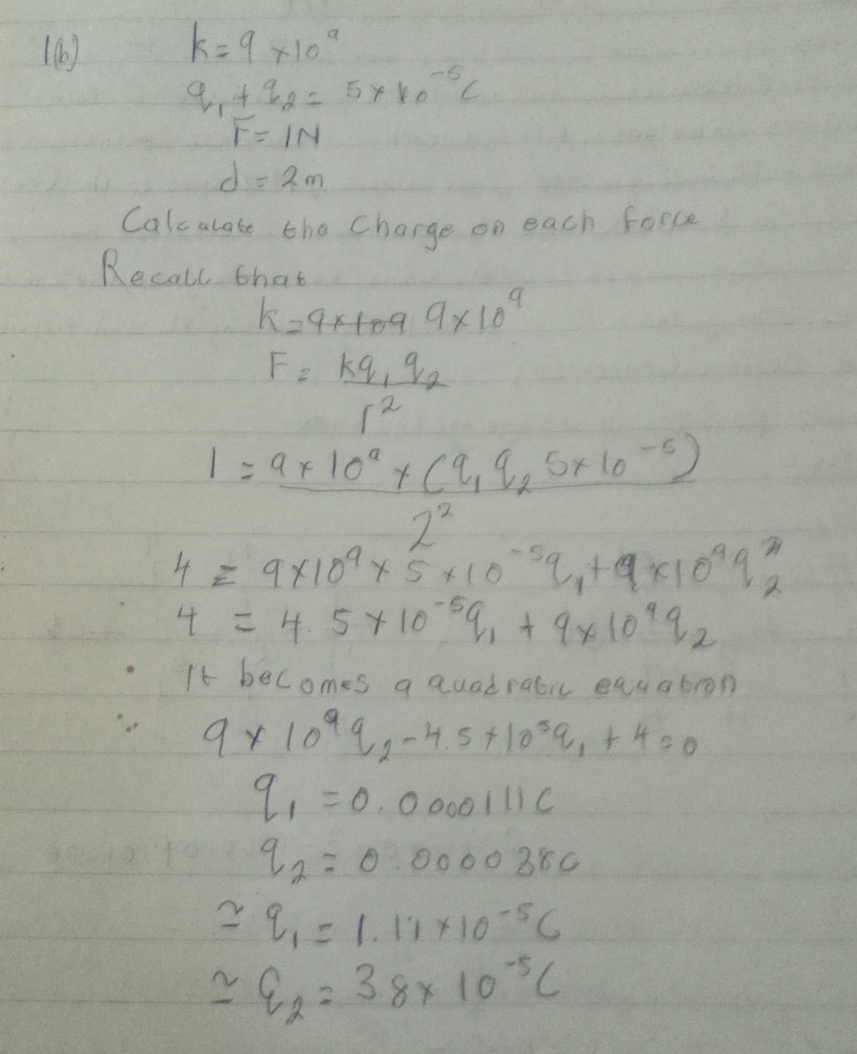

13

1c 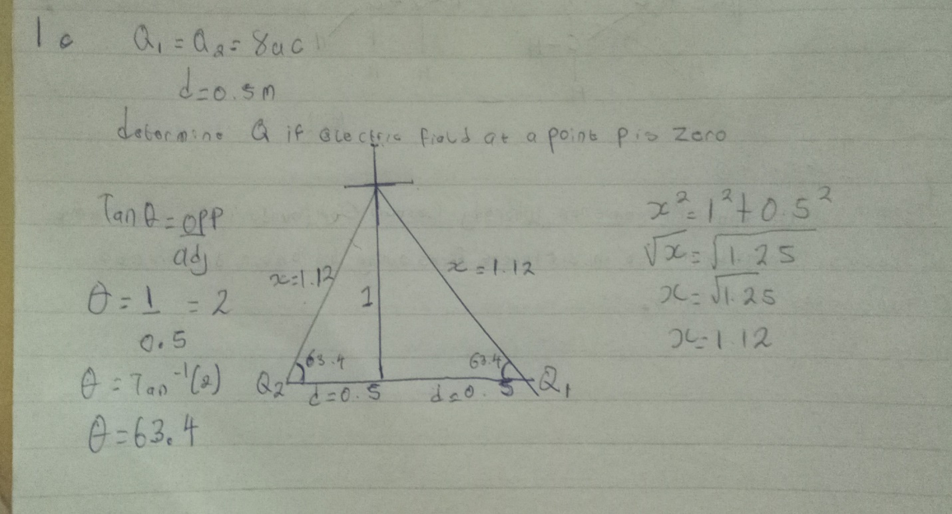

Continuation of 1C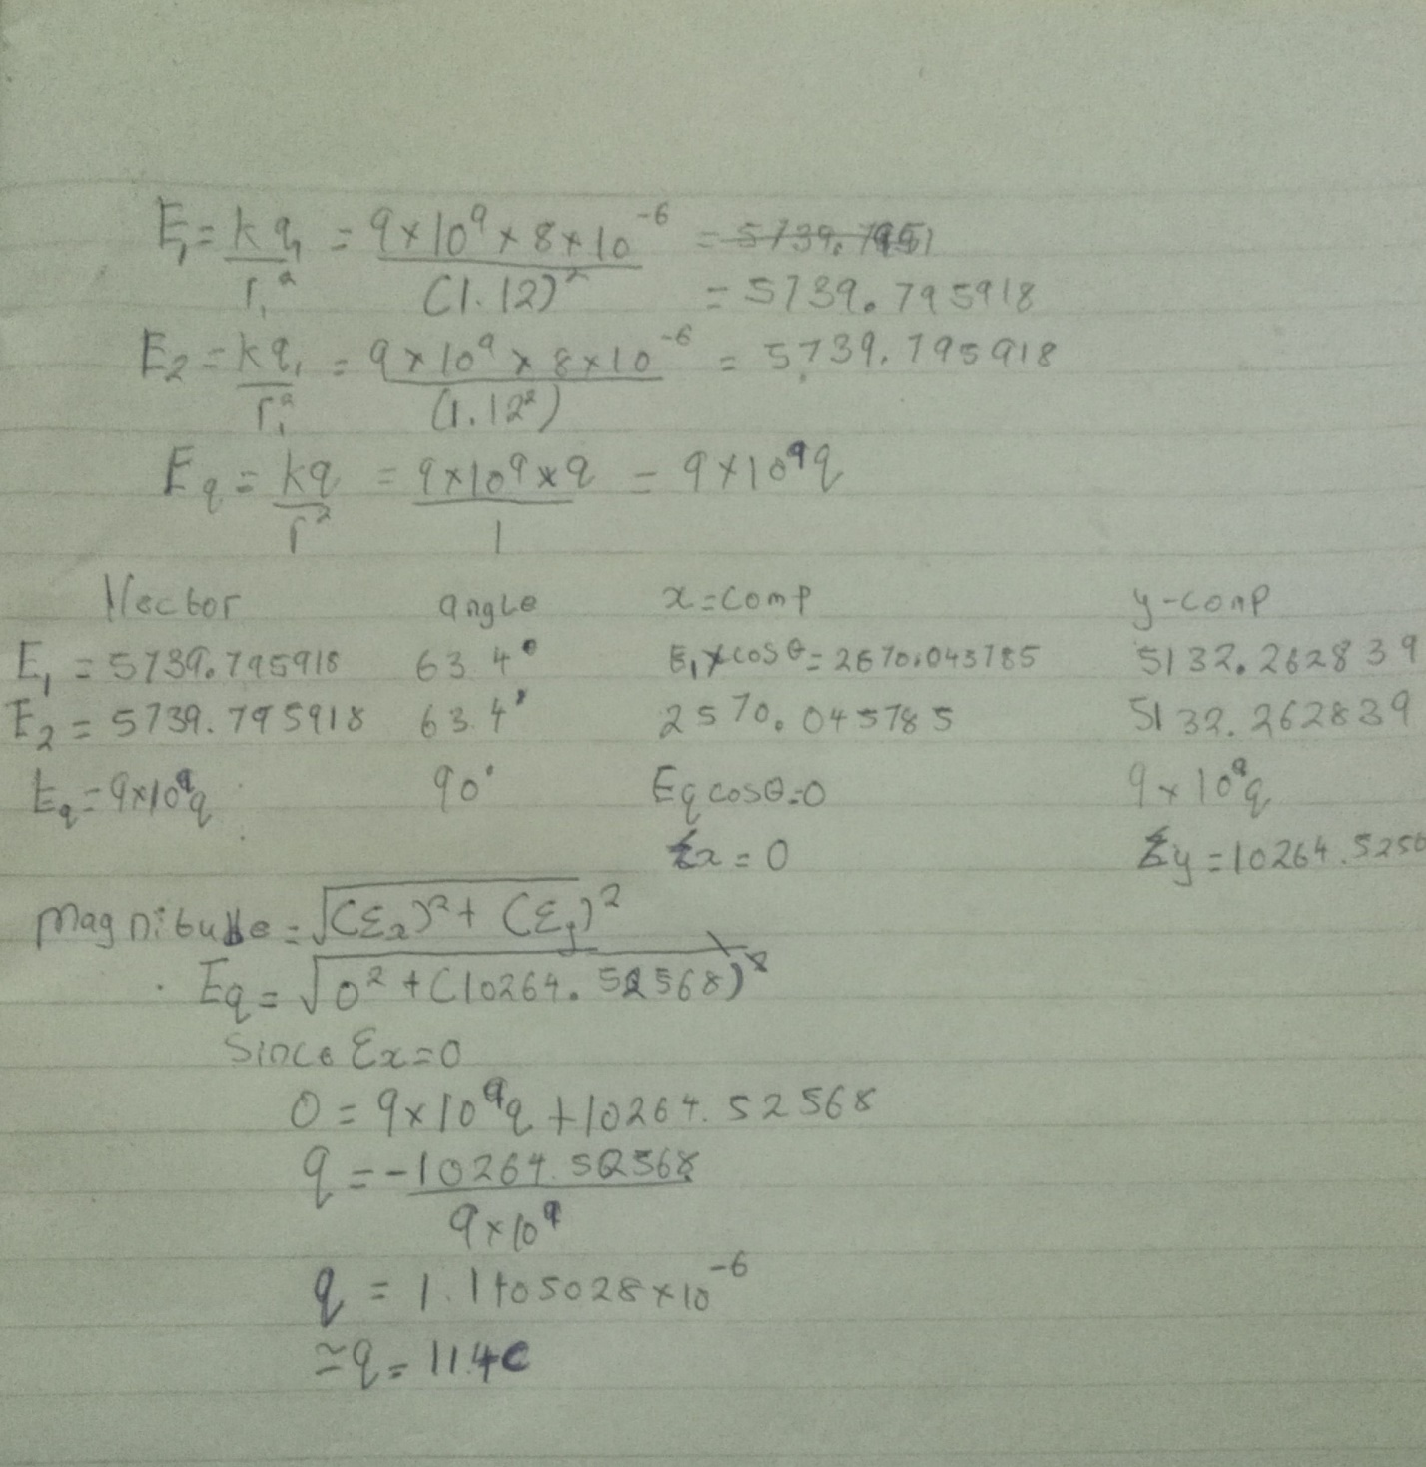

4a. magnetic flux is defined as the strength of the magnetic field which can be represented by line of forces. It is represented by the symbol Φ.mathematically given as Φ=B. d A

4b. 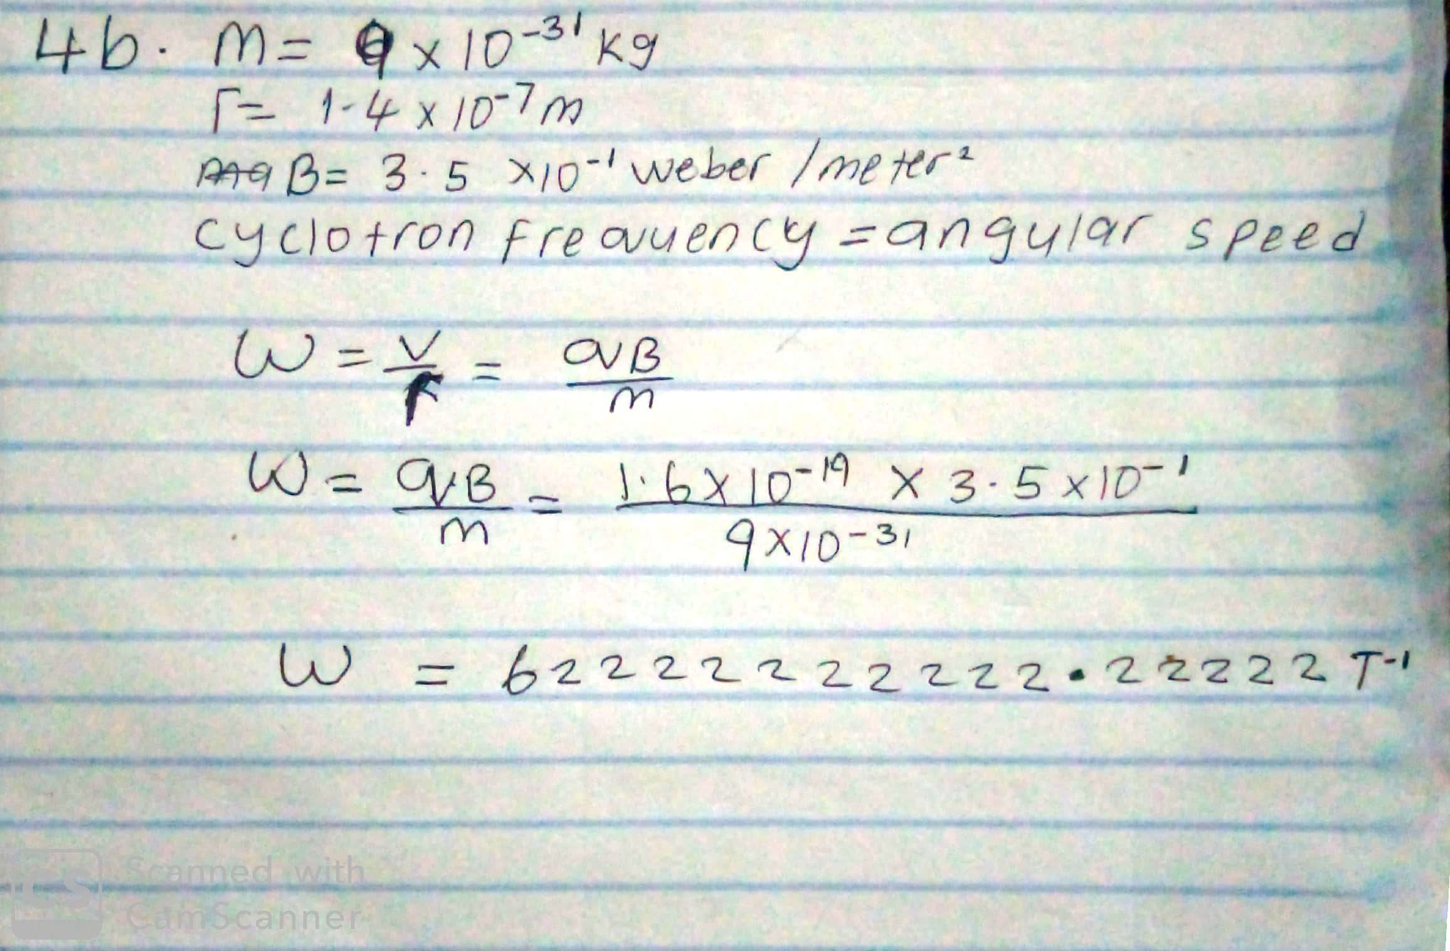

4C. In the question we were given paramiters such as
i.mass of the electron =9.11x10⁻³¹ kg
ii.A radius of 1.4x10⁻⁷m
iii.magnetic field of 3.5x10⁻¹weber\meter square
and you are asked to find the cyclotron frequency which is equal or the same thing as angular speed.it is called cyclotron frequency because it is a frequency of an accelerator called cyclotron.
Recall that angular speed is given as ω=$\frac{v}{r}$=$\frac{qB}{m}$
Substituting we haveω=$\frac{v}{r}$=$\frac{qB}{m}$=1.6x10⌃-10x3.5x10⌃-10
9.11x10⌃-31

$\frac{qB}{m}=\frac{1.6×{10}^{-19}x3.5x10⌃-1}{9.11x10⌃-31}$=62222222222.22222T⁻¹
SO since cyclotron frequency is equal to angular speed the cyclotron frequency is equal to =62222222222.22222^{T-1} , having a unit as 1\T which is equal to the unit of frequency dimensionally.

5A. Biot-savart law states that the magnetic field is directly proportional to the product permeability of free space(µ),the current(I),the change in length, the radius and inversely proportional to square of radius (r² ). It can be represented mathematically by
$$d\vec{B}= \frac{μ_{o}}{4π}\frac{I d\vec{l}×\hat{r}}{r^{2}}$$
where $μ_{o}$ is a constant called Permeability of free space.
$$μ_{o}=4π ×{10}^{-7} T.\frac{m}{A}$$
The unit of $\vec{B}$ is weber\metre square

5b. Magnetic Field of a Straight Current Carrying Conductor
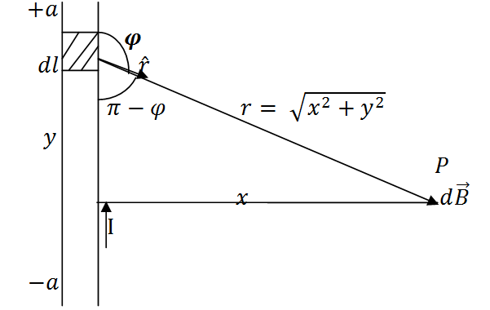
Fig 1: A section of a Straight Current Carrying Conductor
Applying the Biot-Savart law, we find the magnitude of the field $d\vec{B}$
$$B= \frac{μ_{o}I}{4π}\int_{-a}^{a}{\frac{dl\sin{φ}}{r^{2}}}$$
$$sin\left(π –φ\right)= sinθ$$
$$∴B= \frac{μ_{o}I}{4π}\int_{-a}^{a}{\frac{dlsin(π-φ)}{r^{2}}}$$
From diagram, $r^{2}=x^{2}+y^{2} (Pythagoras theorem)$
$$B= \frac{μ_{o}I}{4π}\int_{-a}^{a}{\frac{dlsin(π –φ)}{x^{2 }+ y^{2}}} … (*)$$
$$But sin\left(π-φ\right)= \frac{x}{\sqrt{x^{2 }+ y^{2}}}=\frac{x}{{\left(x^{2 }+ y^{2}\right)}^{1/2}} … (**)$$
Substituting $(**)$ into $(*)$, we have
$$B= \frac{μ_{o}I}{4π}\int_{-a}^{a}{dl}\frac{x}{{{(x}^{2}+ y^{2})\left(x^{2 }+y^{2 }\right)}^{1/2}}$$

$$B= \frac{μ_{o}I}{4π}\int_{-a}^{a}{dl}\frac{x}{{\left(x^{2 }+y^{2 }\right)}^{3/2}}$$
Recall $dl=dy$l=dy
μ_oI/4π_-a^a?x/x^2 +y^2 ^3/2dy
$$B=\frac{μ_{o}Ix}{4π}\int_{-a}^{a}{\frac{1}{{\left(x^{2 }+y^{2 }\right)}^{3/2}}dy} … (***)$$
Using special integrals:
$$\int{\frac{dy}{{{(x}^{2 }+ y^{2})}^{3/2}}}=\frac{1}{x^{2}}\frac{y}{{(x^{2 }+ y^{2})}^{1/2}}$$
Equation $(***)$ therefore becomes
$$B= \frac{μ_{o}Ix}{4π}{\left[\frac{y}{x^{2}{\left(x^{2 }+y^{2}\right)}^{1/2}}\right]}_{-a}^{a}$$
$$B=\frac{μ_{o}Ix}{4π}\left(\frac{2a}{x^{2}{\left(x^{2 }+ a^{2}\right)}^{1/2}}\right)$$
$$B=\frac{μ_{o}I}{4πx}\left(\frac{2a}{{\left(x^{2 }+ a^{2}\right)}^{1/2}}\right)$$
When the length $2a$ of the conductor is very great in comparison to its distance $x$ from point P, we consider it infinitely long. That is, when $a$ is much largerthan $x$,
$${(x^{2 }+ a^{2})}^{1/2}≅a, as a→∞$$
$$∴B= \frac{μ_{o}I}{2πx}$$
In a physical situation, we have axial symmetry about the y- axis. Thus, at all points in a circle of radius $r$, around the conductor, the magnitude of B is
$$B= \frac{μ_{o}I}{2πr} … (\#)$$
Equation $(\#)$ defines the magnitude of the magnetic field of flux density B near a long, straight current carrying conductor.

2a. Electric field is a region of space in which electric charges will experience an electric force while Electric intensity is the force per unit charge

2B
