RAJI UMMI-SALMA ONIZE
18/ENG08/020
BIOMEDICAL ENGINEERING
PHYSIOLOGY ASSIGNMENT
Write short notes on the following:
- Spermatogenesis
- Testosterone
- Semen
- Male orgasm
- Male infertility
ANSWERS
- Spermatogenesis:
Spermatogenesis is the origin and development of the sperm cells within the male reproductive organs, the testes. The testes are composed of numerous thin, tightly coiled tubules known as the seminiferous tubules; the sperm cells are produced within the walls of the tubules. Within the walls of the tubules, also, are many randomly scattered cells, called Sertoli cells that function to support and nourish the immature sperm cells by giving them nutrients and blood products. As the young germ cells grow, the Sertoli cells help to transport them from the outer surface of the seminiferous tubule to the central channel of the tubule.

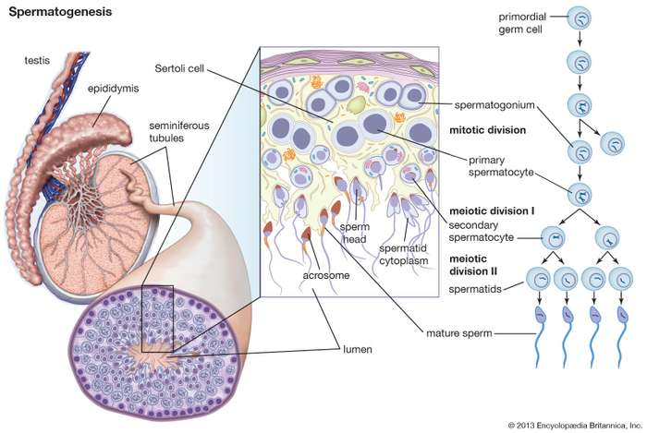
- Testosterone:
Testosterone is the primary male sex hormone and anabolic steroid. In male humans, testosterone plays a key role in the development of male reproductive tissues such as testes and prostate, as well as promoting secondary sexual characteristics such as increased muscle and bone mass, and the growth of body hair. In addition, testosterone is involved in health and well-being, and the prevention of osteoporosis. Insufficient levels of testosterone in men may lead to abnormalities including frailty and bone loss. Testosterone is a steroid from the androstane class containing a keto and hydroxyl groups at positions three and seventeen respectively. It is biosynthesized in several steps from cholesterol and is converted in the liver to inactive metabolites. It exerts its action through binding to and activation of the androgen receptor. In humans and most other vertebrates, testosterone is secreted primarily by the testicles of males and, to a lesser extent, the ovaries of females. On average, in adult males, levels of testosterone are about 7 to 8 times as great as in adult females. As the metabolism of testosterone in males is more pronounced, the daily production is about 20 times greater in men.
- Semen
Semen, also called seminal fluid, fluid that is emitted from the male reproductive tract and that contains sperm cells, which are capable of fertilizing the female eggs. Semen also contains other liquids, known as seminal plasma, which help to keep the sperm cells viable.
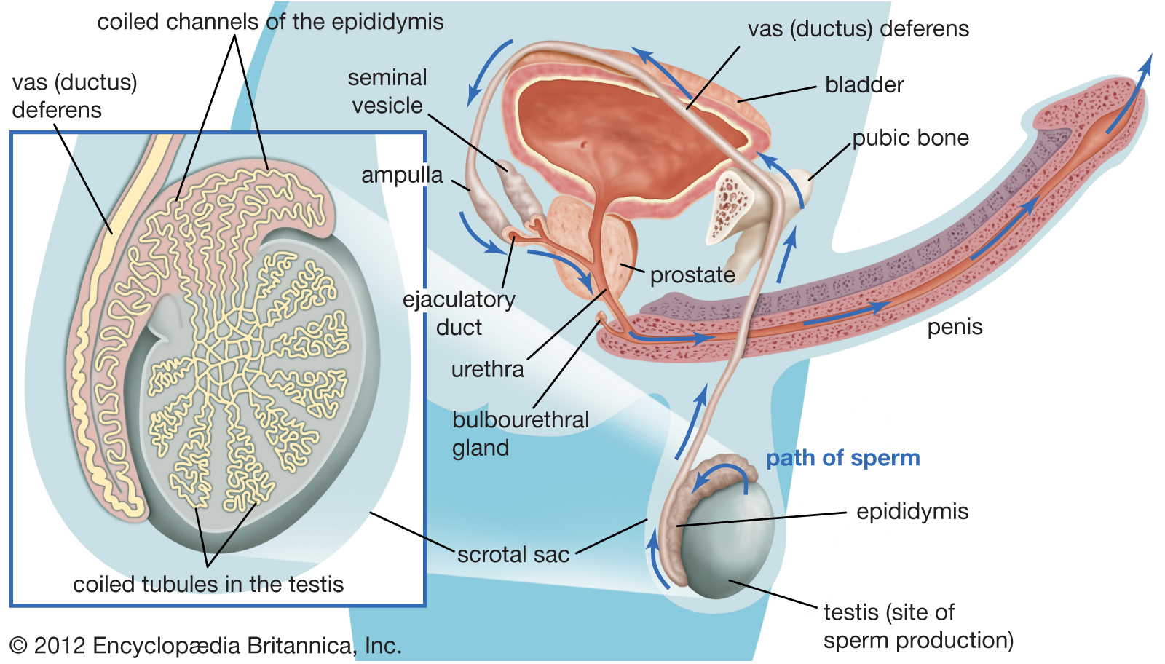
In the sexually mature human male, sperm cells are produced by the testes; they constitute only about 2 to 5 percent of the total semen volume. As sperm travel through the male reproductive tract, they are bathed in fluids produced and secreted by the various tubules and glands of the reproductive system. After emerging from the testes, sperm are stored in the epididymis, in which secretions of potassium, sodium, and glycerylphosphorylcholine (an energy source for sperm) are contributed to the sperm cells. Sperm mature in the epididymis. They then pass through a long tube, called the ductus deferens, or vas deferens, to another storage area, the ampulla. The ampulla secretes a yellowish fluid, ergothioneine, a substance that reduces chemical compounds, and the ampulla also secretes fructose, a sugar that nourishes the sperm. During the process of ejaculation, liquids from the prostate gland and seminal vesicles are added, which help dilute the concentration of sperm and provide a suitable environment for them. Fluids contributed by the seminal vesicles are approximately 60 percent of the total semen volume; these fluids contain fructose, amino acids, citric acid, phosphorus, potassium, and hormones known as prostaglandins. The prostate gland contributes about 30 percent of the seminal fluid; the constituents of its secretions are mainly citric acid, acid phosphatase, calcium, sodium, zinc, potassium, protein-splitting enzymes, and fibrolysin (an enzyme that reduces blood and tissue fibres). A small amount of fluid is secreted by the bulbourethral and urethral glands; this is a thick, clear, lubricating protein commonly known as mucus.
- Male Orgasm:
During a male organsm, the penis usually becomes erect (hard) before an orgasm and flaccid (soft) again after. When a man has an orgasm, his penis spasms and undergoes a series of rhythmic contractions, during which he feels a very strong and enjoyable feeling in his penis and groin, and sometimes in all of his body. In a man, an orgasm usually happens at the same time as an ejaculation, which is a release of semen through the penis that can't be stopped. Young boys can orgasm, but there may be no semen because semen release usually occurs only after puberty has started. After an orgasm, men usually have a deep sense of relaxation, usually felt in the groin and the thighs. Usually the stronger the orgasm, the deeper the relaxation and the longer the relaxation will last.
- Male Infertility:
Male infertility is due to low sperm production, abnormal sperm function or blockages that prevent the delivery of sperm. The main sign of male infertility is the inability to conceive a child. There may be no other obvious signs or symptoms. In some cases, however, an underlying problem such as an inherited disorder, a hormonal imbalance, dilated veins around the testicle or a condition that blocks the passage of sperm causes signs and symptoms. Although most men with male infertility do not notice symptoms other than the inability to conceive a child. The signs and symptoms associated with male infertility include:
- Problems with sexual function, for example, difficulty with ejaculation or small volumes of fluid ejaculated, reduced sexual desire, or difficulty maintaining an erection (erectile dysfunction)
- Pain, swelling or a lump in the testicle area
- Recurrent respiratory infections
- Inability to smell
- Abnormal breast growth (gynecomastia)
- Decreased facial or body hair or other signs of a chromosomal or hormonal abnormality
- A lower than normal sperm count (fewer than 15 million sperm per milliliter of semen or a total sperm count of less than 39 million per ejaculate).

