Name: Ayanka Jesselyn Oritsemisan
Department: Biochemistry
Matric number: 19/sci03/001

1)IUPAC NAMES
a) CH3OCH3-Methoxymethane
b) CH3CH2OCH2CH3-Ethoxyethane
c) (CH3CH2CH2CH2)2O- 1-butoxybutane
d) CH3CH2OCH3-Methoxyethane
e) CH3CH2CH2OCH2CH3-Ethoxypropane

2) PHYSICOCHEMICAL PROPERTIES OF ETHERS
a) Ethers are colorless compounds with characteristic, relatively pleasant odors.

b) They have lower boiling points (bp,s) than alcohols with an equal number of carbon atoms. In fact, an ether has nearly the same bp as the corresponding hydrocarbon in which a -CH2- group replaces the ether’s oxygen. Because of their structures (no O-H bonds), ether molecules cannot form hydrogen bonds with one another.

c) Since oxygen is significantly more electronegative than carbon, ether linkages are dipolar - a negative oxygen dipole linked to two positive carbon dipoles. Because of the presence of this dipole, ethers have the ability to act as hydrogen bond acceptors and
thus they display higher solubility in polar solvents such as water than corresponding hydrocarbons.

d) Ethers are less water soluble than corresponding alcohols, acids or like compounds. Alcohols and acids can both donate and accept hydrogen bonds from water, and may form more hydrogen bonds with water due to the presence of both C-O and O-H dipoles. Ethers contain on C-O dipoles and thus can only accept hydrogen bonds from water and not donate hydrogen bonds. For these reasons ethers are less water soluble than alcohols and other organic compound containing more polar
functionality. As is observed with other organic compounds containing a dipolar functional group, water solubility within a series of ethers is a function of overall structure. As would be expected, water solubility rapidly decreases as the total hydrocarbon content of ethers increase.

3) PREPARATION OF ETHERS.
a) From the Williamson ether synthesis
The Williamson ether synthesis is an organic reaction, forming an ether from an organohalide and a deprotonated alcohol (alkoxide). This reaction was developed by Alexander Williamson in 1850. Typically it involves the reaction of an alkoxide ion with a primary alkyl halide via an SN2 reaction. This reaction is important in the history of organic chemistry because it helped prove the structure of ethers.
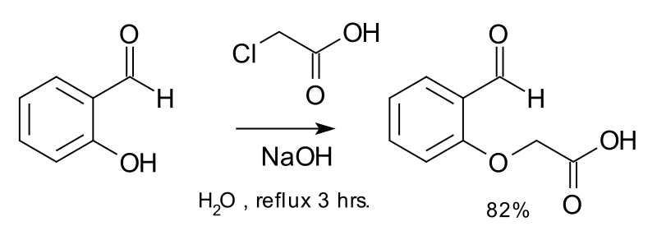
Ether synthesis by reaction of salicylaldehyde with chloroacetic acid and sodium hydroxide.

The general reaction mechanism is as follows:
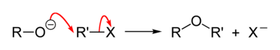
An example is the reaction of sodium ethoxide with chloroethane to form diethyl ether and sodium chloride:

[Na]+[C2H5O]− + C2H5Cl → C2H5OC2H5 + [Na]+[Cl]−

The Williamson ether reaction follows an SN2 bimolecular nucleophilic substitution mechanism. In an SN2 reaction mechanism there is a backside attack of an electrophile by a nucleophile and it occurs in a concerted mechanism (happens all at once). In order for the SN2 reaction to take place there must be a good leaving group which is strongly electronegative, commonly a halide. In the Williamson ether reaction there is an alkoxide ion (RO-) which acts as the nucleophile, attacking the electrophilic carbon with the leaving group, which in most cases is an alkyl tosylate or an alkyl halide. The leaving site must be a primary carbon, because secondary and tertiary leaving sites generally prefer to proceed as an elimination reaction. Also, this reaction does not favor the formation of bulky ethers like di-tertbutyl ether, due to steric hindrance and predominant formation of alkenes instead.

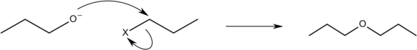
An example for a Williamson ether synthesis to make dipropyl ether. X- product is not shown.

Since alkoxide ions are highly reactive, they are usually prepared immediately prior to the reaction, or are generated in situ. In laboratory chemistry, in situ generation is most often accomplished by the use of a carbonate base or potassium hydroxide, while in industrial syntheses phase transfer catalysis is very common. A wide range of solvents can be used, but protic solvents and apolar solvents tend to slow the reaction rate strongly, as a result of lowering the availability of the free nucleophile. For this reason, acetonitrile and N,N-dimethylformamide are particularly commonly used.
A typical Williamson reaction is conducted at 50 to 100 °C and is complete in 1 to 8 h. Often the complete disappearance of the starting material is difficult to achieve, and side reactions are common. Yields of 50–95% are generally achieved in laboratory syntheses, while near-quantitative conversion can be achieved in industrial procedures.

Catalysis is not usually necessary in laboratory syntheses. However, if an unreactive alkylating agent is used (e.g. an alkyl chloride) then the rate of reaction can be greatly improved by the addition of a catalytic quantity of a soluble iodide salt (which undergoes halide exchange with the chloride to yield a much more reactive iodide, a variant of the Finkelstein reaction). In extreme cases, silver compounds such as silver oxide may be added:
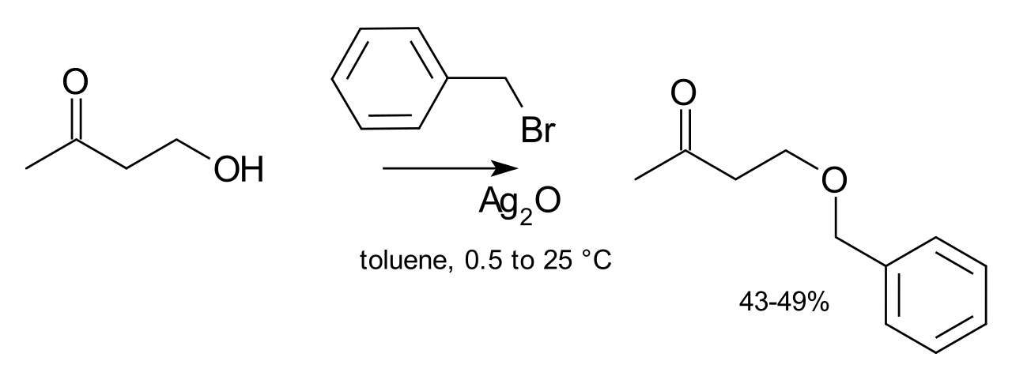
The silver ion coordinates with the halide leaving group to make its departure more facile. Finally, phase transfer catalysts are sometimes used (e.g. tetrabutylammonium bromide or 18-crown-6) in order to increase the solubility of the alkoxide by offering a softer counter-ion.

The Williamson reaction often competes with the base-catalyzed elimination of the alkylating agent,[3] and the nature of the leaving group as well as the reaction conditions (particularly the temperature and solvent) can have a strong effect on which is favored. In particular, some structures of alkylating agent can be particularly prone to elimination. When the nucleophile is an aryloxide ion, the Williamson reaction can also compete with alkylation on the ring since the aryloxide is an ambident nucleophile.

b) From alcohols:
The dehydration of alcohols affords ethers:
2 R–OH → R–O–R + H2O at high temperature
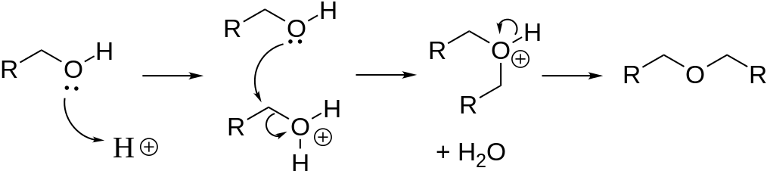
This direct nucleophilic substitution reaction requires elevated temperatures (about 125 °C). The reaction is catalyzed by acids, usually sulfuric acid. The method is effective for generating symmetrical ethers, but not unsymmetrical ethers, since either OH can be protonated, which would give a mixture of products. Diethyl ether is produced from ethanol by this method. Cyclic ethers are readily generated by this approach. Elimination reactions compete with dehydration of the alcohol:
R–CH2–CH2(OH) → R–CH=CH2 + H2O

The dehydration route often requires conditions incompatible with delicate molecules. Several milder methods exist to produce ethers.

4) USES OF ETHYLENE OXIDE.
a)Ethylene oxide is used mainly as a chemical intermediate in the manufacture of ethylene glycol (antifreeze), textiles, detergents, polyurethane foam, solvents, medicine, adhesives, and other products.
b)Relatively small amounts of ethylene oxide is used as a fumigant in certain agricultural products.
c)Ethylene oxide is also used as a sterilant for food (spices) and cosmetics, and in hospital sterilization of surgical equipment and plastic devices that cannot be sterilized by steam.

