What is the meaning of a “Pandemic”
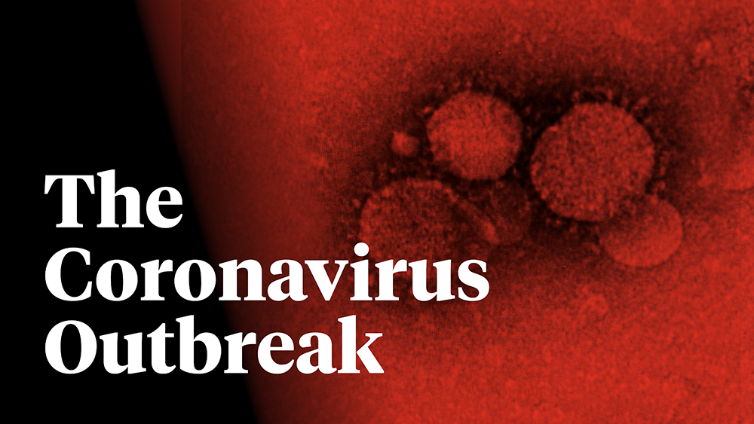
The name for this kind of virus comes from the crown like spikes it has on its surface — “corona” is Latin for “crown.” Coronaviruses are a large group of viruses that infect mostly bats, pigs and small mammals. In rare cases, they are what scientists call zoonotic, meaning they can be transmitted from animals to humans, according to the US Centres for Disease Control and Prevention.

Location Origin and how it spreads
In December 2019, 27 of the first 41 people hospitalised (66%) passed through a market located in the heart of Wuhan city in Hubei province. But, according to a study conducted at Wuhan Hospital, the very first human case identified did not frequent this market. Instead, a molecular dating estimate based on the SARS-CoV-2 genomic sequences indicates an origin in November. This raises questions about the link between this COVID-19 epidemic and wildlife.

How does it spread
Like other coronaviruses – such as the common cold – the virus is spread via droplets when a person coughs or sneezes. It can also be spread when someone touches a contaminated surface such as a door handle.
Hospitals are also key locations for “super spreading” events – when a single patient infects many people. When patients arrive in hospital with vague respiratory symptoms health workers may not know they need to take special precautions such as wearing masks or keeping them away from other patients.
The outbreak originates from animals and the source is thought to be a seafood market in Wuhan which also traded in other live animals such as marmots and bats.
Symptoms of Coronavirus
The viruses can make people sick, usually with a mild to moderate upper respiratory tract illness, similar to a common cold. Coronavirus symptoms include a runny nose, cough, sore throat, possibly a headache and maybe a fever, which can last for a couple of days.
Three to four out of every 10 patients infected with MERS died, according to the CDC. Severe acute respiratory syndrome, also known as SARS, is the other coronavirus that can cause more severe symptoms. First identified in the Guangdong province in southern China, according to the WHO, it causes respiratory problems but can also cause diarrhoea, fatigue, shortness of breath, respiratory distress and kidney failure.
Nigeria has reported the first case of coronavirus in sub-Saharan Africa, raising concerns about the spread of the virus on a continent that health experts say is poorly equipped to deal with a potential pandemic. Officials said the infected person was an Italian businessman who had returned from Milan to Lagos, Nigeria’s commercial centre, where he lives and works. He was clinically stable, with no serious symptoms, the health minister said in a statement on Friday. The case marks the first recorded spread of the virus to a part of the world with deep economic ties to China — where the coronavirus started — and experts believe the continent is the least prepared to diagnose new cases and to contain any rapid spread.
The Italian man carrying the virus had probably been asymptomatic when he arrived in Lagos on a Turkish Airlines flight earlier this week. A form he had filled out on arrival indicated he had not felt ill, Mr Ihekweazu said. A team of epidemiologists were working overtime to trace the contacts the patient had made before he sought medical care.

The 1918 Influenza
People believe that if the Coronavirus ends up getting out of control it would end up like the 1918 influenza. The 1918 influenza pandemic was the most severe pandemic in recent history. It was caused by an H1N1 virus with genes of avian origin. Although there is not universal consensus regarding where the virus originated, it spread worldwide during 1918-1919. In the United States, it was first identified in military personnel in spring 1918.
It is estimated that about 500 million people or one-third of the world’s population became infected with this virus. The number of deaths was estimated to be at least 50 million worldwide with about 675,000 occurring in the United States. Mortality was high in people younger than 5 years old, 20-40 years old, and 65 years and older. The high mortality in healthy people, including those in the 20-40 year age group, was a unique feature of this pandemic.

In Conclusion will this Pandemic end peacefully or is this just the beginning of other deadlier disease

