Momohjimoh Hayatudeen
019/law01/147
Law
Sociology

The dictionary defines family in several ways. One definition is "a fundamental social group in society typically consisting of one or two parents and their children." While this definition is a good starting point, there are several modern family structures that are excluded by this definition, such as childless couples or other variations on the family unit. Another definition is "Two or more people who share goals and values, have long-term commitments to one another and reside usually in the same dwelling." This definition encompasses the vast majority of modern family units

• Procreation and Rearing of Children
• Provision of shelter
• Socialization
• Economic functions
• Educational functions
• Religious functions
• Health related functions

Procreation and Rearing of Children:
It is another important sectional function of family .Necessary arrangement of stable satisfaction of sexual urge resulted in procreation. Family provides the legitimate basis for production of children. It institutionalizes the process of procreation. By performing this function of procreation family contributes to the continuity of family and ultimately human race.
Provision of Home and shelter:
Family perform another important function of providing a home for common living to all it’s members. It is only in a home that children are born and brought up. Even if children are born in hospitals in modern time still they are taken care of and properly nourished in a home only.
Socialization:
It is another important essential function of family. It is said man is not born human but made human. New born human baby became human being after they are socialized. Family plays an important role in the socialization process.
Economic functions:
Since ancient times family has been performing several economic functions. It is an important economic unit. In ancient time family was both a production and consumption unit. It used to fulfill almost all the economic needs of it’s members such as food, clothing, housing etc.
Educational functions:
Family performs many educational functions for it’s members. As an primary educational institution family used to teach letters, knowledge, skill and trade secret to all it’s members. It looks after the primary education of it’s members and moulds their career and character. Mother act as the first and best teacher of a child. Besides he learns all sorts of informal education such as discipline, obedience, manners etc. from family.
Religious functions:
Family is the centre of all religious activities. All the family members offer their prayers together and observe different religious rites, rituals and practices jointly. All the members believe in a particular religion and observe religious ceremonies at home. Children learn different religious values from their parents. Living in a spiritual atmosphere spirituality develops among the children.
Health related functions:
Family as a primary social group performs several health related functions for its members. It look after the health and vigor of its members. It takes care of the sick old and aged persons of the family. By providing necessary nutritive food to its members family takes care of the health of all.
African traditional family
The cultural and physical diversity added with the dramatic social changes of the last three decades on the continent makes the family pattern situation so variegated as to defy any sweeping generalize
African traditional family, is mostly polygamous, polygamy is the act of an individual being married to more than one spouse at the same time, the more commonly practiced in Africa is polygyny “….the legal marriage of one man to two or more women concurrently – is permitted.” Some people argue that because of its perversity, the presence and absence of polygyny was a significant determinant and indicator of the nature of virtually every African social group; whether tribe, clan, or extended family, whether matrilineality or patrilineality was practiced, bride price existed, and how children were raised.
Polygyny was widely practiced in Africa and it often formed the backbone of the traditional African family patterns. According to Mair, “….the polygynous joint family, consisting of a man, his wives, and their children, is the ideal for most Africans.”5 Studies conducted from the 1930s to 1950s indicate that polygyny was common virtually in all regions of Africa.
African family patterns are increasingly faced with the challenge and pressure between traditional and modern family values and structure. There is the steady increase in the pace towards the abandonment of traditional practices for modern ones (western). However, the most popular trend is that of the prevalence of family patterns that are increasing merging traditional and modern marriage norms or practices(Kalu1981:2). This paper has presented a short description of the changes that are characterizing marriage and family size in contemporary sub Saharan Africa. There are other practices taking place such as non-marital childbearing, single parenthood, non-marital unions that were not discussed that are as well gradually gaining momentum in the region. It can be infer from the information provided in this paper that practices that depicted rural sub Saharan African societies are progressively being transformed, this is marked by the shift from polygamy marriages that dominated rural sub Saharan African communities to monogamous marriage and the movement from large household to small ones

Discuss your nuclear family
My nuclear family consists of me, my parents and my three brothers with my two sisters
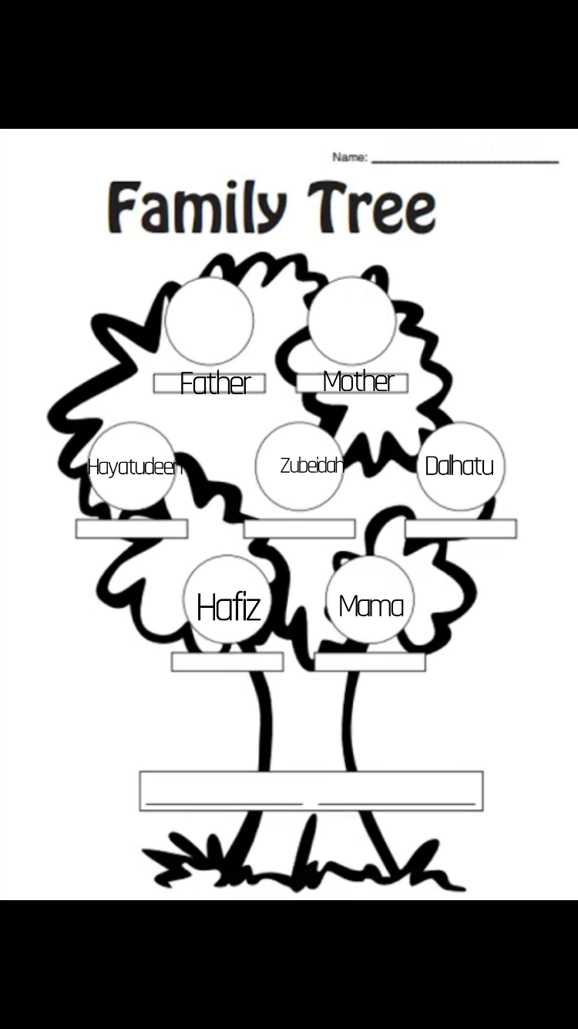
Family tree

