NAME: OWOH JENNIFER CHIEMERIE
DEPT: NURSING
MATRIC NUMBER: 19/MHS02/104
COURSE CODE: PGYSICS 102

SECTION A
1a. Charging by Induction:
Electric charges can be obtained on an object without touching it, by a process called electrostatic induction.
Consider a positively charged rubber rod brought near a neutral (uncharged) conducting sphere that is insulated so that there is no conducting path to ground as shown below. The repulsive force between the protons in the rod and those in the sphere causes a redistribution of charges on the sphere so that some protons move to the side of the sphere farthest away from the rod (fig. 1.3a). The region of the sphere nearest the positively charged rod has an excess of negative charge because of the migration of protons away from this location. If a grounded conducting wire is then connected to the sphere, as in (fig. 1.3b), some of the protons leave the sphere and travel to the earth. If the wire to ground is then removed (fig 1.3c), the conducting sphere is left with an excess of induced negative charge.
Finally, when the rubber rod is removed from the vicinity of the sphere (fig. 1.3d), the induced negatively charge remains on the ungrounded sphere and becomes uniformly distributed over the surface of the sphere.
Diagram:

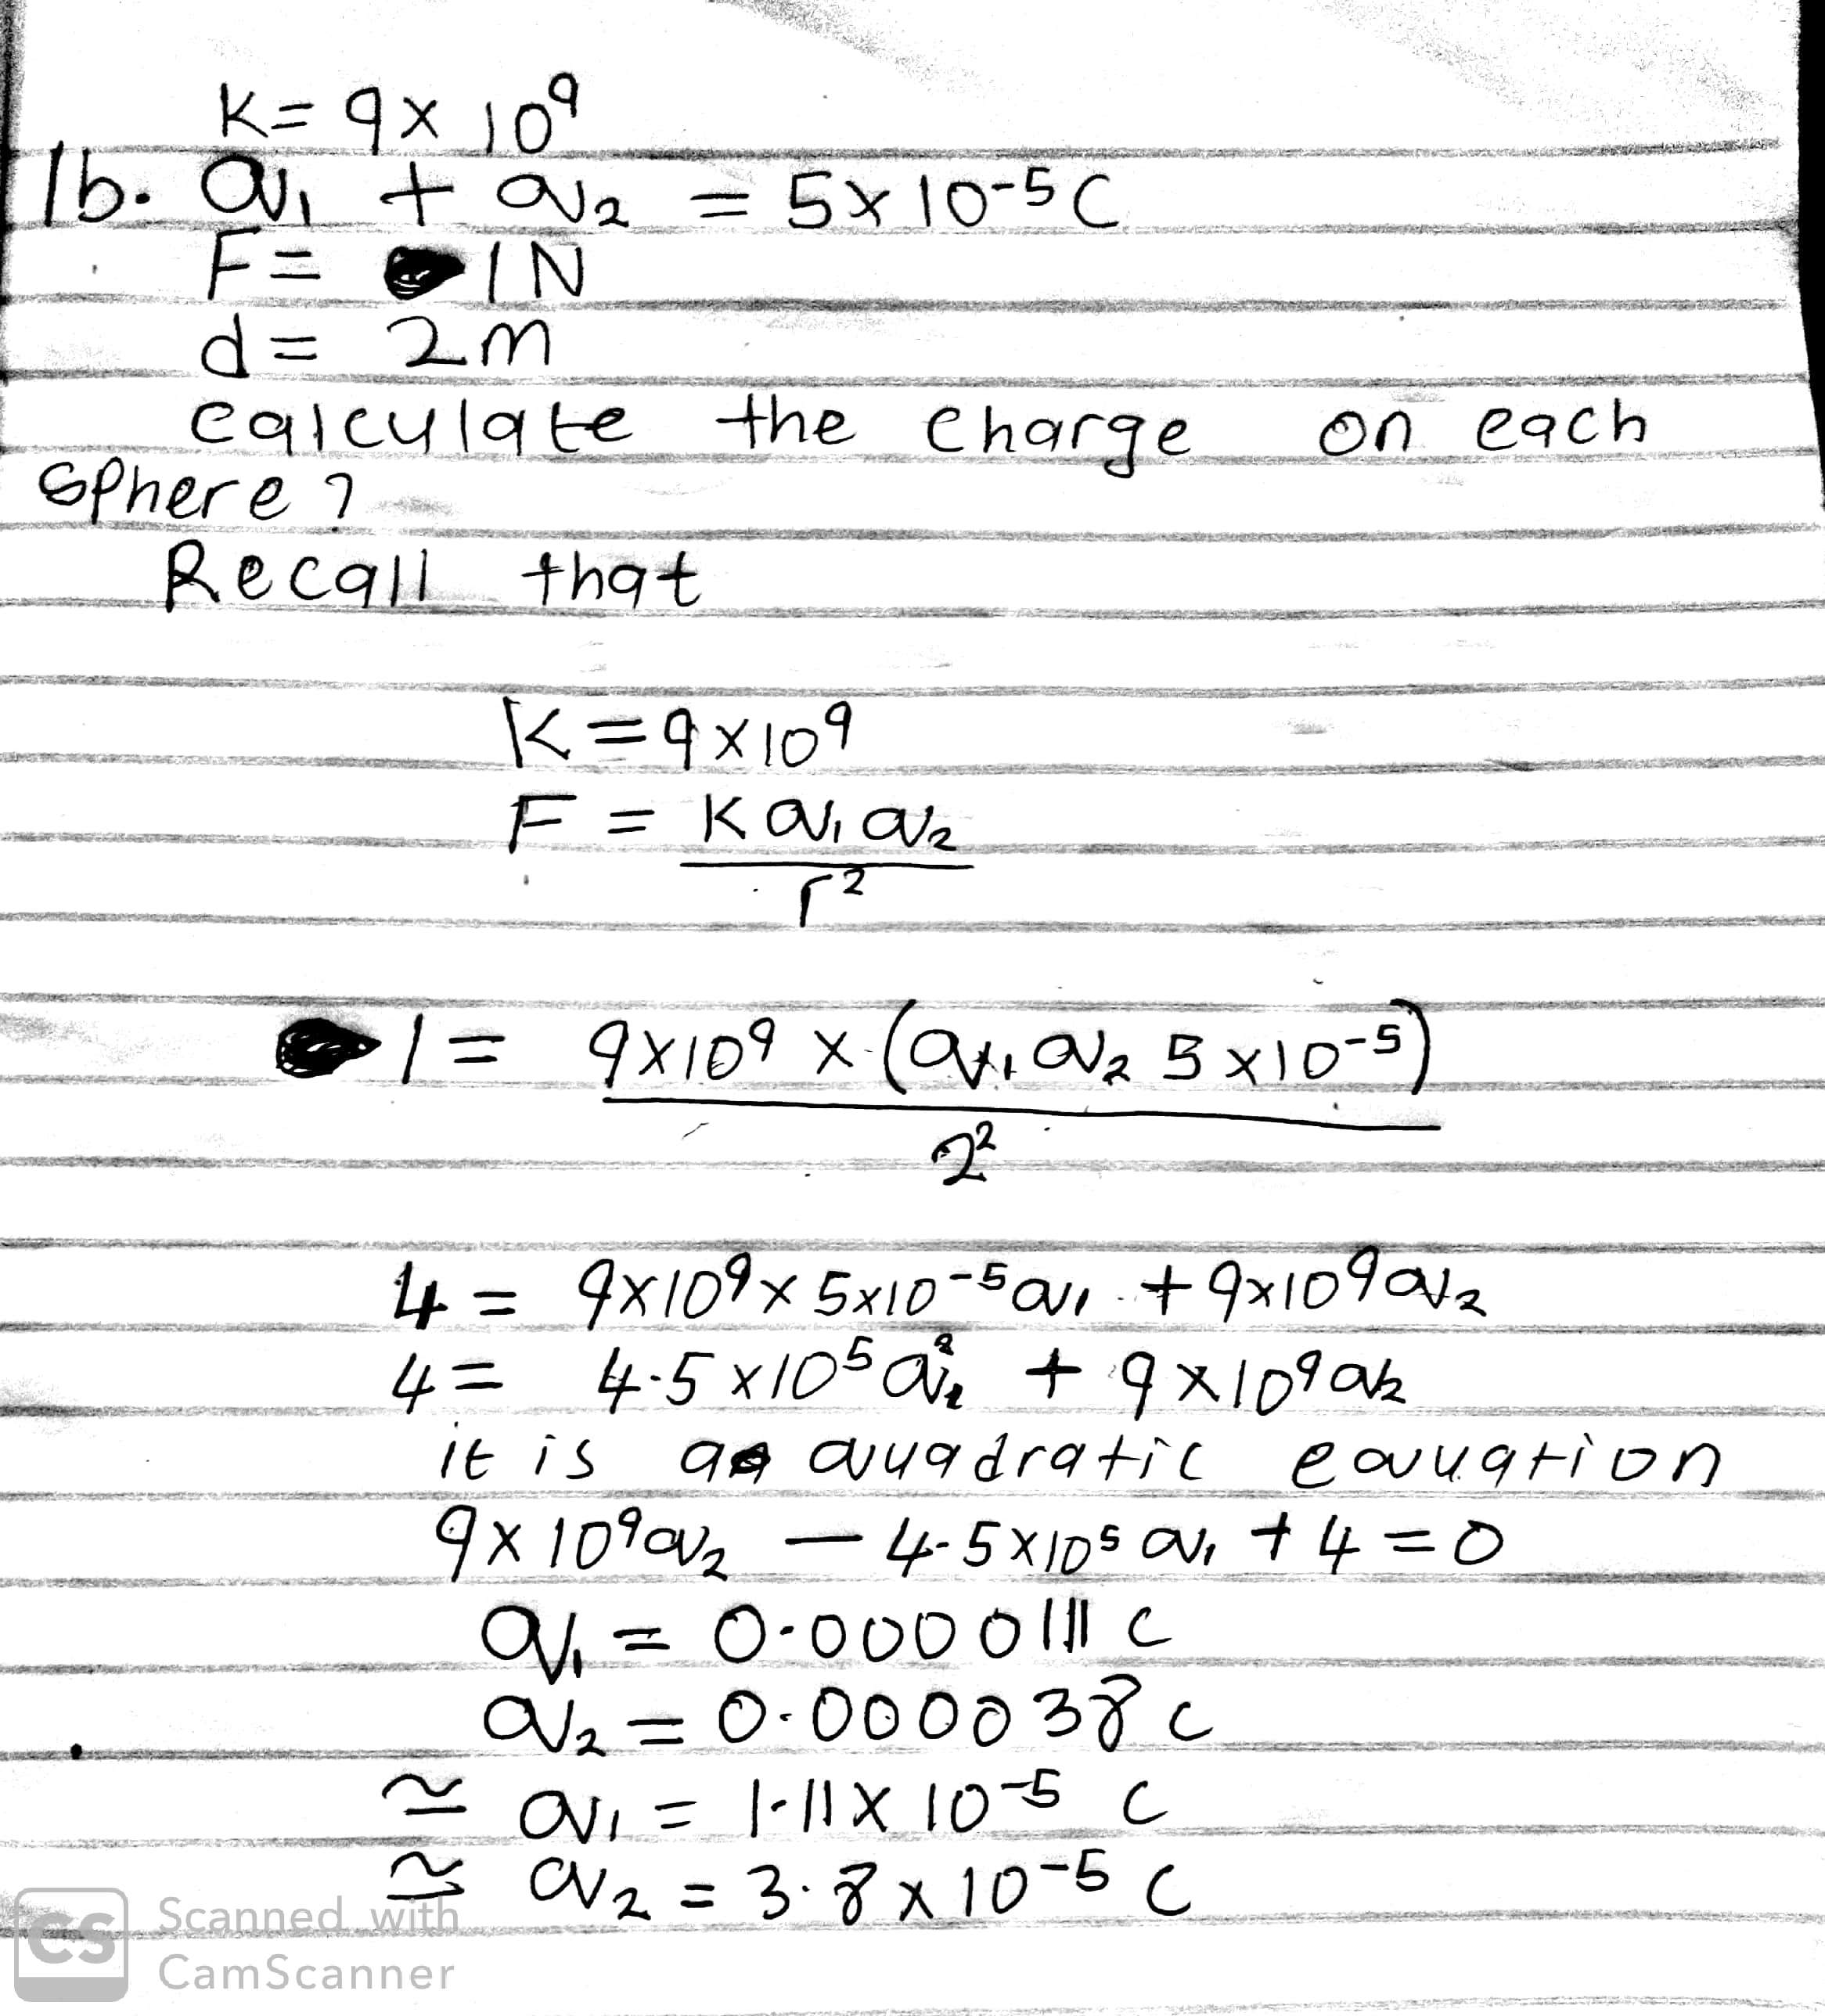1c.
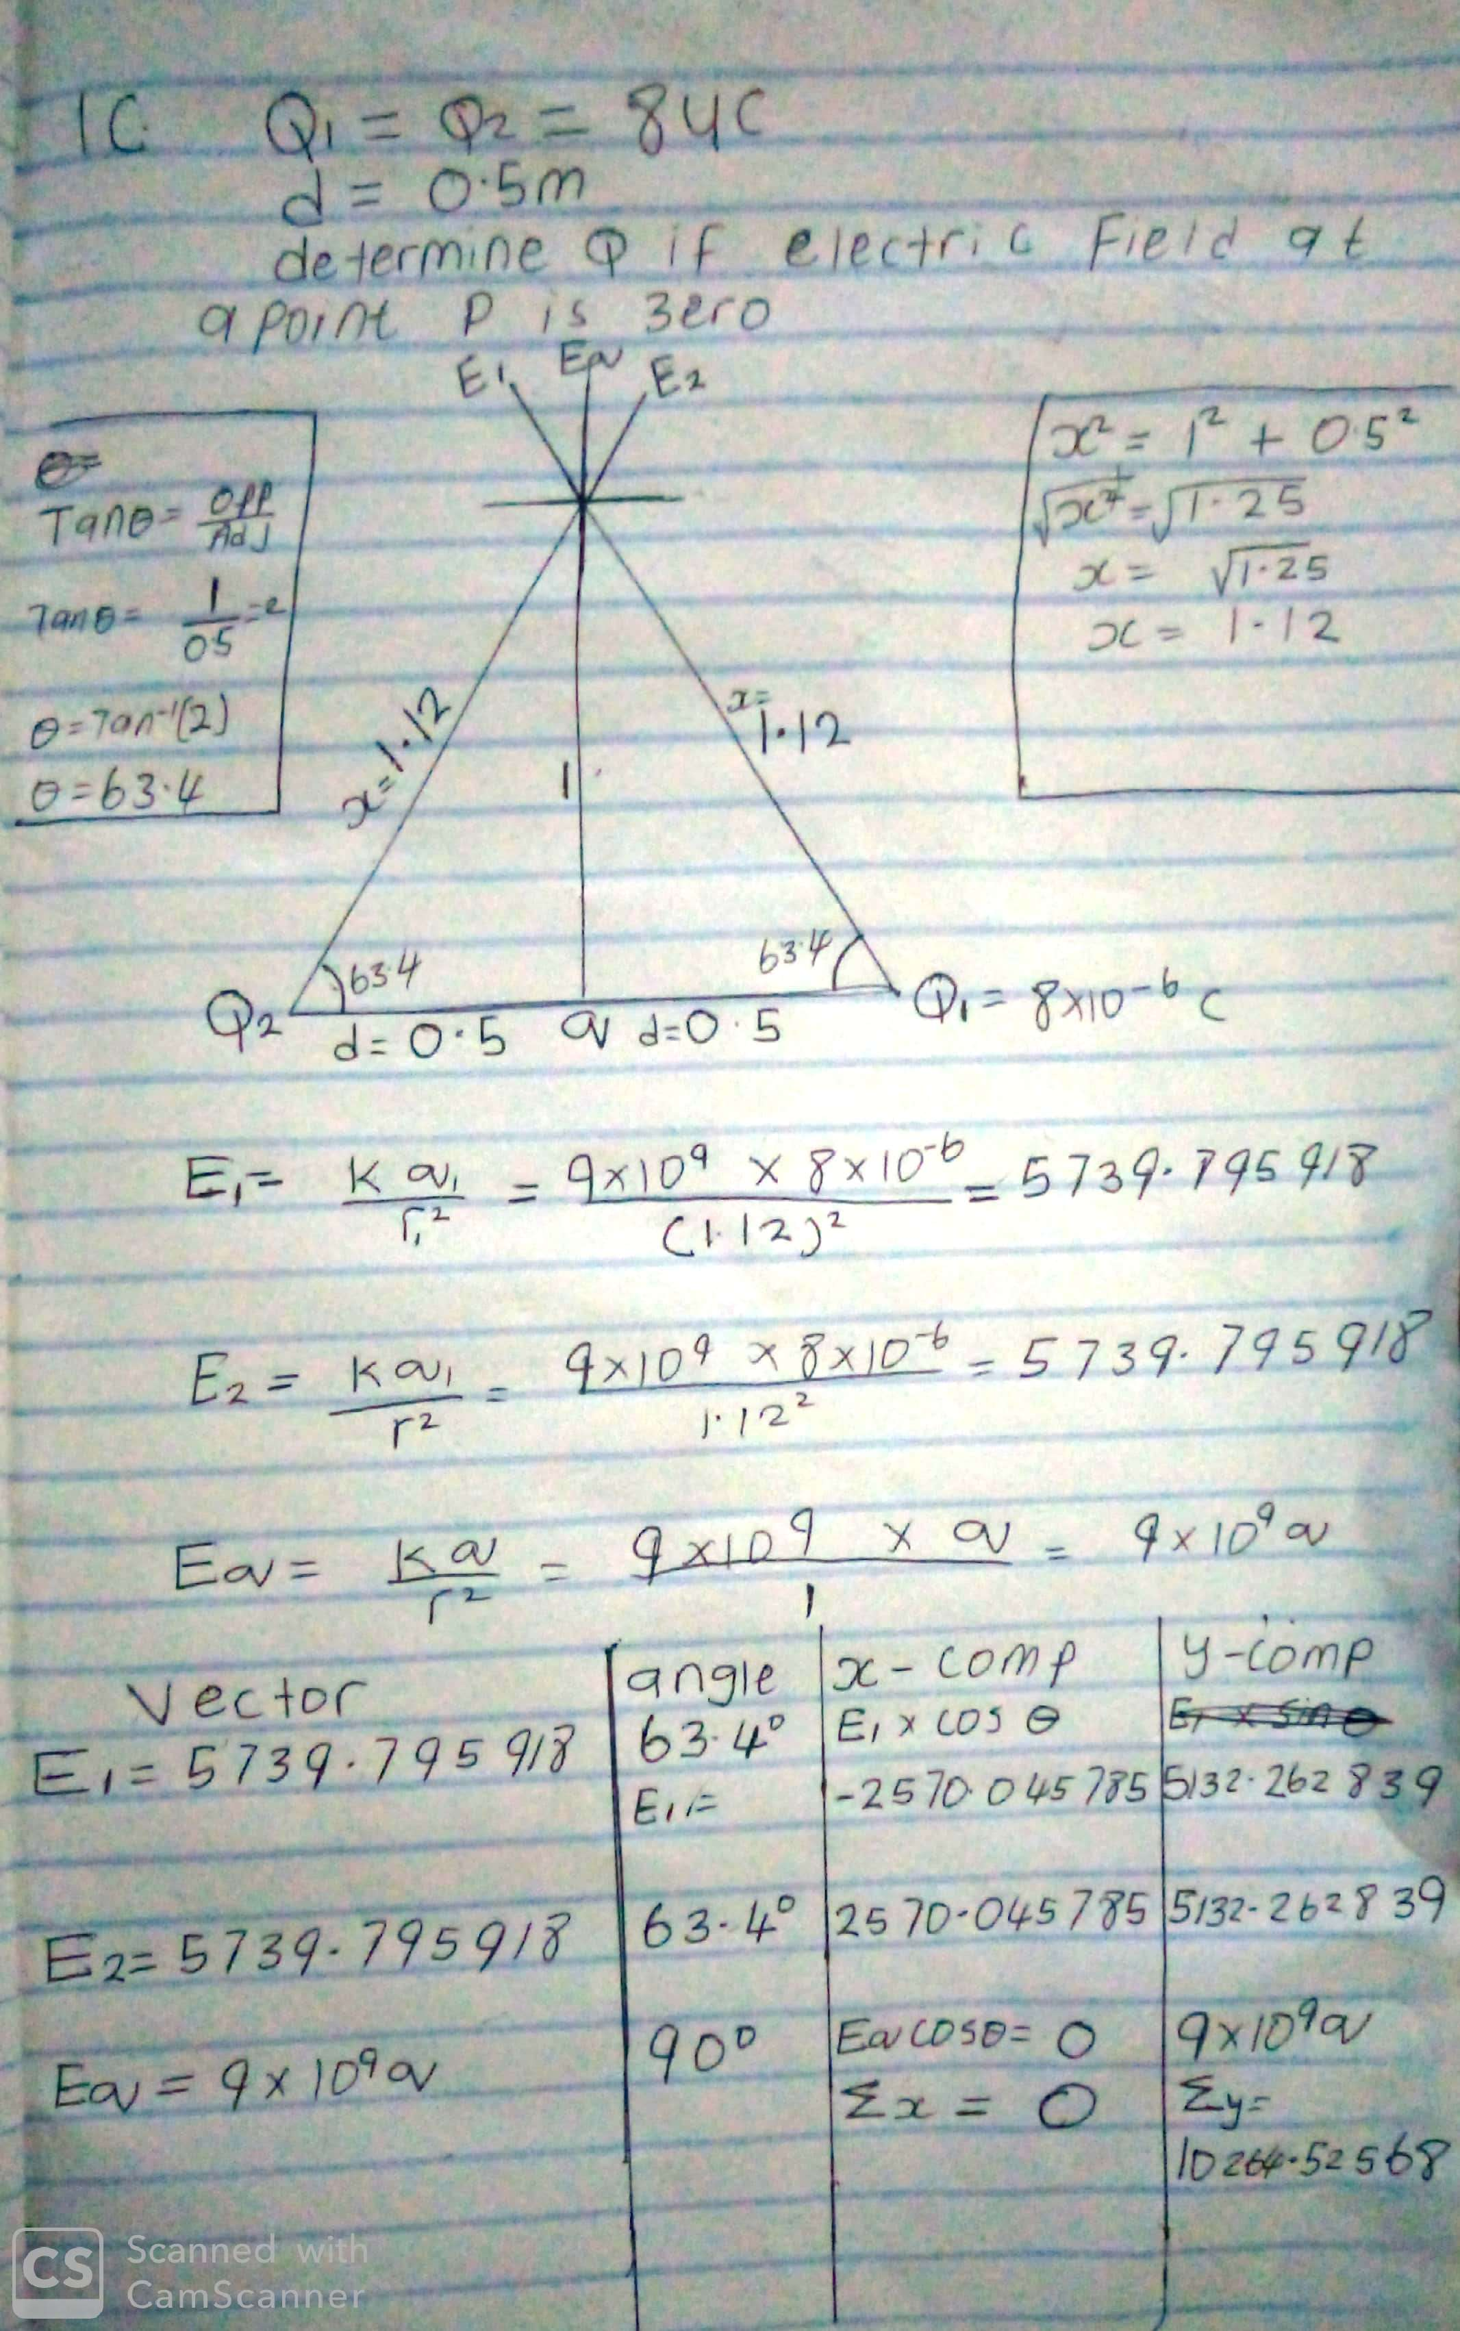
1c.continued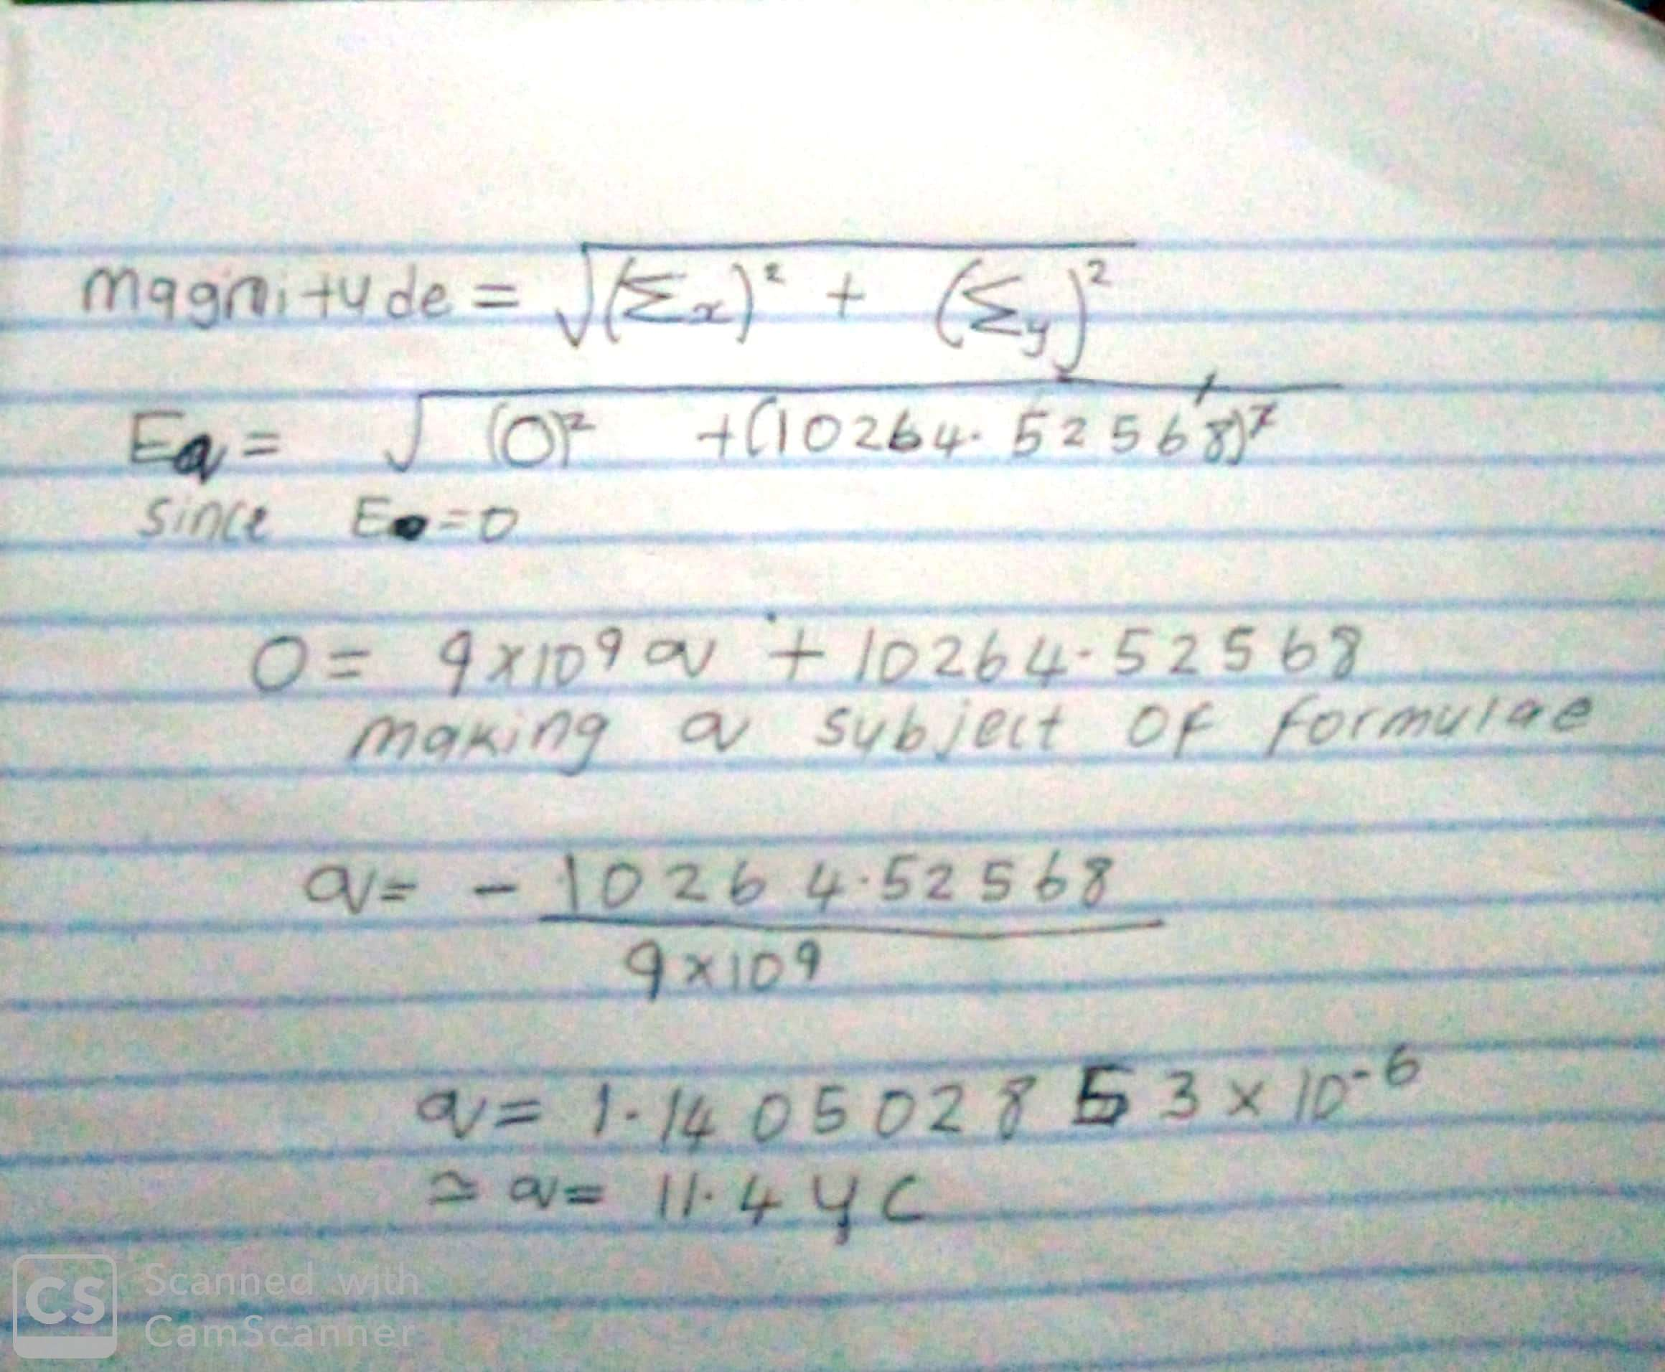

3a.
Volume charge density,
Surface charge density,
Linear charge density,

3b. ELECTRIC POTENTIAL DIFFERENCE
The electric potential difference between two points in an electric field can be defined as the work done per unit charge against electrical forces when a charge is transported from one point to the other. It is measured in Volt or Joules per Coulomb . Electric potential difference is a scalar quantity.
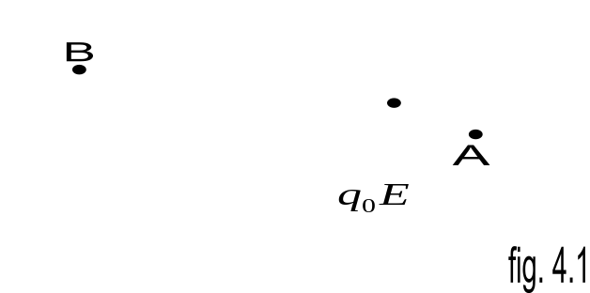
Consider the diagram above, suppose a test charge is moved from point to point along an arbitrary path inside an electric field . The electric field exerts a force on the charge as shown in fig 3.1. To move the test charge from to at constant velocity, an external force of must act on the charge. Therefore, the elemental work done is given as:

But
Substituting equation in yields
W-q_0EdL … (3)
Then total work done in moving the test charge from to is:

From the definition of electric potential difference, it follows that:
Putting equation in yields

SECTION B.

4a. magnetic flux is defined as the strength of the magnetic field which can be represented by line of forces. It is represented by the symbol Φ.mathematically given as Φ=B. d A
4b. 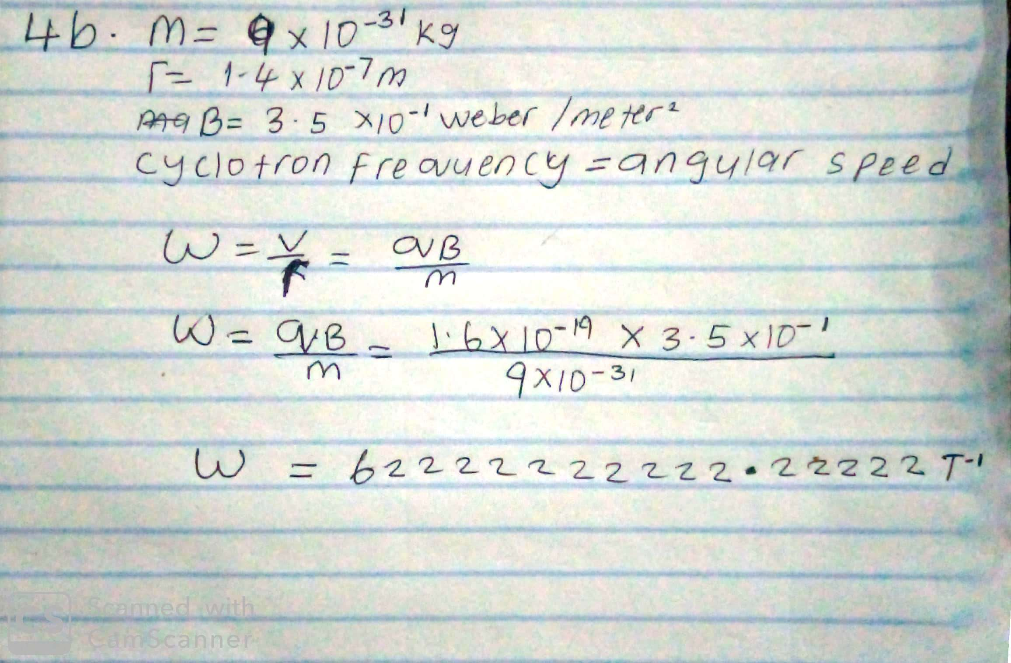

4c. In the question we were given paramiters such as
i.mass of the electron =9.11x10⁻³¹ kg
ii.A radius of 1.4x10⁻⁷m
iii.magnetic field of 3.5x10⁻¹weber\meter square
and you are asked to find the cyclotron frequency which is equal or the same thing as angular speed.it is called cyclotron frequency because it is a frequency of an accelerator called cyclotron.
Recall that angular speed is given as ω==
Substituting we haveω===1.6x10⌃-10x3.5x10⌃-10
9.11x10⌃-31

=62222222222.22222T⁻¹
SO since cyclotron frequency is equal to angular speed the cyclotron frequency is equal to =62222222222.22222^{T-1} , having a unit as 1\T which is equal to the unit of frequency dimensionally.

5b.Biot-savart law states that the magnetic field is directly proportional to the product permeability of free space(µ),the current(I),the change in length, the radius and inversely proportional to square of radius (r² ). It can be represented mathematically by

where is a constant called Permeability of free space.

The unit of is weber\metre square

5b. Magnetic Field of a Straight Current Carrying Conductor
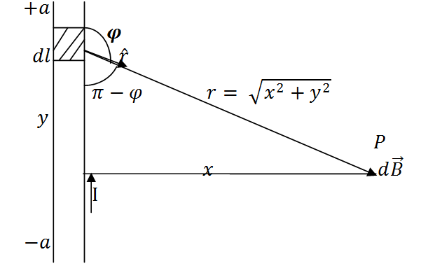
Fig 1: A section of a Straight Current Carrying Conductor
Applying the Biot-Savart law, we find the magnitude of the field

From diagram,

Substituting into , we have

Recall

Using special integrals:

Equation therefore becomes

When the length of the conductor is very great in comparison to its distance from point P, we consider it infinitely long. That is, when is much largerthan ,

In a physical situation, we have axial symmetry about the y- axis. Thus, at all points in a circle of radius , around the conductor, the magnitude of B is

Equation defines the magnitude of the magnetic field of flux density B near a long, straight current carrying conductor.

