NAME: LAWAL AMINAT TEMITOPE
MATRIC NUMBER: 17/MHS01/177
DEPARTMENT: MEDICINE AND SURGERY
LEVEL: 300
ASSIGNMENT: HISTOLOGY OF SPECIAL SENSES
COURSE CODE: ANA 305
QUESTION 1:
HISTOLOGICAL IMPORTANCE OF THE EYE
The eye is an organ which collects light and turns it to electronic messages which are sent to the brain. The brain then turns those signals into a picture for the individual to see. Two pictures are usually created since there are two eyes. These two offset pictures allow us to have depth of vision.
The eye has various components. The eyelids hold the lashes, keep the eye moist and shield it from intense light. The conjunctiva is a membrane that covers most of the eyeball and allows the lids to glide gently over the eye. The clear cornea covers the iris and it allows a small amount of light to enter the eye through the pupil. Along with the lens, the cornea focuses the image onto the retina. The retina is like the film in a camera. It lines the inside of the eye and it is mostly clear. The retina is nourished by the choroid layer or uvea since it has few blood vessels. The choroid also contains pigment cells called melanocytes which absorb any extra light which might distort the retinal picture.
There are cells present in the retina called photoreceptor cells. A photoreceptor cell is a specialized type of neuroepithelial cell found in the retina that is capable of visual phototransduction. A great biological importance of photoreceptors is that they can convert light into signals that can stimulate biological processes. There are currently three known types of photoreceptor cells in the mammalian eyes: rods, cones and retinal ganglion cells. The two classic photoreceptor cells are the rods and the cones. The rods are narrower than the cones and distributed differently across the retina. The retinal ganglion cells do not contribute to sight directly but they are thought to support circadian rhythm and papillary reflex.
Rod cells are extremely sensitive and can be triggered by a single photon. At very low light levels, visual experience is based solely on the rod signal. Cones require brighter light to produce a signal. The three types of cone cells are; S-cones, M-cones and L-cones which respond roughly to light of short, medium and long wavelengths respectively.
The human retina has about 120 million rod cells and about 6 million cone cells. Certain owls have a tremendous amount of rod cells in their retinae. There are about 2.4 million to 3 million ganglion cells in the human retina, with 1 to 2% of them being photosensitive. Photoreceptor cells are typically arranged in an irregular hexagonal grid known as the retinal mosaic.
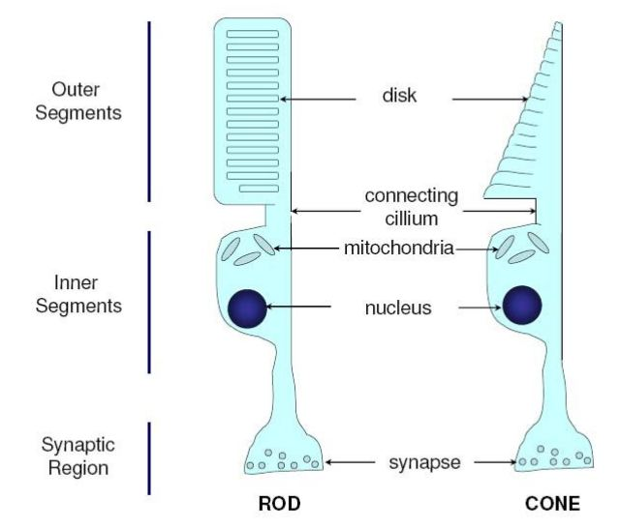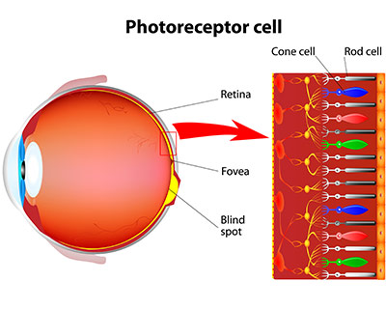
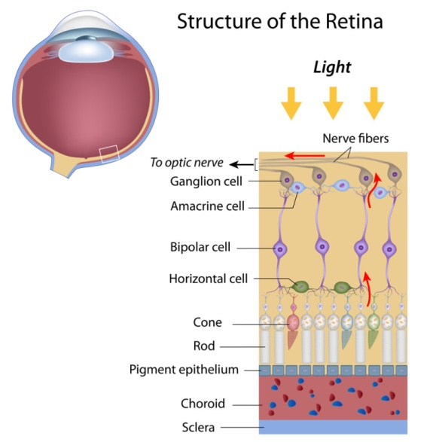
The outermost layer of the eye consists of the sclera and the cornea. The sclera is dense connective tissue made of mainly type I collagen fibres, oriented in different directions. The lack of parallel orientation of the fibers gives the sclera its white appearance as opposed to the transparent nature of the cornea. The four layers of the sclera from external to internal are episclera, stroma, lamina fusca and endothelium.
The cornea consists of type I collagen fibres oriented in a uniform, parallel direction to maintain transparency. It consists of 5 layers: non-keratinized, stratified squamous epithelium, bowman layer, stroma, descemet’s membrane and corneal epithelium.
The iris consists of a pigmented layer of cells and stromal layer. The pigmented layer of cells blocks rays of lights and ensures that light moves through the pupil to reach the retina.
Thus, the layers of the eye perform distinct functions which coalesce to create a unified, perceptual experience.
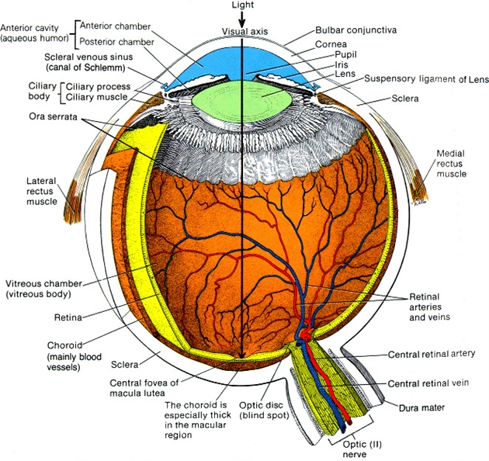
CLINICAL SIGNIFICANCE:
- Chalazion: This is a sterile lump often in the upper eyelid caused by obstruction of the meibomian oil glands.
- Conjunctivitis: Inflammation of the transparent conjunctiva that may be caused by bacterial or viral infections, allergies or exposure to certain chemicals.
- Cataracts: A sclerotic nuclear cataract is the most common and it is due to opacification in the central nucleus of the lens.
QUESTION 2:

LAYERS OF THE RETINA
The retina is the innermost, light-sensitive layer of tissue of the eye of most vertebrates and some mollusks. The optics of the eye create a focused two-dimensional image of the visual world on the retina which translates that image into electrical neural impulses to the brain to create visual perception. The retina serves a function analogous to that of the film or image sensor in a camera.
The neural retina consists of several layers of neurons interconnected by synapses and is supported by an outer layer of pigmented epithelial cells. The primary light-sensing cells in the retina are the photoreceptor cells which are of two types; rods and cones.
Light striking the retina initiates a cascade of chemical and electrical events that ultimately trigger nerve impulses that are sent to various visual centres of the brain through the fibres of the optic nerve.
The vertebrate retina has ten distinct layers. From closest to farthest from the vitreous body, they are;
- Inner limiting membrane: A basement membrane elaborated by Muller cells. It is the boundary between the retina and the vitreous body. It is formed by astrocytes and the footplates of Muller cells together with a basal lamina.
- Nerve fibre layer: It is the layer of optic nerve fibres composed of axons of the ganglion cell bodies. There are also some displaced amacrine cells within this layer. Additionally, this layer also contains the non-rod and non-cone photoreceptors, the photosensitive ganglion cells, which are important for reflexive responses to bright daylight.
- Gaanglion cell layer: It contains nuclei of ganglion cells, the axons of which become the optic nerve fibres, and some displaced amacrine cells.
- Inner plexiform layer: It contains the synapse between the bipolar cell axons and the dendrites of the ganglion and amacrine cells.
- Inner nuclear layer: It contains the nuclei and surrounding cell bodies of the amacrine cells, bipolar cells and horizontal cells. This layer is thicker in the central area of the retina compared with the peripheral retina because of a greater density of cone-connecting second-order neurons (cone bipolar cells) and smaller, closely-spaced horizontal and amacrine cells concerned with the cone pathways. There are also nuclei of the supporting Muller cells.
- Outer plexiform layer: It is also known as the outer synaptic layer. It contains the rod and cone axons, horizontal cell dendrites and bipolar cell dendrites. Synapses among these structures occur within this layer. In the macular region, this layer is termed the fiber layer of Henle.
- Outer nuclear layer: It contains cell bodies of rods and cones. In the central retina, the cone cell bodies outnumber the rod cell bodies, whereas the reverse is true for the peripheral retina.
- Outer / External limiting membrane: It is the layer that separates the inner segment portions of the photoreceptors from their cell nuclei. The rod and cone layer contains the inner and outer segments of the rod and cone photoreceptors cells.
- Inner segment / outer segment layer: These are inner and outer segments of the rods and cones. The outer segments contain a highly specialized light-sensing apparatus.
- Retinal pigment epithelium: It is a single layer of cuboidal epithelial cells. This layer is closest to the choroid and provides nourishment and supportive functions to the neural retina. The black pigment, melanin, in this layer prevents light reflection throughout the globe of the eyeball. This is extremely important for clear vision.
These layers can be grouped into 4 main processing stages; photoreception, transmission to bipolar cells, transmission to ganglion cells and transmission along the optic nerve. At each synaptic stage, there are also laterally connecting horizontal and amacrine cells.
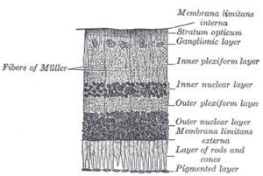
CLINICAL SIGNIFICANCE:
- Retinal detachment: The neural retina occasionally detaches from the pigment epithelium. In some instances, the cause of such detachment is injury to the eyeball that allows fluid or blood to collect between the neural retina and the pigment epithelium. Detachment is occasionally caused by contraction of fine collagenous fibrils in the vitreous humor, which pull the areas of the retina towards the interior of the globe.
- Cone-rod dystrophy (CORD): It describes a number of diseases where vision loss is caused by deterioration of the cones and/or rods in the retina.
- Macular degeneration: It describes a group of diseases characterized by loss of central vision because of death or impairment of the cells in the macula.
- Retinitis pigmentosa: It is a group of genetic diseases that affect the retina and cause the loss of night vision and peripheral vision.

