SOCIOLOGY ( SOC 101) : FAMILY

- What is a family ?
A family can be defined as a specific group of people that may be made up of partners, children , parents , aunts, uncles and grandparents. There are various types of families which include :
- Nuclear: made up of two parents and children.
- Single-Parent : made up of one parent raising one child or more than one child .
- Extended : made up of many relatives living together.
- Childless: made up of a couple with no children.
- Step-Family: made up of two separate families they come together to form a unit.
- Grandparents Family: made up of grandparents taking care of their grandchildren.

- What are the functions of family ?
- Stable satisfaction of sexual needs.
- Procreation of children.
- Socialization.
- Provision of a home.
- Provision of basis for a child’s formal learning.
- Religious training of children.
- Fulfillment of economic needs of its members.
- Emotional support for its members.
- Provides members with social identity.
- Looking after health of all its members both old and young.

- Discuss the African Traditiona Family
Traditional African family patterns are slowly but progressively being altered as a result of the process of modernization which is exhibited through trends like urbanization. Family patterns that were the norm in traditional rural African societies are gradually being altered and substituted by modern values. Sub Saharan Africa has one of the fastest annual population growth rate.
It has the fastest rate of urbanization presently taking place in the world. The transformation of societies in the sub-continent from rural to urban settings has immensely contributed in triggering changes in family structure. This has triggered the distortion of cultural /traditional norms and values that characterized rural communities in the region. African families are increasingly faced with the challenge and pressure emanating from the competition prevailing between traditional and modern family values. Hence, Contemporary family patterns in the region are increasingly subjected to transform and adapt to changing times. Discussions of family patterns in contemporary Sub Saharan Africa are usually made in reference to the process of acculturation, urbanization (the movement from rural to urban areas), which have helped to shape modern family structures, as well as fostered the prevalence of demographic changes). Family in sub Saharan Africa is experiencing changes which are felt in fertility rates that is the number of children women give birth to, and age at marriage to name a few.

- Discuss your nuclear family
A nuclear family can be described as a couple and their dependent children, regarded as a basic social unit.
My nuclear family isn’t any different. It is made up of my mom and dad and my two siblings ( elder brothers). We all live happily together.

- THIS IS AN IDEAL EXAMPLE OF MY FAMILY TREE
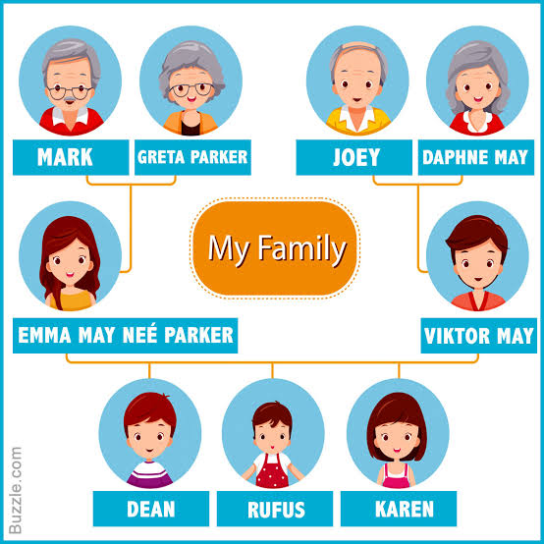
(I was unable to draw the the tree myself due to the inability of the Microsoft word application on my mobile device ) but this is exactly what my family tree is like . It is made up of my maternal grandparents and my paternal grandparents, my parents and my two brothers. All together we are three children.

