EPELLE SOTONYE
15/ENG07/020
PETROLEUM ENGINEERING
PTE 516-MULTIPHASE FLOW IN PIPES
QUESTION 1
Summarize all the horizontal multiphase flow regimes from the attached document
Flow regimes
According to beggs and brills (1978), horizontal gas-liquid flow regimes are classified into;
SEGREGATED FLOWS: in this type of flow, the two phases are separate for the most part.it is further classified into; stratified smooth flow, stratified wavy flow (ripple flow), and annular flow.
Stratified smooth flow consist of liquid flowing along the bottom of the pipe with a smooth interface between the phases, this type of flow occurs at relatively low rates of both phases.at higher gas rates, the interface becomes wavy and stratified wavy flow results. Annular flow occurs at high gas rates and relatively high liquid rates and consists of annulus liquid droplets entrained in gas
INTERMITTENT FLOWS: in this type of flow, the gas and liquid phases are alternating. The intermittent flow regimes are slug flow and plug (elongated bubble flow). The slug flow consists of large liquid slugs alternating with high velocity bubbles of gas that fills almost the entire pipe. In plug flow, large gas bubbles flow along the top of the pipe which is otherwise filled with liquid.
DISTRIBUTIVE FLOW: this type of flow is that in which one phase is dispersed in the other phase. The types of distributive flow regimes described by beggs and brills are bubble, dispersed bubble, mist and froth flow
The bubble flow regimes differ from those described for vertical flow is that the gas bubbles in a horizontal flow will be concentrated on the upper side of the pipe. Mist flow occurs at high gas rates and low liquid rates and consists of gas with liquid droplets entrapped, mist flow will often be similar to annular flow and many flow regime maps use the term “ANNULAR MIST” to denote both of these regimes. Froth flow is used by some authors to describe mist or annular mist flow regimes

QUESTION 2
Solve the question 10-4 on the attached document
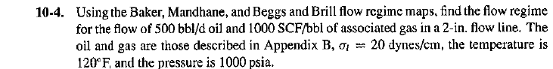

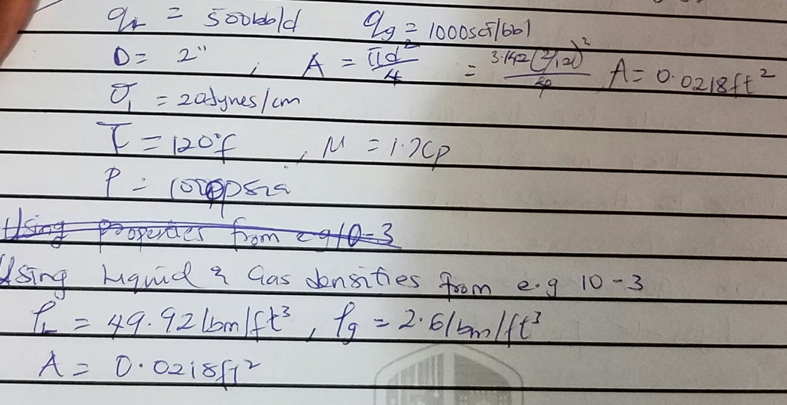

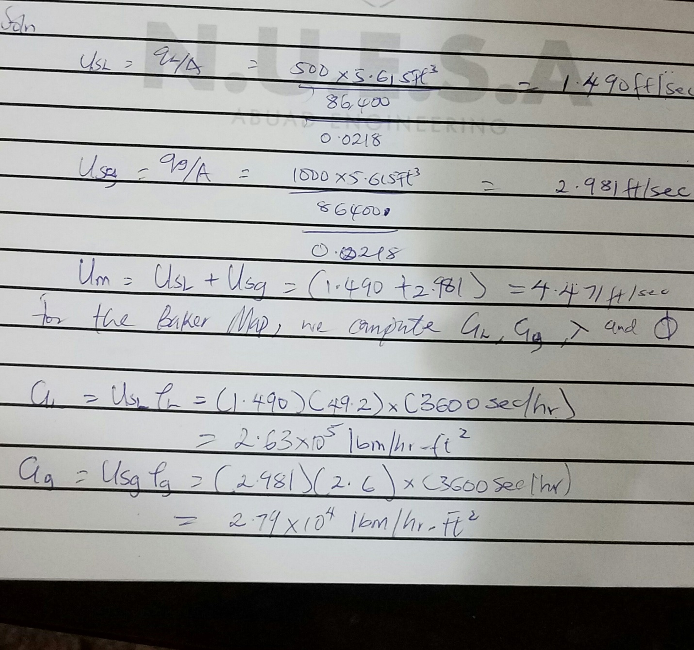

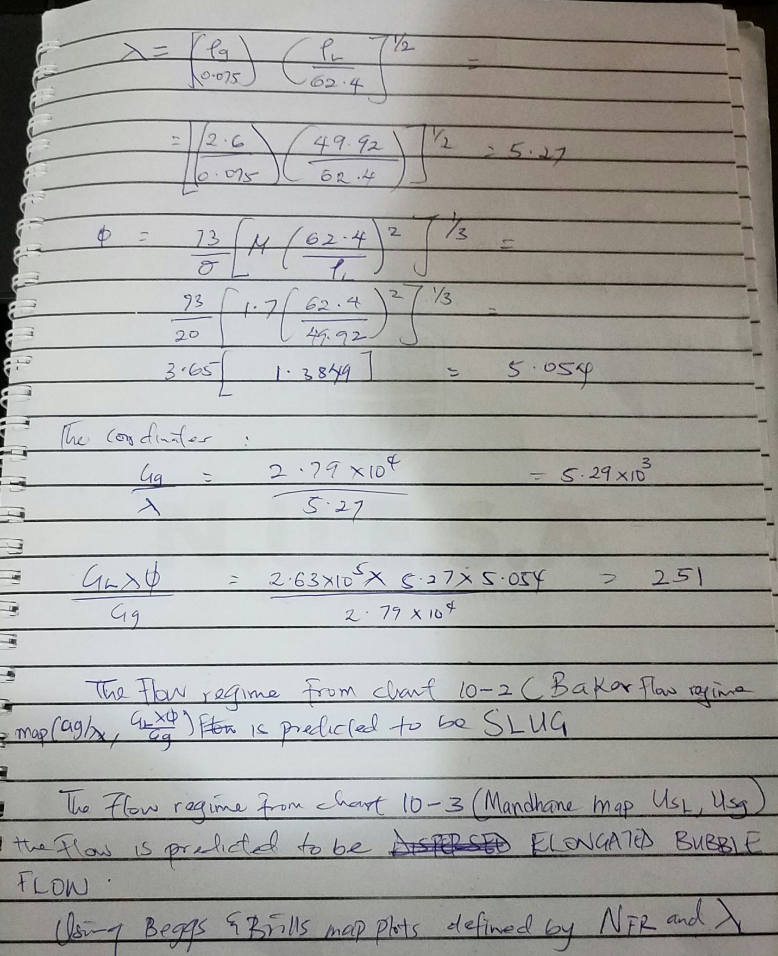

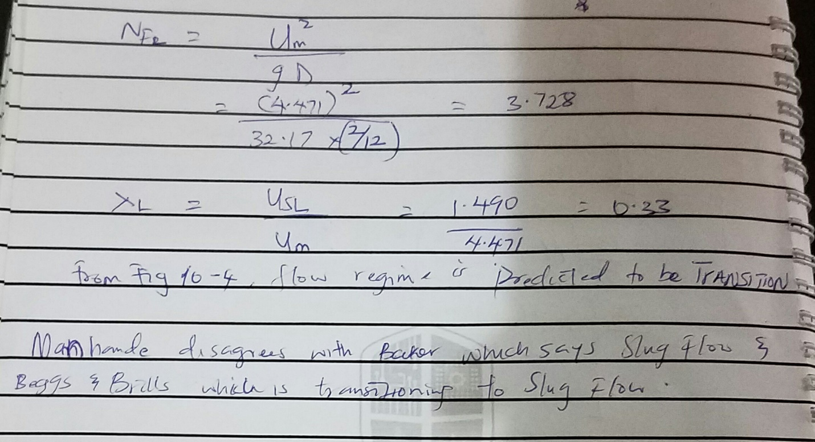
Question 4
Flow through restriction on both single-phase liquid flow and single-phase gas flow
Single-phase liquid flow
The flow through a wellhead choke will rarely consist of single phase liquid, since the tubing pressure is almost always below the bubble point. Flow rate is related to pressure drop across the choke by
$$q=CA\sqrt{\frac{2g{}_{c}∆p}{ρ}}$$

C- Flow coefficient of choke
A-cross sectional area of choke
q-flow rate
Δp-pressure drop
ρ – Density

Single-phase gas flow
When a compressible fluid passes through a restriction, the expansion of the fluid is an important factor. For isentropic flow of an ideal gas through a choke, the rate is related to pressure ration P₂/P₁ by
