NAME: IHENSEKHIEN EBUNOLUWA PEARL MATRIC: 17/MHS01/151 CLASS: 3OOL(MEDICINE AND SURGERY) DATE: 21ST APRIL 2020.
- WRITE AN ESSAY ON THE HISTOLOGICAL IMPORTANCE OF THE EYE IN RELATION TO CELLULAR FUNCTIONS.
Types of cells found in the retina are the neurons and supporting cells can be classified into four group of cells:
- Photoreceptor cells – the retinal rods and cones
- Conducting neurons - bipolar neurons and ganglion cells
- Association neurons and others – horizontal and amacrine neurons
- Supporting (neuroglial) cells – muller’s cells
The Photoreceptors
The rods and cones are the outer segments of photoreceptor cells Whose nuclei form the outer nuclear Layer of the retina-the retina contains approximately 120 million rods and 7 million cones. Functionaly the rods are more sensitive to Light and the receptors used during periods of low light intensity (e.g at dusk or at night).The rod pigments have a maximum absorption at 496nm of visual spectrum. And the image provided is one of the composed of gray tones(a black and while picture)in contrast the cones contain a different visual pigment molecule that is activated by the absorption of light at the blue (420nm), green(531nm)red (588nm) ranges in the color spectrum. Cones provide a visual image composed of color by mixing the appropriate proportion of red, green and blue light.
Each rod and cone receptor consists of three parts:
- The outer segment of the photoreceptor is roughly cylindrical or conical hence, the descriptive name rod or cone. This portion of in photoreceptor is Intimately related to microvilli projecting from the adjacent Pigment epithelial cells.
- The connecting stalk contains a Cilium composed of nine peripheral microtubule doublets extending from a basal body. The Connecting stalk appears as the constricted region of the led that joins the inner to the outer segment doublets extending from a basal body. The Connecting stalk appears as the constricted region of the led that Joins the inner to the outer segment.
- The inner segment is divided into an outer ellipsoid an Inner myoid portion. This segment contains a typical complement of organelles associated with a all that actively synthesize proteins.
The outer segment is the site of photosensitivity, and the inner segment contains the metabolic machinery that supports the activity of the photoreceptor cells. With The TEM 600 to 1,000 regularly spaced horizontal disc have seen in the outer segment. These disc contain the visual pigments. Rod cells contain the visual Pigment rhodopsin (also called visual purpule );cone cells contain the visual pigment lodopsin. Both rhodopsin and lodopsin contain a membrane-bound subunit called an opsin anda second component called a chromophore. The opsin of rods is scotopsin; the opsins of cones are photopsins. The chromophore of rods is a vitamin A-derived carotenoid called retinal. Thus, an adequate intake of vitamin A is essential for normal vision. Prolonged dietary deficiency of vitamin A leads to the inability to see in dim light (night blindness).
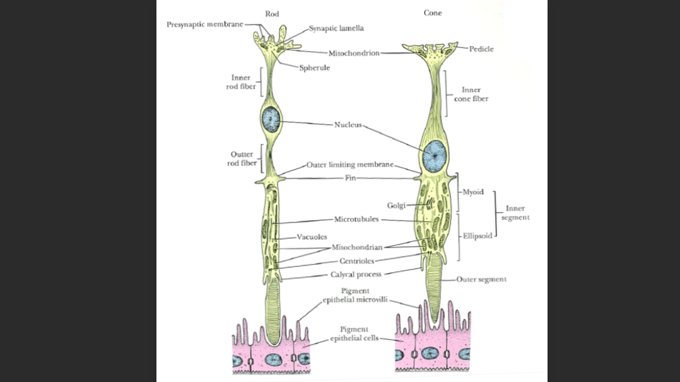

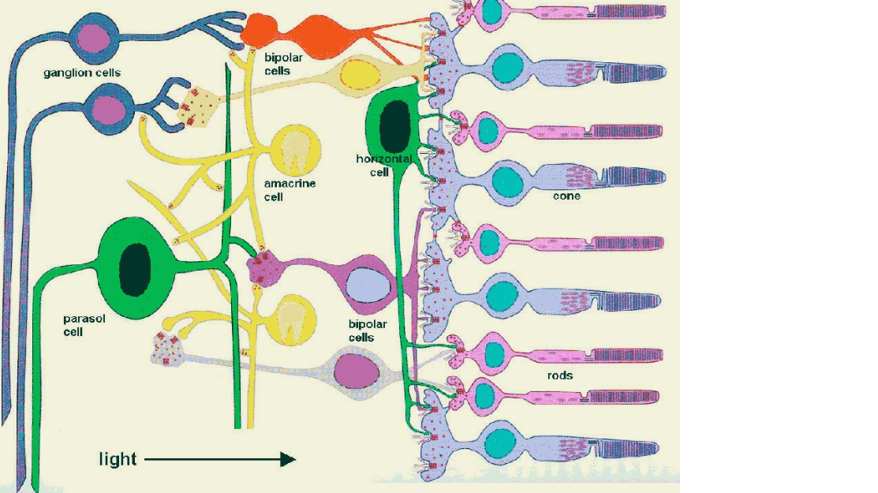

Muller’s cells.
Muller’s was Form the scaffolding For the entire retina . Meer processes most he other cells of the retina so completely that they Fill most of the extracellular space. The basal and apical ends of muller cells form the inner and outer limiting membranes; respectively. microvilli extending from their apical border lie between The photoreceptor cells of the rods and cones
Bipolar cells.
Bipolar cells and their processes extend both the inner and outer plexiform layer. In the peripheral regions of the retina, the axons of bipolar cells pass to the inner plexiform layer where they synapse bipolar cells and their processes extend both the inner and outer plexiform layer. In the peripheral regions of the retina, the axons of bipolar cells pass to the inner plexiform layer where they synapse with several ganglion cells. Through these connections, the bipolar cells establish communication with multiple cells in each layer except in the fovea where they may synapse only with a single ganglion cell to provide greater visual acuity in this region visual acuity in this region.
Horizontal cells
Horizontal cells and their processes extend to the outer plexiform layer where t intermingle with processes of bipolar cells. horizontal cells and their processes extend to the outer plexiform layer where they intermingle with processes of bipolar cells. these cells have synaptic connections with rod , cones and bipolar cells. This electrical coupling of cells is thought to affect the functional threshold between rods and cones and bipolar cells.
Amacrine cells
Amacrine cells processes pass inward contributing to complex Interconnection of cells.Their processes branch extensively to provide sites of synaptic connections with axonal endings of bipolar cells and dendrites of gangLion cells. Besides bipolar and ganglion cells, the amacrine cells synapse in the inner plexiform Layer with Inner plexiform and other amacrine cells.
Specializied Areas of the retina
The visual part of the retina is behind the ora serrata. At the optic disc (the exist of the optic nerve, slightly medial to the posterior pole of the eyeball), there are no phototreceptors , hence, no vision occurs here & it is called the “blind spot the retina”. At the posterior pole of the optical axis, there is a shallow depression the “fovea centralis” where the retina becomes very thin because bipolar& ganglion cells accumulate at the periphery of the fovea. Its center consists only of cone cells with long thin highly packed cones & no rods, in addition, blood vessels do not cross over the photoreceptors cells here. These factors make the fovea the region of the maximal visual acuity & colour perception. Around the fovea centralis is the macula lutea (5.5mm diam), here all the layers of the retina are present, the two plexiform layers are rich in carotenoids( which give yellowish colour) that protect the fovea from dangerous short wavelength light by the their antioxidant properties. When we move towards the periphery of the retina, the number of rods increases & cones decrease.

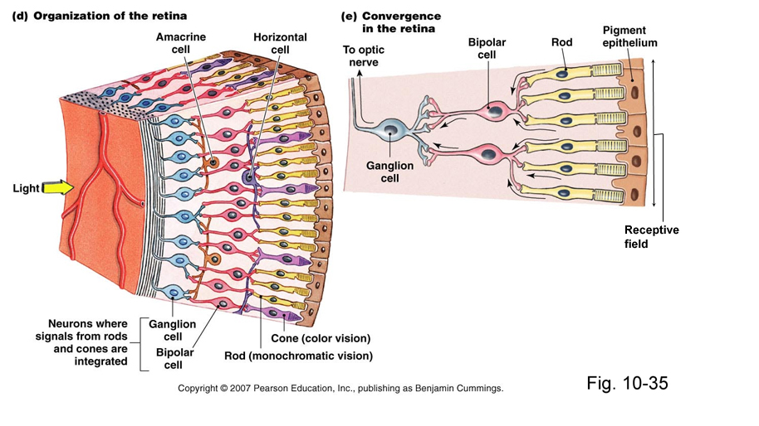

2. CORONA VIRUS CAN PENETRATE THE BODY THROUGH THE EYE AND IMPLICATE THE IMMUNE SYSTEM, BRIEFLY DISCUSS THE LAYER OF RETINA FOR INFORMATION PENETRATION
THE RETINA AND ITS LAYERS.
The retina, the innermost tunic of the eye develops with the 2 fundamental sublayers from the inner and outer layer of the embryonic optic cup.
-The outer pigmented layer is a simple cuboidal epithelieum attached to brush membrane and the choroido capillary lamina of the choroid. This heavily pigmented layer forms the other part of the dual epithelium covering the cilliary body and the posterior iris. -The inner retinal region, the neural layer, is thick anmd stratified with various neurons and photoreceptors. Although its neural structure and visual function extend anterior only as far as the ora serrata, this layer continues as part of the dual cuboidal epithelieum that covers the surface of the ciliary and posterior iris
Retina pigmented epithelieum The pigmented epithelial layer consists of cuboidal or low columnar cells with basal nuclei and surrounds the neural layer of the retina.The cells have well developed junctional complexes, gap junctions and numerous invaginations of the basal membranes associated with mitochondria the apical ends of the cells extend processes and sheath like projections that surrounds the tips of the photoreceptors. Melanin granules are numerous in these extensions and in the apical cytoplasm. This cellular region also contains numerous phagocytic vacuole and secondary lysosomes, perixisomes and abundant ER (SER) sepcialized for retinal (vit A) isomerization. The diverse functions of the retinal pigmented epithelieum include the following; -The pigmented layer absorbs scattered light that passes through the neural layer supplementing the choroid in this regard.
-With many tight junctions, cells of the pigmented epithelieum forms an important part of the protective blood-retinal barrier isolating retina photoreceptors from the highly vascular choroid and regulating ion transport between this compartments.
-The cells play key roles in the visual cycle of retina degeneration, having enzyme systems that isomerizes all-trans-retinal release from photoreceptor and produce 11-cis-retinal that is then transferred back to the photoreceptors. -Phagocytosis of shared components from the adjacent photoreceptors and degradation of this materials occurs in this epithelial cells. - Cells of pigmented epithelium remove free radicals by various protective antioxidant activites and supports the neural retinal but secretion of ATP various polypeptide growth factors, and immune modulatory factors.
Neural Retinal Epithelium
True to its embryonic origin, the neural retina functions as an outpost of the CNS with glial and several interconnected neuronal subtypes in well organized strata. Nine distinct layer comprise the neural retina, described here with their functional significance. Three major layers contains the nuclei of the interconnected neurons
1 .Near the pigmented epithelieum the outer nuclear layer(ONL) contains cell bodies of photoreceptors (Rods and cone cells)
2. The inner nuclear layer (INL) contains the nuclear of various neurons, notably the bipolar cells ,amacrine cells and horizontal cells all of which make specific connections with other neurons and integrate signals from rods and cones over a wide area of the retina.
3. Near the vitreous, the ganglionic layer GL has neurons(ganglion cells) which much longer axons. this axons make up the nerve fiber layer (NFL) and converge to form the optic nerve, which leaves the eye and passes to the brain. The GL is thickest near the central, macular region of the retina, but it this peripherally to only one layer of cells. Between the three layers of cell nuclei are 2 fibrous or plexi-form regions containing only axons and dendrites connected by synapses
4. The outer plexiform layer(OPL) includes axons of the photoreceptors and dendrites of association neurons in the INL.
5. The inner plexiform layer (IPL) consist of axons and dendrites connecting neurons of the INL with the ganglion cells. The rod and cone cells are named for the shape of their other segments, are polarized neurons with their photosensitive portion are lined in the retinal rod and cones layer( RCL). And their axons in the IPL. Both rods and cones cells have highly specialized outer and inner segments.
All neurons of the retina are supported physically by glial cells called muller cells with their nuclei in the INL, muller cells extend fine processes and branching lamelle that serves as scaffold for the neurons and their fibers. Muller cells also organize two boundaries that apply as very thing layers within the retina:
The other limiting layer (OLL) is a faint but well defined series of tight and adherent junctions that form at the level of the rod and cones inner segment between the photoreceptors and muller cell processes. The OLL outer limiting layer forms one side of the compartment that encloses the rods and cones.
The inner limiting layer consists of terminal expansions of other muller cell processes that covers the collagenous membrane of the vitreous body.
All these layers of the retina can be seen by routine light microscope. It is important to note that light must pass thru all the layers of the neural retina before reaching the layers of rods and cones. Branches of the central retina artery and vein run mainly within the nerve fiber and GLS surrounded by perivascular feets of astrocytes located. In some retina regions, capillaries extend as deep as the INL. A few scattered microglial cells occur through out the neural retina.
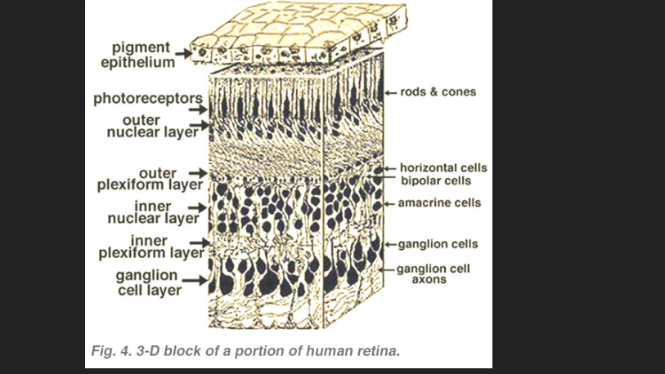

This is how corona virus can penetrate through the eyes
Conjunctivitis is the inflammation or swelling of the conjunctiva, the thin layer of tissue that lines the inner surface of the eyelid. Conjunctivitis is typically caused by a viral or bacterial infection, but it can also develop due to acute allergic reactions or environmental irritants like pollen. The same virus that causes common cold and influenza can cause conjunctivitis. When sick, the virus can spread to your eye through physical contact, such as sneezing into your hand and then rubbing your eye, this also true for the COVID-19 virus. It is the mucous membrane of the (that line various cavities of the body) that are most susceptible to transmission of the virus. So conjunctivitis may be a symptom of the corona virus, a recent study of hospitals across china, published in the new England journal of medicine, found “conjuctival congestion “ or red, infected eyes in nine of 1,099 patients (0.8%) with a confirmed diagnosis of coronavirus.

