OGBONNA WISDOM
17/eng03/037

What is GIS?
A geographic information system (GIS) is a system designed to capture, store, manipulate, analyze, manage, and present spatial or geographic data. GIS applications are tools that allow users to create interactive queries (user-created searches), analyze spatial information, edit data in maps, and present the results of all these operations. GIS (more commonly GIScience) sometimes refers to geographic information science (GIScience), the science underlying geographic concepts, applications, and systems. Since the mid-1980s, geographic information systems have become valuable tool used to support a variety of city and regional planning functions.
Application of GIS in hydrology
Geographic information systems (GISs) have become a useful and important tool in hydrology and to hydrologists in the scientific study and management of water resources. Climate change and greater demands on water resources require a more knowledgeable disposition of arguably one of our most vital resources. As every hydrologist knows, water is constantly in motion. Because water in its occurrence varies spatially and temporally throughout the hydrologic cycle, its study using GIS is especially practical. GIS systems previously were mostly static in their geospatial representation of hydrologic features. Today, GIS platforms have become increasingly dynamic, narrowing the gap between historical data and current hydrologic reality. The elementary water cycle has inputs equal to outputs plus or minus change in storage. Hydrologists make use of a hydrologic budget when they study a watershed. A watershed is a spatial area, and the occurrence of water throughout its space varies by time. In the hydrologic budget are inputs such as precipitation, surface flows in, and groundwater flows in. Outputs are evapotranspiration, infiltration, surface runoff, and surface/groundwater flows out. All of these quantities, including storage, can be measured or estimated, and their characteristics can be graphically displayed in GIS and studied. As a subset of hydrology, hydrogeology is concerned with the occurrence, distribution, and movement of groundwater. Moreover, hydrogeology is concerned with the manner in which groundwater is stored and its availability for use. The characteristics of groundwater can readily be input into GIS for further study and management of water resources. Because 98% of the world’s available freshwater is groundwater, the need to keep a closer eye on its disposition is readily apparent.

Some GIS tools and their uses:
The Intersect Tool; The Intersect Tool is very similar to the clip tool because the extents of input features defines the output. The only exception is that it preserves attributes from all the data sets that overlap each other in the output.

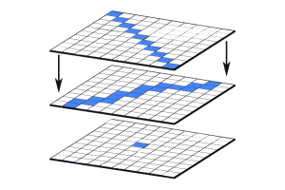

The Union Tool; Some say the Union tool should come with a bottle of antacid. The union tool gets a bad reputation because it creates a lot of features. The Union Tool maintains all input features boundaries and attributes in the output feature class.
After running this geoprocessing tool, it does get a bit messy especially when there are more overlaps. But it’s really not so bad. The Union tool spatially combines two data layers. It preserves features from both layers at the same extents.
The Erase (Difference) Tool; I like the erase tool. It’s always been helpful in erasing things! The input layer is what will be erased. The erase feature determines what to erase. Simple as that.
The Erase Tool removes features that overlap the erase features. This geoprocessing tool maintains portions of input features falling outside the erase features extent. The result is a new feature with the erase feature extent removed.
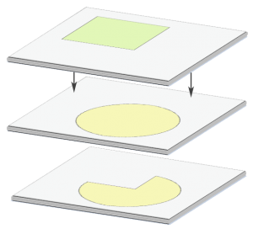
The Buffer Tool; Buffers are proximity functions. When you use this geoprocessing tool, it creates a polygon at a set distance surrounding the features.
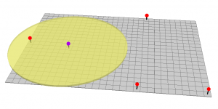
Types of GIS data
Numeric data; This is statistical data which includes a geographical component or field that can be joined with vector files so the data can be queried and displayed as a layer on a map in a GIS. The most common type of numeric data is demographic data from the US Census.
Vector data; This is data that has a spatial component, or X,Y coordinates assigned to it. Vector files can contain sets of points, lines, or polygons that are referenced in a geographic space.
Raster data; This is data in a .JPG, .TIF, .GIF or similar format. Items scanned using a flatbed scanner like this map are examples of raster files. Images taken with a digital camera produce these same types of files.

